CLASS: SY-B ENTC
PRN: 25UET078
NAME: BHAGYASHRI EKANATH BACHATE

SLA-4:
Problem Statement 11: Intelligent Cooperative Multi-Agent System

INTRODUCTION:
The Intelligent Cooperative Multi-Agent System is designed for games in which several intelligent agents must work together to achieve a common goal. When agents make decisions independently, they may choose conflicting actions because each agent has limited information about the game and the plans of its teammates. This can reduce team performance and make it difficult to complete the objective. The proposed system allows agents to share observations, communicate their intentions, coordinate actions, and learn from the results of previous moves. A shared view of the game state helps the agents select actions that support the team rather than only an individual agent. The C4 architecture describes the system at four levels: System Context, Container, Component, and Code/Module Design. Each level presents a different amount of detail and explains how the system works together.
OBJECTIVES:
The main objectives of the Intelligent Cooperative Multi-Agent System are:
• To enable multiple intelligent agents to work together toward a common game objective.
• To share observations and communicate intended actions among agents.
• To coordinate decisions and reduce conflicts between individual agents.
• To store game states, actions, rewards, and outcomes for future reference.
• To learn from previous results and improve the team strategy over repeated gameplay.

C4 LEVEL 1:
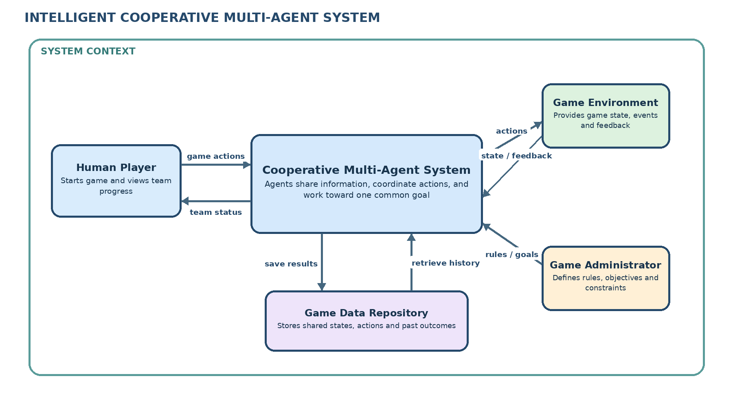

This diagram presents the system context and its external interactions. The human player starts the game and receives progress updates. The game environment supplies the current state, rules, events, and feedback, while the administrator defines the objectives and constraints. The Cooperative Multi-Agent System uses this information to coordinate the agents, select joint actions, and send actions back to the game. The Game Data Repository stores shared observations and outcomes so that the team can use previous experience to make better decisions.

C4 LEVEL 2:
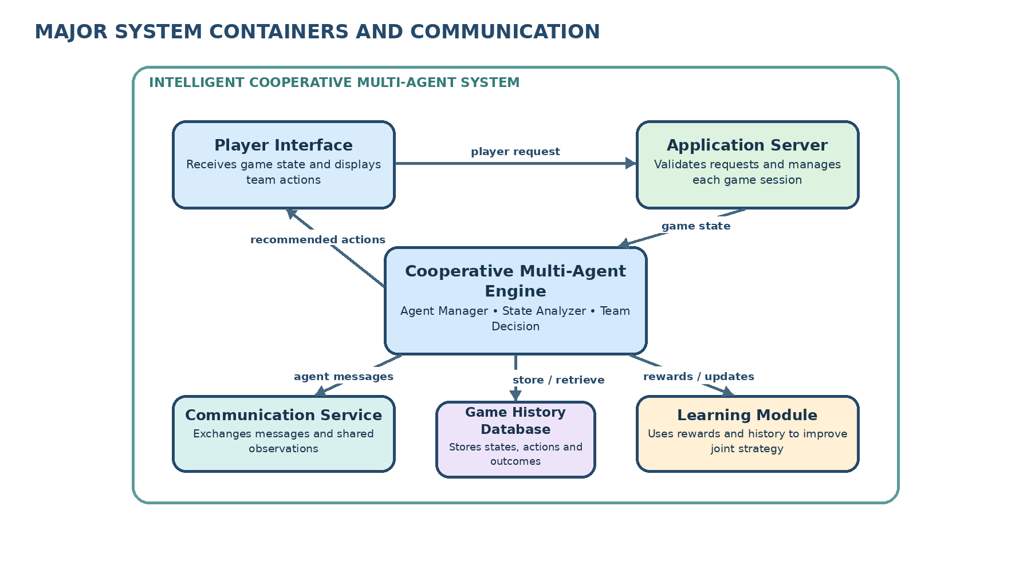

This diagram shows the main containers and how information moves between them. The Player Interface accepts requests and displays results, while the Application Server manages the game session and validates requests. The Cooperative Multi-Agent Engine analyses the shared game state and selects coordinated actions. The Communication Service carries observations and messages between agents. The Learning Module uses team rewards and past outcomes to improve future decisions, and the Game History Database stores game states, actions, rewards, and results. Together, these containers support reliable communication and cooperative gameplay.

C4 LEVEL 3:
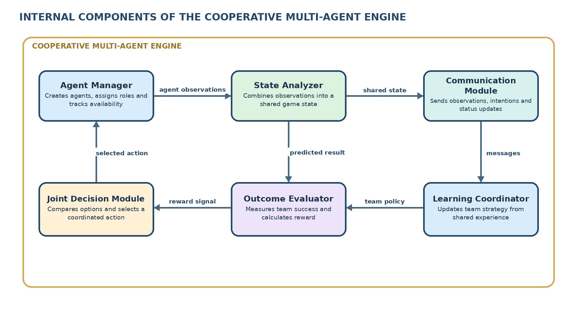

This diagram describes the important components inside the Cooperative Multi-Agent Engine. The Agent Manager creates agents, assigns roles, and tracks their status. The State Analyzer combines individual observations into a shared view of the game. The Communication Module exchanges observations and intended actions. The Joint Decision Module compares possible actions and chooses an action that supports the common objective. The Outcome Evaluator measures the result of the team’s actions, and the Learning Coordinator uses rewards and experience to improve the team strategy. These components help prevent conflicting decisions and encourage coordinated behaviour.

C4 LEVEL 4:

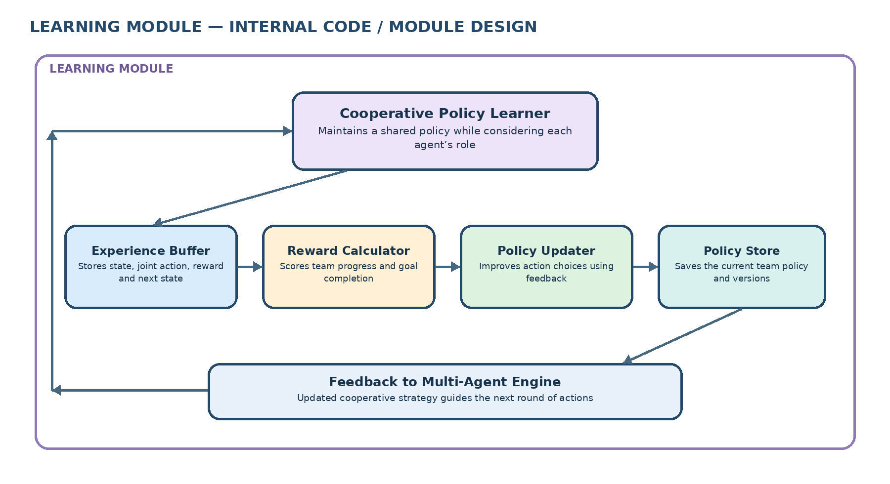
This diagram presents the internal modules of the Learning Module. The Experience Buffer stores previous game states, joint actions, rewards, and next states. The Reward Calculator measures how well the team has progressed toward its common goal. The Policy Updater uses this feedback to improve the agents’ action-selection policy, while the Policy Store saves the current policy for future rounds. The Cooperative Policy Learner combines these modules and sends the updated strategy back to the Multi-Agent Engine. In this way, agents learn from shared experience and can improve coordination over repeated gameplay.
CONCLUSION:
The Intelligent Cooperative Multi-Agent System provides a structured way for intelligent agents to coordinate their actions and achieve a shared goal. The four C4 levels explain the system from its external interactions to its containers, internal components, and learning modules. By sharing information, evaluating outcomes, and learning from past experience, the agents can reduce conflicting decisions and improve team performance. Thus, the proposed system supports more effective and cooperative gameplay.

