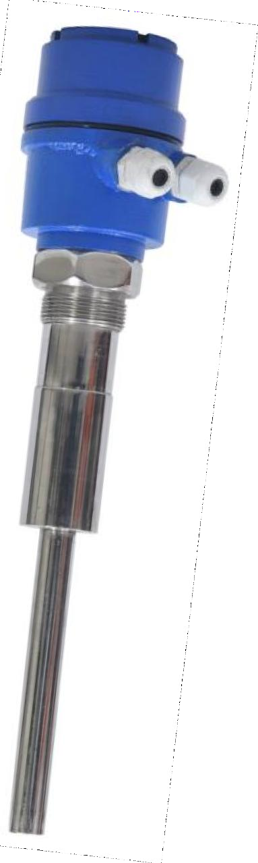
Salient Features:
The Vibrating Rod Level Switch is an economical choice in level detection of powders and bulk solids. The Vibrating Rod Level Switch built with a piezoelectric crystal that vibrates the rod at a natural frequency. Once the rod comes in contact with the material, the vibration will be damped and the switch will change its state. Once the rod is uncovered by the material, the switch will revert to its normal state. Best for silo or hopper applications, its
probe design allows for self-cleaning, ensuring
no build-up or bridging of material and accurate detection. Sensitivity is adjustable for detection ranging from large granular material to small powders with low bulk densities. The failsafe mode can be set for failure on high level or failure on low level using a selector switch in instrument.
Applications:
Flakes, Grains, Coal Powder, cereals, sugar, animal feed, milk powder, flour, insulation, cement, plastic granules, saw dust, wood chips carbon black, light fibers, detergent powders, dyes, chalk, silica,


- Compact size with integral electronics
- No calibration required, so plug and play
- No moving parts so no wear and tear
- Universal Power supply for AC / DC operation
- Relay or open collector PNP outputs available in Options
- Rigid and sturdy design @ 250 mm
- Available in 1&1/2 i n c h and above screwed mounting standards
- IP 68 ingress protection
- Field Selectable fail-safe mode
- LED indicators for status, alarm and normal operation
- Selectable Density setting and switching delay

Model: VFLS-400S
Make: Levtron Instruments Pvt Ltd. Pune
Technical Specifications
Mechanical
Housing: Cast Aluminum lP 68
TYPE: Integral with probe with Electronics Cable Entry: PG 13.5/PG 16
Cable Gland: Single compression PG13.5/PG 16
Mounting: 1 ½” BSP standard.
Mounting Pipe extension M.O.C.: MSIGIISS304 ISS316 asper requirement
Tuning Fork: S316/SS304 Electronics:
Power supply: 24 V DC OR 230 V AC SPECIFY.
Power consumption: 3 VA Max. Out Put: SPDT/DPDT Relay
Relay output: Potential. free change over contacts rated at 6A 230 V AC SO Hz Resonant frequency of fork: 350 Hz approx. for 100 mm fork
Switching delay: Adjustable up to 20 sec. for fork covered or
uncovered condition
Failsafe condition: High I Low field selectable.
Sensitivity: Field selectable for Lowand High density material Indication: By LEDs, Yellow for status, Blue for Normal, and Red for Alarm

Mechanical Drawing:
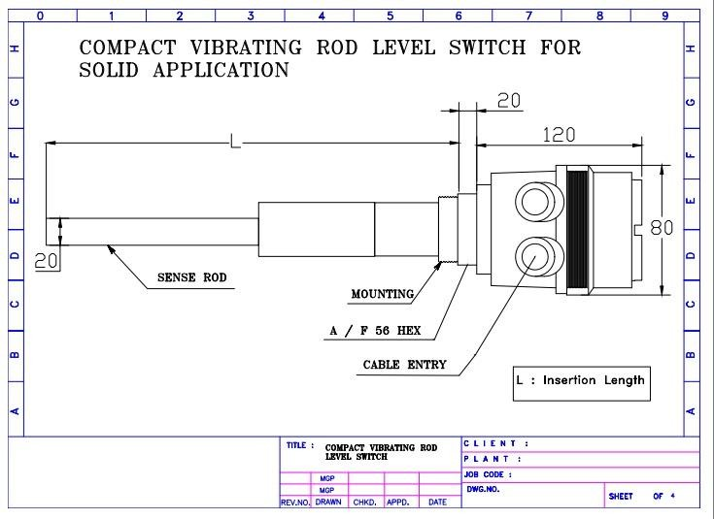

INFORMATION REQUIRED Before Purchase
- Process Parameters: Process Connection, Process Temperature, Vessel pressure if any.
- Application media characteristics: Density, Viscosity, Sp. Gr.
- Supply Voltage, Probe length, Mounting etc.

Manufactured By:

Levtron Instruments Pvt Ltd.
Office No 2, 1st floor, plot no 6, Pandhari Industrial estate, Shivane. Pune 411023, Contact: 09579430012 / 9730042725 E-mail: sales@levtron.in Website : www.Levtron.in

