
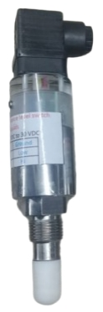
Overview: An AC electric signal is generated at the tip of the sensing electrode. If the sensor is covered with medium,
the capacitance value @ the sense probe changes. This change is detected by the electronics and converted into a switching signal.
Any build-up is ignored to a certain degree and therefore has no influence on the measurement

Applications:-
The MINICAP is a capacitive level sensor typically used in level detection of fine-grained and powdery bulk solids, or liquid media
Typical applications are overfilled and dry run protection. The small sensor can also be used in thin pipelines for liquid level detection.

Features:-
Simple connections
Maximum Working Life, because wear and maintenance free Design Optimized for light, powdered bulk materials, Exact switching function independent of process condition

Technical Details:-
Supply: - 12-35 VDC
Output signal: -Std. PNP /SPDT Relay output (Specify) Process fitting: - Thread ½”, BSP Male threading (Specify) Max pressure: - 1 to 10 Bar
Max temp-: --40 To 125 Deg C

Electrical connection:-
- Voltage supply + V 12 V DC to 35 V DC
- Gnd / 0 V
- NO Of Relay /PNP -NO @ 350 mA max
- Pole and 5 NC

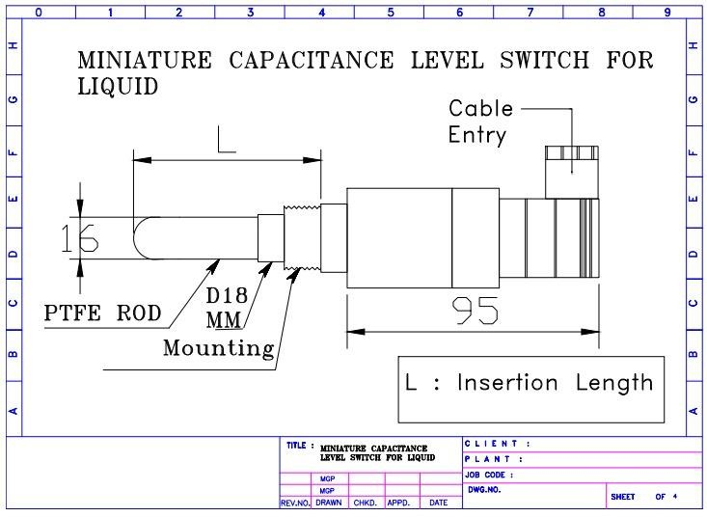
Mechanical Drawing:

