
INFRA POINT LEVEL SWITCH
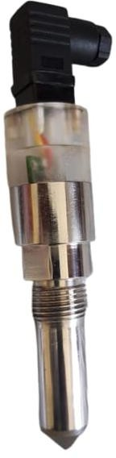
INFRA LEVEL SWITCH instruments are suitable for the detection of liquid level in small vessels where space is limited. Level detection is unaffected by electrical and physical parameters of the media such as conductivity, dielectric constant, density, viscosity, air bubbles, color and refractive index. It is very compact and fits in constrained spaces. It is unaffected by vapour and can be easily removed, cleaned and reinstalled. It has no moving parts and can be used for the detection of level in chemical and Pharmaceutical industries, food processing, beverages, breweries, hydraulic fluids, oils, water and aqueous media.

OPERATING PRINCIPLE: -
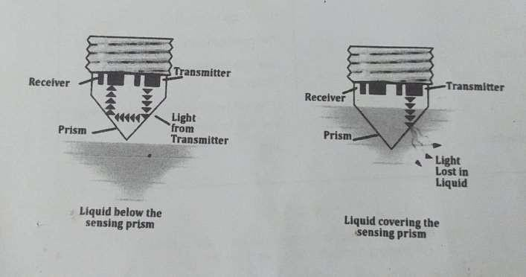
An infrared emitter sends pulsed light into the prism. When the prism is not covered by the media, the light undergoes a total internal reflection and the returning beam is detected by the Photo Detector. When the Prism gets covered by the media the light is dispersed and only a weak beam returns to the Photo Detector. The change in the received intensity is processed by the electronics to signal an Alarm.

SALIENT FEATURES:-
- Compact design, no moving parts.
- No calibration required.
- Selectable Fail-Safe mode for High- or Low-level Alarm.
- Built in level status, Alarm and Normal Indicators.
- Pulsed light operation for high ambient light immunity.
- Open Collector PNP Transistor output for connection to PLC or external replay.

Variety of models available to cater to different applications
Technical Datasheet / Specifications:

Housing | : Stainless Steel SS316
Process Connection | : ½” BSP/NPT, other on request.
Light Guide | : Polysulfide
Minimum insertion Distance from Prism apex to opp. Surface | : >=10mm
Input Supply | : 15 to 30V DC
Max circuit current | :<15mA, reverse polarity protected
Ambient Temperature | : -20 to 100 º C
Operating pressure | : 150 PSI
Response Time | : Preset to <1 S
Fail Safe | : High/Low Selectable.
Output Type | : PNP open collector standard.
Output Active | : Max 120 mA, momentary short circuit protected.
Indication  Applications: | : LED’s , Blue for Normal and Red for Alarm.  : Transparent and semitransparent liquids, Non coating liquids.

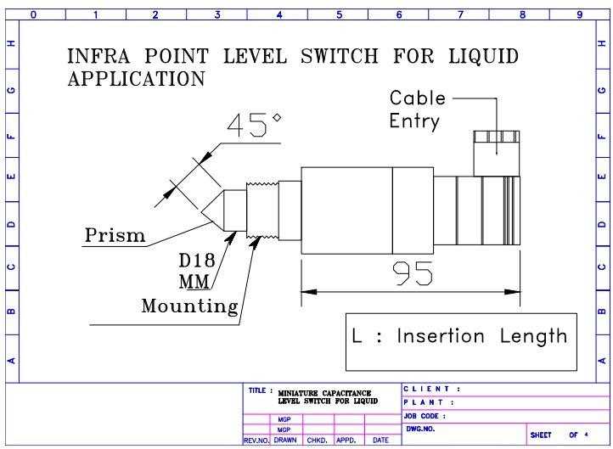
Mechanical Drawing:
Wired Connector Drawing:

Black |  | Ground | O V | O V
RED |  | HI | + 24 V DC POWER | Output
GREEN |  | LOW | OUTPUT | + 24 V DC POWER
Silver |  | Shield | Earth | Earth

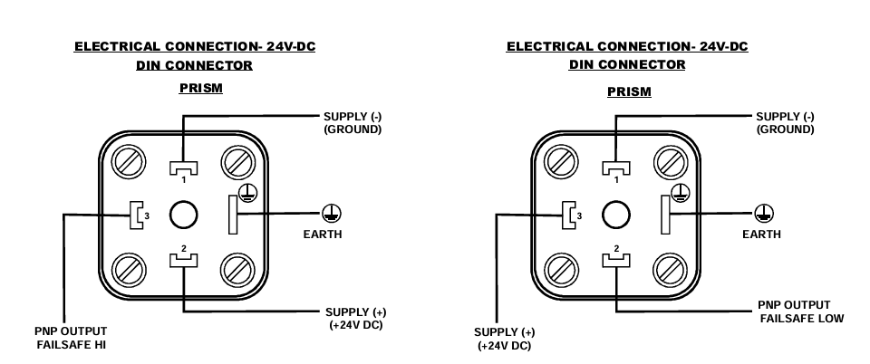
DIN Connection Drawing:

