
Point level detection for bins and chutes
A diaphragm level switch is a type of pressure switch used to detect Low or Hi Levels in silos/bins containing dry, non-hazardous free flowing materials. Diaphragm switch works by activating a sensitive micro-switch when material reaches the level of the switch in the Silo / bin. Output switch can be used to start or stop a process or alert to a high, medium, or low-level detection.

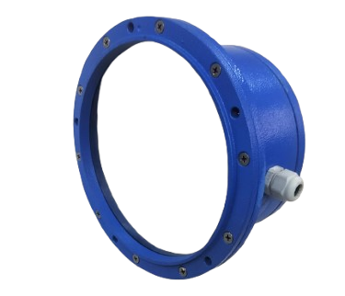
Features:
- Point level detection in bins and silos
Rugged construction, simple design
- Durable Cast Aluminum housing
- Corrosion resistant Paint
- Silicone diaphragm material
- external mounting.
- Monitoring levels of dry, free flowing materials
- Eliminate overflow or maintain a level specific of material
- Detect overfilling/plugging of chutes or conveyors
- Material density from 20 lb./cu. ft. • Installation in ordinary locations

Applications:
- Dry fertilizer and granular and chemicals, • Powders, bentonite, or potash
- resin pellets, regrinds, Plastic and rubber beads
- Wood pellets, chips, or sawdust
- Nut crops such as peanuts, sunflower, or sesame seeds
- Foodstuffs such as rice, wheat, oats, or sugar beets.

SPECIFICATIONS:

SS Diaphragm Switch Model No: SDLS-1500S
Normal sensitivity: 200 gm (Rubber) / 400 gm (SS) Diaphragm Membrane material: Nitrile Rubber or, SS Ambient temperature: 60° C Electrical contacts: Micro switch, 15 Amp,230 VAC, Potential free
Cable Gland: PG 13 / PG 16 Main body: Cast Aluminum
Switching Housing: Cast Aluminum for Rubber type and Polymer for SS type
Protection for switching housing: IP 67

Drawings:
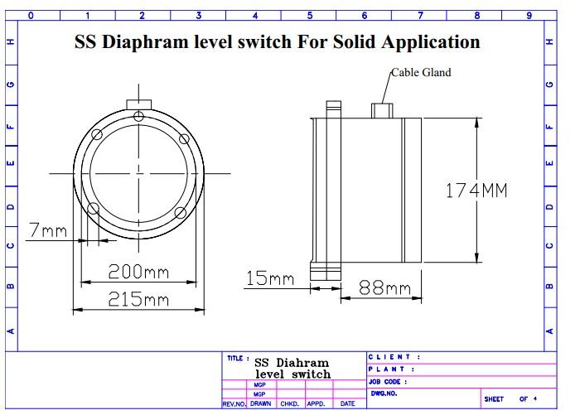

Manufactured By:

Levtron Instruments Pvt Ltd.
Office No 2, 1st floor, plot no 6, Pandhari Industrial estate, Shivane. Pune 411023, Contact: 09579430012 / 9730042725 E-mail: sales@levtron.in Website : www.Levtron.in

