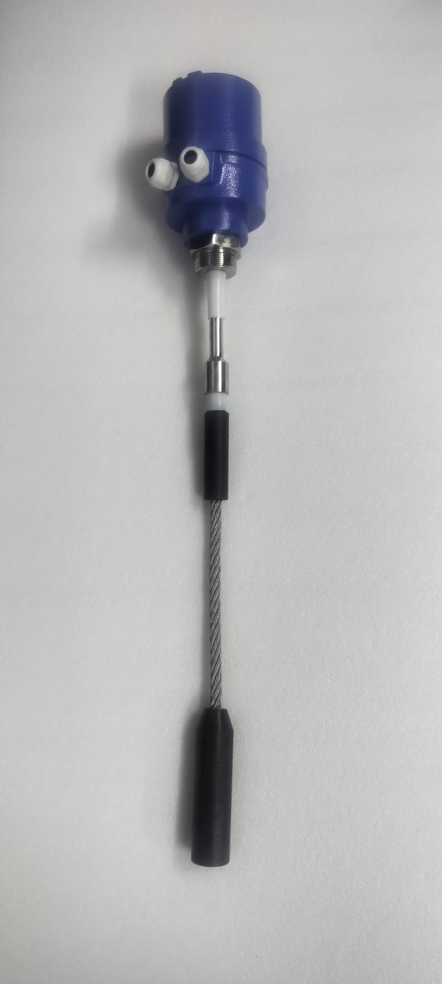
RF Admittance type level switch is a simple, low cost, rugged point Level Switch designed for Level detection of Bulk materials in a bins or silo. This level switch can be used for detecting high, low level or for differential level detection and is used in various level detection applications, cement industries, material handling plants, chemical industry, power utilities industry, food industry, pulp/paper industry, pharmaceuticals industry, water/ treatment plants, foundry industry etc.
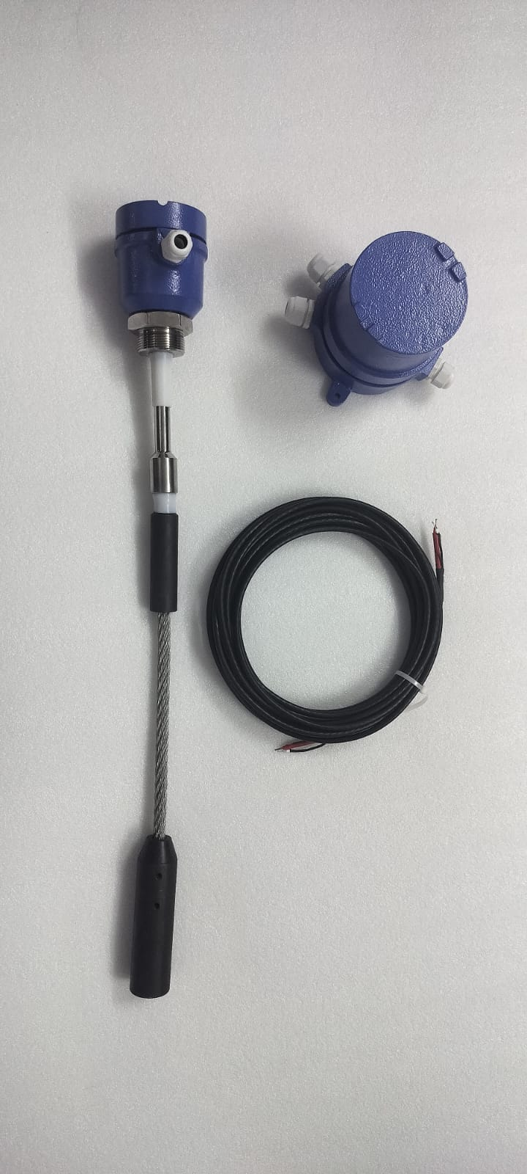
The specialty of the probe is that it tends to ignore the build-up on the probe, thus making it suitable for application, which tends to stick on the probe.
The unit has options with integral and Remote electronics along with time delay feature, LED indication, fail safe mode etc.

SALIENT FEATURES
- Wide range of application
- Easy installation and maintenance.
- Weatherproof/Flameproof enclosure as per requirement
- PTFE insulated electrode capable of withstanding 180°C
- No moving parts, no mechanical wear and tear.
- Adjustable differential time delay with ON/OFF timing.
- Fail Safe High/Low Selection Feature (Field configurable)
- Ignores Build Up of Sticky and Conductive Material between Probe and Vessel Walls
Model: RFLS-300SR
SUPPLY VOLTAGE | 230VAC or 110VAC or 24V DC (factory selectable)
OUTPUT TYPE | 1 DPDT Relay
CONTACT RATING | 05 AMPS at 230VAC /24VDC, Resistive load Dual,
CABLE ENTRY | “PG 16, etc.
TEMPERATURE | 0-150°C for integral type.
 | 0-150°C for integral with Standoff, type
 | 0-180°C for Remote with Standoff, type
PROBE | Type: Rigid Probe with Coat guard electrode Insulation:
 | Teflon/Ceramic (for high temperature up to 450°C)
 | Probe Length: As per requirement, Housing: Cast Al.
MATERIALS | Probes (Sense & Shield SS316/SS304), Flange/Adapter: SS316/SS304/C.S.
 | Flanged or threaded process connection as per requirement.
MOUNTING | Weatherproof as per IP 66 Flameproof (optional)
FREQUENCY | 120 KHz (±10%)
TIME DELAY | 0 To 30 seconds adjustable with ON/OFF delay Selection
FAIL SAFE | Selectable.
Make: Levtron Instruments Pvt Ltd. Pune
INFORMATION REQUIRED Before Purchase
- Process Parameters: Temperature, pressure, atmosphere hazardous /non-hazardous.
- Application media characteristics: Sp. Gr., Dielectric constant, hazardous or not, corrosiveness, viscosity.
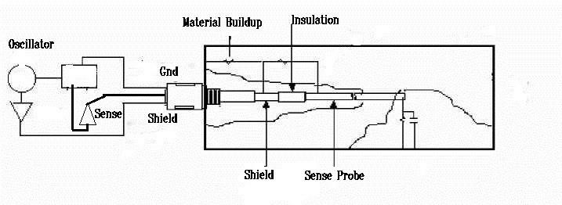
Probe Construction suitable for material built up:
Normal probe tends to fail when there is a build-up on the probe. The COAT Guard electrode senses the material build up on the probe by employing a special Build up sensing technology. The COAT guard unit is insulated from the active probe and the ground is driven with same RF frequency as that of active electrode and having the same polarity. When a material build up is formed on the probe, the RF current from the COAT guard unit tends to saturate the build-up area between COAT guard probe and silo wall, thereby no electrical energy will flow from active probe to tank wall. When the material level goes up and touches the sense probe a RF current will flow from the sense probe to ground over and above the saturated region formed by the Built-up sensing circuitry.
Mechanical Drawing: Integral Rope Type
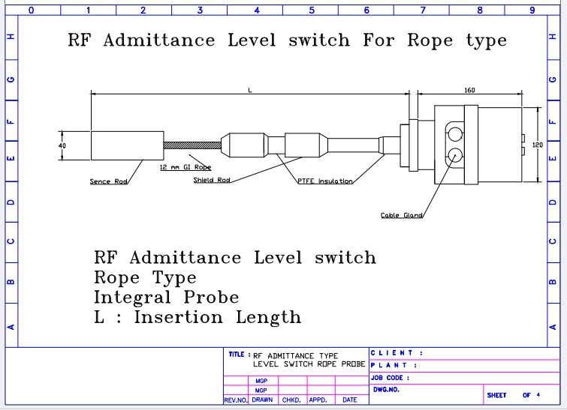

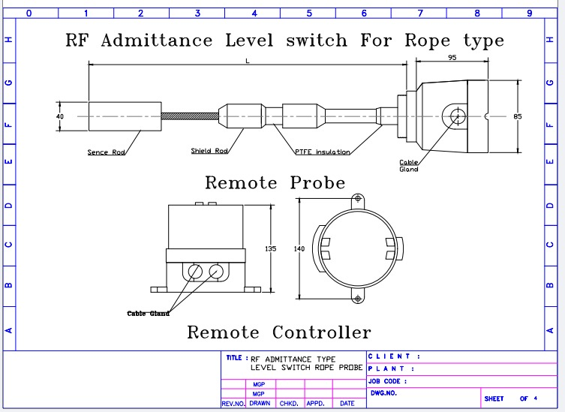
Mechanical Drawing: Remote Probe Type

