
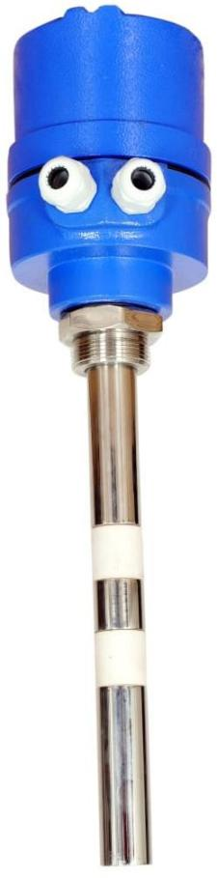
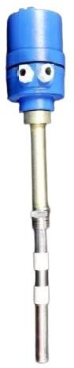
➢
➢
➢
➢
➢
➢
RF Admittance type level switch is a simple, low cost, rugged point Level Switch designed for Level detection of Bulk materials in a bins or silo. This level switch can be used for detecting high, low level or for differential level detection and is used in various level detection applications like. cement industries, material handling plants, chemical industry, power utilities industry, food industry, pulp/paper industry, pharmaceuticals industry, water/ treatment plants, foundry industry etc.
The specialty of the probe is that it tends to ignore the build- up on the probe, thus making it suitable for application, which tends to stick on the probe.
The unit shown above is integral Type Rod Probe along with time delay feature, LED indication, fail safe mode etc.
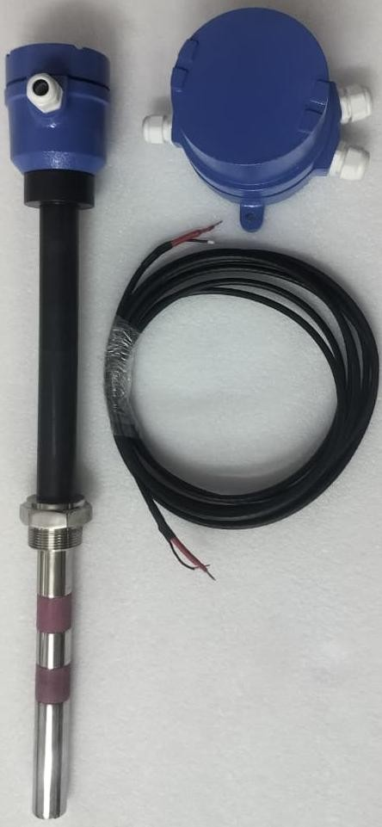
Unit Shown Below is Remote type Rod Probe along with time delay feature, LED indication, fail safe mode etc.

SALIENT FEATURES
Easy installation and maintenance, Wide range of application Weatherproof/Flameproof enclosure as
per requirement
Sturdy electrode to withstand impact due to accidental clinker formation. UHMWPE insulated electrode works up to 80°C
No moving parts, no mechanical wear and tear.
Adjustable differential time delay with ON/OFF timing.
Fail Safe High/Low Selection Feature (Field configurable)

Datasheet:

Model: RFLS-300HD

SUPPLY VOLTAGE 230VAC or 110VAC or 24V DC (factory selectable) OUTPUT TYPE 1 DPDT Relay
CONTACT RATING 05 AMPS at 230VAC /24VDC, Resistive load Dual, CABLE ENTRY PG 16
TEMPERATURE 0-120°C for integral type.
0-250°C for integral with Standoff, type 0-450°C for Remote with Standoff, type
PROBE Type: Rigid Probe with Coat guard electrode
Insulation: Teflon/Ceramic (for high temperature)

Probe Length:
Housing:
Std :300MM / As per requirement, Cast Aluminum.

MATERIALS Probes (Sense & Shield SS316/SS304), SS316/SS304/C.S. Flange/Adapter: Flanged or threaded process connection as per requirement.

Mounting: Enclosure
1½” BSP Standard / Specify.
Weatherproof as per IP 68/ Flameproof (optional)

Failsafe Field selectable

Mechanical Drawing: Integral Type
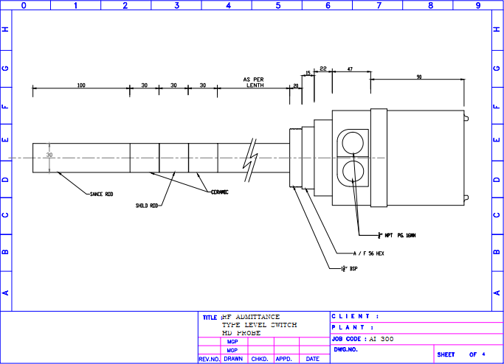

Mechanical Drawing: Remote Type
