
Hydrostatic Level Transmitter for Liquid Application
Model: HSLT-2000L

evel TransmitterLevel Transmitter
Description:
Model LV36 submersible liquid level transducers and transmitters with flush diaphragm is designed for a wide variety of level measurement applications. This model pressure sensor and is protected by the stainless steel (SS) housing. Featuring the flush diaphragm makes the LV36 suitable to measure viscous media or media with small particles, so as to have diverse measurement applications.

The standard reference pressure is gauge (or relative) pressure realized through a vent tube in the cable. The reference pressure can also be absolute pressure on request.

The measuring range of LV36 transmitters spans from 0~1 to 0~200 meter water column (mH2O) with measuring accuracy of 0.5%fs (fs = full scale). The output signal of transmitters can be configured to either current loop (4~20mA,standard), voltage output (0.5~4.5V, 1~5V), or digital output (I2C or SPI). The millivolt signal directly from the Wheatstone ridge circuit is also available on request (transducer version).
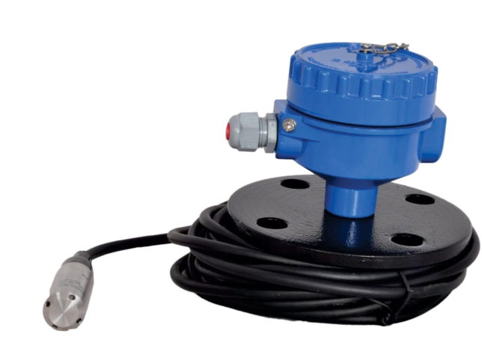
Features :
measuring ranges: 0~1m, 2m, 3m, 5m, 6m, 8m, 10m, 12m 15m Higher length request output signal: 4~20mA (standard), other o/p optional
(~80mV @5Vdc) available on request accuracy: 0.5%fs
compensated temperature range: 0~70oC
materials: 316L SS (pressure membrane), 316 SS (housing) construction: all stainless steel housing, rigid and robust environment protection: IP68
Technical Data

Parameters |  | Units | Specifications | Notes
measuring media |  |  | viscous fluid, or fluid with particles which is compatible with 316L SS
measuring ranges* |  | mH2O | 1m, 2m, 3m, 5m, 6m, 8m, 10m, 12m, 15m | 1 & 2
overload |  | %fs | 150
output signal | for transmitters |  | 4~20mA (standard). 2
 | for transducers | mV/V | ≥ 15
power supply | for transmitters | Vdc | 24 (typical), 12, ..., 36
excitation | for transducers | Vdc | 5, ..., 10
 |  | mA | 0.5, ..., 2
accuracy |  | %fs | ≤ ±0.5
long-term stability |  | %fs/year | ≤ ±0.2 (standard), ≤ ±0.1 is available on requst
response time |  | ms | < 1 (10%~90% of leading edge)
input resistance | for transducers | Ω | 2000~8000
output resistance |  | Ω | 3500~6000
load resistance | for transmitters | Ω | 250~1150
insulation resistance |  | MΩ @500Vdc | > 500 (transducer only)
storage temperature range |  | °C | -40~+100
operating temperature range |  | °C | -20~+85
compensated temperature range |  | °C | 0~70
temperature coeﬃcient of zero |  | %fso/oC | ≤ ±0.02
temperature coeﬃcient of span |  | %fso/oC | ≤ ±0.02
process connection |  |  | submersible in
electrical connection |  |  | Φ7.3mm, 4-core shielded black PVC cable with/without a vent tube
membrane material |  |  | 316L SS
housing material |  |  | 316 SS
environment protection |  | IP rating | IP68
weight (without cable) |  | gram | ~250

HydrostatiHydrostatic Level Transmitter for Liquid Application
Model: HSLT-2000LLevel Transmitter
Ordering Information
pos. 7
pos. 6
pos. 5
pos. 4
pos. 3
pos. 2
pos.1
“(*)” is necessary only if any customized parameter is required, otherwise it is neglectable.
pos. 7: customized specifications
Φ7.3/2(*)/PVC/vent/2m = Φ7.3mm, 2-core(*) shielded black PVC cable, with a vent tube (for gauge pressure),
cable length = 2m, this length is determined by customers.
Φ7.3/2(*)/PVC/2m = Φ7.3mm, 2-core(*) shielded black PVC cable,
without a vent tube (for absolute pressure),
cable length = 2m , this length is determined by customers . (*): 2-core cable for 4~20mA output;
- core cable for 0~5V or 0~10V output;
- core cable for mV, IC2 , and SPI bus.
pos. 6: electrical interface
0.5%fs
pos. 5: accuracy
SPI
I2C
0.5/4.5V
1/5V
4/20mA (standard)
15mV/V
pos. 4: output signal
A: absolute pressure
G: gauge pressure (standard)
pos. 3: pressure referene
5mH2O 50mH2O
Note: Indicate the range as 0/?mH2O, e.g., 0/5mH2O, which is corresponding to the transmitter output options.
100mH2O
200mH2O
10mH2O
20mH2O
1mH2O
2mH2O
pos. 2: measuring ranges
LV36
position (pos.) 1: model

Example of Ordering Code

- standard products: LV36-0/1mH2O-G-4/20mA-0.5%fs-Φ7.3/2/PVC/vent/2m LV36-10mH2O-A-15mV/V-0.5%fs-Φ7.3/4/PVC/11m
- customized products: LV36-0/1mDiesel[850kg/m]3-G-0.5/4.5V-0.5%fs -Φ7.3/3/PVC/vent/2m with the customized medium and medium density.
Make - BCM sensors Technologies (Belgium)
Notes: 1. For customer ranges, consult BCM. For ranges ≤ 0.5 mH2O, accuracy = 1%fs.
- If in your applications the measured medium has different density than water, please inform BCM about the density.
- 4-core cable for mV, IC2 and SPI bus; 2-core cable for 4~20mA output; 3-core cable for 0.5~4.5V or 1~5V output.
- For cable length ≤ 0.5m, the output can be IC2 bus without other interface;
For cable length = 1m, ..., 15m, an RS-232 interface is applied to realize IC 2bus. For cable length > 15m, an RS-485 interface is applied to realize IC2bus.
- The vent tube is provided in the cable if the pressure type is gauge (relative) pressure. The cable will not be equipped with the vent tube if the pressure type is absolute.
The listed specifications and dimensions are subject to change without prior notice.

Dimensions
63
20
113
Ø 23.8
Ø 20

E
M/S. Levtron Instruments Pvt Ltd.
Office No 2, 1st floor, plot no 6,
Pandhari Industrial estate,
Shivane. Pune 411023,
Contact: 09579430012 / 9730042725
E-mail: sales@levtron.in Website : www.Levtron.i

