Magnetic Level Indicator: LMLI-2100L

Magnetic Level Indicator / Gauge provides clear, high-quality indication, are principally designed as an alternative to glass level gauges. Magnetic Level Gauge is available in Top and Side mounted construction.
Magnetic Level Gauge consists of three major components: Float chamber, Float and Indicator system. The visual indicator is available in two types Follower Capsule and Bi-Colour Flapper.
Magnetic Level Indicator operates on principles of magnetic field coupling, to provide fluid level information. Float chamber is typically constructed with non-magnetic pipe having process connection that matches to the vessel connections. Float size and weight is determined by the process fluid, pressure, temperature and the specific gravity of process fluid. Float contains magnets to provide 360⁰ magnetic flux field.
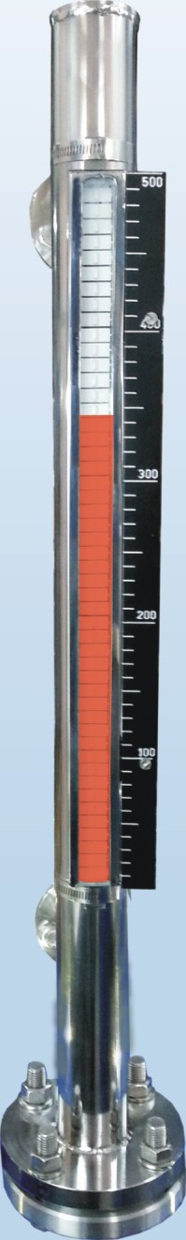
Simple non-magnetic pipe with flange allows a magnet connected to the Float move up and down inside the tube. An external Bi-Colour Flapper channel or Follower Capsules indicates the level based on magnet position.
Bi-Colour Flapper Design:
Indicator system consists of Bi-Colour Flapper equipped with magnets mounted on rail inside the housing. As the level starts rising or falling magnetic Float also travels with liquid level in non-magnetic chamber. The magnetic interaction between magnets in Float and Bi-Colour Flapper causes each Flapper to rotate 180⁰
Follower Capsule Design:
Indicator system consists of colour Follower Capsule which moves in glass tube inside the housing. As the level starts rising or falling, magnetic Float also travels with liquid level in non-magnetic chamber. The magnetic interaction between magnets in Float and Capsule causes Capsule to travel along with magnetic Float.
For application where high and low electrical signals are required adjustable limit switch assemblies are provided. In application where continuous output is required, Reed transmitter are supplied.
Application:
Suitable for aggressive, combustible, toxic, high pressure & high temperature liquid storage tanks. It is most widely used in Fuels, Oil, Chemical, Acids, Solvents, Syrups, Beverages, Water, dyes.

Side Mounted Magnetic Level Indicator
12 | Level Switch
1 1 | Drain Plug
10 | Level Transmitter
09 | Mounting Clamp
08 | Flapper
07 | Vent Plug
06 | Scale
05 | Float Chamber
04 | Process Connection
03 | Chamber Flange
02 | Float Rod
01 | Float
Sl.No. | part
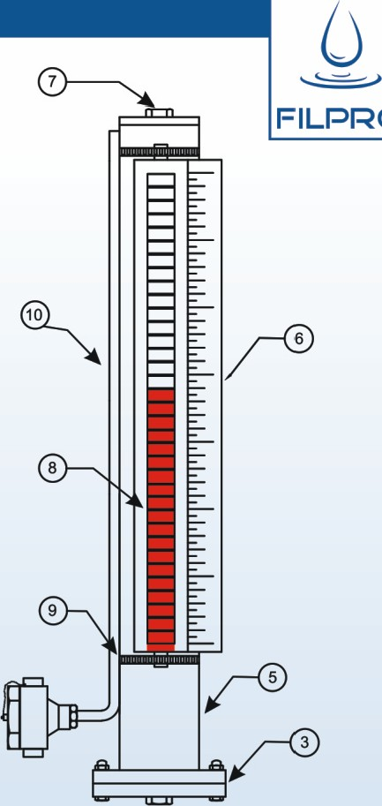
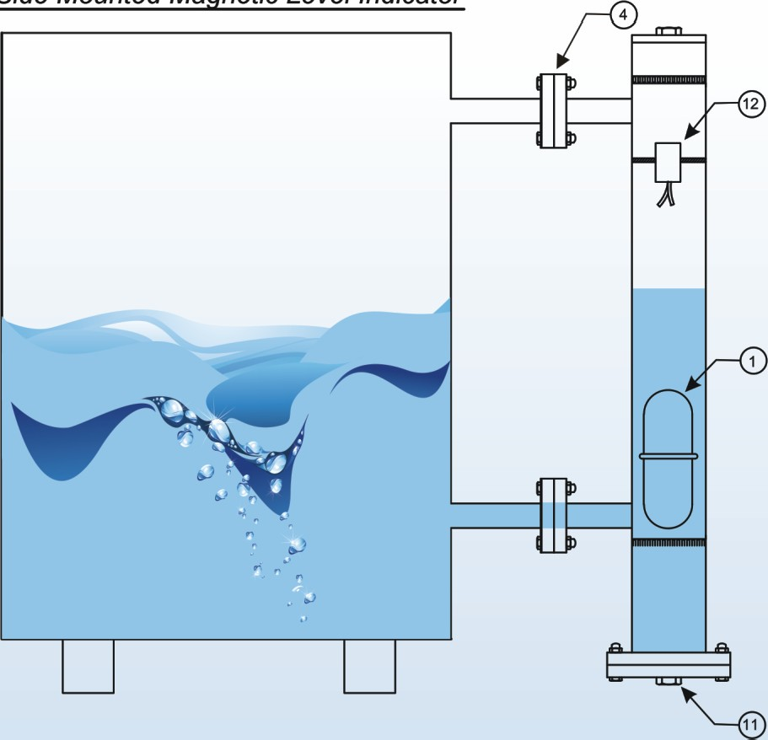

TOP Mounted magnetic Level Indicator
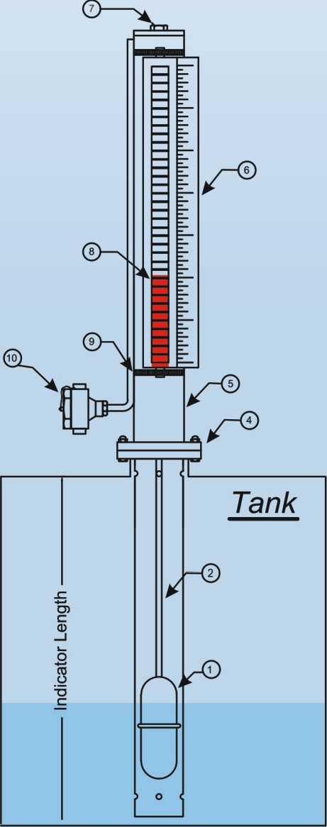 Detail view of Indicator

Specifications
Mounting Type Indicator: Length (C/C Distance)
Indicator system
Housing for Indicator
MOC Of Bi-Colour Flapper
Float chamber
MOC Of Float chamber
Float
Scale
Process Connection
Vent
Drain
Maximum Temperature
Pressure ordering information LMLI2100L-

Side Mounting-S Top mounting-T
300MM To 6000MM
Bi-Colour Flapper / Follower Capsule SS housing For SS Flapper
Aluminium Housing for Aluminium Flapper SS 304/ Aluminium
50NB No-Magnetic Standard Pipe (other size on request)
Follower capsule-Glass Tube in Aluminium/SS Channel
SS 304, SS 316, SS3161, PR PVDF, Others on Request
SS 304, SS 316, SS3161, PR PVDF, Others on Request
Flange/Thread/Tri Clover/Union In Various Sizes
½” Plugged / ½” Ball Valve
½” Plugged / ½” Ball Valve
700C for PP, 1500C for SS, Higher Temperature on Request
2kg/cm 2For PP, 10kg/cm 2For SS, More Pressure on request

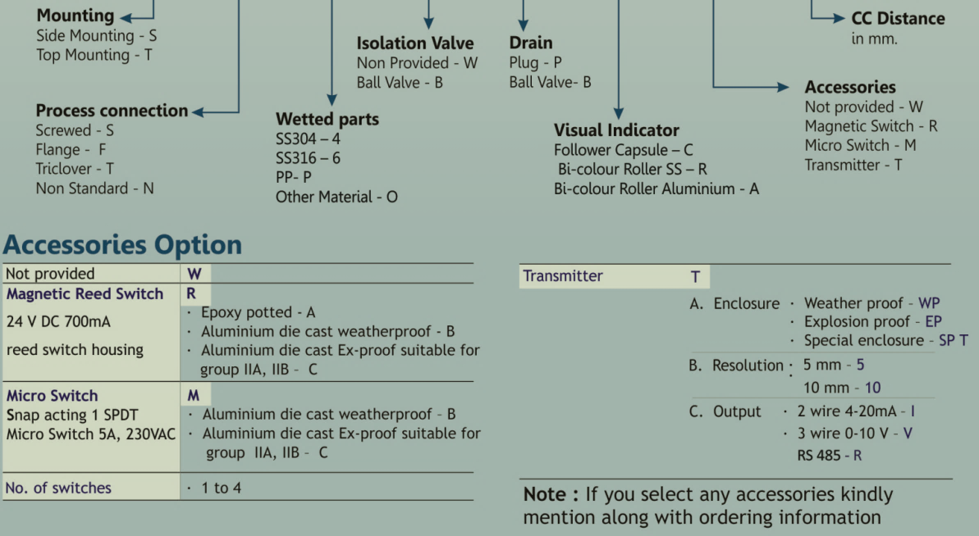

.

Levtron Instruments Pvt Ltd
Office No-02, 1St Floor, Plot No 6, Sr No.78/1, Pandhari Industrial Estate, Shivane, Pune-411023
Mob No: 9730042725 /9579430012
GSTIN : 27AAFCL7569M1ZP

