
Tubular Level Indicator
Model No-LTLI-2200L
Tubular level indicator

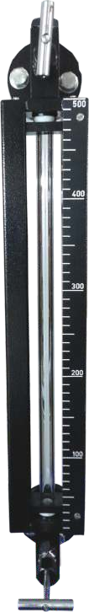
Description :
Tubular liquid level indicator is a simple and reliable device for direct reading in atmospheric or pressurized tanks.

Construction & Design Features
The Indicator is fitted between two end blocks through gland packings. The indicator is mounted parallel to tank so as to form a close loop causing tank liquid to seek its level in the gauge.
Guards are provided in the form of Tie-rods for 360O visibility or
C- channels around the gauge to protect it from accidental blows. Glass removal for replacement possible w/o dismantling the gauge.
100% PTFE bush as packing to ensure positive leak tightness for full vacuum as well as 6 kg/cm service pressure.
It is available in single length of 2000mm c/c distance. We can extend the length by coupling 2 or more through coupler.
We are providing Air Vent plug at top & drain plug at bottom for taking sample.
We can also provide inbuilt isolation valve or offset constructed isolation valve on request.
The connection provided will be Flanged/Screwed/TC joint.

Applications
It can be used in almost every application like Water, waste water, Effluent treatment plants, Liquid sewerage tanks, chemical dosing systems, chemical Reactors, Fertilizer, Power generation, Automobile, Pharmaceutical etc.,

1.Glass tube | 19mm OD-9  25mm OD-5
2. Protection guard | MS ‘C’ Channels-MC  SS 304 ‘C’ Channels-SC  MS Tie Rods-MT  SS 304 Tie rods-ST
3. End Fittings | SS 304-4  SS 316-6  CS-C  PP-P  Other Material-N
4.lsolation Valve | Not Provided-W  Needle Valve-N
5. Drain | Plug-P  Ball Valve-B
6.Process Connection | Flanged-F  Screwed-S
7.Scale | Aluminum-A  SS 304-S  Polycarbonate-P

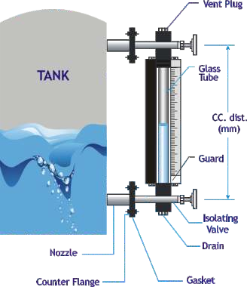
Schematic Diagram

Ordering Information
LTLI
Glass Tube

CC Distance

9 Protection Guard
5 MC
SC MT ST OM
Scale A
S P
in mm.

Order Example: LTLI – 9 MC C W P F A – 2000
End fittings | Isolation Valve | Drain | Process Connection
4 | W | P | F
6  C P O | N | B | S

Tubular level indicator with 19mm glass tube, MS C channel protection guard, cast steal end fitting without isolation valve, with drain plug, flanged process connection, with aluminum scale of length 2000 mm.

Levtron Instruments Pvt Ltd.
Office No 2, 1st floor, plot no 6, Pandhari Industrial estate, Shivane. Pune 411023,
Contact: 09579430012 / 9730042725 E-mail: sales@levtron.in ; Website: www.Levtron.in

