

Levtron Instruments Pvt Ltd.

INTRODUCTION
The Levtron Float & Board Level Indicators are designed for an
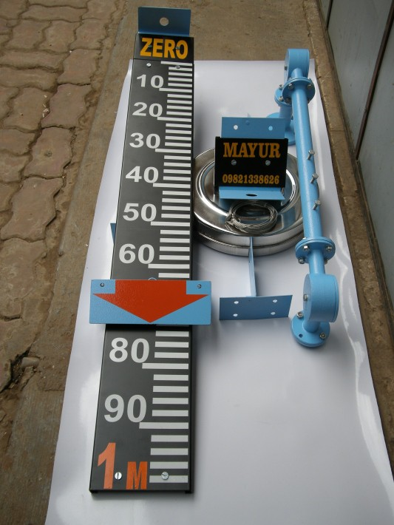

accurate, reliable & trouble free float operated technique used in large non
-pressurized storage tanks.

PRINCIPLE
The Float & Board Level Indicators consists of a float connected to a pointer through a rope via a set of pulleys. The pointer glides over a calibrated gauge board, positioned parallel to the tank. The float accurately follows liquid level variations in vertical direction. The vertical float movement is such that the pointer in ‘TOP POSITION’ when tank is ‘EMPTY’ and in ‘BOTTOM POSITION’ when ‘FULL’.

FILPRO

Gauge Classification
Measuring Range :
Float :
Calibrated Gauge Board : Least Count :
Maximum Temperature : Maximum Pressure :
Float Wire Rope :
Installation :
Specific Gravity of Fluid : Connecting Pipe : Local Indication
Direct :
Follower Magnet :
Pulley Assemblies : (2 Nos.)
Protection Conduit
Horizontal Limb :
Vertical Limb : Process Connections: Gauge Board Brackets :

Special Features
Seal Pot :
Adjustable S/W :
Note :

Up to 25 meters. For more than 25 meters please consult factory. 12 “ or 15 “
6” wide x Al white powder coating with black graduations & numericals 5mm
80°C (PP) / 150°C (SS)
5 Kg/cm2
Ø1.6mm x SS 316 / SS 304 (multistrand) / Ø6mm x PP (multistrand) Grounded Level Tank / Underground Tank (sump) / Overhead Tank 0.75
Carbon Steel Powder Coated
Powder coated Red CI pointer with Nylon Rollers to provide super smooth movement along gauge board. Pointer Tip indicates ‘Level’.
Red Capsule moving inside indicator tube. White annular line on capsule indicates ‘Level’. Cadmium Plated Steel Pulley with PTFE bush and SS shaft housed in weather proof CI enclosure.

GI pipe 25NB x 400mm to 800mm (adjustable) GI pipe 25NB x 195mm & 100mm long
1” 150#
Powder coated MS

For Tanks with vapour pressure upto 600 mm WC or corrosive fumes Reed S/W - 40VA (N/O), 60VA (C/O),
Micro S/W - 5A, 230 VAC (C/O)
Custom made assemblies can be provided for specific applications

Levtron Instruments Pvt Ltd.

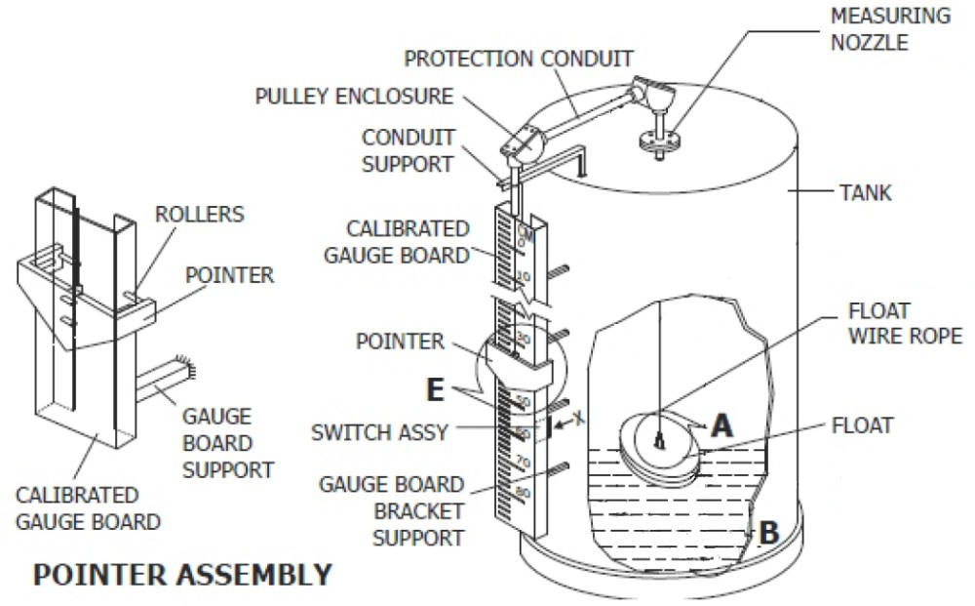
Float & Board Level Indicator Assembly

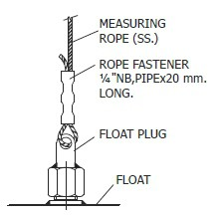
ORDERING INFORMATION

Float Assembly
BASIC MODEL
MATERIAL OF PROCESS CONNECTION
CS = Carbon Steel S1 = SS 304
S2 = SS 316
PROCESS CONNECTION

F501 = ½” 150# RF F503 = ½” 300# RF F506 = ½” 600# RF F751 = 3/4” 150# RF F753 = 3/4” 300# RF F756 = 3/4” 600# RF
XXX = NON STANDARD
Flanged Connections(As per ANSI B 16.5)
F101 = 1” 150# RF
F103 = 1” 300# RF
F106 = 1” 600# RF F151 = 1½” 150# RF F153 = 1½” 300# RF F156 = 1½” 600# RF
F201 = 2” 150# RF
F203 = 2” 300# RF
F206 = 2” 600# RF
F301 = 3” 150# RF
F303 = 3” 300# RF
F306 = 3” 600# RF
MATERIAL OF FLOAT
S2 = SS 316
S3 = SS 316 L
MATERIAL OF SCALE
AL = Aluminum (Standard)
S1 = SS 304
RANGE
Please specify in mm (e.g. Write 2000 for 2000 mm)
(This indicator will be supplied from 1000 mm up to 20000 mm)
OPTIONS
AR1 = Adjustable Reed Switch x 1 AR2 = Adjustable Reed Switch x 2 AM1 = Adjustable Micro Switch x 1 AM2 = Adjustable Micro Switch x 2

Levtron Instruments Pvt Ltd.
Office No 02, 1st Floor, Plot No 6, Sr. No. 78/1, Pandhari Industrial Estate, Shivane,
Pune- 411023 Mob No: 9730042725 /9579430012
Web: www.levtron.in Email: Sales@levtron.in

