1. Project overview
Problem we are solving:
Citizens visiting government offices often face long and unpredictable waiting times. They may spend several hours waiting even for relatively simple services.
Our solution:QueueLess is a web-based virtual queue management system that allows citizens to select a government office, choose a service, generate a virtual token remotely and track their queue position with estimated waiting time.
The system also provides queue management facilities for government staff and administrative control over the platform.
Our main objective is:Help citizens spend less time physically waiting at government offices by providing virtual tokens, live queue tracking and waiting-time predictions.
2. End users – 3 roles
We have finalized three types of users.
1. Citizen
The person visiting a government office.
- Register and login.
- Select a government office.
- Select a service.
- Generate a virtual token.
- Track queue position.
- View estimated waiting time.
- Receive notifications as their turn approaches.
- View peak hours and crowd information.
- Cancel their token.
2. Government Staff / Operator
The person responsible for managing the queue at a counter.
- Login to operator dashboard.
- View assigned office and counter.
- View waiting tokens.
- Call the next token.
- Start serving a citizen.
- Complete a token.
- Skip or recall a token.
- Update counter availability.
3. Admin
The person responsible for managing the platform.
- Login to admin dashboard.
- View registered offices.
- Manage services.
- Manage counters.
- Create and manage staff accounts.
- Assign staff to offices and counters.
- Monitor queue activity across offices.
- View analytics.
3. Office structure
We have decided to initially support exactly two government offices.
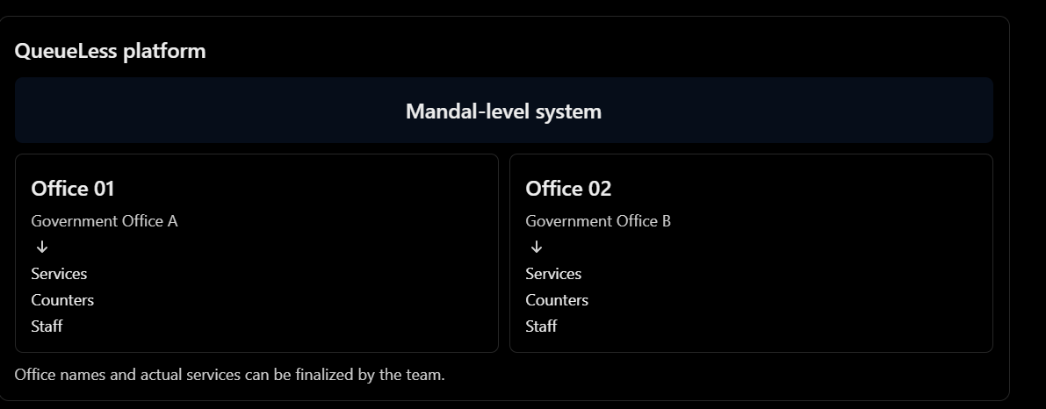
Scalability decision
We are designing the database to support additional offices.
However:
- Initially, only two office records will be created.
- Citizens can select either office.
- Services and counters are associated with their respective office.
- Admin will not have an add-office option in this version.
- We will not create an add-office API route yet.
- Future expansion will not require redesigning the database relationships.
This is an important scope boundary.

4. Exact citizen flow :This is the main user journey of our application.
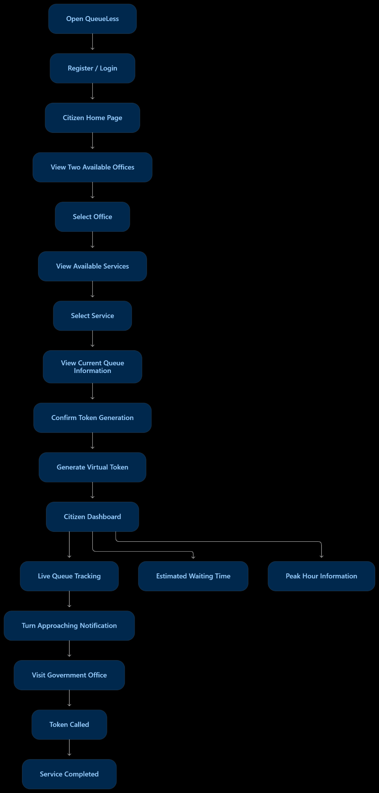
What the citizen sees after generating a token
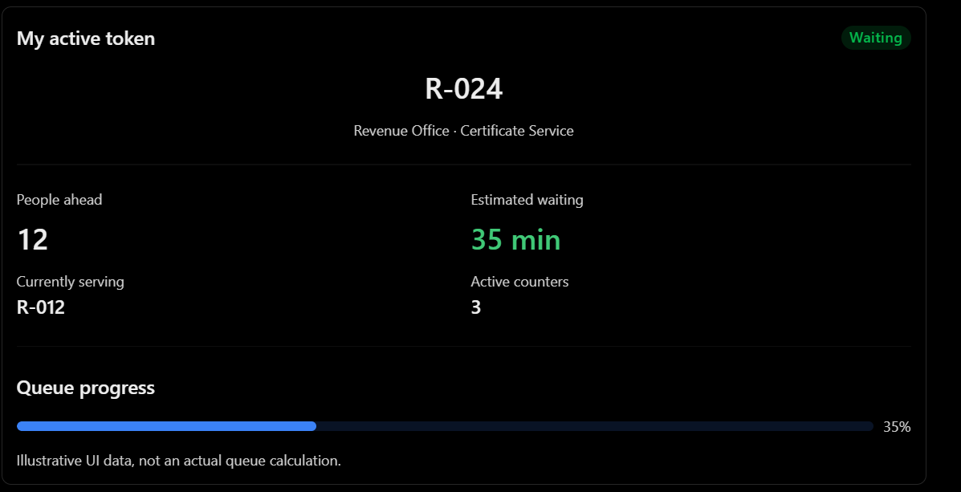
One important distinction: The citizen's token is reserved remotely, and the citizen does not have to stand physically in the queue. We still need to define the exact arrival and no-show rules before implementation.
5. Exact operator flow
The operator is responsible for updating the queue.
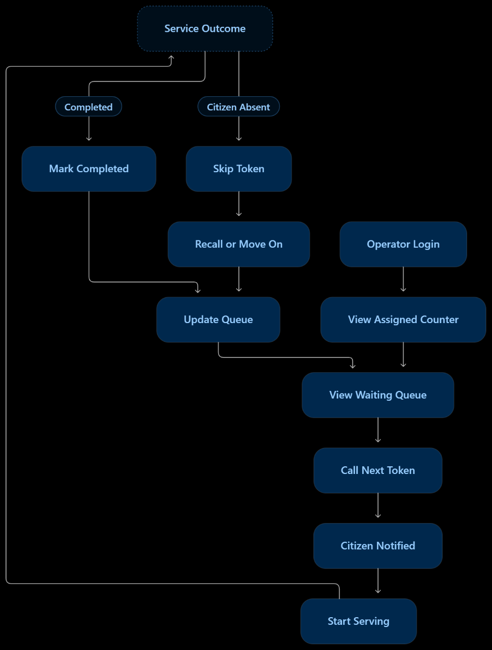
Operator actions we have discussed:
Action | Meaning
Call next | Call the next eligible token
Start serving | Begin service
Complete | Finish the service
Skip | Handle an absent citizen
Recall | Call a skipped token again
Pause counter | Temporarily stop counter operations
Change status | Update counter availability
Every queue-changing action should update the citizen's live dashboard and waiting-time calculation.
6. Exact admin flow
Admin manages the configuration and overall system.
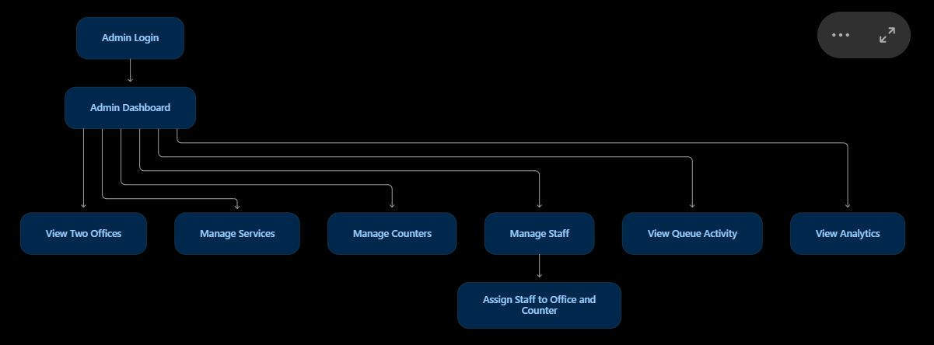
Remember: Adding offices is a future capability, not an implemented admin function in our hackathon version.
7. Database models – 5 models
We have discussed five main models.
Model | What it stores
User | Citizens, operators and admins
Office | Government office details
Service | Services belonging to an office
Counter | Counters belonging to an office
Token | Token details and queue status
Relationships
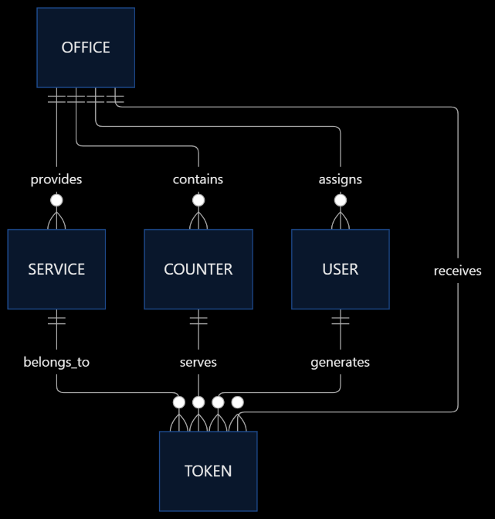
We won't create separate collections for queues, predictions or notifications in the initial version.
Queue position can be calculated from Token records. Waiting-time calculation will be handled by the backend.
8. Waiting-time prediction and peak-hour analytics
This is the intelligent component of QueueLess.
We have two related but different functions.
A. Current waiting-time prediction
Inputs:
- Number of people ahead.
- Average service duration.
- Number of active counters.
- Service type.
- Current queue activity.
Our initial mathematical baseline:

For example:
- 12 people ahead.
- 5 minutes average service duration.
- 3 effective active counters.
Estimated waiting time = 20 minutes.
This is a simplified baseline. A real implementation must account for counter assignments, service eligibility and queue order.
B. Peak-hour analytics
We want to show citizens:
- Busiest hours.
- Less crowded hours.
- Busiest days.
- Average waiting time.
- Current crowd compared with usual crowd.
For the hackathon, we can use sample historical data for demonstration. Later, actual queue history can improve the predictions.
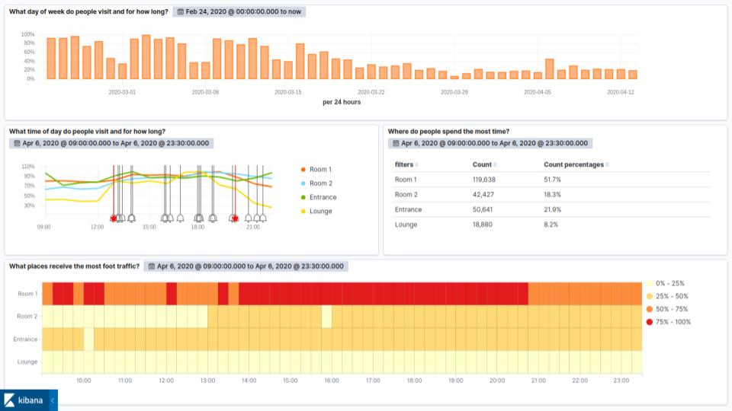
reelyactive.github.io
Python ML is optional. We will first make the prediction work using Node.js. Python can be integrated if time permits and if it adds genuine value.

9. Technology stack
Layer | Technology
Frontend | React
Styling | Tailwind CSS + Material UI
Routing | React Router
Backend | Node.js + Express
Database | MongoDB Atlas
Live updates | Socket.IO
Prediction | Node.js initially
Optional ML | Python + FastAPI
Frontend deployment | Vercel
Backend deployment | Render

We will not introduce Redux, Redis or microservices unless we find a concrete need.

