“Om sai ram”

PIZZA SALES SQL QUERIES

1. **KPI’S :**
2. **Total Revenue :**

select round(sum(total_price), 2) as Total_Revenue from pizza_sales;

**Output**

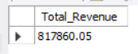

1. **Average Order Value :**

select sum(total_price) / count(distinct order_id) as Avg_Order_Value from pizza_sales;

**Output**

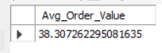

1. **Total Pizzas Sold :**

select sum(quantity) as Total_Pizzas_Sold from pizza_sales;

**Output**



1. **Total Orders :**

select count(distinct order_id) as Total_Orders from pizza_sales;

**Output**

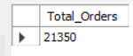

1. **Average Pizzas Per Order :**

select round(sum(quantity) / count(distinct order_id) , 2 ) as Avg_pizzas_per_order from pizza_sales;

**Output**

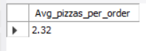

1. **Daily Trend of Total Orders :**

select Dayname(order_date_time) as order_day, count(distinct (order_id)) as Total_Orders

from pizza_sales

group by order_day;

**Output**

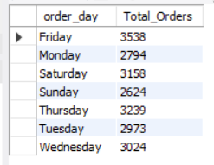

1. **Monthly Trend of Total Orders :**

select monthname(order_date_time) as monthly_order, count(distinct(order_id)) as total_orders

from pizza_sales

group by monthly_order

order by total_orders desc;

**Output**

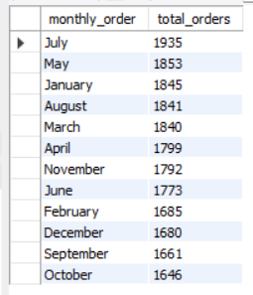

1. **Percentage of Sales by Pizza Category :**

select pizza_category, round(sum(total_price) * 100 / (select sum(total_price) from pizza_sales) , 2) as percentage_sales

from pizza_sales

group by pizza_category

order by percentage_sales desc;

**Output**

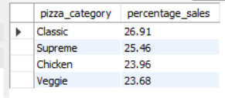

1. **Percentage of Sales by Pizza Category, using where clause (filter of month) :**

select pizza_category, round(sum(total_price) , 1) as total_sales, round(sum(total_price) * 100 / (select sum(total_price) from pizza_sales where month(order_date_time) = 01) , 2)

as percentage_sales

from pizza_sales

where month(order_date_time) = 01

group by pizza_category

order by percentage_sales desc;

**Output**

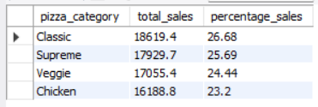

1. **Percentage of Sales by Pizza Size**

select * from pizza_sales;

select pizza_size, round(sum(total_price), 1) as total_Sales ,round(sum(total_price) * 100 / (select sum(total_price) from pizza_sales), 2) as Percentage_sales from pizza_sales

group by pizza_size

order by Percentage_sales desc;

**Output**

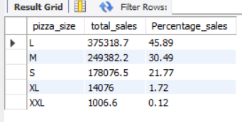

1. **Percentage of Sales by Pizza Size using where clause to filter quarter 1 sales**

select pizza_size, round(sum(total_price) , 1) as total_sales, round(sum(total_price) * 100 / (select sum(total_price) from pizza_sales where quarter(order_date_time) = 1),2) as percentage_sales

from pizza_sales

where quarter(order_date_time) = 1

group by pizza_size

order by percentage_sales desc;

**Output**

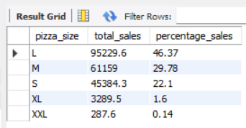

1. **Top 5 best sellers by Revenue :**

select pizza_name, round(sum(total_price) , 2) as total_Revenue

from pizza_sales

group by pizza_name

order by total_revenue desc limit 5;

**Output**

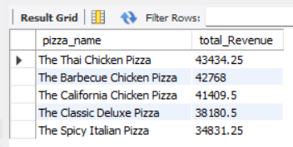

1. **Bottom 5 worst sellers by Revenue**

select pizza_name, round(sum(total_price) , 2) as total_Revenue from pizza_sales

group by pizza_name

order by total_Revenue asc limit 5;

**Output**

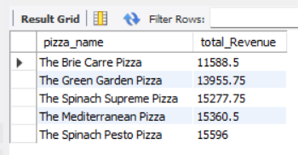

1. **Top 5 Best sellers by Quantity**

select pizza_name, sum(quantity) as total_quantity from pizza_sales

group by pizza_name

order by total_quantity desc limit 5;

**Output**

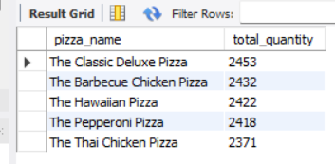

1. **Bottom 5 worst sellers by quantity**

select pizza_name, sum(quantity) as total_quantity from pizza_sales

group by pizza_name

order by total_quantity asc limit 5;

**Output**

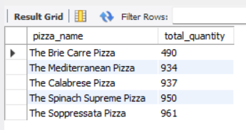

1. **Top 5 Best sellers by Total Orders**

select pizza_name, count(distinct order_id) as total_orders from pizza_sales

group by pizza_name

order by total_orders desc limit 5;

**Output**

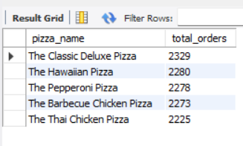

1. **Bottom 5 sellers by Total Orders**

select pizza_name, count(distinct order_id) as total_orders from pizza_sales

group by pizza_name

order by total_orders asc limit 5;

**Output**

