**Project Summary: Weeks 1-3:**

Project 1: Sales Data Analysis

➢ Objective: Analyze a retail store’s sales data to extract key insights. ➢ Key Features:

✓ Load data from a CSV file and clean it for analysis.

✓ Calculate metrics like total sales, average sales, and sales trends over time.

✓ Visualize sales performance using bar charts or line plots.

➢ Optional: Identify top-performing products or regions.

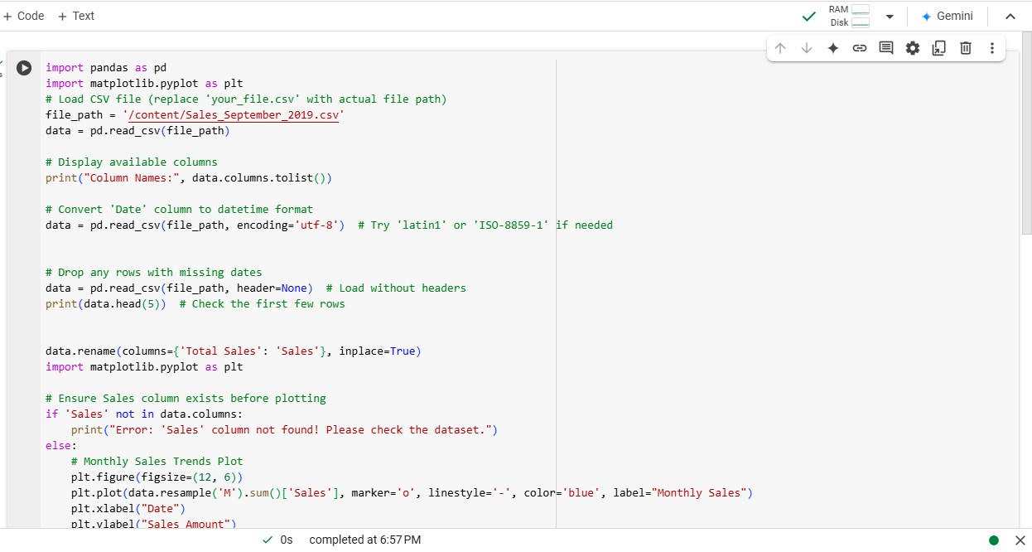

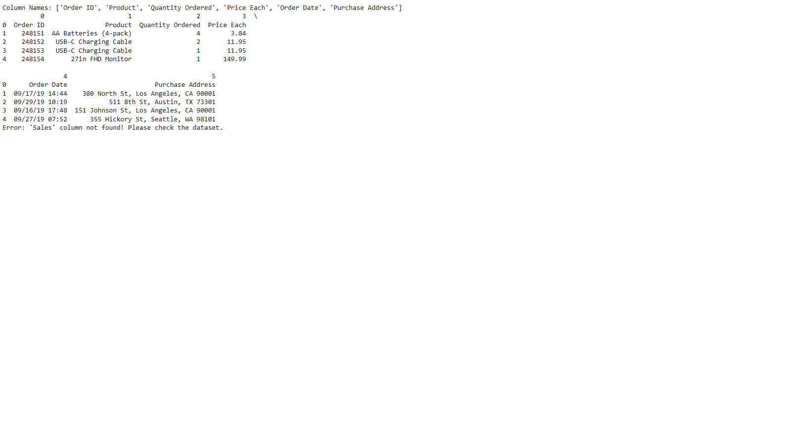

Project 3: Weather Data Visualization

➢ Objective: Create visualizations from a weather dataset.

➢ Key Features:

✓ Analyze temperature trends and patterns over time.

✓ Create line plots, scatter plots, and bar charts to visualize findings.

✓ Identify anomalies like extreme temperatures

. ➢ Optional: Predict future weather patterns using simple statistical models.

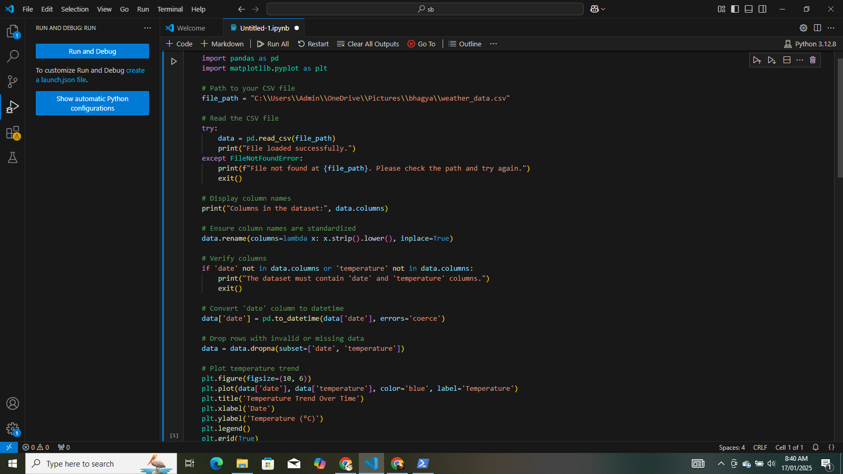

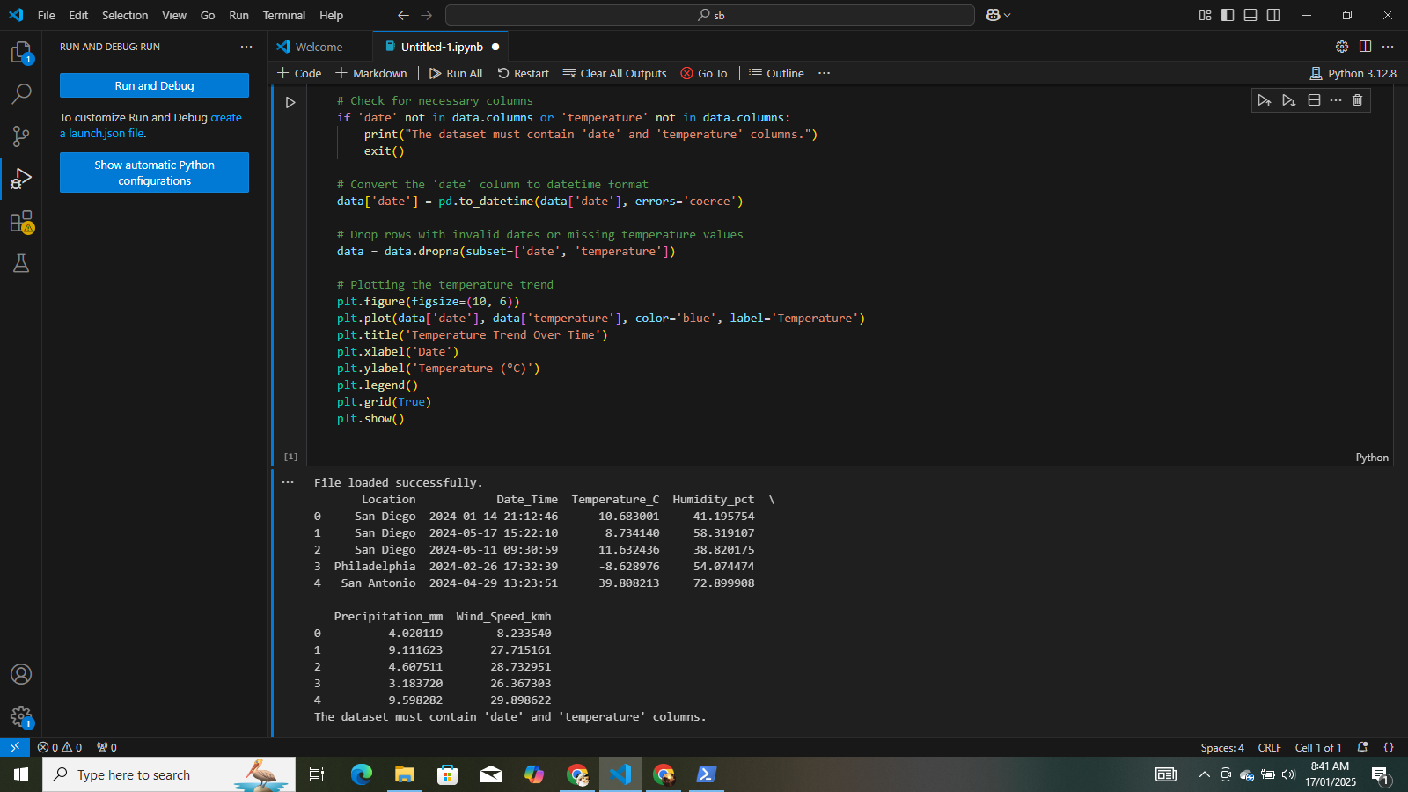

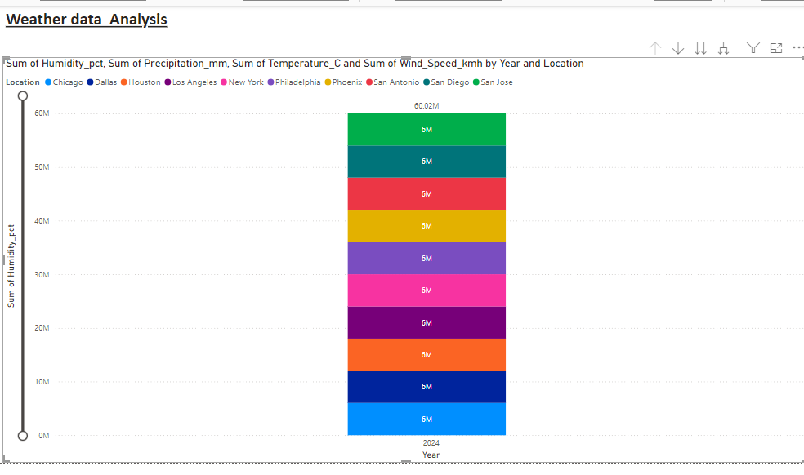

Project 5: Predicting House Prices

➢ Objective: Build a machine learning model to predict house prices.

➢ Key Features:

✓ Load a dataset with house features (e.g., size, location) and prices.

✓ Train a regression model (e.g., Linear Regression) to predict prices.

✓ Evaluate the model’s performance using metrics like MAE or R².

➢ Optional: Tune hyperparameters or add new features for better predictions.

