**Steps:**

Step 1: Create a ASP.NET Web Service. Click on File->New->Website->ASP.NET Web Service

and name the Web Service.

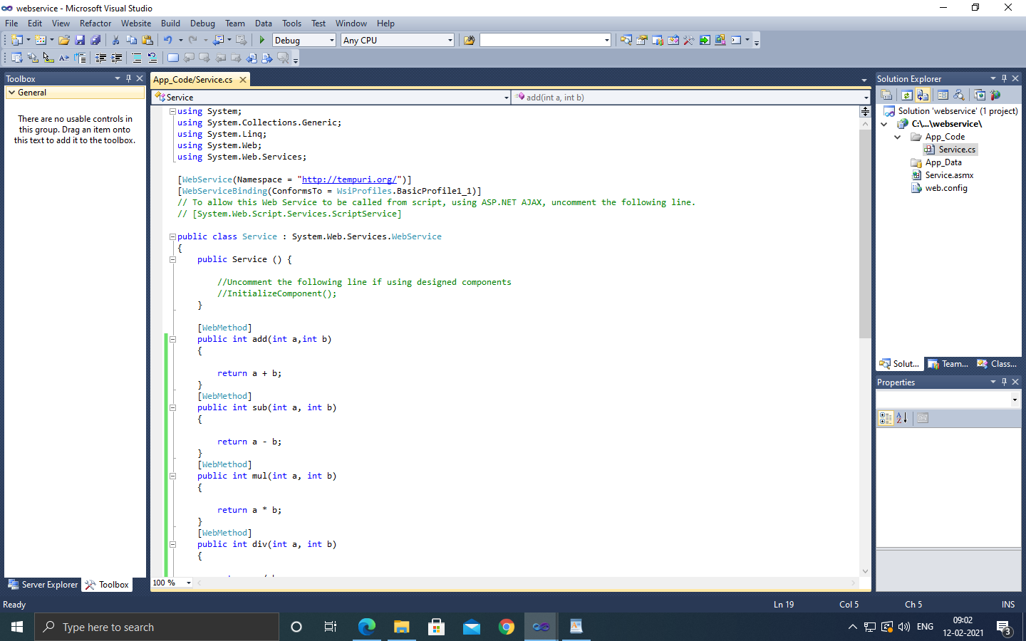

Step 2: Type the following code:

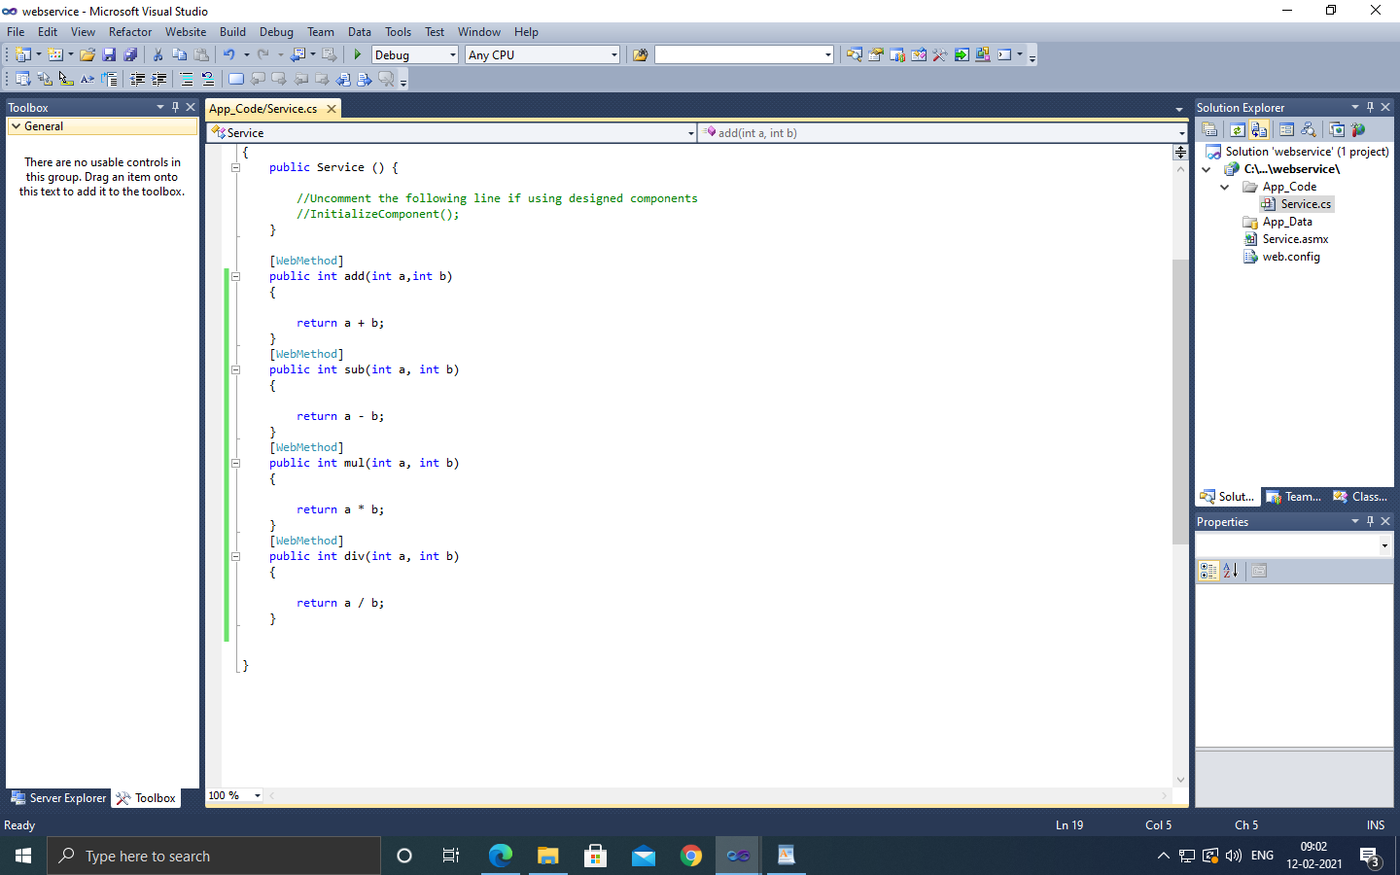

using System;

using System.Collections.Generic;

using System.Linq;

using System.Web;

using System.Web.Services;

[WebService(Namespace = "<http://tempuri.org/>")]

[WebServiceBinding(ConformsTo = WsiProfiles.BasicProfile1_1)]

// To allow this Web Service to be called from script, using ASP.NET AJAX, uncomment the following line.

// [System.Web.Script.Services.ScriptService]

public class Service : System.Web.Services.WebService

{

public Service () {

//Uncomment the following line if using designed components

//InitializeComponent();

}

[WebMethod]

public int add(int a,int b)

{

return a + b;

}

[WebMethod]

public int sub(int a, int b)

{

return a - b;

}

[WebMethod]

public int mul(int a, int b)

{

return a * b;

}

[WebMethod]

public int div(int a, int b)

{

return a / b;

}

}

Step 3: Debug the Web Service and Copy the path.

Step 4: Create a ASP.NET We Application. Click on File->New->Project->Web Application and name the Web Application.

Step 5: Design the simple calculator.

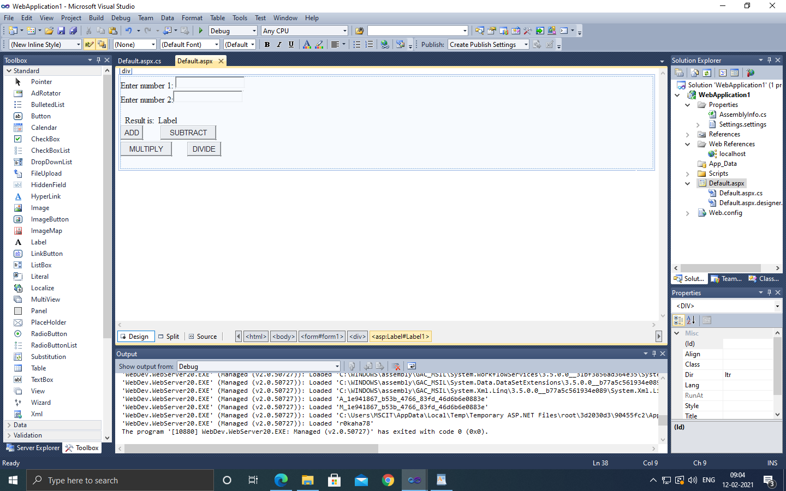

Step 6: Type the following code.

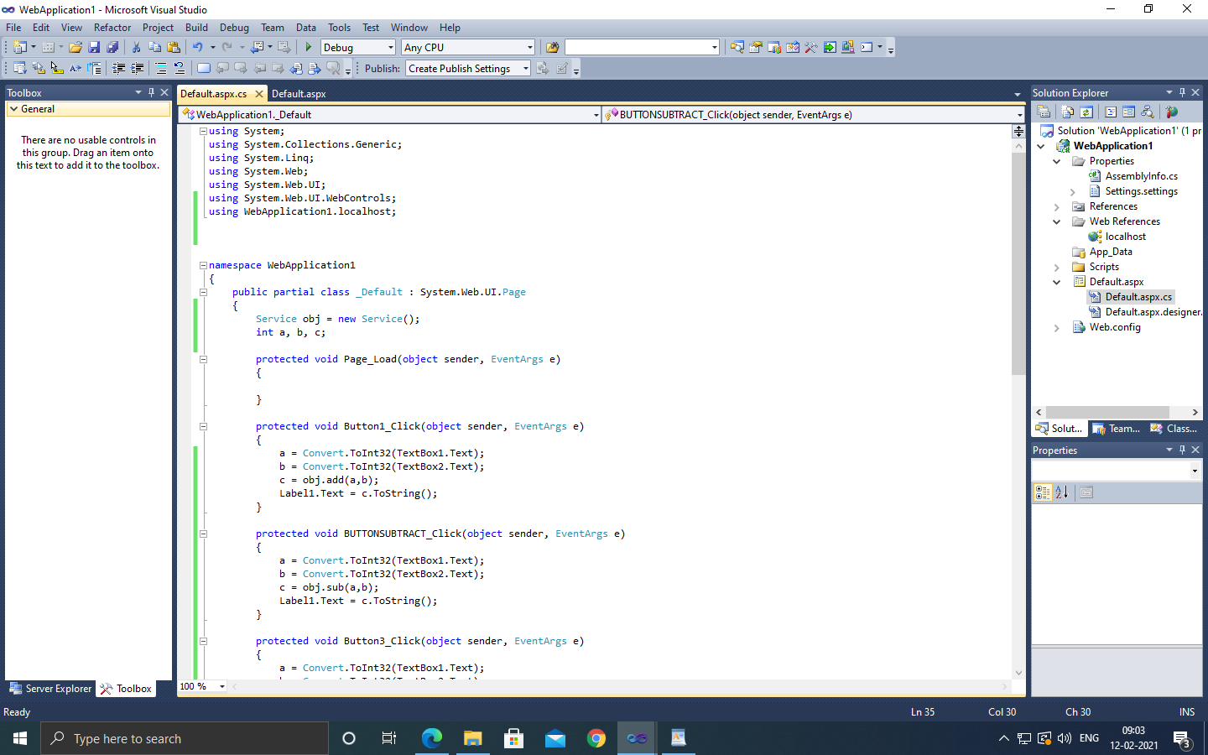

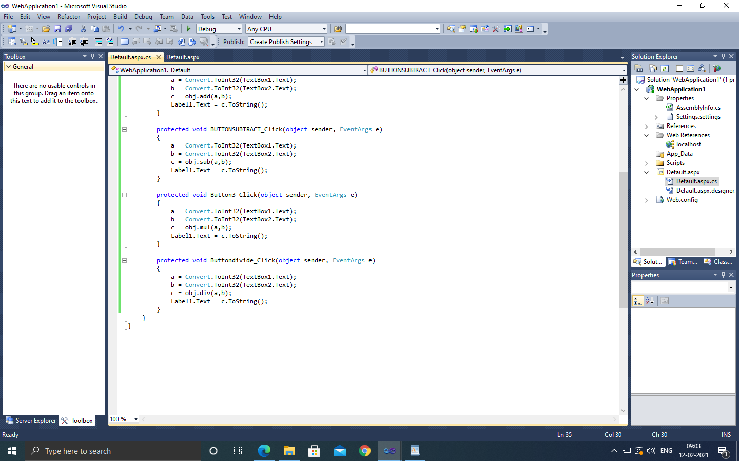

using System;

using System.Collections.Generic;

using System.Linq;

using System.Web;

using System.Web.UI;

using System.Web.UI.WebControls;

using WebApplication1.localhost;

namespace WebApplication1

{

public partial class _Default : System.Web.UI.Page

{

Service obj = new Service();

int a, b, c;

protected void Page_Load(object sender, EventArgs e)

{

}

protected void Button1_Click(object sender, EventArgs e)

{

a = Convert.ToInt32(TextBox1.Text);

b = Convert.ToInt32(TextBox2.Text);

c = obj.add(a,b);

Label1.Text = c.ToString();

}

protected void BUTTONSUBTRACT_Click(object sender, EventArgs e)

{

a = Convert.ToInt32(TextBox1.Text);

b = Convert.ToInt32(TextBox2.Text);

c = obj.sub(a,b);

Label1.Text = c.ToString();

}

protected void Button3_Click(object sender, EventArgs e)

{

a = Convert.ToInt32(TextBox1.Text);

b = Convert.ToInt32(TextBox2.Text);

c = obj.mul(a,b);

Label1.Text = c.ToString();

}

protected void Buttondivide_Click(object sender, EventArgs e)

{

a = Convert.ToInt32(TextBox1.Text);

b = Convert.ToInt32(TextBox2.Text);

c = obj.div(a,b);

Label1.Text = c.ToString();

}

}

}

Step 7: Right click on the web application and click ->Add Web reference and copy the path and click on add Reference.

Step 8: Debug the Web application.

**OUTPUT:**

