**Lab Practical #10:**

Study the concept of routing using packet tracer. (Static Routing)

**Practical Assignment #10:**

1. Connect the two different networks based on the calculated IP addresses and subnet using a packet tracer.

Router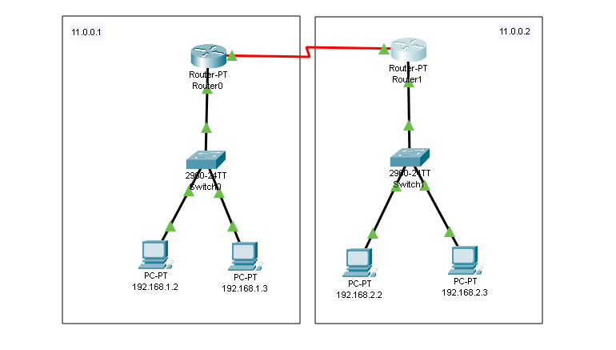

* **Router0 :**

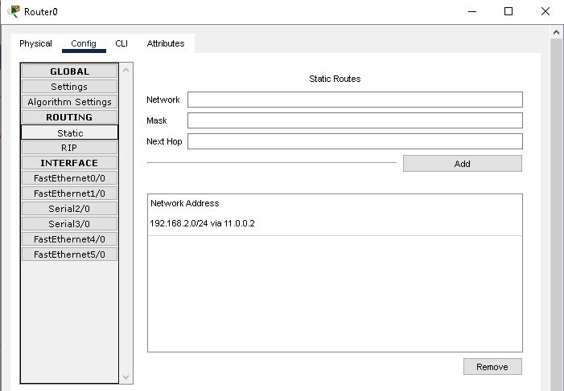

* **Router1 :**

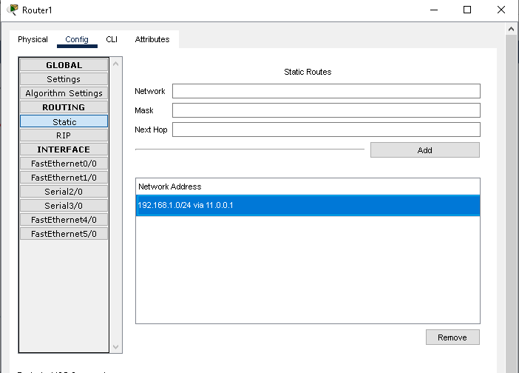

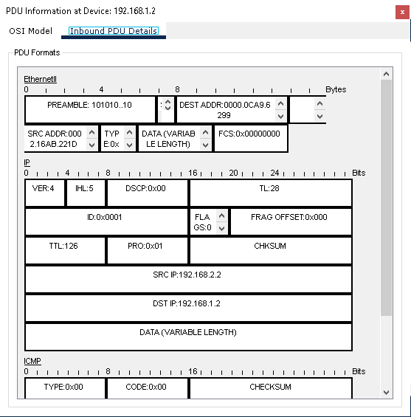

1. Connect the three different networks based on the calculated IP addresses and subnet using a packet tracer.

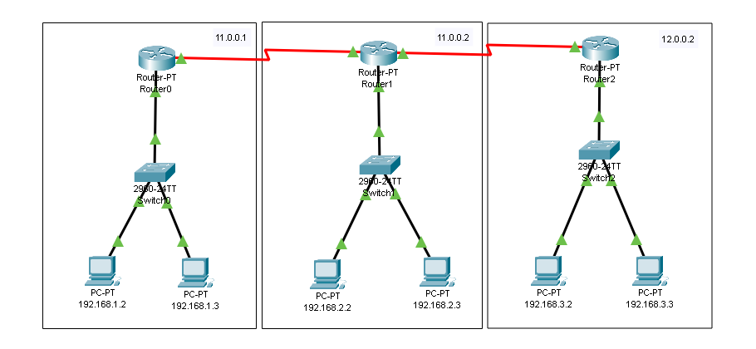

* **Router0 :**

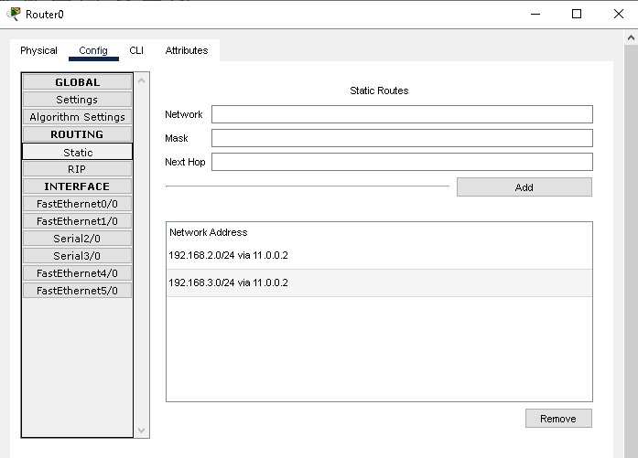

* **Router1 :**

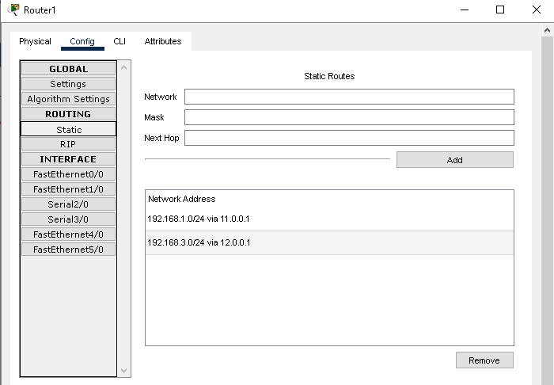

* **Router2:**



