**Lab Practical #13:**

Study & Survey of Institute organization network infrastructure.

**Practical Assignment #13:**

1. **Identify type of network in your institute. Draw a design of network in your institute (Any Lab/Floor/Building).**

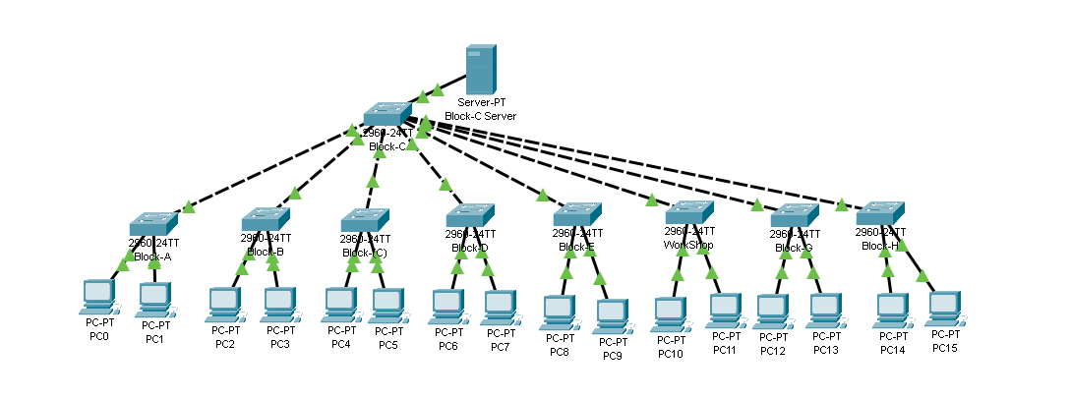

* **Explanation :**
* Above Diagram is the network of Darshan University
* C - Block is the designated primarily to Computer Department and the Server

Room is located here

* Through Air-fiber on the terrace of C - Block we are receiving internet connection
* from the ISP from Madhapar Chawk, Rajkot
* Each Block of Darshan University is connected to server room which is located at Block-C
* Through a L-3/L-2 Switch placed in each lab connected directly to server room provides ethernet Connection to each Computer in lab.
* In some labs we have WiFi-6E routers available for extra connectivity
* For more security Sophos is implemented.
* Sophos provides firewall protection, Intrusion detection and prevention to protect from cyber threats.
* When we want to use Internet then we need to connect to Sophos using userid and password.
* Here we have our Fiber Optic Switch which is used to connect to the ISP and to provide Fast Internet to all other blocks

1. **List how many network devices and types of cable used and give its details.**

* Network type : LAN
* Network Devices :
  + **Sophos:** for firewall and gateway
  + **L-3 Switch:** used to connect each block and ISP from C-Block to provide internet to each block.
  + **Router:** used for wireless connectivity to each block.
  + **L-2 Switch:** used to connect each Computer in labs of each block to use internet service.
  + **Wireless APs:** wireless Access Points are used to provide connectivity in H Block
  + **Uninterruptible Power Supplies(UPS):** provide backup power to critical devices in case of outages.
  + **Antennas:** used to connect to the ISP which is located 18 km far from Darshan University
  + **Servers:** to store data centrally
  + **Cables:** twisted pair cable and fiber optic cable
  + **Connectors:** RJ45
* Darshan University pay 12 lakh INR , which covers the usage and maintenance of ISP connection.