**Lab Practical #02:**

Study of different types of network cables & connectors and crimping a LAN.

**Practical Assignment #02:**

1. List various networks cable. Also, write short description.
2. Difference between guided and unguided media.
3. Give cross-wired cable and straight through cable diagram (Color Code wise).

## List various networks cable and connectors. Also, write short description.

1. **Twisted Pair Cable:** 
   * **Description**:

Twisted-pair Category 5e cables, also called CAT5e, are the industry standard for unshielded twisted-pair cables (UTP) for in-home and small business networking. Cables that are manufactured to prevent electromagnetic interference are shielded twisted-pair, or STP cables. CAT5e cables have an Ethernet capability of up to 1,000 megabits per second (Mbps) and can often carry infrared (IR or remote) control signals, eliminating the need for a separate IR network. They connect phones, computer networks, home automation networks and audio/video distribution systems.

CAT5e cables typically consist of four pairs of wire (eight total conductors) wrapped in a single jacket. In addition, Category 6, or CAT6 cable, is a standardized twisted pair network cable designed to meet more stringent standards for crosstalk and system noise than CAT5e. Older categories, such as CAT5, have reduced transmission rates.

* + **Diagram**:

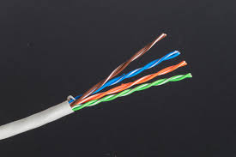

1. **Coaxial Cable:** 
   * **Description**:

Coaxial cables are metallic cables most often used to carry television signals and connect video equipment. They provide protection from electromagnetic interference, allowing signals with low power to be transmitted over longer distances. They feature a central bayonet wire conductor covered with a dielectric or non-conducting insulator surrounded by mesh or a metal sheath. These components are then covered by a thin plastic layer for protection.

Sometimes called “coax,” they often carry infrared (IR or remote) control signals, eliminating the need for a separate IR network. While no longer installed for the purpose, coax was among the first Ethernet network cable types.

Coaxial cable conductors carry electromagnetic signals and can come either in single-core or multi-core models. While a single-core coaxial cable has only one central metal, multi-core cables have many metal wires.

Coaxial cables were used in the earlier days of computer networks.

* + **Diagram**:

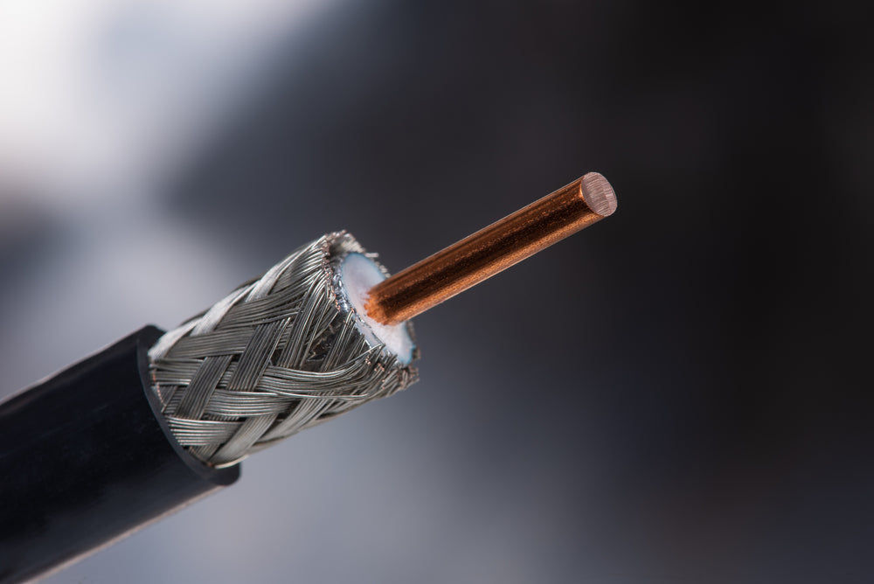 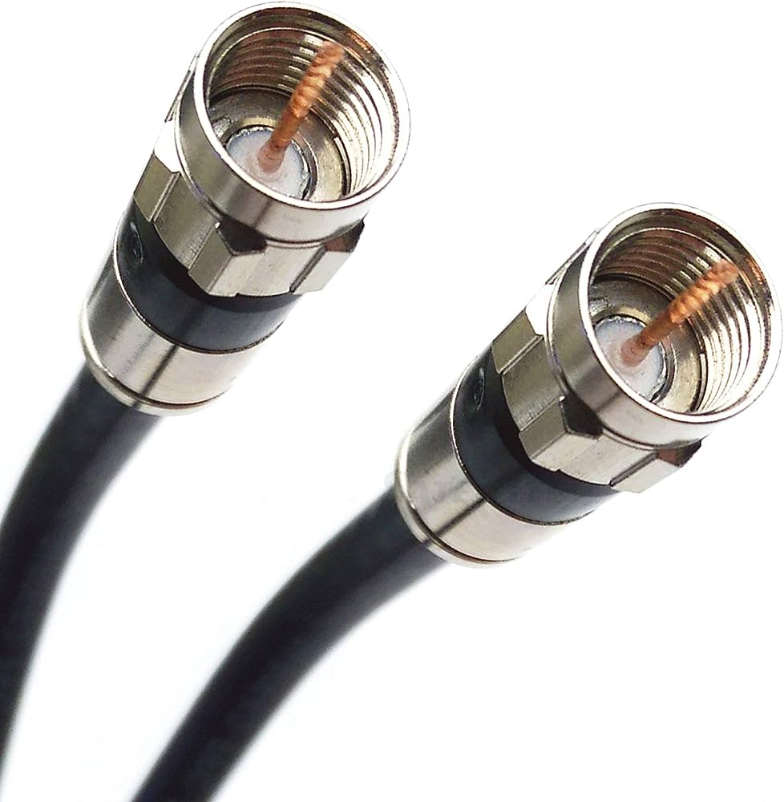

**c) Fiber Optic Cable:**

* + **Description**:

Fiber optic cables use glass or plastic threads to transmit data quickly and efficiently using pulses of light rather than electrical signals. Apart from connecting components in home theaters, they are not as readily available for residential use as are coax and CAT5e. They transmit data at higher rates than coaxial or twisted-pair cables.

Optical audio cables may be used for phones, computer networks and cable television. They have less signal loss than copper and deliver clearer phone conversations or television reception. Multi-mode fiber is designed to carry data over shorter distances by using several rays of light at the same time.

* + **Diagram**:

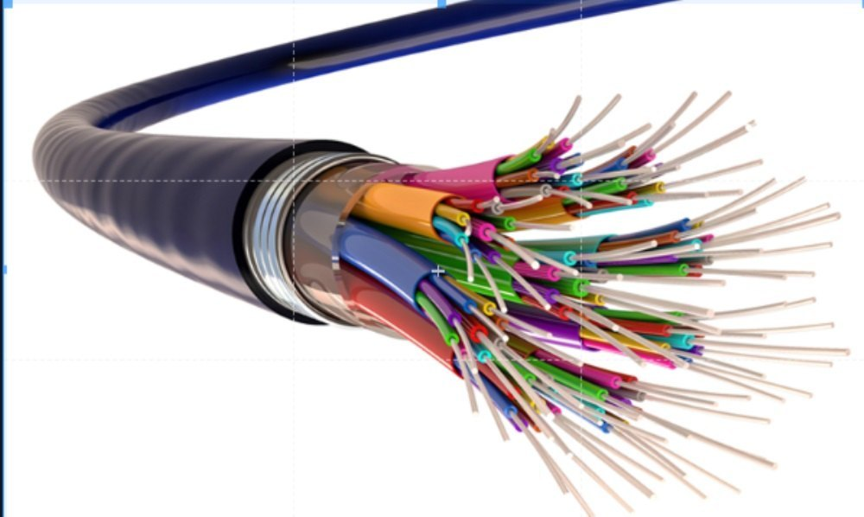

1. **BNC connectors:** 
   * **Description**:

BNC(Bayonet Neill–Concelman) connectors are a type of F-series connectors commonly found in households. This type of connector for RG59 or RG6 coaxial cable is used for cable television equipment, broadcast TV antennas and CCTV security camera installations. They are easy to connect and disconnect from equipment and provide inexpensive, stable connections to these communications devices and other cables.

To install a BNC connector, use a stripping tool to remove protective shields from the cable. The connector is pushed onto the end and then squeezed around the conductive material using a special compression crimper.

Twist-on F-connectors are also available for making quick and easy repairs to TV equipment without the need for special tools.

* + **Diagram**:

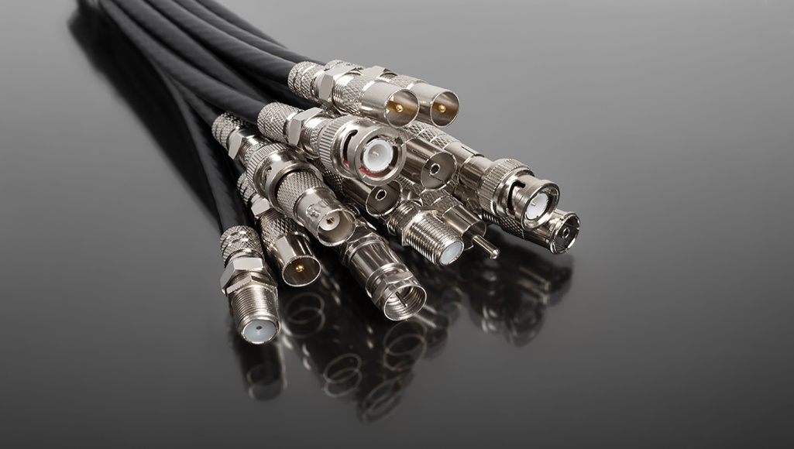

1. **RJ45 connector:** 
   * **Description**:

RJ45 connectors are used for CAT6 cables and CAT5e cables. These connectors for twisted-pair Ethernet cables are similar in appearance to a standard telephone cord connector. They are wider, however, because they have eight conductors compared to only four conductors on a telephone jack.

To install these types of wiring connectors, a stripping tool is used to expose the twisted pairs of wires from the cable, which are then positioned into the appropriate slots on the terminal plug. The connector is then crimped to the cable using a crimping tool.

* + **Diagram**:

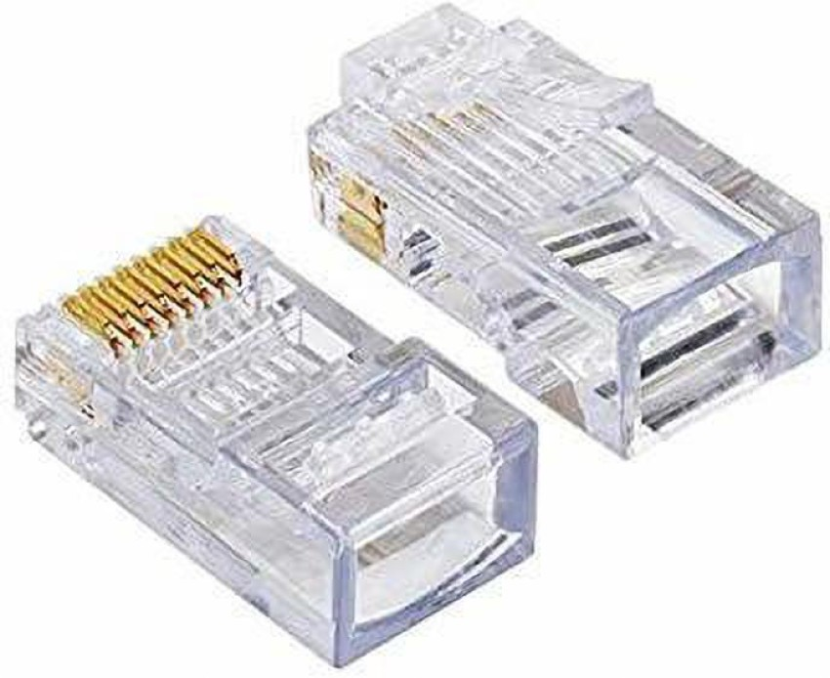

1. **Fiber optic** **connector:** 
   * **Description**:

Fiber optic connectors require different types of connectors from those used with coax or twisted-pair cables, such as CAT5e. These types of connectors in networking must align glass fibers with precision to allow for communication. If you choose to use optical cable over twisted pair Ethernet, you may need to install a special adapter in your computer to utilize various fiber optic cable connector types.

The type of wiring connector used depends on the style of jack in the peripheral device.

* SC connectors: A push-pull latching mechanism in SC connectors provides quick insertion and removal while also ensuring a positive connection.
* ST connectors: ST connectors were among the first connectors in networking fiber optic cable. These use a plug and socket, which is locked in place with a twist-style bayonet lock.
* LC connectors: LC-type connectors have a squarish duplex configuration. Installation of this small form factor (SFF) connector is quick for rapid repair of replacement needs.

* + **Diagram**:

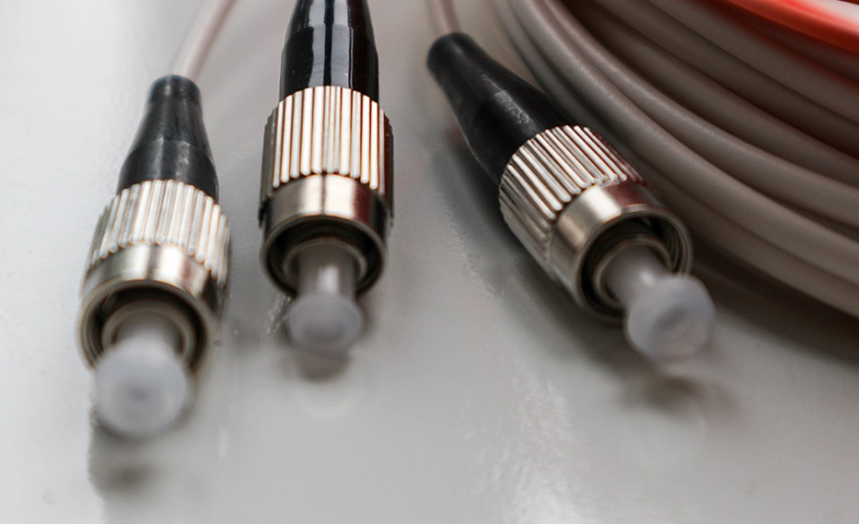

1. **Difference between guided and unguided media.**

|  |  |
| --- | --- |
| **Guided Media** | **Unguided Media** |
| Also called Wired communication. | Also called wireless communication. |
| Signal energy propagates through wires in guided media. | Signal energy propagates thought the air in unguided media. |
| It is cost effective. | It is quiet expensive. |
| It is best for shorter distances. | It would be better for longer distances. |
| Point-to-Point connection | Suited for radio broadcasting in all directions. |
| Examples of guided media are Twisted Pair cables, Coaxial cables, and Fiber  Optic cables. | Examples of unguided media are microwave, radio wave, infrared waves. |

## Give cross-wired cable and straight through cable diagram (Color Code wise).

1. Cross-wired Cable Diagram (Color Code)

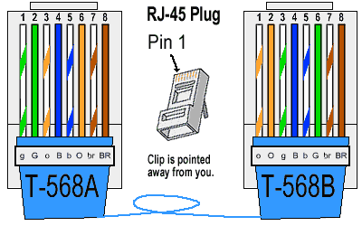

1. Straight Through Cable Diagram (Color Code)

