**Lab Practical #05:**

Study the concept of VLAN using packet tracer.

**Practical Assignment #05:**

1. **Implement the different network structures in VLAN and VLAN trunking. Also check connectivity between them using ping command or PDU utility.**

**Example-1**

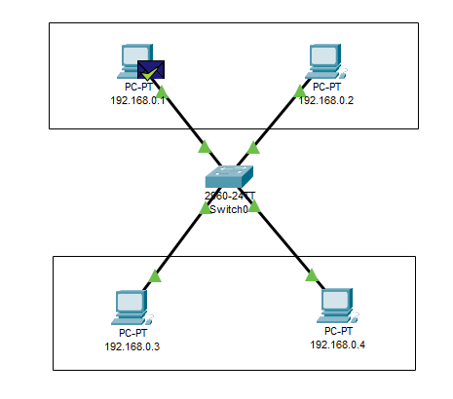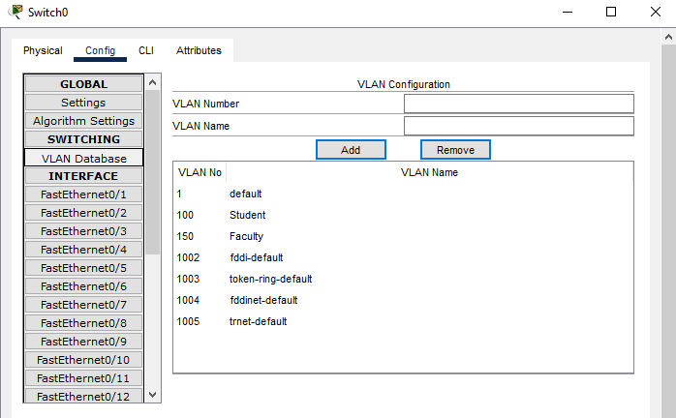

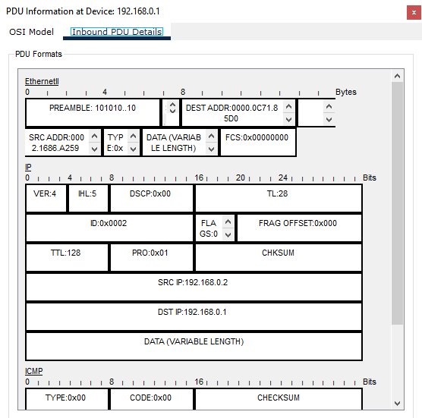

* **Steps**

Step 1: Set Up the Network Devices

1. Add a Switch: - Drag and drop a switch onto the workspace from the "Switches" section.

2. Add PCs: - Drag and drop four PCs onto the workspace from the "End Devices" section.

Step 2: Assign IP Addresses to PCs

* + Click on PC to open its configuration window.
  + Go to Config tab and after go to FastEthernet0.
  + Now set the IP address and set Subnet Mask.
  + Click on Setting and set Display Name same as your IP Address.
  + Do these for all other PCs.

Step 3: Connect the PCs to the Switch

o Use the "Copper Straight-Through" cable to connect each PC to the switch.

o Connect 192.168.0.1 to port FastEthernet0/1.

o Connect 192.168.0.2 to port FastEthernet0/2.

o Connect 192.168.0.3 to port FastEthernet0/3.

o Connect 192.168.0.4 to port FastEthernet0/4.

Step 4: Configure the VLANs

1. Open the Switch Configuration:

o Click on the switch to open its configuration window.

o Go to the "Config" tab.

2. Create VLANs:

o In the "VLAN Database" section, add VLAN 100 and name it "Students".

o Add VLAN 150 and name it "Faculty".

3. Assign Ports to VLANs:

o In the "Interface" section, select FastEthernet0/1.

▪ Set the "VLAN ID" to 100.

o Select FastEthernet0/2.

▪ Set the "VLAN ID" to 100.

o Select FastEthernet0/3.

▪ Set the "VLAN ID" to 150

o Select FastEthernet0/4.

▪ Set the "VLAN ID" to 150.

Step 5: Verify the VLAN Configuration

1. Verify VLANs on the Switch:

* + Go to the "VLAN Database" section in the switch configuration and ensure VLAN 100 and VLAN 150 are listed with the correct ports.

2. Test Connectivity:

* + - Send a Message (PDU) from PC 192.168.0.1to the 192.168.0.2 if Message was send
    - successfully then VLAN is works.
    - Send a Message (PDU) from 192.168.0.1 to the 192.168.0.2 if Message was failed

then VLAN is not works.

**Example-2**

* **Steps**
  + Take 8 pc and assign Ip address and label to each pc.
  + Take 2 Switch and Make 2 Lan with 4 pc each.
  + Now there is local area network but We need to implement Virtual Lan database
  + for implement Virtual Lan we need to configure Virtual Lan database in configure
  + Section in switch.
  + Make 2 New Virtual Lan configuration with unique Virtual Lan number and name.
  + Now check the Port where the pc is connected and open that port configuration
  + in switch and set Virtual Lan to access mode and select your Virtual Lan database
  + name in dropdown.
  + Now we need to connect both Switch but here we need to give Virtual Lan mode
  + to trunk because there are number different Virtual Lan signal travel threw it.
  + Now you configure two Virtual Lan in different local area network

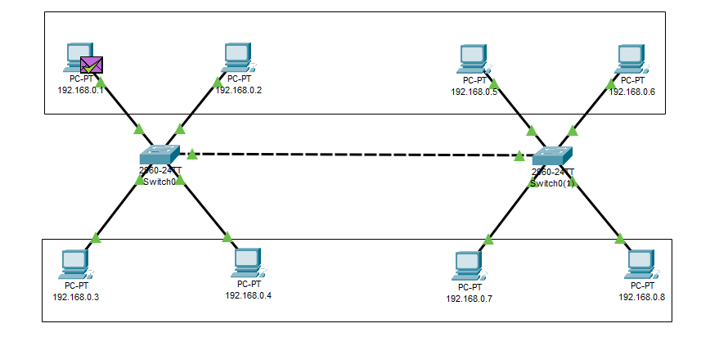

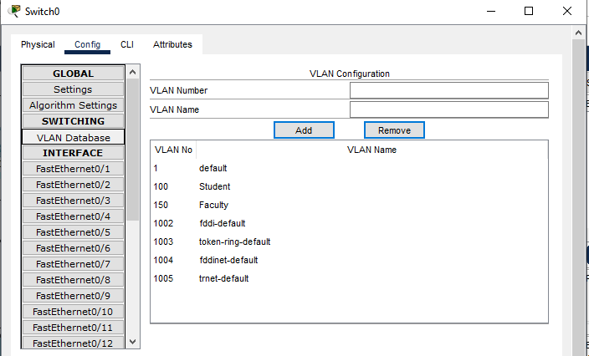

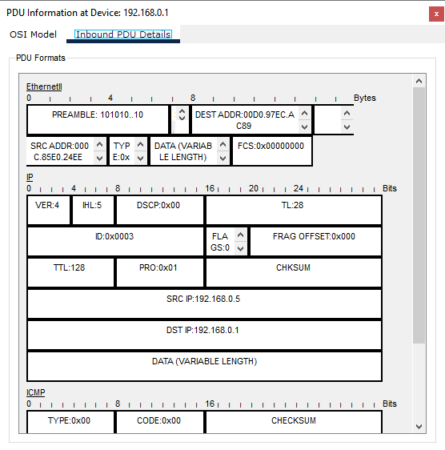

**Example-3**

* **Steps**
* Take 6 pc and assign Ip address and label to each pc.
* Take 2 Switch and Make 2 Lan with 3 pc each.
* Now there is local area network first for Group-1(Students) and second for Group2(Faculty) but We need to implement Virtual Lan database for implement Virtual
* Lan we need to configure Virtual Lan database in configure Section in switch.
* Make 2 New Virtual Lan configuration with unique Virtual Lan number and name.
* Now check the Port where the pc is connected and open that port configuration
* in switch and set Virtual Lan to access mode and select your Virtual Lan database
* name in dropdown.
* Now we need to connect both Switch but here we need to give Virtual Lan mode
* to trunk because there are number different Virtual Lan signal travel threw it.
* Now you configure two Virtual Lan in different local area network.

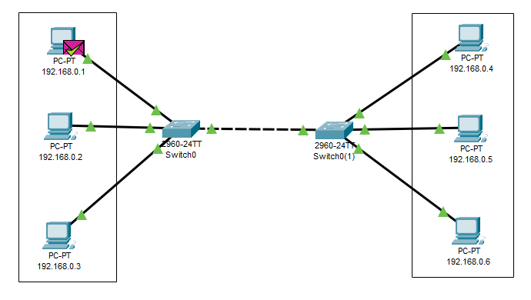



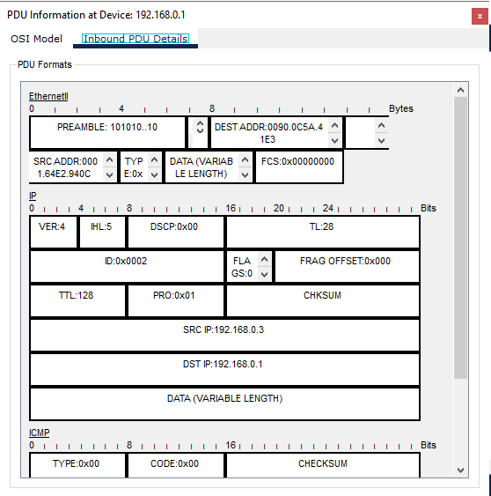

**Example-4**

* **Steps**
  + Take 8 pc and assign Ip address and label to each pc.
  + Take 2 Switch and Make 2 Lan with 4 pc each.
  + Now there is local area network and group in to Group-1(Student), Group2(Faculty), Group-3(Student2) and Group-4(Faculty2) but We need to implement Virtual
  + Lan database for implement Virtual Lan we need to configure Virtual Lan database
  + in configure Section in switch.
  + Make 4 New Virtual Lan configuration with unique Virtual Lan number and name.
  + Now check the Port where the pc is connected and open that port configuration
  + in switch and set Virtual Lan to access mode and select your Virtual Lan database
  + name in dropdown.
  + Now we need to connect both Switch but here we need to give Virtual Lan mode
  + to trunk because there are number different Virtual Lan signal travel threw it.
  + Now you configure two Virtual Lan in different local area network.

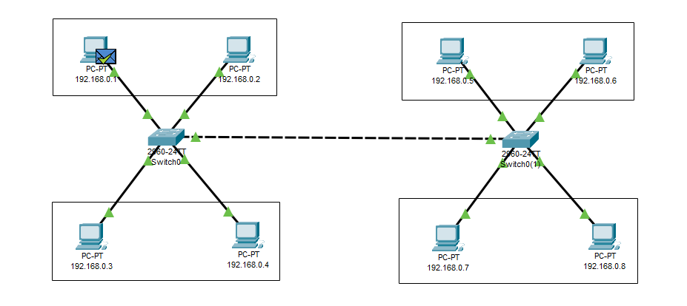

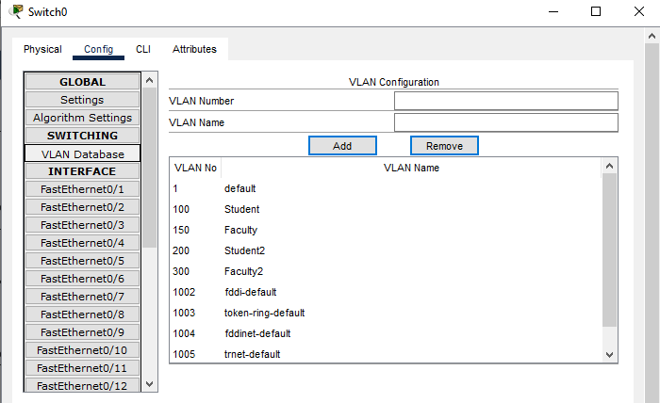

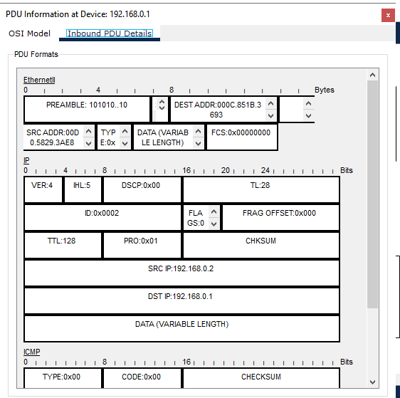

**Instructions:**

1. Different VLANs configuration setup screenshot. (VLAN example given by lab faculty)
2. Write steps to create VLANs in packet tracer.
3. Mention IP address of each pc as label.
4. Ping command or PDU screenshot between two VLANs.