**Lab Practical #06:**

Study the application layer protocol DNS, DHCP, FTP.

**Practical Assignment #06:**

1. **Implement the application layer protocol DNS, DHCP, and FTP. Also check connectivity between them using ping command or PDU utility.**

**DNS(Domain Name System) :**

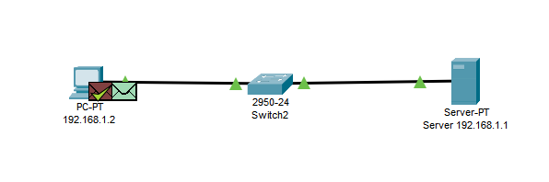

* Make a network displayed as per the above image.
* Assign **192.168.1.1** IP address to Server and assign **192.168.1.2** IP address to PC.
* Click on **Server(192.168.1.1)** and choose **Services**
* Now Choose **DNS** from the left side.
* Now click **On the** radio button as per the below image.
* Fill out **google** in Name textbox and **192.168.1.1** in Address textbox. Click on the Add button.

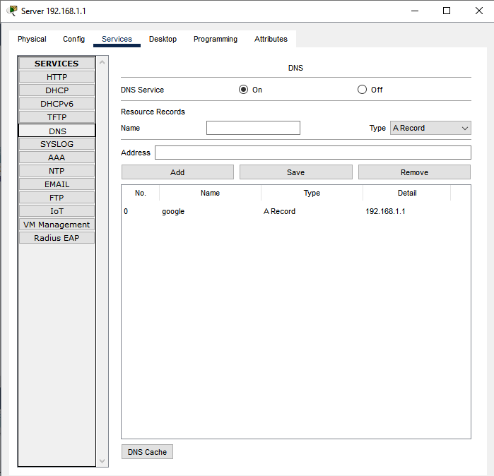

* Click on **192.168.1.2(PC)** and choose **Desktop** then choose **web browser** from it.
* Enter [**http://google**](http://google) in the URL textbox and click on Go.
* After some time output will be displayed.

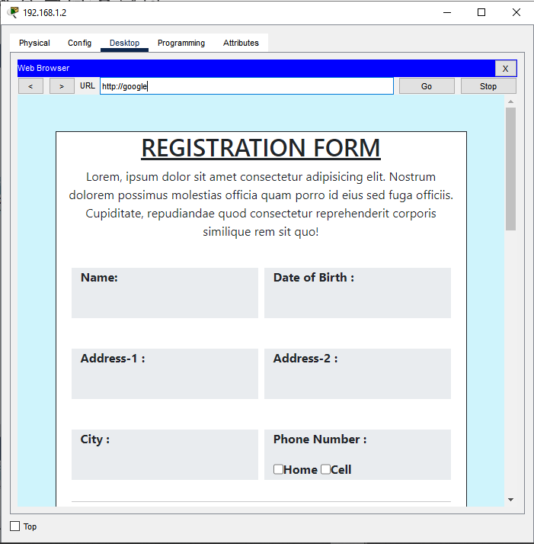

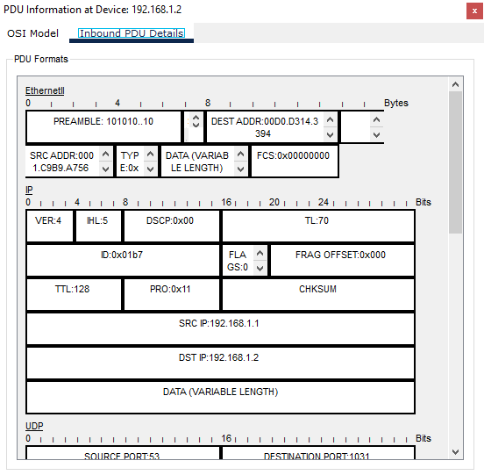

**DHCP(Dynamic Host Configuration Protocol) :**

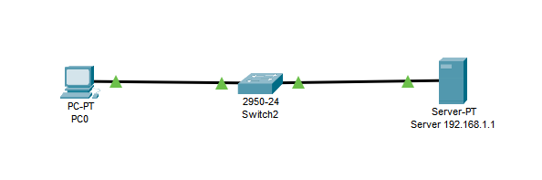

* Make a network displayed as per the above image.
* Assign **192.168.1.1** IP Address to Server.
* Click on Server(**192.168.1.1)** and choose **Services**
* Now Choose **DHCP** from the left side.
* Now select the **On** radio button of Service as per the below image.
* Enter **Default Gateway, Start IP Address, Subnet Mask, and Maximum Number of Users** as per the below image.
* Click on the Add button.
* Your added serverPool will displayed below.

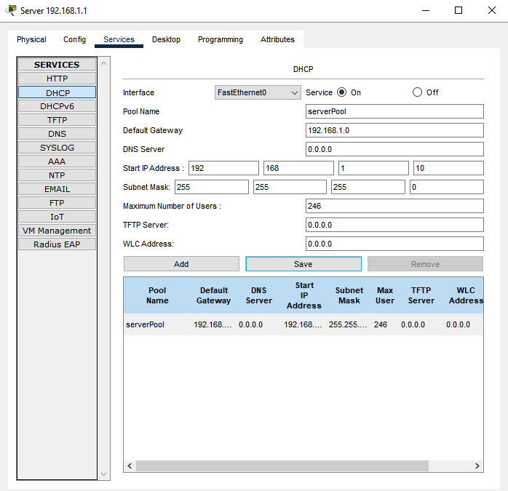

* Click on **PC0** and choose **Config**.
* Choose **FastEthernet0**  from the left side.
* In the **IP Configuration tab** select **DHCP** after some time server will automatically assign the IP Address from a given range.

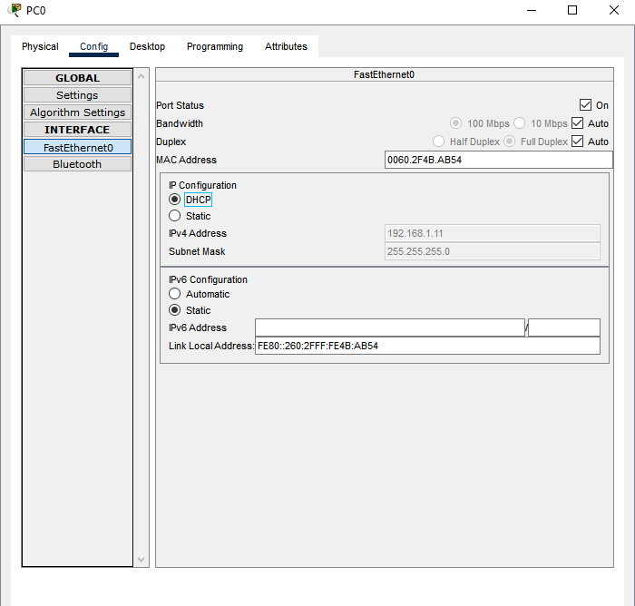

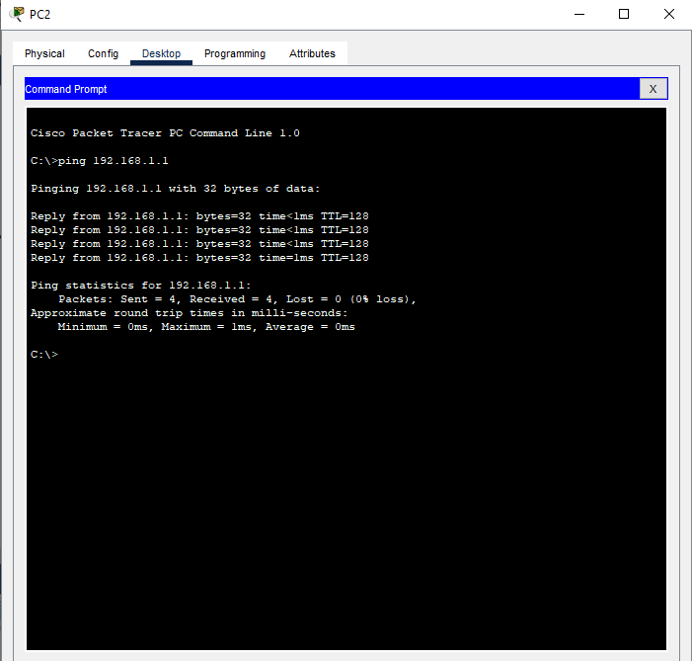

**FTP(File Transfer Protocol) :**

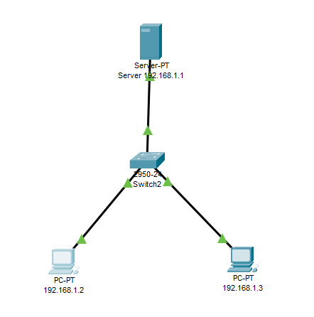

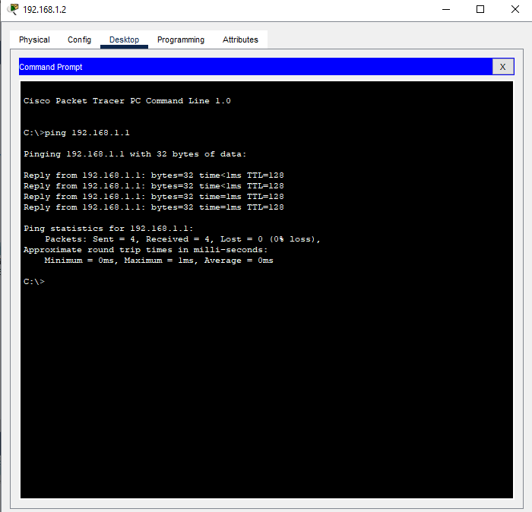

* Click on **192.168.1.2** choose desktop and select Text Editor
* Make new text file named “HelloWorld.txt”

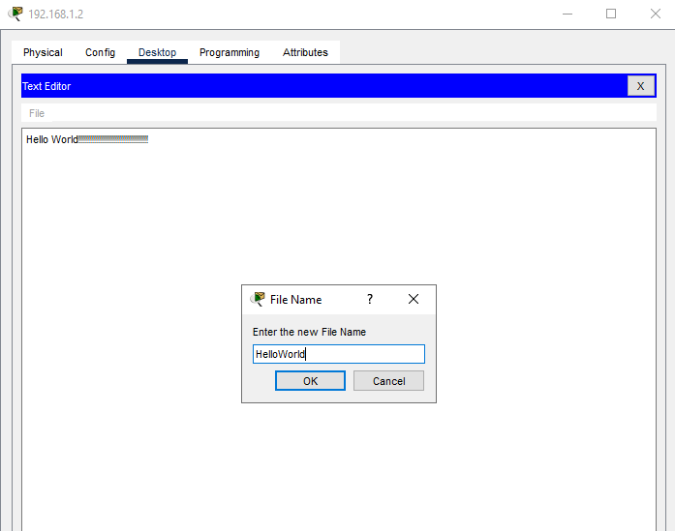

* Now again click on **192.168.1.2** and choose **desktop** and select **Command Prompt**.
* Write ftp 192.168.1.1 in Command Prompt.
* Enter **Username** and **Password**.
* Write **“?”** to display all ftp related options.
* Now write **“put HelloWorld.txt”** to upload file on server.
* Now write “**dir”** to check file uploaded to server or not.

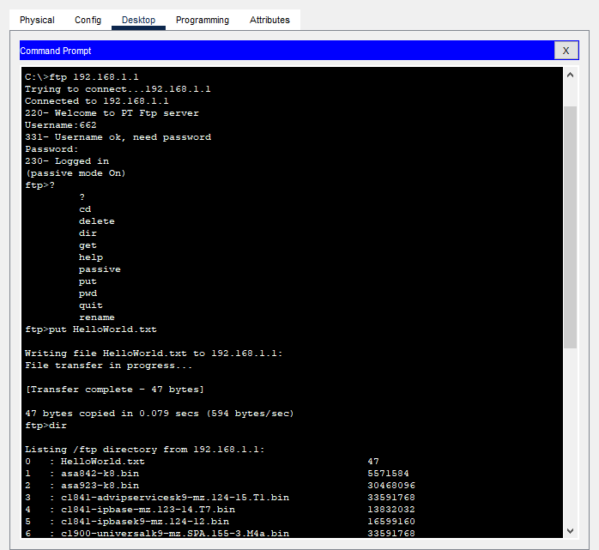

* Write “quit” to close ftp service.
* Now click on **192.168.1.3** and choose **desktop** and select **Command Prompt**.
* Write **ftp 192.168.1.1** in Command Prompt.
* Enter **Username** and **Password.**
* Write **“get HelloWorld.txt”** to download file from server.
* Write “**quit”** to close ftp service.
* Write **“dir”** to check required file downloaded or not.

