**Lab Practical #08:**

Study Packet capture and header analysis by Wireshark (HTTP, TCP, UDP, IP, etc.)

**Practical Assignment #08:**

1. **Explain usage of Wireshark tool.**

Wireshark is a network protocol analyzer that captures and inspects data traveling across a network in real-time. It’s an essential tool for network administrators, cybersecurity professionals, and developers for troubleshooting, analysis, and monitoring of network traffic

**How to Use :**

1. **Install Wireshark:** First, download and install Wireshark from the official website.
2. **Select a Network Interface:** When you open Wireshark, you'll see a list of network interfaces (like Wi-Fi, Ethernet). These represent the different connections your computer is using. Choose the one you want to monitor (e.g., your Wi-Fi connection).
3. **Start Capturing Packets:** Click the "Start Capturing Packets" button (the blue shark fin icon). Wireshark will begin recording all the network traffic passing through the selected interface.
4. **Analyze the Data:** As Wireshark captures packets, you'll see them listed in real-time with details like the source and destination IP addresses, protocols used, and data. You can stop the capture at any time to analyze the data more closely.
5. **Use Filters:** Wireshark lets you apply filters to narrow down the data. For example, you can filter by IP address, protocol, or even specific data within the packets.
6. **Save and Export:** Once you've captured the data you need, you can save it for future analysis or export it in various formats

**Usage:**

* **Packet Capture:** Wireshark listens to a network connection in real time and then grabs entire streams of traffic – quite possibly tens of thousands of packets at a time.
* **Filtering:** Wireshark is capable of slicing and dicing all of this random live data using filters. By applying a filter, you can obtain just the information you need to see.
* **Visualization:** Wireshark, like any good packet sniffer, allows you to dive right into the very middle of a network packet. It also allows you to visualize entire conversations and network streams.
* **Network Troubleshooting:** Identify and diagnose issues like slow network performance, packet loss, or connectivity problems by analyzing packet data.
* **Protocol Analysis:** Examine how specific protocols (e.g., HTTP, DNS, TCP) operate on the network, helping in debugging and understanding network communication.
* **Security Monitoring:** Detect unauthorized access, malware activity, or unusual traffic patterns that could indicate a security breach.
* **Application Performance Tuning:** Monitor and optimize the performance of networked applications by analyzing the communication between client and server.
* **VoIP Analysis:** Capture and analyze Voice over IP (VoIP) traffic to troubleshoot call quality issues and inspect SIP and RTP protocols.
* **Network Forensics:** Investigate network incidents, such as data breaches or cyberattacks, by reviewing captured packet data for evidence.
* **Learning and Education:** Study network protocols, packet structures, and traffic patterns to enhance your understanding of networking concepts.
* **Bandwidth Usage Analysis:** Monitor and analyze network bandwidth consumption to identify heavy bandwidth users or applications.
* **Network Mapping:** Visualize the flow of data across the network, helping in understanding network topology and device communication.
* **Compliance Auditing:** Ensure that network communications adhere to organizational policies and regulatory requirements by capturing and inspecting relevant traffic.

1. **Packet capture and header analysis by Wireshark (HTTP, TCP, UDP, IP, etc.)**

* **HTTP :**

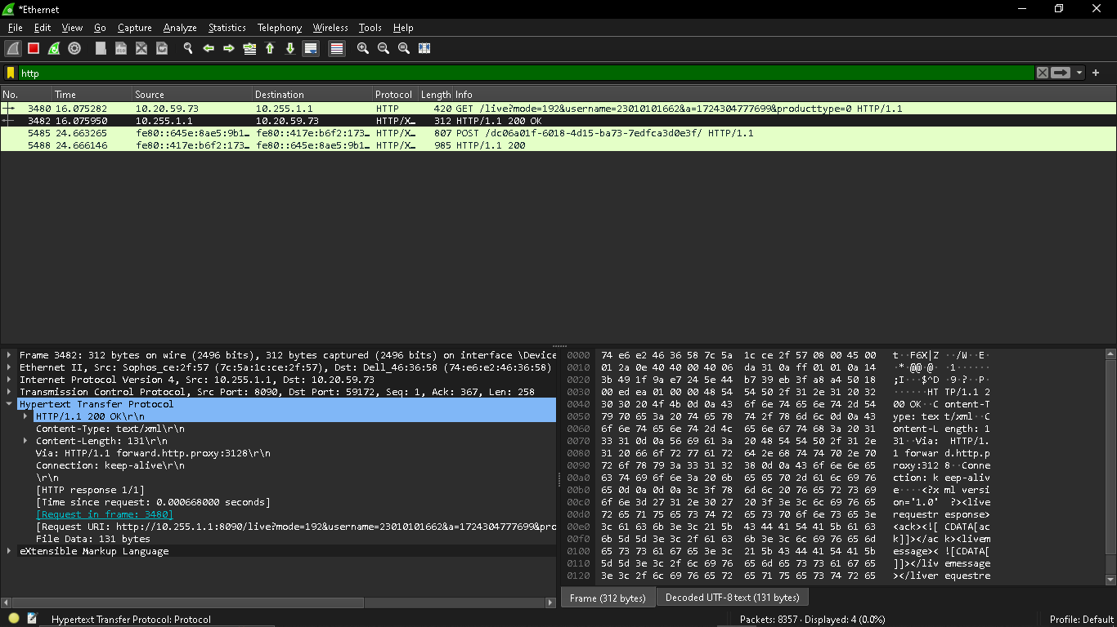

* **TCP :**

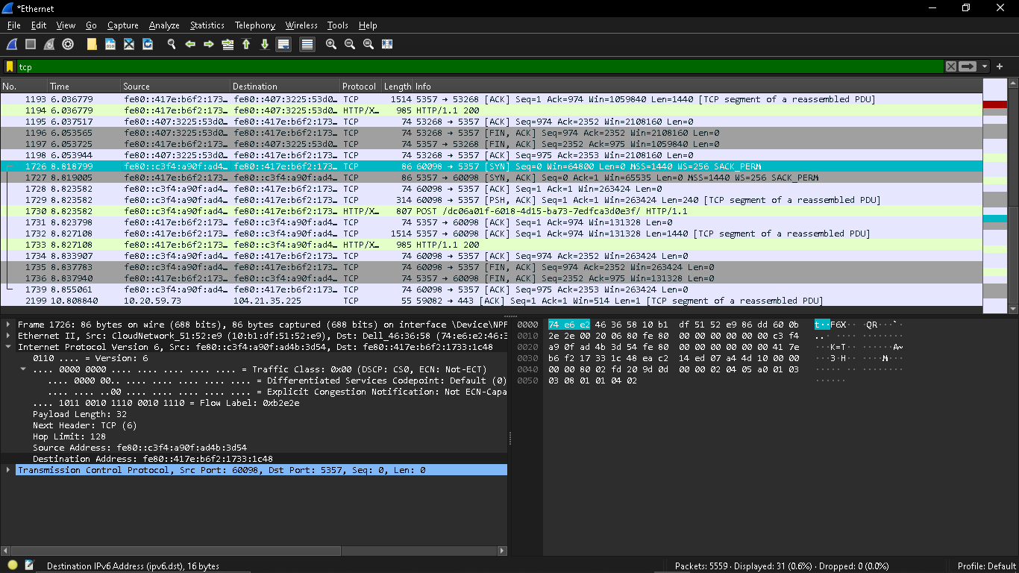

* **UDP :**

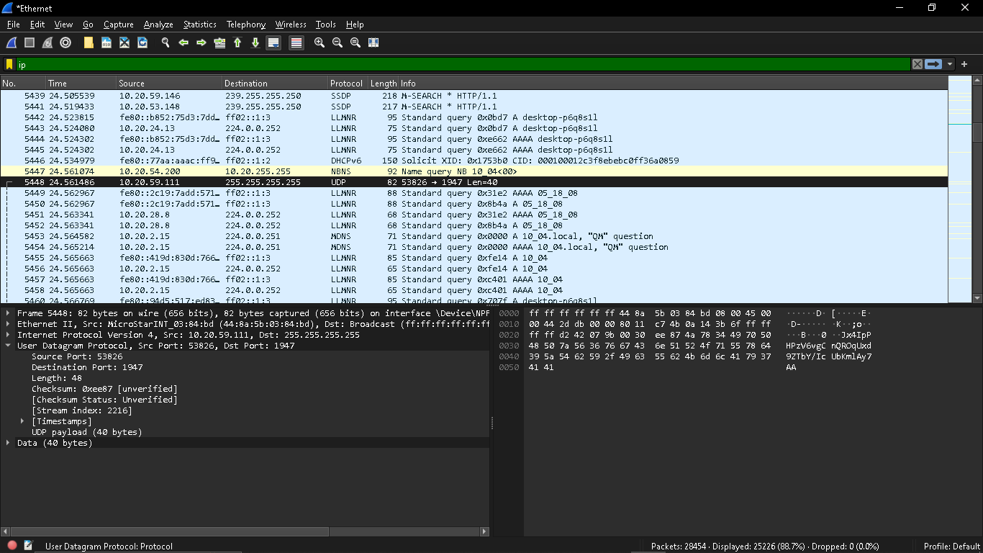

* **IP :**

