CCNA-WAN Technologies
Task-1: Create a table comparing at least three types of WAN connections (such as leased line, DSL, and MPLS) with columns for speed, cost, and typical use cases.

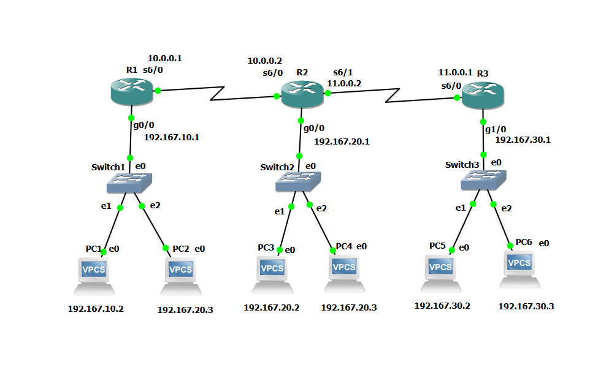
Router-1
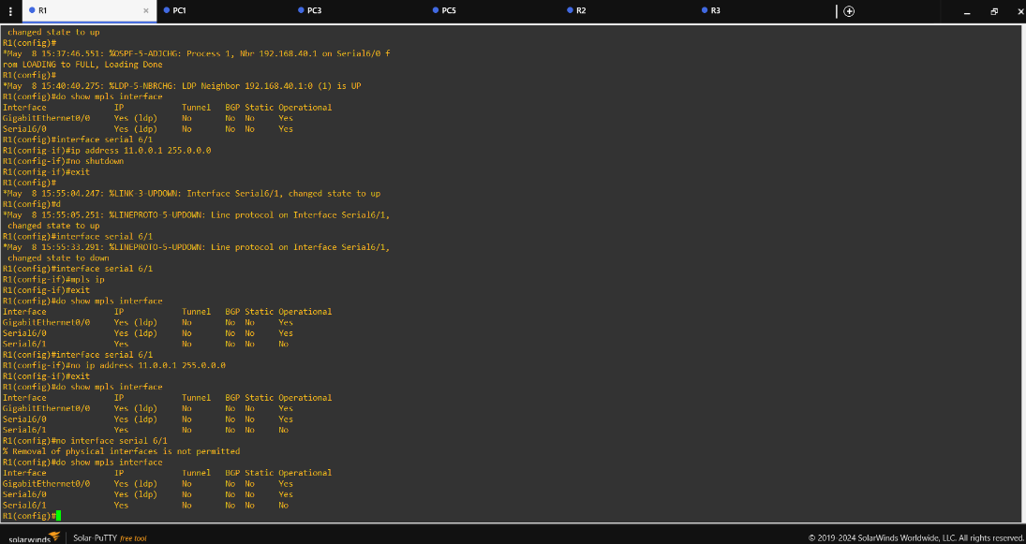

Router-2
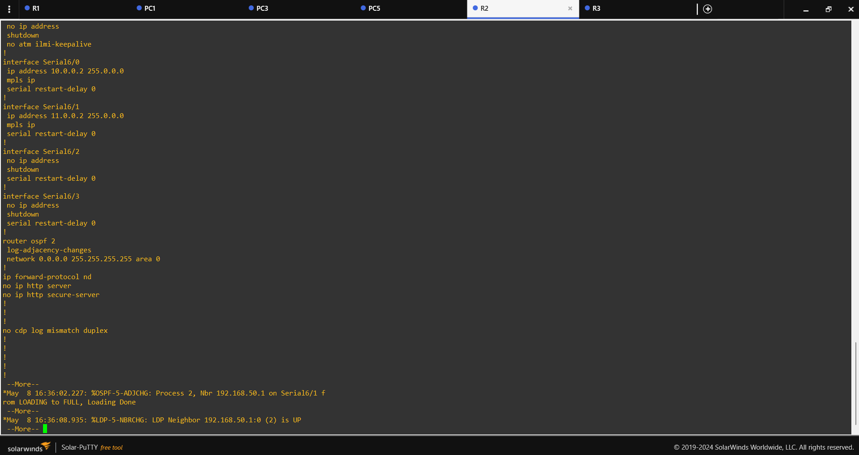

Router-3
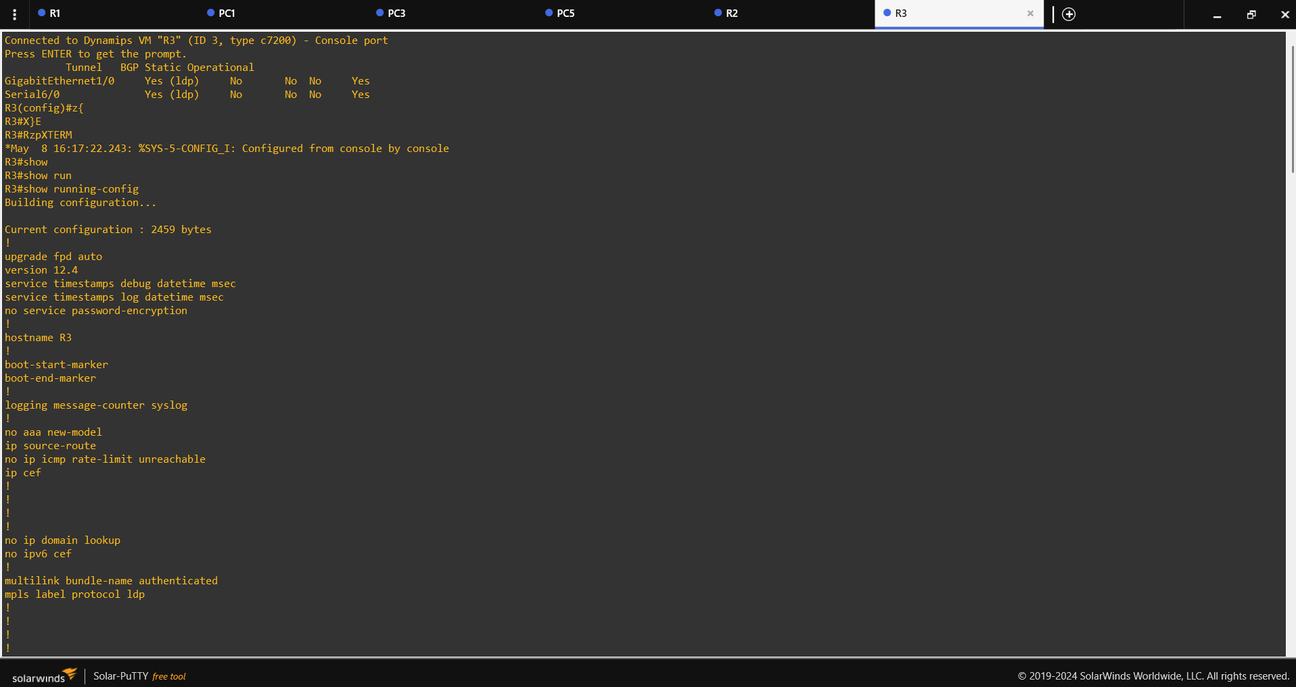

PC-1
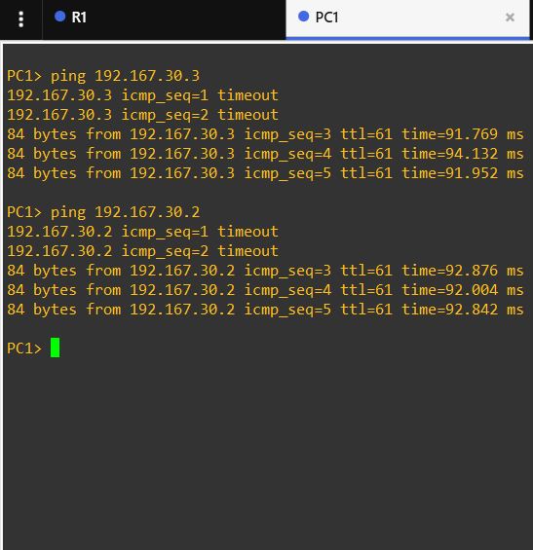

PC-3
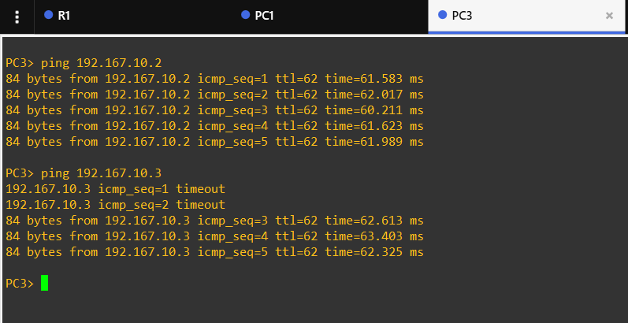

PC-5
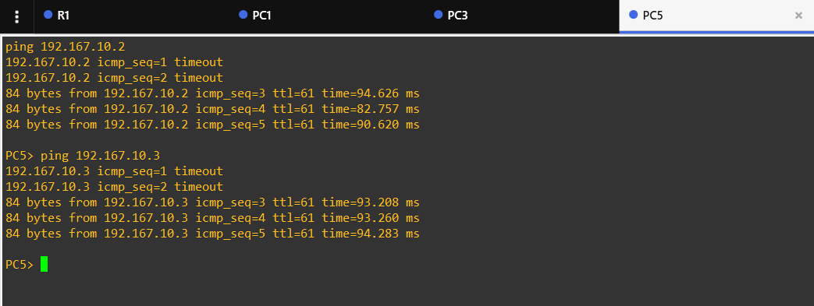

Task-2: Draw a labeled diagram (on paper or using any drawing tool) showing how a CSU/DSU connects a router to a WAN service provider, and explain the role of each device in 2-3 sentences.

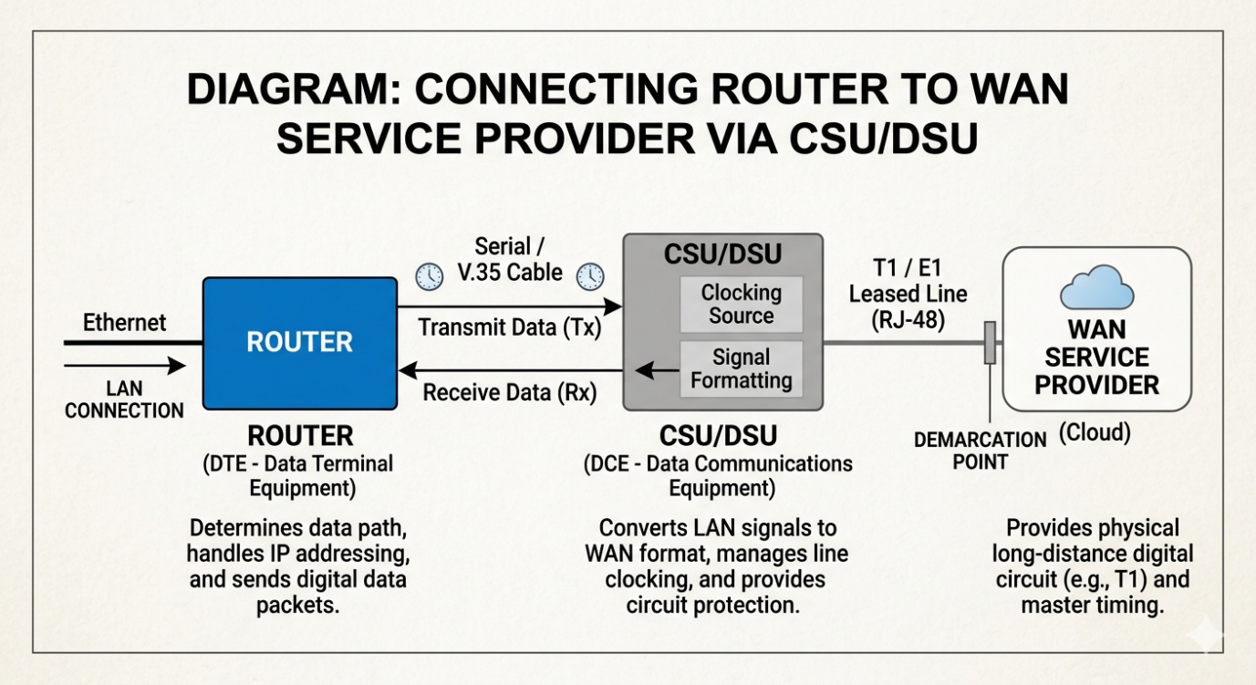

Router: This acts as the brain of your network that determines the best path for data to travel. It handles routing protocols and IP addressing, but its digital output is typically not compatible with long-distance WAN lines
CSU/DSU (Channel Service Unit/Data Service Unit): This intermediary device translates the router’s digital signals into a format that the WAN service can carry, and vice versa. It acts as a digital modem, managing the timing and line clocking of the circuit while providing a barrier against electrical faults.
WAN Service Provider: The telecommunications company or ISP that provides the physical wide-area transmission lines (like T1, E1, or optical circuits). They manage the master clock and transmit your data across long geographic distances to their destination

Task-3: List three real-world examples of popular apps or services (like IRCTC, WhatsApp, or Zomato) that rely on WAN connections, and briefly describe how WAN enables their functionality.
The below applications are using WAN connections.
1. UPI Apps: Phone Pay, Google Pay, Paytm.
UPI apps must securely connect your smartphone to multiple independent financial systems instantly. A secure national WAN infrastructure links the app servers, the National Payments Corporation of India (NPCI), and thousands of core banking servers across the country. This expansive network verifies your biometric data, checks account balances, and shifts digital funds between different banks in under two seconds.
2. Blinkit (Instamart or Zepto)
Quick-commerce services rely on hyper-local fulfillment centers managed by a centralized brain. A high-speed WAN connects hundreds of scattered "dark stores" (local warehouses) to the company's central inventory management cloud. When you place an order, the WAN instantly updates stock levels across the entire region, alerts the nearest dark store packer, and assigns a nearby delivery rider via GPS.
3. BookMyShow
This platform manages live seat inventories for thousands of cinema halls and event venues simultaneously. A dedicated WAN links individual theater ticketing software directly to BookMyShow’s central cloud servers. This real-time synchronization ensures that when you select seat E-12 in a local multiplex, that exact seat is instantly locked and hidden from buyers on other devices across the country.
WAN Security vs. Cellular Connections
Because apps like PhonePe, Blinkit, and BookMyShow send data over massive, public networks, they use specific layers of security to keep information private:
Encryption (SSL/TLS): This turns your data (like credit card details or home addresses) into scrambled code before it leaves your device. Even if someone intercepts the data while it travels across the WAN, they cannot read it without the digital decryption key.
Secure Gateways (APIs): Think of these as strict digital security guards. When an app needs to talk to a bank or a ticket server, it passes through a secured gateway that verifies the request is genuine and blocks malicious traffic.
Private Virtual Networks (VPNs): For backend operations, like a Blinkit dark store updating the central warehouse, businesses often use private tunnels over the WAN. This keeps corporate inventory data completely invisible to the general internet.
Cellular WANs vs. Fixed-Line Enterprise WANs
Cellular WANs (4G/5G): This is what you and the delivery riders use. It relies on wireless cell towers to transmit data through the air over large geographic areas, offering flexibility and mobility so you can order food or send money while moving.
Fixed-Line Enterprise WANs: This is what the banks, data centers, and corporate offices use. It relies on physical underground cables (like fiber optics). It is stationary, but it offers much faster speeds, higher reliability, and stronger security than wireless networks to handle millions of requests at once.
Task-4: Research online and find an image or datasheet of a physical WAN aggregator device used in enterprise networks. Paste the image or link, and write two key features of that device.
The Device is Cisco Catalyst 8500 Series Edge Platforms which have physical WAN aggregator device which is used in enterprise networks
High-Performance SD-WAN & Crypto Scaling: Powered by custom, third-generation Quantum Flow Processor (QFP) ASICs, the platform delivers up to 51 Gbps of clear-text forwarding and 22.6 Gbps of secure, hardware-accelerated SD-WAN IPsec throughput. This allows enterprises to aggregate thousands of remote branch tunnels safely without bottle-necking speeds.
Flexible Core Density & Built-In Redundancy: The unit occupies a single rack space (1RU) but packs dense interface options supporting 1GE, 10GE, 40GE, and 100GE ports. It maintains high-availability uptime through factory-default dual redundant hot-swappable power supplies
