**20cs3019**

**Bhagyesh Rashinkar**

***Project Report***

**Project Description**

**Online Hostel Complaint Management System** is a website through which we can register and manage hostel related complaints online. The website provides with a form through which students can register their complaints, it also provides with options to delete the complaints and update the complaint status (resolved or unresolved).

The project **aims** to make the complaint management process completely paper free and helps to handle the complaints with transparency and efficiency.

The project **uses** HTML, CSS for website design, MongoDB for database to store complaints and Node JS, Express JS to perform the CRUD (Create Read Update Delete) operations on the database.

**Modules required**

Open cmd in project directory and type **npm install <package name>** to install each module.

* **express:** Node JS web application framework.
* **mongoose:** MongoDB object modelling tool.
* **hbs:** Express JS view engine to render .hbs files.
* **nodemon:** Automatically starts server after changes in directory are detected.
* **dotenv:** Loads environment variables from .env file.

**Database schema**

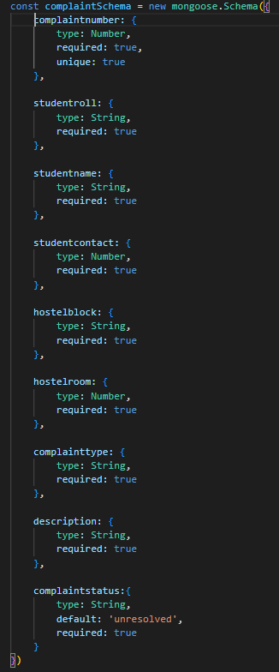

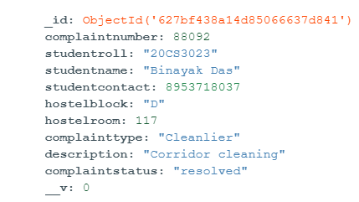

**Queries used**



In this statement we find the data from database and sort it in descending order with respect to **_id.**

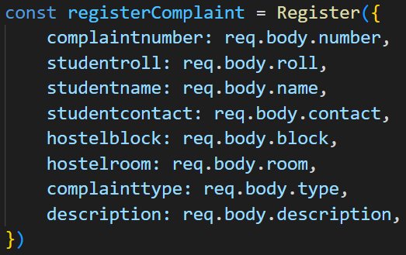

In this we are posting data to database by using a form. Here we are querying the inputs filled in the using the name attribute.



In order to delete any item from database we have to find that specific item using its primary key(_id) and then call the delete method.

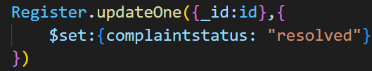

In order to change the complaint status we query the database using primary key(_id) and then update the status.