**Bhagyshree Khote  
Roll No – 502  
M.Sc. CS Part I**

**ALGORITHM PRACTICALS**

**Practical 1** - Write a Program for Randomized Selection Algorithm

from random import randrange  
def partition(x, pivot_index = 0):  
 i = 0  
 if pivot_index !=0: x[0],x[pivot_index] = x[pivot_index],x[0]  
 for j in range(len(x)-1):  
 if x[j+1] < x[0]:  
 x[j+1],x[i+1] = x[i+1],x[j+1]  
 i += 1  
 x[0],x[i] = x[i],x[0]  
 return x,i

def RSelect(x,k):  
 if len(x) == 1:  
 return x[0]  
 else:  
 xpart = partition(x,randrange(len(x)))  
 x = xpart[0] # partitioned array  
 j = xpart[1] # pivot index  
 if j == k:  
 return x[j]  
 elif j > k:  
 return RSelect(x[:j],k)  
 else:  
 k = k - j – 1  
 return RSelect(x[(j+1):], k)

x = [3,1,8,4,7,9]  
for i in range(len(x)):  
 print (RSelect(x,i))

**Output:**

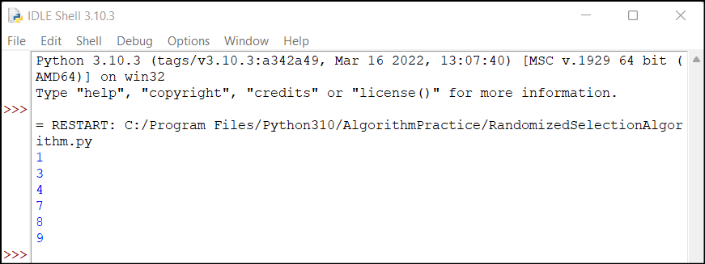

**Practical 2** - Write a Program for Heap Sort Algorithm.  
  
def heapify(arr, n, i):   
 largest = i  
 l = 2 * i + 1  
 r = 2 * i + 2  
 if l < n and arr[i] < arr[l]:  
 largest = l  
 if r < n and arr[largest] < arr[r]:  
 largest = r  
 if largest != i:  
 arr[i],arr[largest] = arr[largest],arr[i]  
 heapify(arr, n, largest)  
def heapSort(arr):  
 n = len(arr)  
 for i in range(n, -1, -1):   
 heapify(arr, n, i)  
 for i in range(n-1, 0, -1):  
 arr[i], arr[0] = arr[0], arr[i]  
 heapify(arr, i, 0)  
arr = [ 12, 11, 13, 5, 6, 7]   
heapSort(arr)  
n = len(arr)  
print ("Sorted array is")  
for i in range(n):  
 print ("%d" %arr[i]),

**Output:**

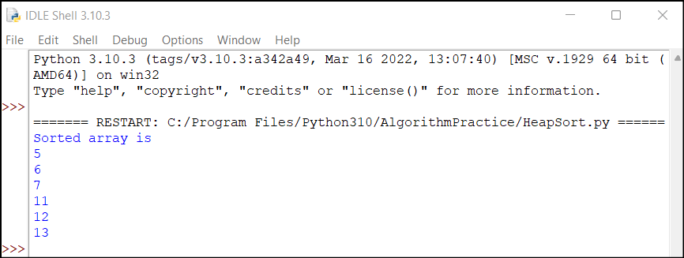

**Practical 3** - Write a Program to perform Radix Sort Algorithm.

def countingSort(arr, exp1):  
 n = len(arr)  
 output = [0] * (n)  
 count = [0] * (10)  
 for i in range(0, n):  
 index = (arr[i]/exp1)  
 count[int((index)%10)] += 1  
 for i in range(1,10):  
 count[i] += count[i-1]  
 i = n-1  
 while i>=0:  
 index = (arr[i]/exp1)  
 output[ count[ int((index)%10) ] - 1] = arr[i]  
 count[int((index)%10)] -= 1  
 i -= 1  
 i = 0  
 for i in range(0,len(arr)):  
 arr[i] = output[i]  
def radixSort(arr):  
 max1 = max(arr)  
 exp = 1  
 while max1/exp > 0:  
 countingSort(arr,exp)  
 exp *= 10

arr = [ 170, 45, 75, 90, 802, 24, 2, 66]  
radixSort(arr)  
for i in range(len(arr)):  
 print(arr[i],end=" ")

**Output:**

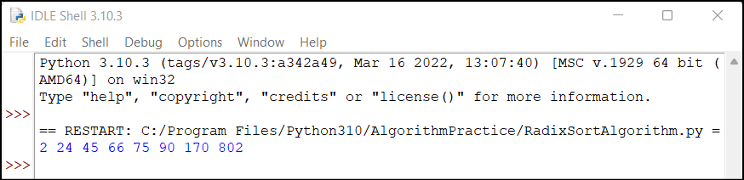

**Practical 4 -**  Write a Program to Perform Bucket Sort Algorithm

def insertionSort(b):

    for i in range(1, len(b)):

        up = b[i]

        j = i - 1

        while j >=0 and b[j] > up:

            b[j + 1] = b[j]

            j -= 1

        b[j + 1] = up

    return b

def bucketSort(x):

    arr = []

    slot_num = 10

    for i in range(slot_num):

        arr.append([])   
    for j in x:

        index_b = int(slot_num * j)

        arr[index_b].append(j)   
    for i in range(slot_num):

        arr[i] = insertionSort(arr[i])

    k = 0

    for i in range(slot_num):

        for j in range(len(arr[i])):

            x[k] = arr[i][j]

            k += 1

    return x

x = [0.897, 0.565, 0.656,

     0.1234, 0.665, 0.3434]

print("Sorted Array is")

print(bucketSort(x))

**Output:**

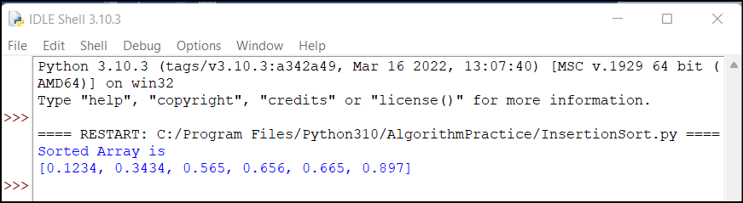

**Practical 5** - Write a Program to Perform Folyd-Warshall algorithm

V = 4

INF = 99999

def floydWarshall(graph):

    """ dist[][] will be the output

       matrix that will finally

        have the shortest distances

        between every pair of vertices """

    """ initializing the solution matrix

    same as input graph matrix

    OR we can say that the initial

    values of shortest distances

    are based on shortest paths considering no

    intermediate vertices """

    dist = list(map(lambda i: list(map(lambda j: j, i)), graph))

    """ Add all vertices one by one

    to the set of intermediate

     vertices.

     ---> Before start of an iteration,

     we have shortest distances

     between all pairs of vertices

     such that the shortest

     distances consider only the

     vertices in the set

    {0, 1, 2, .. k-1} as intermediate vertices.

      ----> After the end of a

      iteration, vertex no. k is

     added to the set of intermediate

     vertices and the

    set becomes {0, 1, 2, .. k}

    """

    for k in range(V):

        for i in range(V):

            for j in range(V):

                dist[i][j] = min(dist[i][j],

                                 dist[i][k] + dist[k][j]

                                 )

    printSolution(dist)

def printSolution(dist):

    print("Following matrix shows the shortest distances\

 between every pair of vertices")

    for i in range(V):

        for j in range(V):

            if(dist[i][j] == INF):

                print("%7s" % ("INF"), end=" ")

            else:

                print("%7d\t" % (dist[i][j]), end=' ')

            if j == V-1:

                print()

# Driver's code

if __name__ == "__main__":

  """

              10

         (0)------->(3)

          |         /|\

        5 |          |

          |          | 1

         \|/         |

         (1)------->(2)

              3           """

  graph = [[0, 5, INF, 10],

         [INF, 0, 3, INF],

         [INF, INF, 0,   1],

         [INF, INF, INF, 0]

         ]

  floydWarshall(graph)

**Output**:

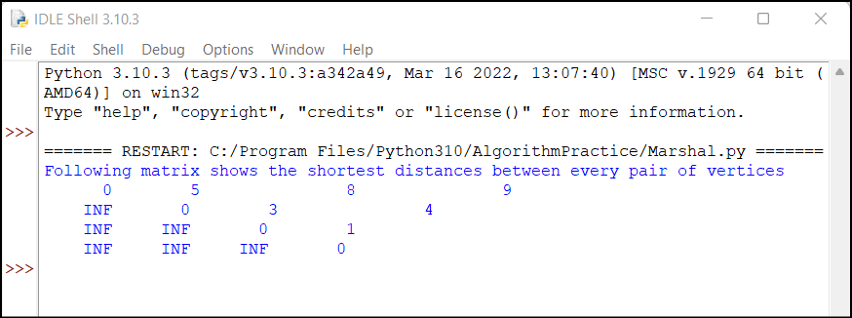

**Practical 6** - Write a Program for Counting Sort Algorithm in python

def countSort(arr):

output = [0 for i in range(len(arr))]

count = [0 for i in range(256)]

ans = ["" for _ in arr]

for i in arr:

count[ord(i)] += 1

for i in range(256):

count[i] += count[i-1]

for i in range(len(arr)):

output[count[ord(arr[i])]-1] = arr[i]

count[ord(arr[i])] -= 1

for i in range(len(arr)):

ans[i] = output[i]

return ans

if __name__ == '__main__':

arr = "geeksforgeeks"

ans = countSort(arr)

print("Sorted character array is % s" % ("".join(ans)))

**Output:**

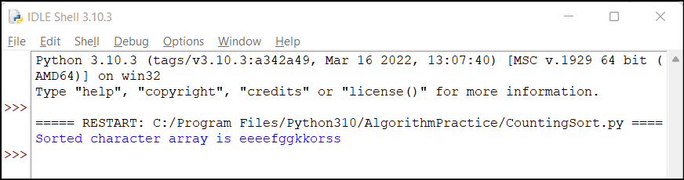

**Practical 7** - Write a program for Set Covering Problem

def set_cover(universe, subsets):

    """Find a family of subsets that covers the universal set"""

    elements = set(e for s in subsets for e in s)

    # Check the subsets cover the universe

    if elements != universe:

        return None

    covered = set()

    cover = []

    # Greedily add the subsets with the most uncovered points

    while covered != elements:

        subset = max(subsets, key=lambda s: len(s - covered))

        cover.append(subset)

        covered |= subset

    return cover

def main():

    universe = set(range(1, 11))

    subsets = [set([1, 2, 3, 8, 9, 10]),

        set([1, 2, 3, 4, 5]),

        set([4, 5, 7]),

        set([5, 6, 7]),

        set([6, 7, 8, 9, 10])]

    cover = set_cover(universe, subsets)

    print(cover)

if __name__ == '__main__':

    main()

**Output**:

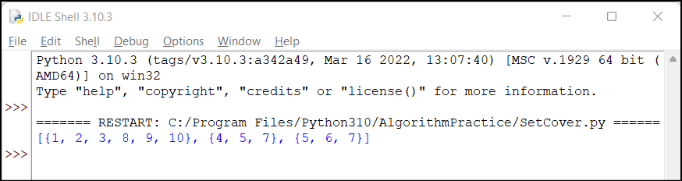

**Practical 8** - Write a Program for found a subset with given sum

def isSubsetSum(set,n, sum) :

    # Base Cases

    if (sum == 0) :

        return True

    if (n == 0 and sum != 0) :

        return False

    # If last element is greater than

    # sum, then ignore it

    if (set[n - 1] > sum) :

        return isSubsetSum(set, n - 1, sum);

    # else, check if sum can be obtained

    # by any of the following

    # (a) including the last element

    # (b) excluding the last element

    return isSubsetSum(set, n-1, sum) or isSubsetSum(set, n-1, sum-set[n-1])

# Driver program to test above function

set = [3, 34, 4, 12, 5, 2]

sum = 9

n = len(set)

if (isSubsetSum(set, n, sum) == True) :

    print("Found a subset with given sum")

else :

    print("No subset with given sum")

**Output:**

