**Assignment 12**

**Name : Bhairavi Nitin Chaudhari**

**PRN: 240840320023**

1. Write a query that selects all customers whose ratings are equal to or greater than ANY of Serres’.

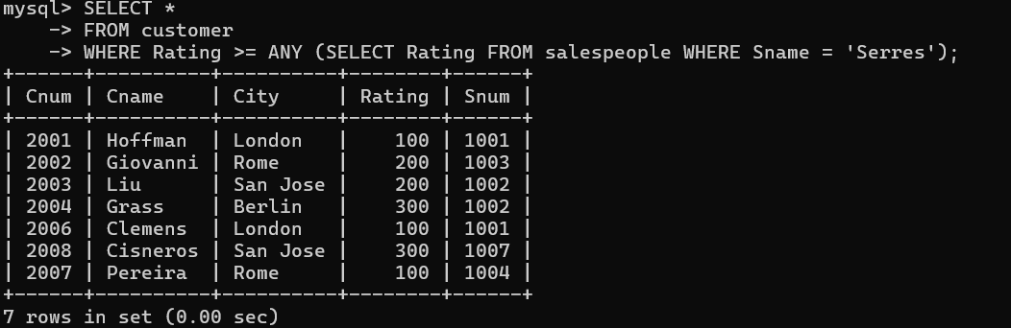

1. Write a query using ANY or ALL that will find all salespeople who have no customers located in their city.

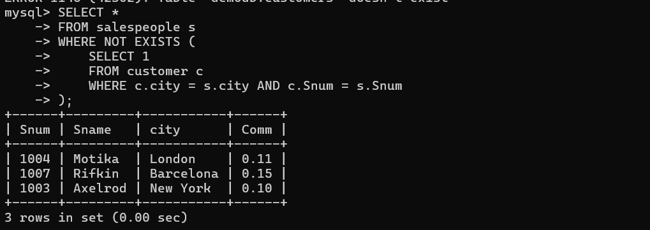

1. Write a query that selects all orders for amounts greater than any for the customers in London.

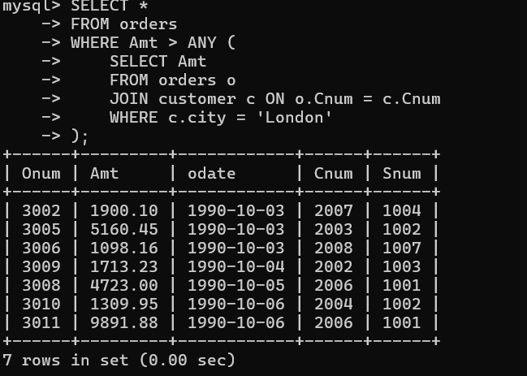

1. Write the above query using MIN or MAX.

