**Assignment : 5**

**Name : Bhairavi Nitin Chaudhari**

**PRN: 240840320023**

1. Write a query that will give you all orders for more than Rs. 1,000.

SELECT * FROM ORDERS WHERE Amt > 1000;

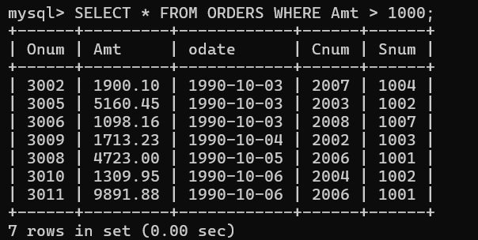

1. Write a query that will give you the names and cities of all salespeople in London with a commission above .10.

SELECT Sname, City FROM SALESPEOPLE WHERE City = 'London' AND Comm > 0.10;

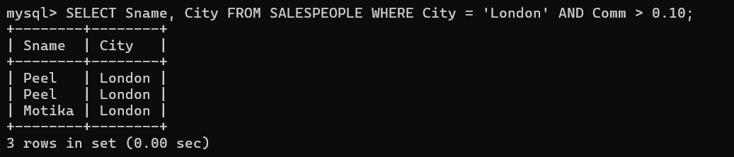

1. Write a query on the Customers table whose output will exclude all customers with a rating <= 100, unless they are located in Rome.

SELECT * FROM CUSTOMER WHERE Rating > 100 OR City = 'Rome';

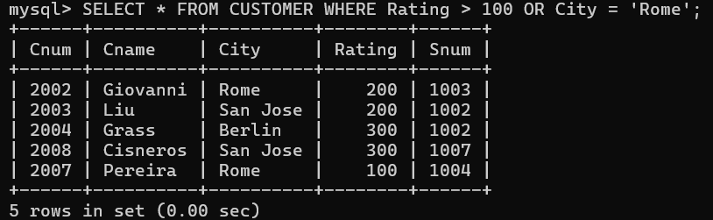

1. What will be the output from the following query? Select * from Orders where (amt < 1000 OR NOT (odate = ‘1990-10-03’ AND cnum > 2003));

SELECT * FROM ORDERS WHERE (Amt < 1000 OR NOT (Odate = '1990-10-03' AND Cnum > 2003));

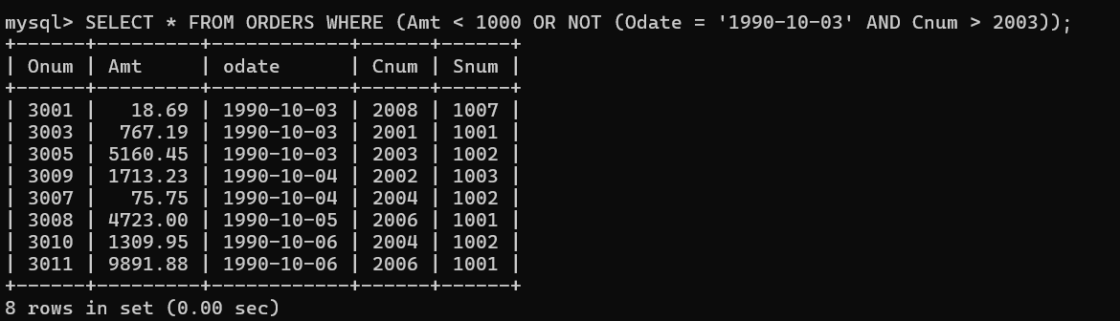

1. What will be the output of the following query? Select * from Orders where NOT ((odate = ‘1990-10-03’ OR snum >1006) AND amt >= 1500);

SELECT * FROM ORDERS WHERE NOT ((Odate = '1990-10-03' OR Snum > 1006) AND Amt >= 1500);

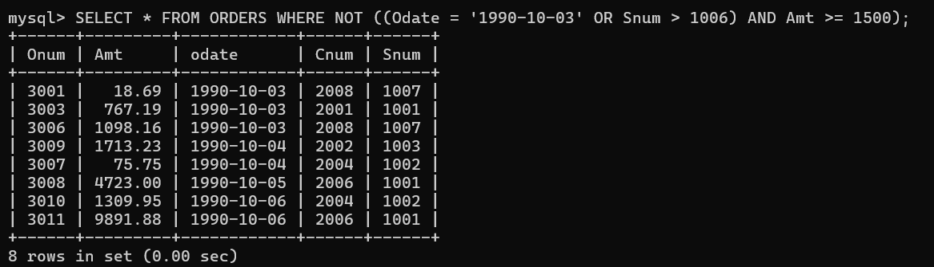

1. What is a simpler way to write this query? Select snum, sname, city, comm From Salespeople where (comm > .12 OR comm <.14);

SELECT Snum, Sname, City, Comm FROM SALESPEOPLE WHERE Comm BETWEEN 0.12 AND 0.14;

