**Assignment : 6**

**Name : Bhairavi Nitin Chaudhari**

**PRN: 240840320023**

1. Write two different queries that would produce all orders taken on October 3rd or 4 th, 1990.
   1. SELECT * FROM orders WHERE order_date IN ('1990-10-03', '1990-10-04');

OR

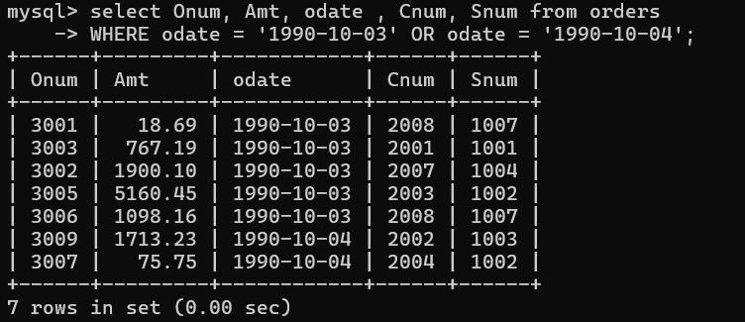

1. Write a query that selects all of the customers serviced by Peel or Motika. (Hint: the snum field relates the two tables to one another).

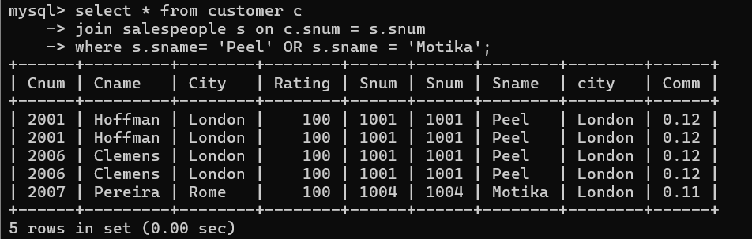

1. Write a query that will produce all the customers whose names begin with a letter from ‘A’ to ‘G’.

select * from customer

WHERE cname LIKE '[A-G]%';

Empty set (0.00 sec)

1. Write a query that selects all customers whose names begin with the letter ‘C’.

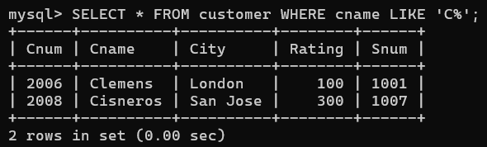

1. Write a query that selects all orders except those with zeroes or NULLs in the amt field

