**Exercise 6:**

**Name : Bhairavi Nitin Chaudhari**

**PRN: 240840320023**

1. Display all the Suppliers with the same Status as the supplier, ‘CLARK’.

Empty ;

1. Display all the Employees in the same department as the employee ‘MILLER’.

Empty;

1. Display all the Parts which have more Weight than all the Red parts.

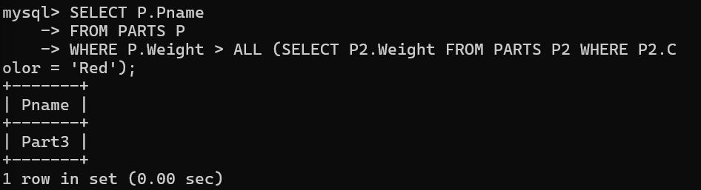

1. Display all the Projects going on in the same city as the project ‘TAPE’.

Empty;

1. Display all the Parts with Weight less than all the Green parts.

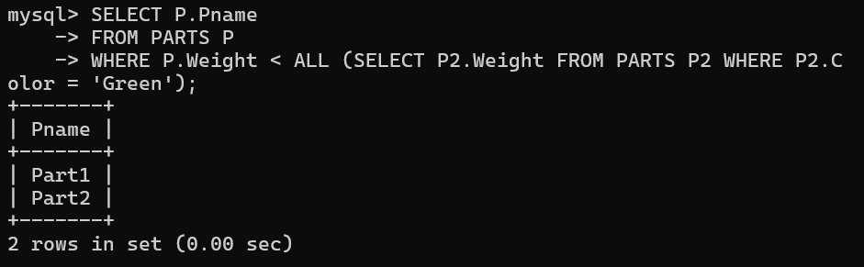

6. Display the name of the Supplier who has sold the maximum Quantity (in one

sale).

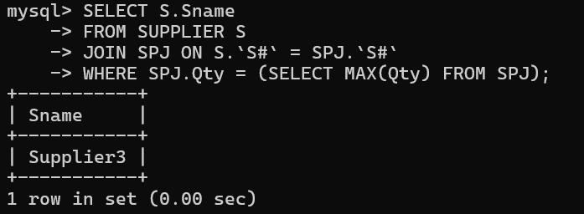

7.Display the name of the Employee with the minimum Salary.

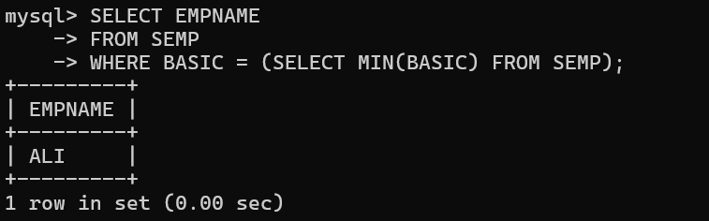

8. Display the name of the Supplier who has sold the maximum overall Quantity (sum

of Sales).

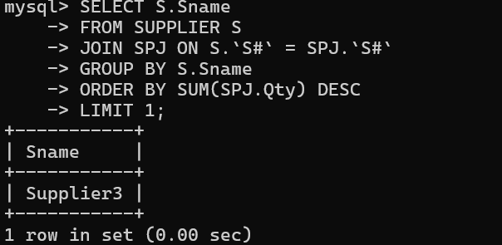

9. Display the name of the Department with the maximum number of Employees.

