**Problem 1:**

Navigate and List: a. Start by navigating to your home directory and list its contents. Then, move into a directory named "LinuxAssignment" if it exists; otherwise, create it.

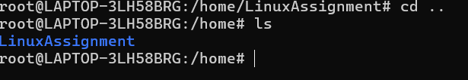

ls : to get the list of all files and directories

File Management: a. Inside the "LinuxAssignment" directory, create a new file named "file1.txt". Display its contents.

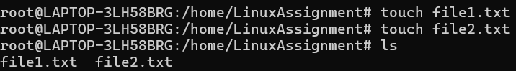

Directory Management: a. Create a new directory named "docs" inside the "LinuxAssignment" directory.

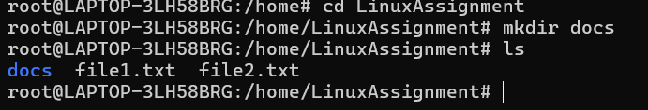

mkdir: to create new directory.

Copy and Move Files: a. Copy the "file1.txt" file into the "docs" directory

and rename it to "file2.txt".

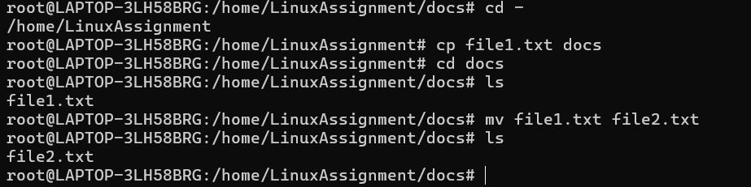

cd: to change directory.

mv : to copy the file 1 content into file2

Permissions and Ownership: a. Change the permissions of "file2.txt" to allow read, write, and execute permissions for the owner and only read permissions for others. Then, change the owner of "file2.txt" to the current user.

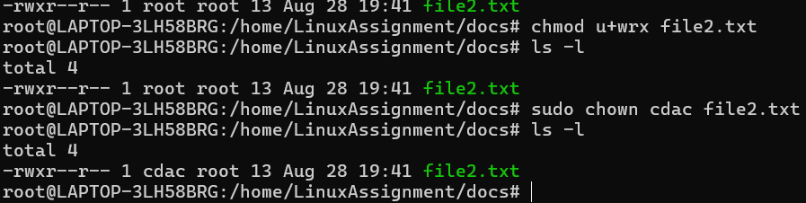

Chmod: to give or remove the permission to read write

Chown : to change the owner of the file or directory.

Final Checklist: a. Finally, list the contents of the "LinuxAssignment" directory and the root directory to ensure that all operations were performed correctly.

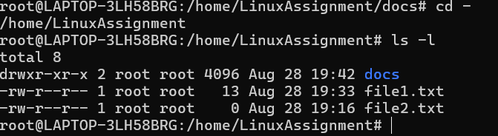

ls –l: to list out all the files in the directory

File Searching: a. Search for all files with the extension ".txt" in the current directory and its subdirectories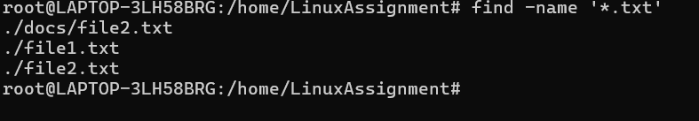

Find : used to find the name of file where the .txt extension file is located.

. b. Display lines containing a specific word in a file (provide a file name and the specific word to search).



System Information: a. Display the current system date and time.

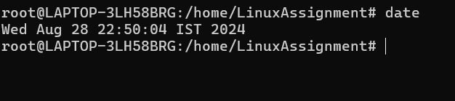

Date: command is used to display date and time.

Networking: a. Display the IP address of the system.

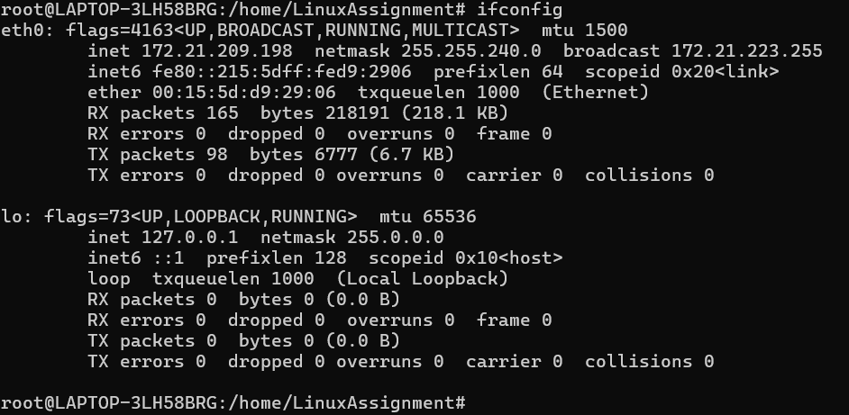

b. Ping a remote server to check connectivity (provide a remote server address to ping).

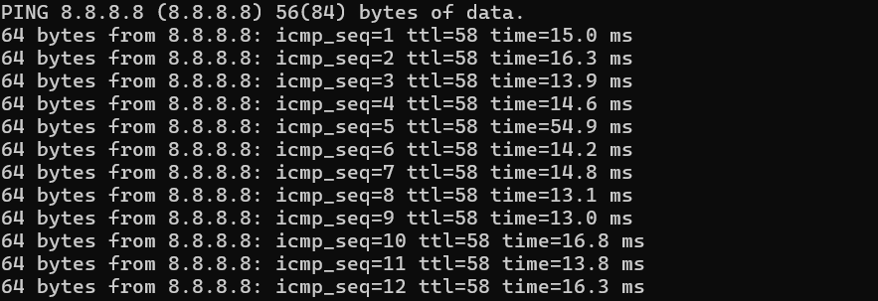

File Compression: a. Compress the "docs" directory into a zip file. b. Extract the contents of the zip file into a new directory.

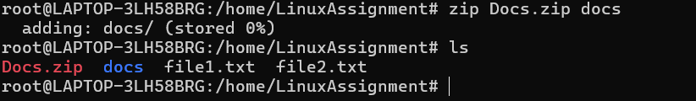

Zip: zip command is used to compress the file.

b. Extract the contents of the zip file into a new directory.

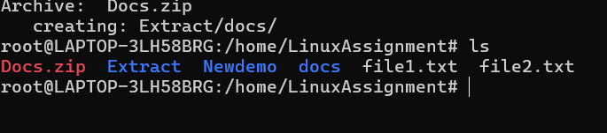

File Editing: a. Open the "file1.txt" file in a text editor and add some text to it.

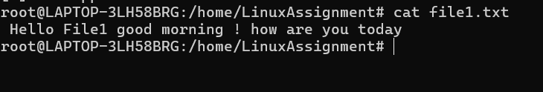

b. Replace a specific word in the "file1.txt" file with another word (provide the original word and the word to replace it with)

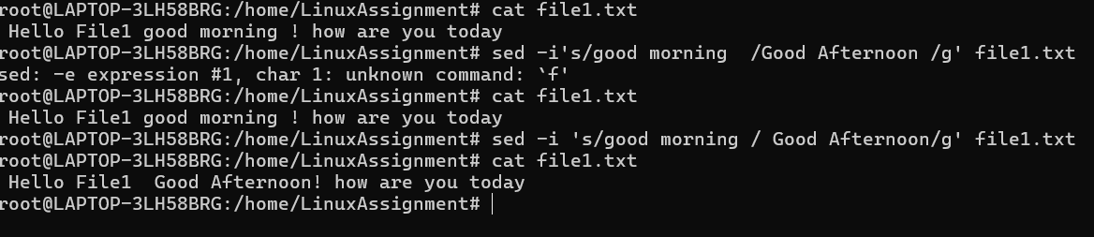

**Problem 2:**

a. Suppose you have a file named "data.txt" containing important information. Display the first 10 lines of this file to quickly glance at its contents using a command.

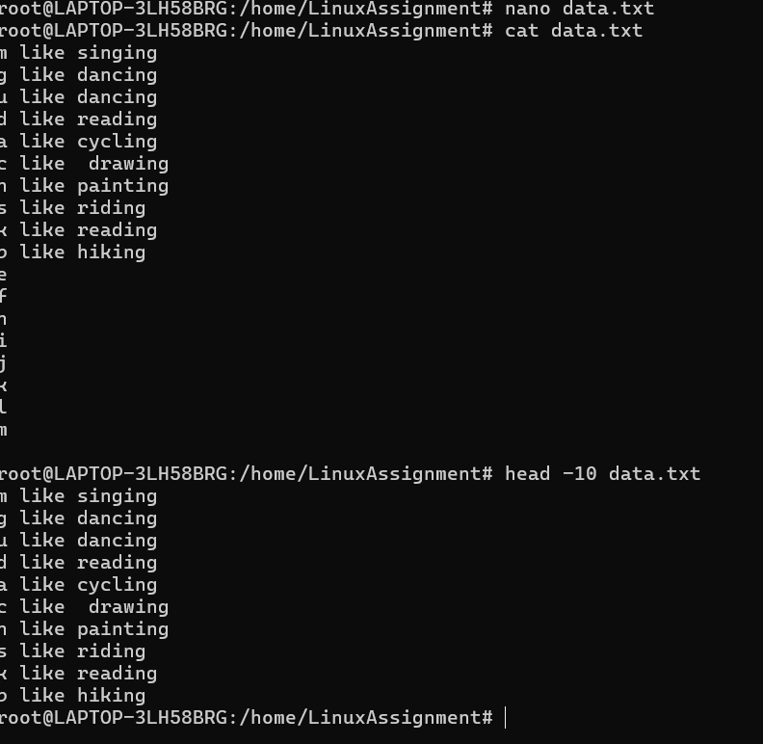

Now, to check the end of the file for any recent additions, display the last 5 lines of "data.txt" using another command.

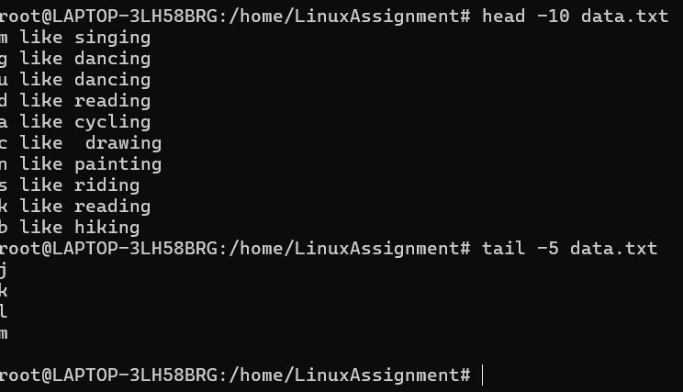

In a file named "numbers.txt," there are a series of numbers. Display the first 15 lines of this file to analyze the initial data set. 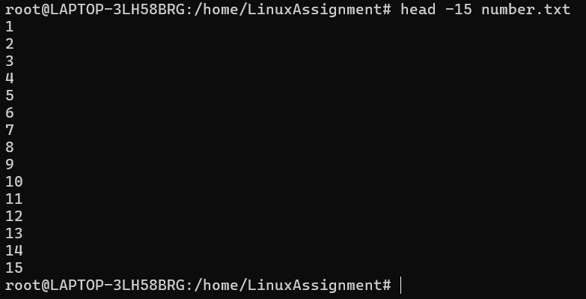

To focus on the last few numbers of the dataset, display the last 3 lines of "numbers.txt".

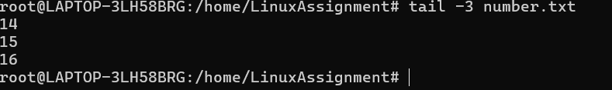

Imagine you have a file named "input.txt" with text content. Use a command to translate all lowercase letters to uppercase in "input.txt" and save the modified text in a new file named "output.txt."

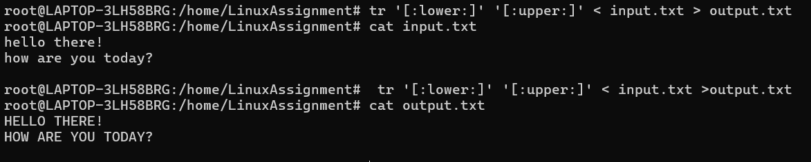

In a file named "duplicate.txt," there are several lines of text, some of which are duplicates. Use a command to display only the unique lines from "duplicate.txt."

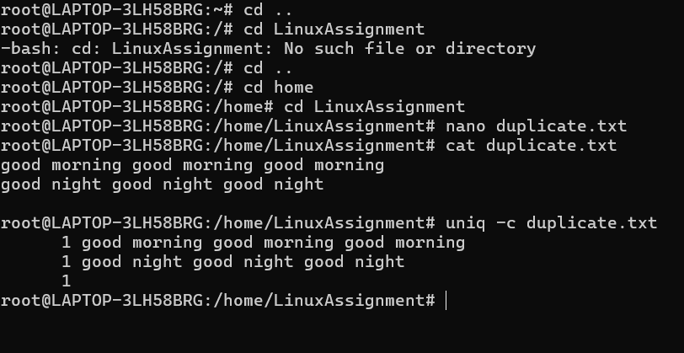

In a file named "fruit.txt," there is a list of fruits, but some fruits are repeated. Use a command to display each unique fruit along with the count of its occurrences in "fruit.txt."

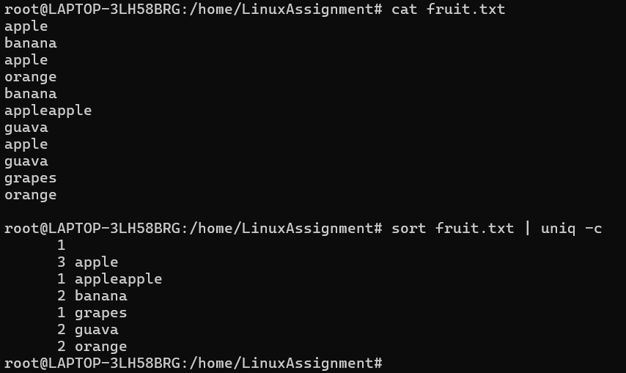

**Problem 1:**

Navigate and List: a. Start by navigating to your home directory and list its contents. Then, move into a directory named "LinuxAssignment" if it exists; otherwise, create it.



File Management: a. Inside the "LinuxAssignment" directory, create a new file named "file1.txt". Display its contents.



Directory Management: a. Create a new directory named "docs" inside the "LinuxAssignment" directory.



Copy and Move Files: a. Copy the "file1.txt" file into the "docs" directory

and rename it to "file2.txt".



Permissions and Ownership: a. Change the permissions of "file2.txt" to allow read, write, and execute permissions for the owner and only read permissions for others. Then, change the owner of "file2.txt" to the current user.



Final Checklist: a. Finally, list the contents of the "LinuxAssignment" directory and the root directory to ensure that all operations were performed correctly.

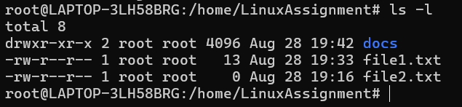

Final Checklist: a. Finally, list the contents of the "LinuxAssignment" directory and the root directory to ensure that all operations were performed correctly.



File Searching: a. Search for all files with the extension ".txt" in the current directory and its subdirectories

. b. Display lines containing a specific word in a file (provide a file name and the specific word to search).



System Information: a. Display the current system date and time.



Networking: a. Display the IP address of the system. b. Ping a remote server to check connectivity (provide a remote server address to ping).

File Compression: a. Compress the "docs" directory into a zip file. b. Extract the contents of the zip file into a new directory.



b. Extract the contents of the zip file into a new directory.



File Editing: a. Open the "file1.txt" file in a text editor and add some text to it.



b. Replace a specific word in the "file1.txt" file with another word (provide the original word and the word to replace it with)



**Problem 2:**

a. Suppose you have a file named "data.txt" containing important information. Display the first 10 lines of this file to quickly glance at its contents using a command.



Now, to check the end of the file for any recent additions, display the last 5 lines of "data.txt" using another command.



In a file named "numbers.txt," there are a series of numbers. Display the first 15 lines of this file to analyze the initial data set. 

To focus on the last few numbers of the dataset, display the last 3 lines of "numbers.txt".



Imagine you have a file named "input.txt" with text content. Use a command to translate all lowercase letters to uppercase in "input.txt" and save the modified text in a new file named "output.txt."



In a file named "duplicate.txt," there are several lines of text, some of which are duplicates. Use a command to display only the unique lines from "duplicate.txt."



In a file named "fruit.txt," there is a list of fruits, but some fruits are repeated. Use a command to display each unique fruit along with the count of its occurrences in "fruit.txt."

