**Part A**

**Name :Bhairavi Nitin Chaudhari**

**Center: Kharghar**

What will the following commands do?

• echo "Hello, World!"

Echo command is used to display the text ,variable on to the standard output.

It will display Hello, World!

• name="Productive"

name is the variable name and productive is the value for the variable.

The productive is the value assigned to the name.

• touch file.txt

Touch command is used to create a empty file .

In this command empty file named as file.txt is created.

• ls -a

ls is a terminal navigation command use to display the list of directory and files.

-a is a flag to show the list of all files including hidden files.

• rm file.txt

rm is used to remove the file from the directory.

The above command will remove the file named file.txt.

• cp file1.txt file2.txt

cp : cp command is used to copy the file.

The above command copy the file1.txt into file2.txt.

Here the file 1 is the destination file and file2 is destination file.

• mv file.txt /path/to/directory/

mv : is used to move file to the another directory

• chmod 755 script.sh

gives read, write, and execute permissions to the owner, and read and execute permissions to group and others.

• grep "pattern" file.txt

grep is used to Searching and manipulating text pattern in file.

• kill PID

The kill command requires the process id of process we want to terminate.

• mkdir mydir && cd mydir && touch file.txt && echo "Hello, World!" > file.txt && cat file.txt

This command created a directory using mkdir then the file.txt is created in the mydir drectory > sign redirected in the file.txt where the echo prints Hello, World! On the command line.

The output of the command is Hello, World!

• ls -l | grep ".txt"

This command would select from the output of ls –l the files that has extension of .txt

• cat file1.txt file2.txt | sort | uniq

The command combines the contents of file1.txt and file2.txt, sorts them alphabetically, and removes duplicate lines, leaving only unique lines in the output

• ls -l | grep "^d"

This command would select from the output of ls –l that are directory.

• grep -r "pattern" /path/to/directory/

Recursively searches for pattern within all files in the specified directory and its subdirectories.

• cat file1.txt file2.txt | sort | uniq –d

The command is used to search for files in a specified directory and its subdirectories that match a particular name pattern.

The command combines the contents of file1.txt and file2.txt, sorts them, and then displays only the lines that are duplicated in the combined, sorted output.

• chmod 644 file.txt

The command is used to change the permissions of the file file.txt. It will give permission of Read and write to owner and read only for group and others.

• cp -r source_directory destination_directory

The command is used in to copy directories and their contents from one location to another. cp to copy and -r with all the content.

• find /path/to/search -name "*.txt"

Searche all files ending in .txt within the specified directory and its subdirectories.

• chmod u+x file.txt

It gives permission for execution to the owner on file.txt.

• echo $PATH

The command is used to display the current value of the PATH environment variable

**Part B Identify True or False:**

1. ls is used to list files and directories in a directory.

: True

1. mv is used to move files and directories.

:true.

1. cd is used to copy files and directories.

False. cd is used to change directory.

1. pwd stands for "print working directory" and displays the current directory.

True.

1. grep is used to search for patterns in files.

True

1. chmod 755 file.txt gives read, write, and execute permissions to the owner, and read and execute permissions to group and others.

True

1. mkdir -p directory1/directory2 creates nested directories, creating directory2 inside directory1 if directory1 does not exist.

true

1. rm -rf file.txt deletes a file forcefully without confirmation.

True

Identify the Incorrect Commands:

1. chmodx is used to change file permissions.

chmod command is used to change file permissions.

1. cpy is used to copy files and directories.

Cp is used to copy file and directories

1. mkfile is used to create a new file.

touch or nano is used to create new file.

1. catx is used to concatenate files.

cat is used to concatenate files.

1. rn is used to rename files.

Mv command is used to rename file.

Part C Question

**1: Write a shell script that prints "Hello, World!" to the terminal.**

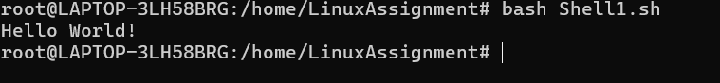

**Question 2: Declare a variable named "name" and assign the value "CDAC Mumbai" to it. Print the value of the variable.**



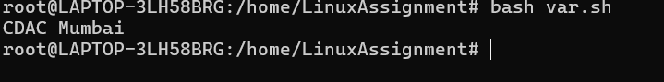

**Question 3: Write a shell script that takes a number as input from the user and prints it.**

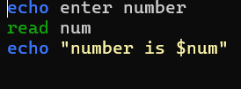

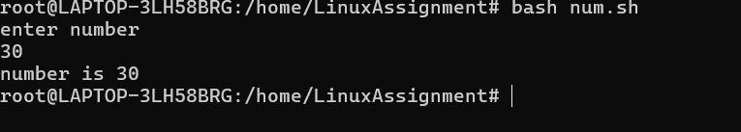

**Question 4: Write a shell script that performs addition of two numbers (e.g., 5 and 3) and prints the result**.

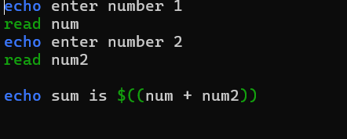

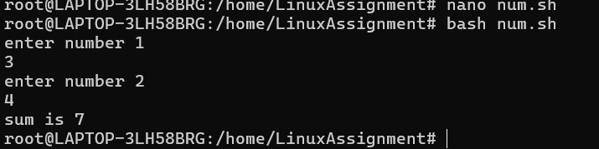

**Question 5: Write a shell script that takes a number as input and prints "Even" if it is even, otherwise prints "Odd".**

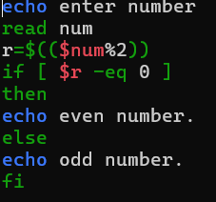

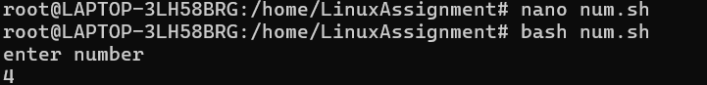

Question 6: Write a shell script that uses a for loop to print numbers from 1 to 5.

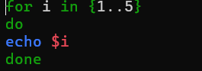

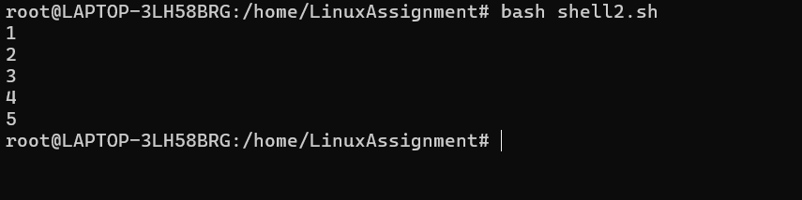

Question 7: Write a shell script that uses a while loop to print numbers from 1 to 5.

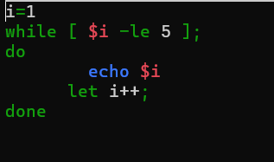

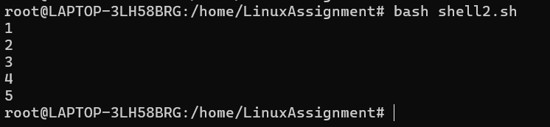

Question 8: Write a shell script that checks if a file named "file.txt" exists in the current directory. If it does, print "File exists", otherwise, print "File does not exist".

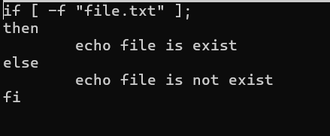



Question 9: Write a shell script that uses the if statement to check if a number is greater than 10 and prints a message accordingly.

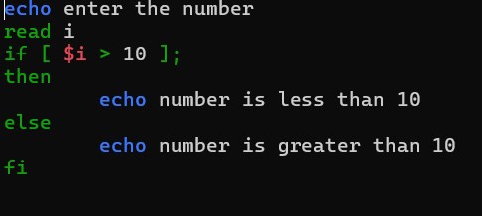

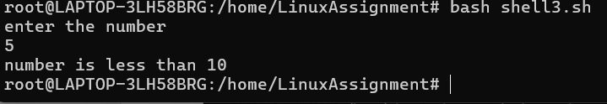

Question 10: Write a shell script that uses nested for loops to print a multiplication table for numbers from 1 to 5.

The output should be formatted nicely, with each row representing a number and each column representing the multiplication result for that number.

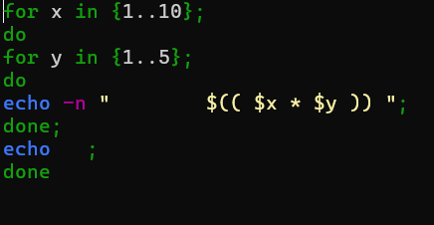

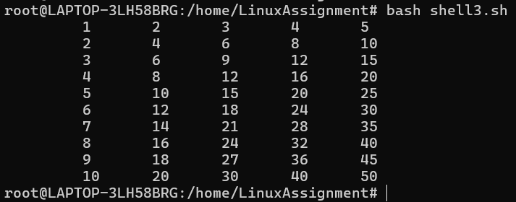

Question 11: Write a shell script that uses a while loop to read numbers from the user until the user enters a negative number. For each positive number entered, print its square. Use the break statement to exit the loop when a negative number is entered.

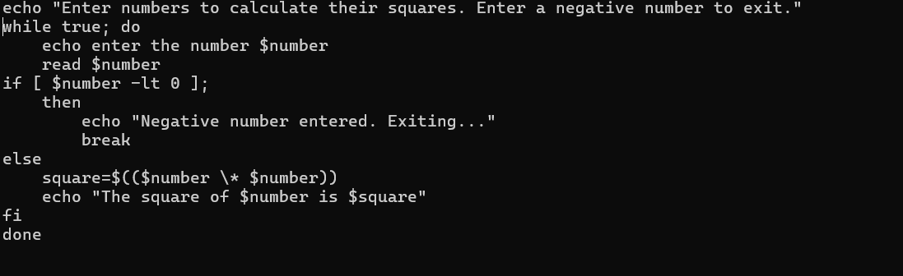

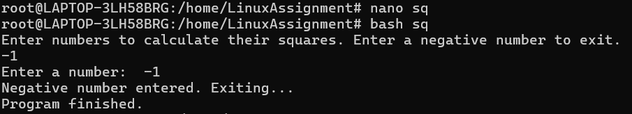

PART E

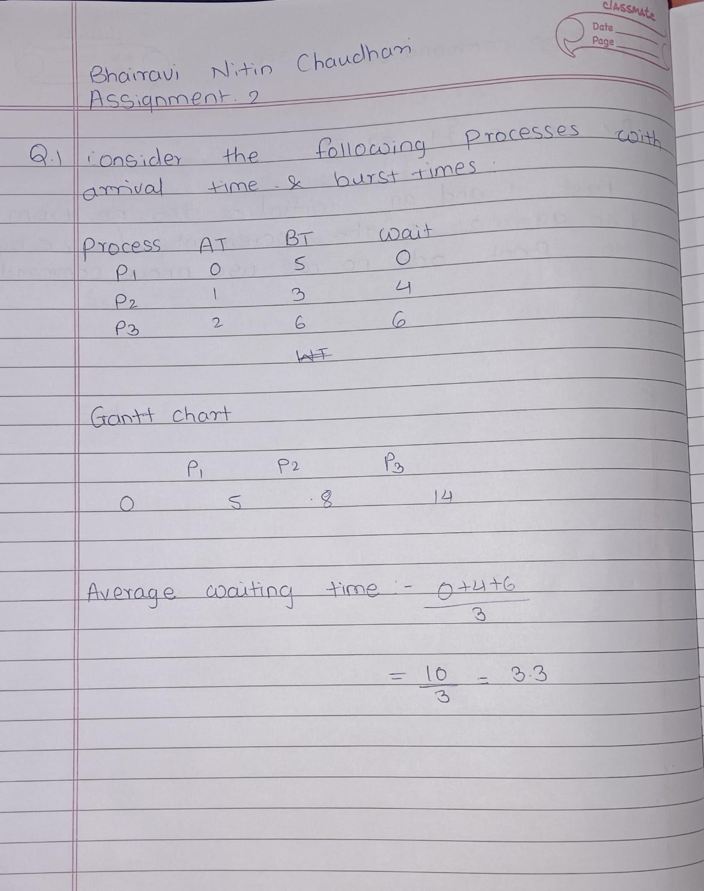

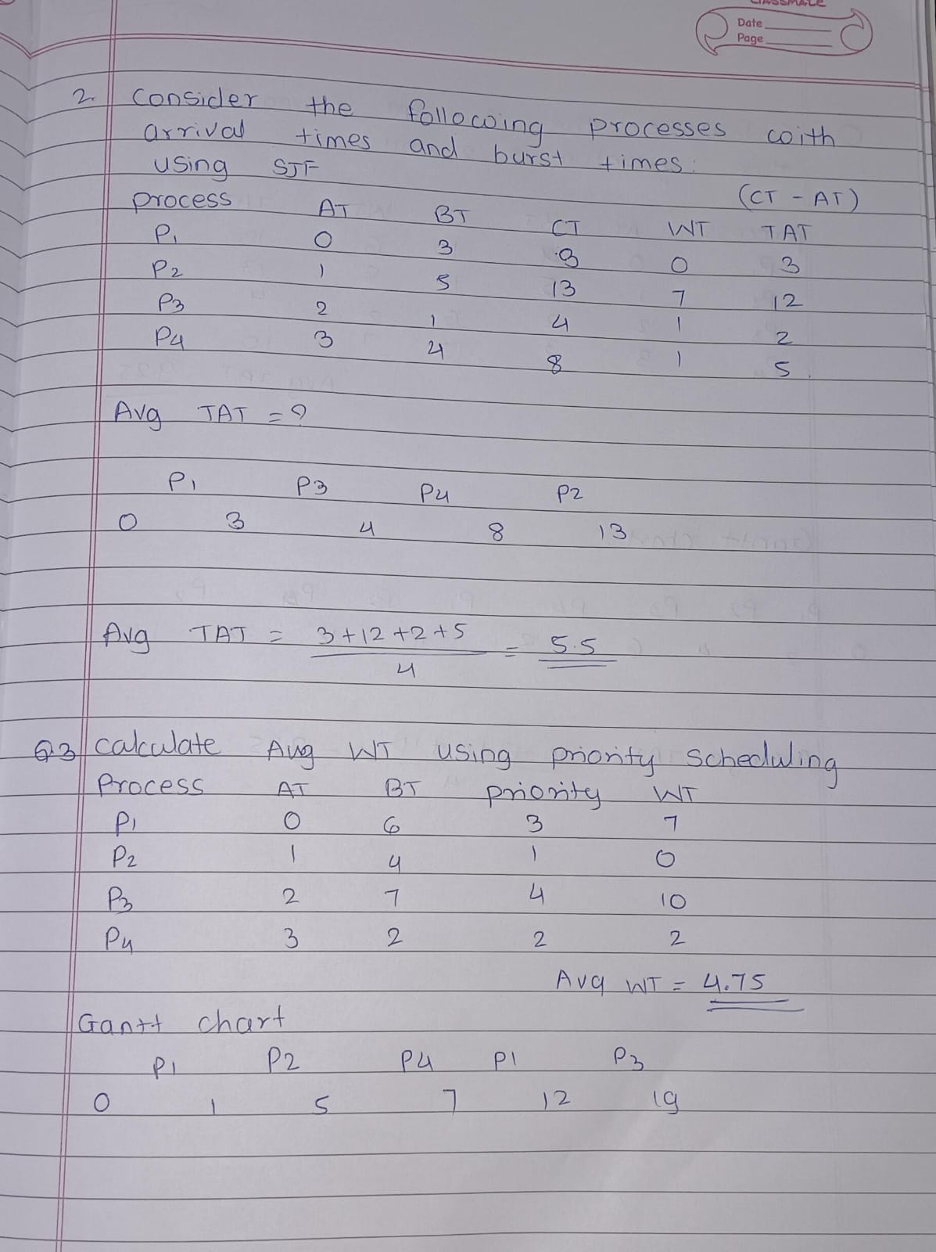

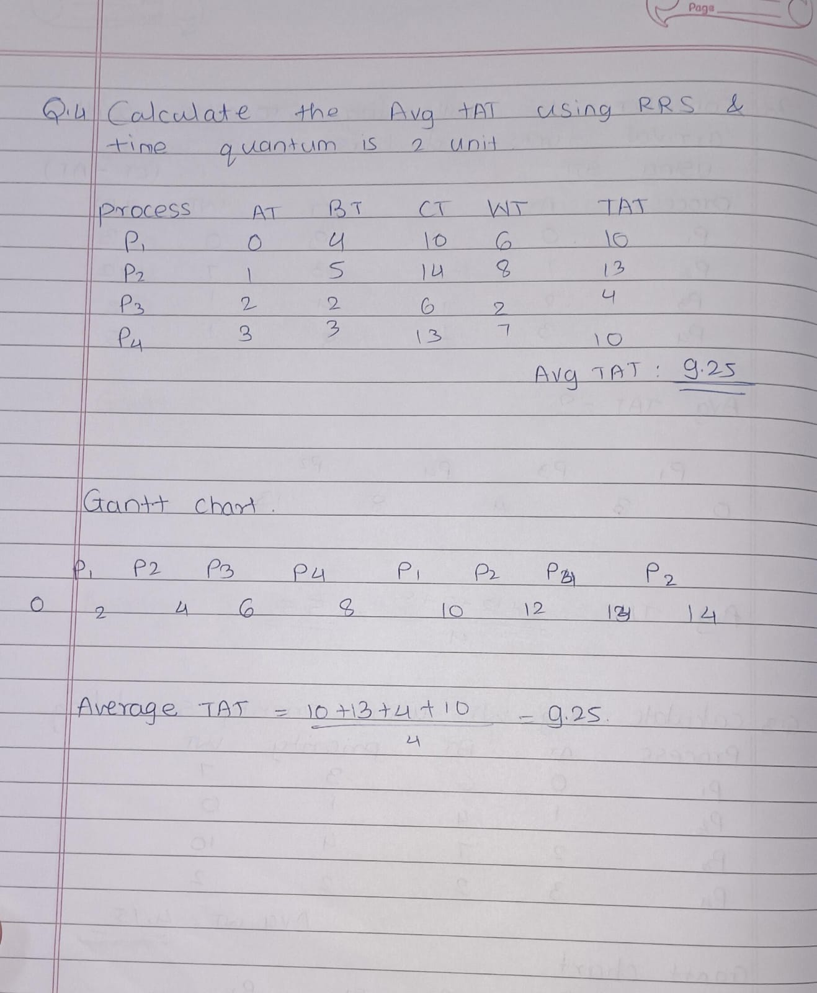

Consider a program that uses the fork() system call to create a child process. Initially, the parent process has a variable x with a value of 5. After forking, both the parent and child processes increment the value of x by 1. What will be the final values of x in the parent and child processes after the fork() call?

