# SPIDEY

# A PROJECT REPORT

***Submitted by***

**Ankit Das**

**20BEM1019**

**Bhajneet Singh Bedi**

**20BEM1050**

**Harsh Mehra**

**20BEM1077**

***In partial fulfilment for the award of the degree of***

# BACHELORS OF ENGINEERING

**in**

## MECHATRONICS ENGINEERING



**UNIVERSITY INSTITUTE OF ENGINEERING CHANDIGARH UNIVERSITY**

**GHARUAN, MOHALI, PUNJAB, INDIA-140413 MARCH 2023**



# BONA FIDE CERTIFICATE

Certified that this project report entitled **“SPIDEY”** is the bona fide work of **“ANKIT DAS,** **BHAJNEET SINGH BEDI, HARSH MEHRA”.** who carried out the work under my supervision.

## SIGNATURE SIGNATURE

Inderpreet Dr. Gurmeet Singh

## SUPERVISOR HEAD OF THE DEPARTMENT

Mechatronics Mechatronics

Submitted for the Project Viva-voce examination held on

INTERNAL EXAMINER EXTERNAL EXAMINER

# ACKNOWLEDGEMENT

It gives us proud privilege to complete this project work. This is the only page where I have the opportunity to express my emotions and gratitude from the core of my heart. It is our great pleasure in expressing sincere and deep gratitude towards my guide for his valuable and firm suggestions, guidance and constant support throughout the completion of project named “SPIDEY". I am thankful to Chandigarh University for providing me various resources and infrastructure facilities. I also offer my most sincere thanks to my team members and staff members of Mechatronics Department, University Institute of Engineering, Chandigarh University for cooperation provided by them in many ways.

# TABLE OF CONTENTS

ACKNOWLEDGEMENT i

LIST OF FIGURES v

LIST OF TABLES vi

LIST OF ABBREVIATIONS vii

LIST OF STANDARDS viii

ABSTRACT ix

CHAPTER 1

INTRODUCTION 10

* 1. Client Identification/Need Identification/Identification of relevant Contemporary issue 10
  2. Identification of Problem 10
  3. Identification of Task 11
  4. Timeline 12
  5. Preparatory functions 13
  6. Organization of the report 14

CHAPTER 2

LITERATURE REVIEW 15

2.1 Timeline of the reported problem 15

* 1. Existing solutions 18
  2. Problem Definition 19
  3. Goals and Objectives 20

CHAPTER 3

DESIGN FLOW/PROCESS 21

* 1. Evaluation & Selection of Specifications/Features 21
  2. Design Constraints 21
     1. Regulations 21
     2. Economic Constraints 22
     3. Environmental Constraints 22
     4. Health Constraints 22
     5. Manufacturability 22
     6. Safety Impact 22
     7. Political and ethical impact 22
  3. Analysis and Feature finalization subject to constraints 23
  4. Design Flow 24
  5. Design Selection 26
  6. Implementation 27
     1. Methodology 27
     2. Structural components 28
     3. Electronic module 29
     4. Software module 36
     5. Working 41
     6. Block diagram 42
     7. Flow chart 44

CAHPTER 4

RESULT AND DISCUSSION 45

* 1. Implementation of solution 45
  2. Design drawings/schematics/ solid models 46
  3. Cost analysis 48
  4. Project cost estimation 48

CHAPTER 5

CONCLUSION AND FUTURE WORK 50

REFERENCES 51

Appendix 54

1. Source code 54

# LIST OF FIGURES

Fig 3.1 Coding on IDE 28

Fig 3.2 PLA

Fig 3.3 Raspberry PI PICO 31

Fig 3.4 MG90S Servo Motor 33

Fig 3.5 Li-po Battery 35

Fig 3.6 Connecting wires 36

Fig 3.7 Solidworks Interface  38

Fig 3.8 Thonny IDE 40

Fig 3.9 Block Diagram 43

Fig 3.10 Flow chart 44

Fig 4.1 Solidworks model (Top view) 46

Fig 4.2 Solidworks model (Front view) 46

Fig 4.3 Solidworks model (Isometric view) 47

Fig 4.4 Physical Model 47

# LIST OF TABLES

Table 1 Timeline distribution table 3

Table 2 Literature Review 18

Table 3 Cost estimation table 18

# LIST OF ABBREVIATIONS

DOF - Degree of Freedom

IDE - Integrated Development Environment

IC - Integrated Circuit

PLA - Polylactic acid

# LIST OF STANDARDS

|  |  |  |  |
| --- | --- | --- | --- |
| **S.No.** | **Name of the standard** | **About the standard** | **Page number** |
| 1. | American National Standards Institute - B11.22 | This standard provides safety requirements for CNC turning centers, which could also be applicable to 2D plotter CNC machines. | 10 |
| 2. | American Society for Testing and Materials - D4673 | Standard Classification System for and Basis for Specification for Acrylonitrile-Butadiene- Styrene (ABS) Plastics and Alloys Molding and Extrusion Materials: This standard provides a classification system and basis for specification for ABS molding and extrusion materials. | 11 |
| 3. | American Society for Testing and Materials - D638 | Standard Test Method for Tensile Properties of Plastics: This standard provides a method for testing the tensile properties of ABS plastics, such as tensile strength, elongation, and modulus of elasticity. | 11 |

# ABSTRACT

Spidey is a 12 degree-of-freedom (DOF) hexapod robot, designed and developed for various applications such as exploration, surveillance, and search-and-rescue operations. The robot is equipped with high-torque MG90S servo motors for precise and smooth movements, an Arduino Nano for controlling the robot's locomotion and behavior, and Li-po batteries for power supply. The robot's body parts are 3-D printed using PLA material, which makes it lightweight and durable.

The transmitter-receiver system provides wireless communication between the robot and the operator, which allows for remote control and monitoring of the robot's movements and operations. The robot's kinematic structure is based on the hexapod locomotion principle, which provides superior stability and maneuverability on rough and uneven terrain.

The project aims to design and develop a hexapod robot that can operate in a wide range of environments and perform various tasks. The robot's design and construction are based on a rigorous engineering process, and extensive testing and validation have been performed to ensure its reliability and performance.

**Keywords: Hexapod robot, MG90S Servo Motors, Arduino Nano, Li-po Batteries, 3-D Printing PLA material, Transmitter-receiver system, Exploration, Surveillance, Search-and-rescue operations, Kinematic structure, Hexapod locomotion principle, Engineering process, Testing and validation**

**CHAPTER 1**

**INTRODUCTION**

## Client Identification/ Need Identification

One relevant contemporary issue for the Project Spidey 12 DOF Hexapod is the development and implementation of autonomous robotic systems in various industries. This issue relates to the increasing demand for automation and the use of robotics in industries such as manufacturing, healthcare, and logistics. The development of autonomous robots has the potential to revolutionize the way we work and live, but it also raises concerns about the displacement of human workers and the ethical considerations of giving decision-making power to machines.

The automation of tasks previously performed by humans has the potential to increase productivity and efficiency in industries, leading to cost savings and improved outcomes. However, this advancement also brings about apprehensions regarding the impact on employment. As autonomous robots take on more responsibilities, there is a concern that human workers may be displaced and left without job opportunities. Finding a balance between the benefits of automation and the preservation of employment opportunities for humans is a significant challenge that needs to be addressed.

Furthermore, the ethical considerations surrounding the use of autonomous robots are of great importance. Granting decision-making power to machines raises questions about accountability, responsibility, and the potential for biased or unfair outcomes. The development and implementation of appropriate ethical frameworks and regulations are crucial to ensure the responsible use of autonomous robotic systems.

Additionally, there are concerns about the safety and security of autonomous robotic systems like the Project Spidey 12 DOF Hexapod. As these systems rely on advanced technologies and connectivity, there is a risk of them being hacked or malfunctioning, leading to unintended consequences. Ensuring the robustness and reliability of the system, as well as implementing effective security measures, is vital to mitigate these risks and build trust in the technology.

Another issue that is relevant to the Project Spidey 12 DOF Hexapod is the need for more sustainable and environmentally-friendly technologies. With climate change becoming an increasingly pressing issue, there is a growing demand for technologies that reduce carbon emissions and promote sustainability. The Project Spidey 12 DOF Hexapod could be developed with these concerns in mind, using materials and components that are eco-friendly and energy-efficient. By incorporating sustainable practices into the design and manufacturing processes, the hexapod can contribute to a greener and more environmentally conscious future.

Finally, the issue of data privacy and security is also relevant to the Project Spidey 12 DOF Hexapod. As an autonomous robotic system, it will likely collect and store sensitive data, such as user preferences, operational information, and potentially even personal or confidential data. Ensuring the security and privacy of this data will be essential to building trust in the technology and ensuring its widespread adoption. Implementing robust data protection measures, including encryption and secure storage practices, is crucial to safeguarding the privacy of individuals.

## Identification of Problem

One problem that the Project Spidey 12 DOF Hexapod could face is the challenge of achieving optimal balance and stability while in motion. With twelve degrees of freedom, this hexapod has the potential to move in a variety of ways, but maintaining balance and stability during these movements could be difficult. This challenge arises from the need to coordinate and control the movement of multiple limbs simultaneously. The hexapod will require sophisticated algorithms and control systems to ensure smooth and stable locomotion in various environments and terrains. Addressing this problem will involve extensive testing, fine-tuning of control parameters, and potentially the integration of sensor systems to provide feedback for real-time adjustments.

Additionally, the design and construction of the hexapod could present challenges in terms of weight distribution, power management, and control. Achieving an optimal weight distribution is crucial to maintain stability and prevent tipping or imbalance during movement. The positioning of components and the selection of lightweight yet sturdy materials will be critical considerations in the design process. Efficient power management is also essential to ensure the hexapod's autonomy and endurance, as it will require a reliable and long-lasting power source. The control system must be capable of efficiently managing the power supply, ensuring that energy is distributed appropriately to the various components and subsystems.

Another potential problem is the cost of developing and manufacturing the hexapod. With twelve degrees of freedom and advanced capabilities, the Project Spidey 12 DOF Hexapod could require expensive components and specialized manufacturing processes, which could drive up costs. The challenge lies in finding a balance between performance, durability, and affordability. Efficient design optimization and the exploration of cost-effective alternatives for components and materials will be necessary to mitigate this problem.

Furthermore, there may be issues related to the integration of the hexapod with other technologies or systems. For example, if the hexapod is designed for use in a manufacturing or logistics setting, it will need to be compatible with existing software and hardware systems. Integration challenges may arise due to differences in communication protocols, data formats, or interfaces. Collaborating with experts from relevant industries and conducting thorough compatibility testing will be crucial to ensure seamless integration and interoperability.

Finally, there may be regulatory and ethical considerations that need to be addressed when developing and deploying an autonomous robotic system like the Project Spidey 12 DOF Hexapod. These could include issues related to safety, privacy, and the ethical use of automation technology. Ensuring the hexapod complies with safety standards and regulations will be essential to prevent accidents or harm to humans or the environment. Additionally, privacy concerns may arise if the hexapod collects or processes sensitive data, necessitating robust data protection measures. Ethical considerations surrounding the use of automation technology, such as transparency, accountability, and avoiding biased decision-making, should also be taken into account during the development and deployment stages.

## Identification of Task

To successfully implement a 12dof hexapod robot, there are several key tasks that need to be undertaken. These tasks include:

1. Assessing Needs: Before investing in a 12 DOF hexapod robot, a thorough assessment of needs is crucial. This involves evaluating the specific requirements and goals of the intended purpose. For example, in a manufacturing setting, the types of products that need to be produced, the materials used, and the production processes involved should be carefully analyzed. Understanding these needs will help determine if a hexapod is the right technology for the task at hand or if alternative solutions may be more suitable.

2. Analysing Costs: A comprehensive cost analysis is essential to determine the feasibility of investing in a 12 DOF hexapod robot. This analysis goes beyond the initial cost of purchasing the robot and includes factors such as installation, maintenance, and operational costs. It is important to consider the long-term benefits and return on investment that the hexapod can provide, such as increased productivity, improved product quality, and reduced waste. Comparing the costs and benefits will aid in making an informed decision about the viability of integrating the hexapod into the workflow.

3. Personnel Training: Operating a 12 DOF hexapod robot requires specialized knowledge and skills. Therefore, providing proper training to existing employees or hiring specialized personnel is crucial. The training should cover various aspects, including understanding the hexapod's operating principles, programming, troubleshooting common issues, and ensuring safe operation. Well-trained personnel will maximize the efficiency and performance of the hexapod, reducing the risk of errors or accidents.

4. Maintenance Plan: Establishing a maintenance plan is essential to ensure the reliable operation of the hexapod robot. Regular servicing, cleaning, and inspection should be scheduled to prevent unexpected downtime and costly repairs. The maintenance plan should include guidelines for routine maintenance tasks, such as lubrication, checking for loose connections, and replacing worn-out components. Adhering to the maintenance plan will prolong the lifespan of the robot and minimize disruptions to production.

5. Material Selection: Choosing suitable materials for use with the 12 DOF hexapod robot is vital to ensure compatibility and optimize its performance. Different materials may exhibit varying degrees of stiffness, weight, and durability, which can affect the robot's movement and stability. Conducting material testing and evaluation will help determine the best materials to use for different applications. Factors such as strength, flexibility, and resistance to wear should be considered to ensure the materials can withstand the stresses and strains imposed by the hexapod's movements.

6. Quality Control: To ensure the hexapod robot consistently produces accurate and high-quality products, implementing a robust quality control system is crucial. This involves establishing quality standards, conducting regular checks on the robot's performance and product output, and implementing corrective measures when deviations are detected. Quality control can include monitoring factors such as positioning accuracy, repeatability, and dimensional precision. By maintaining strict quality control measures, the hexapod can contribute to efficient and reliable manufacturing processes.

By addressing these key tasks, the implementation of a 12 DOF hexapod robot can be carried out effectively, ensuring that it aligns with the specific needs of the application, offers a positive return on investment, operates safely and reliably, and produces high-quality products.

## Timeline

|  |  |
| --- | --- |
| **Task To Be Done** | **Time taken** |
| Project Scope, Planning and  Task Definition | 20 Feb – 10 March |
| Literature Review | 11 March – 27 March |
| Preliminary Design | 28 March – 15 April |
| Detailed System  Design | 16 April – 26 April |
| Manufacturing And Assembly | 26 April – 15 May |
| Hardware Testing | 15 May – 20 May |

Table 1 Timeline distribution table

## Preparatory functions

* Component selection: One of the first steps in preparing for the Project Spidey 12 DOF Hexapod would be to carefully select the appropriate components for its construction. This includes considering factors such as the desired performance, compatibility, and reliability. In this case, the selected components include MG90S servo motors known for their torque and precision, Arduino Nano for controlling the motors, Li-po batteries for power supply, connecting wires for interconnections, 3-D printing PLA material for the physical structure, and a transmitter-receiver system for remote control or communication.
* Design and modeling: Once the components have been selected, the next step would involve designing and modeling the hexapod using computer-aided design (CAD) software. This process allows the team to visualize the hexapod's structure, plan the arrangement of components, and ensure that all parts fit together properly. Detailed modeling helps identify any potential issues or design improvements before proceeding to the manufacturing phase.
* 3-D printing: With the design complete, the 3-D printing process comes into play. This involves setting up and calibrating a 3-D printer and using PLA material to fabricate the various components of the hexapod. 3-D printing provides flexibility in manufacturing complex geometries and allows for customization and rapid prototyping.
* Servo motor assembly: The MG90S servo motors are a key component of the hexapod's movement. The assembly process involves carefully attaching and positioning the motors onto the 3-D printed components. This may require soldering wires to the motors and ensuring secure and reliable connections.
* Electronic wiring: Once the motors are properly assembled, the electronic wiring phase begins. This step involves connecting the servo motors to the Arduino Nano and battery, ensuring that all connections are correct and secure. Attention to detail is essential to prevent loose connections or short circuits, which could affect the hexapod's performance.
* Programming: With the hardware assembled and wired up, the hexapod requires programming to control its movements. The programming process involves writing code that runs on the Arduino Nano or a separate control board, such as the Raspberry Pi PICO. The code defines the behavior and movement patterns of the hexapod, allowing it to walk, turn, and perform other desired actions.
* Testing: Once the hexapod is assembled, wired, and programmed, it undergoes rigorous testing to ensure its functionality and performance. This testing phase involves verifying that all components are working together seamlessly, and that the hexapod can execute the desired movements accurately and reliably. Any issues identified during testing can be addressed by making adjustments to the code or hardware configuration to improve performance and overall functionality.

## Organization of the report

In this report, we provide a comprehensive explanation of the implementation process for our 12 DOF hexapod robot. To set the context, we begin by discussing previous research conducted by scientists worldwide. We highlight their approaches to the problem and present their findings, demonstrating our awareness of the existing knowledge in the field. By incorporating insights from these studies, we enrich our own project with a broader understanding of the subject matter.

Moving forward, the subsequent chapters of the report delve into the specifics of our implementation process. We meticulously outline the methodology employed throughout the project, detailing the step-by-step approach taken to design, construct, and program the hexapod robot. By presenting the actual working design, we provide a clear picture of how the various components and technologies come together to create a functional robot.

Furthermore, we present the findings that emerged from our project. These findings may include observations, measurements, and data collected during the implementation and testing phases. We evaluate and analyze the results to ascertain the effectiveness and efficiency of our hexapod robot, comparing it to the desired objectives set at the beginning of the project.

To validate our project, we subject it to rigorous testing and validation processes. This ensures that the robot performs as intended and meets the defined criteria for success. We discuss the outcomes of the validation process, highlighting any challenges encountered and the solutions implemented to overcome them. This serves to establish the credibility and reliability of our project.

In the final sections of the report, we draw conclusions based on our findings and project outcomes. We summarize the key points, highlighting the achievements, limitations, and potential areas for improvement. Additionally, we explore the future prospects and potential applications of our hexapod robot, discussing how this idea could be further developed or adapted for different purposes or industries.

Overall, this report provides a detailed account of our 12 DOF hexapod robot implementation. It combines our original ideas with the knowledge gained from previous research, offering a comprehensive understanding of the project's methodology, design, findings, validation, conclusions, and future possibilities

# CHAPTER 2 LITERATURE REVIEW

## 2.1 Timeline of the reported problem

The aim of the Spidey hexapod robot project is to create a flexible and nimble robotic platform capable of operating effectively in diverse settings, such as disaster response and relief missions. In order to gain valuable insights for our project, we conducted an extensive literature review encompassing prior studies and research endeavors that focused on hexapod robots. The review specifically delved into their applications, as well as the technologies employed in their development.

* + 1. Hexapod robots have been extensively studied, and researchers have primarily concentrated on their mobility, stability, and control mechanisms. For instance, Li et al. (2018) conducted a study in which they designed a hexapod robot tailored for exploration in extreme terrains, such as deserts and mountains. The robot was meticulously engineered to be lightweight, incorporating high-torque motors and a flexible body structure capable of adapting to uneven surfaces.
    2. Another notable study conducted by Zhang et al. (2019) involved the development of a hexapod robot intended for indoor navigation and obstacle avoidance. This particular robot was equipped with sensors and cameras that provided real-time feedback, while employing a combination of neural networks and genetic algorithms for effective navigation and control.
    3. The application of hexapod robots spans various fields, including agriculture, surveillance, and search-and-rescue missions. For instance, Qamar et al. (2020) undertook a study where they designed a hexapod robot specifically for crop monitoring and management. This robot was equipped with sensors to gather data on crop health and growth, aiding in precision agriculture.
    4. In terms of the technologies employed in hexapod robot development, servo motors and microcontrollers, such as Arduino, have emerged as widely adopted components. Wang et al. (2017) conducted a study where they designed a hexapod robot utilizing an Arduino-based control system, while employing 3D printing techniques to fabricate the robot's body structure.

Overall, this literature review underscores the immense potential of hexapod robots in various applications, including their utilization in disaster response and relief efforts. The Spidey hexapod robot project seeks to contribute to this field by developing a highly versatile and agile robotic platform. By assimilating insights from previous studies, our project endeavors to leverage the advancements in hexapod robot research, culminating in the creation of a cutting-edge platform capable of effectively addressing the challenges encountered in disaster response and relief operations.

|  |  |  |
| --- | --- | --- |
| **S.NO.** | **AUTHORS NAME** | **CONCLUSION** |
| 1 | By Martin Buehler, Uluc Saranli, and Daniel E. Koditschek (2001) | RHex is a reliable and robust hexapod robot with only six actuators. It achieves stable locomotion using a clock-driven, open-loop tripod gait. The robot exhibits significant intrinsic mobility on rugged terrain without controlled adaptation. |
| 2 | Jiying Wang, Alberto Rovetta, Xilun Ding, and J.M. Zhu (2010) | This chapter presents a detailed study of hexagonal hexapod gaits, including normal and fault-tolerant ones, and compares rectangular and hexagonal six-legged robots in terms of stability, fault tolerance, terrain adaptability, and walking ability. A new mixed gait for hexagonal six-legged robots is proposed, and fault-tolerant gaits for when two adjacent or separated legs are damaged are detailed and validated with simulations. |
| 3 | Giuseppe Carbone and Franco Tedeschi (2014) | This paper provides an overview of six-leg walking robots, discussing design issues and constraints that affect their performance. A design procedure is outlined that systematically considers factors such as mechanical structure, leg configuration, actuating mechanisms, payload, and gait, providing a useful tool for designing these robots. A case study is presented to illustrate the effectiveness and feasibility of the procedure |
| 4 | R.D. Quinn, G.M. Nelson, R.J. Bachmann, W.C. Flannigan (1997) | This paper presents the design and simulation of a hexapod robot that uses pneumatic actuators and is based on the Blaberus cockroach's capabilities. The robot has five, four and three degrees of freedom in the front, middle and back legs, respectively, to mimic the functions of cockroach legs. A dynamic simulation is developed as a design tool, and preliminary results suggest the robot can move quickly and climb over rough terrain. |
| 5 | Fernando Ribeiro, Bruno Dias, Joana Coelho, Gil Lopes and Paulo Flores (2021) | Most hexapod research aims to design robots that can navigate complex environments, but few studies mention a specific application. Traditional controllers are still prevalent, but model-free controllers are gaining popularity. Most bio-inspired systems have only been tested on indoor terrain, while RL-based systems are limited to regular grounds. There is potential for combining bio-inspired architectures with self-learning algorithms to improve adaptability. |
| 6 | P. Gonzalez de Santos, R. Ponticelli, M. Armada and E. Garcia (2008) | This paper discusses energy optimization for autonomous robots, specifically six-legged robots using alternating-tripod gaits. A method to minimize energy consumption for one tripod is derived, and minimizing consecutive tripods reduces energy consumption throughout the entire trajectory. The method works on irregular terrain and requires terrain knowledge. Energy expenditure was computed using the SILO-6 walking robot, designed for demining missions. Energy loss from electronics is also addressed. Ongoing research focuses on real-time application of the method. |
| 7 | Ricardo Campos, Cristina Santos, Vitor Matos (2010) | This paper presents a bio-inspired controller for hexapod robots to generate locomotion and switch between different gaits. Motor patterns are generated by nonlinear oscillators modulated by a drive signal, allowing for initiation, stopping, and smooth gait switching. A posture controller is also demonstrated using the dynamical systems approach. Simulation results show the controller's capability for locomotion generation and gait transition, as well as maintaining balance. |
| 8 | He Zhang, Jie Zhao, Jihong Yan, Yubin Liu, and Jie Chen (2014) | This work develops a hexapod robot with integrated sensors and foot-force compensation to improve stability on unstructured terrain. The PCFDC controller effectively reduces trunk vibration and enhances stability, with promising simulation and experimental results. Future research will focus on improving PCFDC implementation over highly unstructured terrain and using stereo vision for selecting safe footholds. |
| 9 | E. Z. Moore, F. Grimminger, D. Campbell, and M. Buehler (2002) | RHex, a robot with a simple design and one actuator per leg, can climb human-sized stairs using pre-programmed leg trajectories. Future research will focus on improving its performance on circular stairs and developing task level feedback algorithms to enhance reliability and reduce energy consumption. The stair-descending algorithm will also be enhanced. |
| 10 | Z.-Y. Wang, A. Rovetta and X.-L. Ding (2010) | This paper presents a detailed study of hexagonal hexapod gaits, including normal and fault-tolerant ones, and compares them with rectangular hexapods. The results contribute to the development of intelligent locomotion for six-legged robots, with potential applications in off-road terrain and planetary exploration. Future work should focus on studying the energy cost of different gaits, dynamic gaits, and intelligent walking. |

**Table 2 Literature Review**

## Existing solution

While hexapod robots offer significant potential for various applications, there are some challenges that researchers and developers face when designing and implementing these robots. Some of the existing solutions to these problems are discussed below:

1. Mobility: Achieving optimal mobility is crucial for hexapod robots to navigate uneven terrains and surmount obstacles. The inherent design of hexapod robots with six legs offers inherent advantages in terms of stability and maneuverability. However, challenges arise when it comes to adapting to different environments and terrains. To address this challenge, researchers have focused on developing lightweight and flexible body structures for hexapod robots. These structures allow the robot to conform to the terrain, providing enhanced stability and adaptability. Additionally, high-torque motors with precise control algorithms have been utilized to improve the robot's locomotion capabilities. These advancements enable hexapod robots to move with agility and efficiency even on challenging surfaces, making them suitable for applications in disaster response and relief efforts.
2. Control: Hexapod robots require precise and responsive control to ensure safe and efficient operation. To tackle this challenge, researchers have explored various control methods and algorithms. Neural networks and genetic algorithms have been employed to optimize the robot's decision-making processes and navigation capabilities. These techniques enable the robot to learn and adapt to its surroundings, enhancing its autonomy and versatility. Additionally, feedback control systems play a crucial role in stabilizing the robot's movements and maintaining balance during locomotion. Remote control systems have also been developed, allowing operators to have easy and precise control over the hexapod robot's movements. These control advancements contribute to the robot's ability to perform complex tasks and maneuver through challenging environments.
3. Power: Hexapod robots require a reliable and long-lasting power source to operate in remote or disaster-stricken areas. Addressing this challenge involves developing energy-efficient solutions. Researchers have focused on designing motors that consume less power while delivering sufficient torque for the robot's movements. Additionally, lightweight and high-capacity batteries have been developed to provide extended operational durations. In some cases, researchers have explored solar-powered systems to harness renewable energy and enable sustained operation in outdoor environments. By developing efficient power solutions, hexapod robots can operate for longer durations without interruptions, making them well-suited for applications in disaster response and relief efforts.
4. Manufacturing: The complex and intricate design of hexapod robots can make manufacturing challenging and time-consuming. Researchers have sought to address this challenge through the utilization of advanced manufacturing technologies. 3D printing and other rapid prototyping methods have been employed to simplify and accelerate the manufacturing process. These technologies allow for the creation of complex geometries and intricate structures with reduced production time and cost. By streamlining the manufacturing process, researchers can bring hexapod robots closer to practical implementation in various environments.
5. By addressing these challenges, researchers and developers contribute to the advancement of hexapod robot technology, creating more advanced and functional robots that can be deployed in diverse environments and applications. The Spidey hexapod robot project aligns with these objectives, aiming to provide a highly functional and versatile robotic platform specifically designed to overcome these challenges. The project aims to contribute to the field of disaster response and relief efforts by providing a practical solution that exhibits enhanced mobility, precise control, reliable power management, and streamlined manufacturing processes.

## Problem Definition

The Spidey hexapod robot project was undertaken to address the existing limitations and challenges associated with available hexapod robots in the market. These limitations include high costs, limited capabilities, and lack of accessibility for researchers, hobbyists, and educators.

One of the primary goals of the Spidey hexapod robot project was to create a versatile and highly maneuverable robot platform that could be used for various applications. The team recognized the need for a robot that could navigate challenging terrains, overcome obstacles, and perform complex movements with precision.

To achieve these goals, the Spidey hexapod robot was designed to be affordable, making it more accessible to a wider range of individuals and organizations. By offering a cost-effective solution, the project aimed to lower the barriers to entry for those interested in developing and testing new robotics technologies. This affordability enables researchers, hobbyists, and educators to explore and experiment with hexapod robotics without significant financial constraints.

In addition to affordability, the Spidey hexapod robot was also designed to provide advanced features and capabilities. The team focused on incorporating high-torque motors, flexible body structures, and advanced control algorithms to enhance the robot's mobility, stability, and overall performance. By utilizing these technologies, the Spidey hexapod robot can effectively navigate uneven terrains and overcome obstacles with ease.

Furthermore, the project emphasized the importance of ease of construction and accessibility. The Spidey hexapod robot was designed to be easy to build, allowing individuals with varying levels of technical expertise to assemble and customize the robot according to their specific needs. The project provided detailed documentation, tutorials, and support to ensure a smooth and hassle-free building process.

## Goals and Objectives

**Goals:**

* **To design and develop a versatile and highly maneuverable hexapod robot platform:**

The primary objective of the Spidey hexapod robot project was to create a platform that offers exceptional maneuverability and versatility. This involved extensive research and development to design a robot that could effectively navigate different types of terrain, traverse uneven surfaces, and overcome obstacles. The team focused on optimizing the robot's mobility by incorporating lightweight and flexible body structures that could adapt to various environments. By achieving high degrees of mobility, the Spidey hexapod robot offers enhanced capabilities for applications in fields such as disaster response, exploration, and industrial settings.

* **To create a robot that is affordable and easy to build, yet provides advanced features and capabilities:**

A key aspect of the Spidey hexapod robot project was to address the cost and accessibility challenges associated with existing hexapod robots. The team aimed to provide a solution that is not only affordable but also user-friendly, allowing individuals with varying levels of technical expertise to construct their own robot. By designing the robot with off-the-shelf components and utilizing 3D printing technology, the project significantly reduced manufacturing costs. The documentation and tutorials provided by the project further simplified the building process, enabling users to assemble their own Spidey hexapod robot without the need for extensive technical knowledge.

* **To provide a platform that can be used for a wide range of applications:**

The versatility of the Spidey hexapod robot was a key focus of the project. The team aimed to create a platform that could be utilized in various applications, including research and development, education, and hobbyist projects. The robot's advanced features and capabilities, combined with its affordability and ease of use, make it an attractive choice for individuals and organizations seeking a flexible and adaptable robot platform. Whether it be for exploring new robotics technologies, conducting experiments, or learning about robotics principles, the Spidey hexapod robot offers a versatile tool that can be tailored to meet different needs.

* **To demonstrate the capabilities of the Spidey hexapod robot through various test scenarios:**

The Spidey hexapod robot project involved rigorous testing to evaluate and showcase its capabilities. The team conducted a series of test scenarios to assess the robot's mobility, stability, and control. These tests involved navigating different types of terrains, climbing over obstacles, and performing complex movements. By demonstrating the robot's performance and versatility through these scenarios, the project aimed to highlight its potential for real-world applications. The test results and observations provided valuable insights for further improvements and refinement of the Spidey hexapod robot's design and functionality.

Through the pursuit of these objectives, the Spidey hexapod robot project aimed to contribute to the field of robotics by providing an affordable, versatile, and accessible platform. By expanding the possibilities for research, education, and innovation, the project aimed to empower individuals and organizations to explore the potential of hexapod robots in various domains.

**Objectives:**

* **To design a 12 degrees of freedom (DOF) hexapod robot that is stable and highly maneuverable:**

The goal of designing a 12 DOF hexapod robot is to provide a robot with a greater range of motion and flexibility. This allows the robot to perform complex movements, navigate challenging terrains, and adapt to different environments. By increasing the number of degrees of freedom, the robot can achieve improved stability, balance, and overall maneuverability. The design process involves carefully selecting the mechanical structure, joint configurations, and control mechanisms to ensure that the robot can effectively execute a wide range of motions.

* **To use high-quality components, including MG90S servo motors, Raspberry pi PICO, Li-po batteries, and 3D printing PLA material, to ensure that the robot is reliable and durable:**

Using high-quality components is essential to ensure the reliability and durability of the hexapod robot. The selection of components such as MG90S servo motors, Raspberry pi PICO microcontroller, Li-po batteries, and 3D printing PLA material contributes to the overall performance and longevity of the robot. High-quality servo motors provide precise control and sufficient torque for smooth and accurate movements. The Raspberry pi PICO microcontroller offers advanced processing power and programming capabilities for controlling the robot's operations. Reliable Li-po batteries provide a stable power source for extended operation. The use of durable 3D printing PLA material ensures the structural integrity and longevity of the robot's body and parts.

* **To develop a transmitter-receiver system to allow remote control of the robot:**

Implementing a transmitter-receiver system enables remote control of the hexapod robot, providing greater flexibility and convenience in operating the robot. This allows the user to control the robot's movements, perform tasks, and interact with its surroundings from a distance. The development of a reliable and responsive transmitter-receiver system ensures efficient communication between the user and the robot, enabling real-time control and feedback.

* **To program the robot using the Raspberry pi programming language to enable advanced features such as obstacle avoidance, object tracking, and motion planning:**

Programming the hexapod robot using the Raspberry pi programming language unlocks a wide range of advanced features and functionalities. By utilizing the capabilities of the Raspberry pi, developers can implement algorithms for obstacle avoidance, object tracking, and motion planning. These features enable the robot to autonomously navigate its environment, detect and avoid obstacles, track objects of interest, and plan efficient trajectories for accomplishing tasks. The programming aspect plays a crucial role in unleashing the full potential of the hexapod robot, making it more intelligent and adaptable to different scenarios.

* **To conduct testing to evaluate the performance of the robot and its ability to perform various tasks and maneuvers:**

Thorough testing is a crucial step in the development of the hexapod robot to ensure its performance and functionality. Testing involves assessing the robot's ability to perform various tasks, maneuvers, and functionalities under different conditions and environments. This includes evaluating its stability, accuracy of movements, response to commands, obstacle avoidance capabilities, payload capacity, and energy efficiency. Testing helps identify any shortcomings or areas for improvement in the robot's design, control algorithms, and overall performance, ensuring that it meets the desired objectives and requirements.

By focusing on these objectives and elaborating on each aspect, the development of the 12 DOF hexapod robot can be approached systematically, leading to a stable, highly maneuverable, and efficient robotic platform.

# CHAPTER 3 DESIGN FLOW/PROCESS

## Evaluation & Selection of Specifications/Feature

To ensure the success of your hexapod project, it is essential to evaluate and select the appropriate specifications and features that meet your requirements. Here's an expansion and elaboration on each factor to consider:

* Mechanical design: The mechanical design of your hexapod plays a crucial role in its overall stability and performance. It should be sturdy and robust, capable of withstanding the stresses and strains encountered during locomotion. Good weight distribution and balance are essential to ensure smooth movement and prevent tipping or instability.
* Actuators: Selecting the right actuators is vital for the hexapod's leg movements. High-torque servo motors, such as MG90S, are commonly used in hexapod robots due to their ability to provide smooth and precise movement to each leg. These servo motors offer sufficient torque to support the weight of the robot and enable controlled leg articulation.
* Power supply: The power supply system of your hexapod should be reliable and capable of providing sufficient voltage and current to drive all the servo motors. Li-po batteries are a popular choice for portable applications due to their high energy density and lightweight nature. They can deliver the necessary power to the hexapod while maintaining a reasonable weight-to-power ratio.
* Control system: The control system is responsible for coordinating the movements of the hexapod’s legs. It should be easy to program and provide precise control over the robot's motion. The Raspberry pi PICO is a versatile microcontroller that can serve as the brain of the hexapod, offering advanced processing capabilities and programmability. With the Raspberry pi PICO, you can implement control algorithms to coordinate leg movements and enable various functionalities.
* Communication system: A reliable and fast communication system is essential to interact with the hexapod wirelessly. This allows you to send commands and receive feedback from the robot without the need for physical connections. Depending on your requirements, you can choose a suitable communication protocol such as Wi-Fi or Bluetooth to establish a seamless and robust wireless connection.
* Material: The choice of material for designing the hexapod’s parts is crucial. 3D printing PLA (Polylactic Acid) material is commonly used due to its lightweight and easy-to-print nature. It provides good structural integrity while keeping the weight of the robot relatively low. Additionally, PLA is affordable and readily available, making it a practical choice for prototyping and building the hexapod’s components.

By carefully evaluating and selecting the appropriate specifications and features for your hexapod, you can ensure that it meets your desired objectives and performs optimally. Each factor contributes to the overall functionality, reliability, and performance of the hexapod, enabling you to create a successful and capable robotic platform.

## Design Constraints

Design constraints play a critical role in shaping a project and influencing the decision-making process. Let's elaborate on the various design constraints and how they apply to the hexabot project:

* Regulatory requirements: The project must adhere to any applicable regulations or standards set by regulatory bodies. These may include safety regulations, electromagnetic compatibility standards, and certifications required for deployment in certain environments. Compliance with these regulations ensures that the hexabot operates safely and legally.
* Economic considerations: Design constraints related to economics involve factors such as budget limitations, cost-effectiveness, and return on investment. The project needs to be developed within a specified budget, taking into account the costs of materials, components, manufacturing processes, and any additional expenses. Finding a balance between cost and functionality is crucial to ensure the project's viability and affordability.
* Environmental concerns: Environmental constraints focus on minimizing the project's impact on the environment. This includes considerations such as energy efficiency, use of sustainable materials, and waste reduction. The hexabot should be designed with energy-efficient components and systems to optimize power consumption. Additionally, the choice of materials should take into account their environmental impact and recyclability.
* Health and safety issues: Design constraints related to health and safety require careful consideration to protect users and mitigate potential risks. The hexabot should be designed with proper safety features to prevent accidents and injuries. This may involve incorporating sensors and algorithms for obstacle detection and collision avoidance, implementing fail-safe mechanisms, and ensuring user-friendly operation.
* Manufacturability: Design constraints associated with manufacturability involve considerations of the ease and efficiency of production. The hexabot's design should be optimized for manufacturing processes, such as 3D printing or injection molding, to minimize production time and costs. Design choices should also take into account the availability and compatibility of manufacturing techniques and equipment.

By addressing and navigating these design constraints effectively, the hexabot project can be developed in a manner that meets legal and regulatory requirements, economic feasibility, environmental sustainability, user safety, manufacturing efficiency, and ethical considerations. Balancing these constraints ensures the project's success and acceptance in various contexts, contributing to its long-term viability and positive impact.

## Regulations

Compliance with regulations and standards is a critical aspect of any project, ensuring the safety, functionality, and marketability of the product. In the case of the hexabot project, it is essential to adhere to relevant regulations and standards, such as safety, electromagnetic compatibility (EMC), and radio frequency (RF) regulations. Here is an elaboration and expansion on this aspect:

* Safety regulations: Safety regulations are designed to protect users, operators, and bystanders from potential harm or hazards associated with the hexabot. These regulations may include guidelines for electrical safety, mechanical safety, and operational safety. Adhering to safety regulations ensures that the hexabot is designed and built with proper safeguards and precautions to prevent accidents and injuries.
* Electromagnetic Compatibility (EMC) regulations: EMC regulations aim to limit electromagnetic interference (EMI) generated by electronic devices and ensure that they can operate without causing disruption to other devices or systems. Compliance with EMC regulations is particularly crucial for wireless communication systems used in the hexabot, such as the transmitter-receiver system. It involves testing and designing the system to minimize electromagnetic emissions and susceptibility to external interference.
* Radio Frequency (RF) regulations: RF regulations govern the use of radio frequency spectrum and wireless communication devices. These regulations include guidelines for frequency allocation, transmission power limits, and licensing requirements. Compliance with RF regulations is important for the hexabot's transmitter-receiver system, as it ensures legal and authorized use of wireless communication frequencies.

To ensure compliance with regulations and obtain certifications, the hexabot project may involve several steps, including:

- Researching and understanding the applicable regulations and standards related to safety, EMC, and RF.

- Incorporating design features and components that meet the required specifications and guidelines.

- Conducting thorough testing and assessment to verify compliance with the regulations.

- Documenting the compliance process and preparing the necessary documentation for certification.

- Engaging with regulatory bodies or certification agencies to obtain the required certifications.

## Analysis and Feature finalization subject to constraints

**Analysis:**

* Mechanical Constraints:

1. Stability and Maneuverability: The mechanical design of the hexabot must prioritize stability and maneuverability. This involves careful consideration of factors such as weight distribution, center of gravity, and leg design. By optimizing these aspects, the hexabot can maintain balance and stability during various locomotion tasks, including walking, climbing, and turning. Additionally, the design should allow for smooth and precise movements to ensure effective maneuverability in different environments.
2. Weight and Size Constraints: To enhance portability and versatility, the hexabot's mechanical design must minimize weight and size constraints. This involves utilizing lightweight materials without compromising structural integrity. Additionally, compact design elements, such as folding or telescopic legs, can help reduce the overall size of the hexabot, making it easier to transport and deploy in various scenarios.

* Electrical Constraints:

1. Power and Control: The electrical system of the hexabot must be designed to provide sufficient power to drive the servo motors and other components. This requires selecting appropriate power sources, such as Li-po batteries, capable of delivering the required voltage and current for efficient operation. Moreover, the electrical system should incorporate control mechanisms, such as motor drivers and microcontrollers, to ensure precise and reliable control over the robot's movements.
2. Safety and Reliability: Electrical constraints also include ensuring the safety and reliability of the hexabot's electrical system. This involves implementing proper insulation, circuit protection mechanisms, and grounding techniques to prevent electrical hazards and minimize the risk of malfunctions or failures. Adhering to electrical safety standards and best practices is essential to mitigate potential risks and ensure the longevity of the hexabot.

* Software Constraints:

1. Efficient Operation: The software controlling the hexabot should be designed to enable efficient and optimized operation. This involves developing algorithms and control strategies that allow the robot to perform tasks with minimal energy consumption and maximum efficiency. Efficient software design can improve the hexabot's overall performance, including its speed, accuracy, and response time.
2. Safety and Reliability: Similar to the electrical system, the software controlling the hexabot must prioritize safety and reliability. This entails implementing error handling mechanisms, incorporating safety checks and constraints, and conducting thorough testing and validation to ensure that the software operates as intended and minimizes the risk of malfunctions or unintended behaviors.

**Feature Finalization:**

* Actuators: The selection of MG90S Servo Motors as the actuators for the hexabot is based on several factors. Firstly, their cost-effectiveness makes them a suitable choice, especially for projects with budget constraints. Additionally, these motors offer sufficient power and torque to drive the robot's legs, allowing for smooth and precise movements. The reliability of MG90S motors ensures consistent performance and durability, essential for prolonged operation and various applications.
* Microcontroller: The Raspberry Pi PICO is a versatile and cost-effective microcontroller chosen for its compatibility with the selected MG90S motors. The PICO's GPIO pins can be easily programmed to control the servo motors, enabling seamless integration and precise control over the hexabot's movements. Its compact size and low power consumption make it ideal for embedded applications, providing ample computational power to support advanced features and algorithms.
* Power Supply: The decision to use Li-po batteries as the power supply for the hexabot offers several advantages. Li-po batteries are known for their high power density, allowing for extended operation without frequent recharging. Their low weight contributes to the overall agility and maneuverability of the robot. Moreover, Li-po batteries can provide the necessary voltage and current required to drive the MG90S motors efficiently.
* Structural Material: PLA (Polylactic Acid) 3D printing material is selected for the robot's body due to its favorable properties. PLA is lightweight, which helps minimize the overall weight of the hexabot, allowing for better mobility and energy efficiency. Its durability ensures that the robot can withstand mechanical stress and impacts during operation. Additionally, PLA is widely available and easy to print, making it a practical choice for rapid prototyping and customization.
* Communication: The hexabot will utilize a transmitter-receiver system for communication, ensuring reliable and fast data exchange between the robot and the user. This communication system allows for remote control and monitoring of the hexabot's movements and functionalities. By implementing a reliable communication system, the hexabot can receive commands and transmit important data, enabling seamless interaction and operation.
* Control System: The hexabot will employ a tripod gait, a common walking pattern for hexapod robots. This gait involves three legs moving simultaneously while the other three remain stationary, providing stability and balance. The control system will utilize a clock-driven, open-loop mechanism, where predefined sequences of servo motor movements are executed based on timing. This control approach simplifies the software design and ensures precise coordination between the legs, facilitating stable and efficient locomotion.
* Safety Features: To ensure the safety of users and bystanders, the hexabot will be equipped with emergency stop buttons and fail-safe mechanisms. The emergency stop buttons allow for immediate termination of robot movements in case of any unexpected behavior or hazardous situations. Fail-safe mechanisms, such as position sensors or limit switches, can detect abnormal conditions and trigger automatic shutdown or corrective actions, preventing accidents and mitigating potential risks.

These finalizations have been made while keeping the various constraints in mind, such as economic, environmental, health, safety, and political impacts, as well as manufacturability and ethical considerations. After finalizing the features subject to constraints, the design process continued, and a prototype was developed. The prototype was tested, and modifications were made to ensure that all features and constraints were met. The final design met all regulatory, economic, environmental, health, manufacturability, safety, political, and ethical constraints while achieving the desired functionality.

## Design Flow

Designing a 12-DOF hexapod robot requires a systematic approach that involves various stages. The design flow starts with defining the project goals and objectives, followed by selecting the hardware and software components. Once the hardware and software components are selected, the mechanical and electrical design is carried out. This is followed by the prototyping and testing of the robot, after which the final design is implemented. The following is a detailed design flow for a 12-DOF hexapod robot.

* Define Project Goals and Objectives:

Defining clear and specific project goals and objectives is crucial to guide the design process effectively. These goals and objectives should be well-defined, measurable, and aligned with the intended purpose of the hexapod robot. For example, the project goal may be to design a 12-DOF hexapod robot capable of traversing rough terrains, while the objectives could include achieving a certain speed, ensuring stability during locomotion, and implementing obstacle detection and avoidance capabilities.

* Select Hardware and Software Components:

Careful selection of hardware and software components is essential to ensure the hexapod robot meets its performance requirements. This involves choosing servo motors with the appropriate torque and speed characteristics to facilitate smooth leg movements. The microcontroller, such as the Raspberry Pi PICO, should be capable of handling the computational demands of the control system and interfacing with other components. Additionally, sensors, batteries, communication devices, and other necessary components should be chosen based on their compatibility and suitability for the project objectives.

* Mechanical Design:

The mechanical design of the hexapod robot focuses on creating a sturdy, stable, and maneuverable structure. This includes designing the leg mechanism, body, chassis, and any additional components needed to support the robot's weight. Factors such as weight distribution, balance, and ground clearance need to be considered to ensure optimal performance. The mechanical design should also address manufacturability, allowing for efficient fabrication and assembly processes.

* Electrical Design:

The electrical design encompasses the power and control systems of the hexapod robot. This involves designing the wiring layout, PCB (Printed Circuit Board), and power distribution system. The electrical design should consider the power requirements of the chosen components and ensure safe and efficient power delivery. Proper grounding, insulation, and protection mechanisms should be implemented to mitigate risks associated with electrical hazards.

* Prototyping and Testing:

Prototyping and testing are crucial stages to validate the design and identify any potential issues or improvements. Building a prototype allows for real-world evaluation of the mechanical, electrical, and control systems. Rigorous testing should be conducted to assess the robot's performance, stability, maneuverability, and adherence to the project objectives. Iterative refinement based on the test results helps optimize the design and address any identified limitations or weaknesses.

* Final Design:

Based on the insights gained from prototyping and testing, the final design can be refined and implemented. This involves incorporating any necessary design modifications or improvements to meet the project goals and objectives. The final design should consider factors such as manufacturability, cost-effectiveness, safety, and regulatory compliance. Comprehensive documentation of the final design, including detailed specifications and drawings, ensures proper replication and future reference.

* Manufacturing and Assembly:

Once the final design is established, the manufacturing and assembly phase begins. This involves fabricating the mechanical components according to the design specifications and assembling the electrical components based on the electrical design. Quality control measures should be implemented during manufacturing to ensure consistency and reliability. The assembly process should be documented to facilitate efficient replication and troubleshooting.

## Design Selection

Design selection is a critical step in any engineering project. It involves evaluating various design options based on their feasibility, performance, cost, and other factors. In the case of the hexapod robot 12dof project, the design selection process is crucial to ensure the robot meets the desired performance objectives while also being practical to build and operate. As per the evaluation of different design options and subject to the identified constraints, the following design has been selected for the 12DOF hexapod robot project:

1. Mechanical Design:

The mechanical design of the hexapod robot focuses on achieving stability, maneuverability, and biomimicry. The hexapod structure with six legs provides a stable platform for locomotion. Each leg comprises two degrees of freedom, allowing for a wide range of movements and adaptability to different terrains. The choice of MG90S servo motors as actuators ensures precise and reliable leg movements, enabling the robot to walk, turn, and perform various maneuvers.

The 3D printing process using PLA material offers several advantages for the mechanical design. PLA is lightweight, durable, and easily moldable, making it suitable for creating intricate parts with complex geometries. Additionally, 3D printing allows for rapid prototyping and customization, enabling the design to be refined and optimized iteratively.

1. Control System:

The Raspberry Pi PICO serves as the central control system for the hexapod robot. It provides the computational power and processing capabilities to manage the robot's movements, sensor data, and communication. The use of inverse kinematics allows the control system to determine the appropriate joint angles and leg positions based on the desired movement or navigation commands.

The transmitter-receiver system enables remote control of the robot, allowing the operator to send commands wirelessly to the hexapod. This system facilitates convenient operation and interaction with the robot, enhancing its versatility and usability.

1. Power System:

The power system of the hexapod robot revolves around a Li-po battery. Li-po batteries are known for their high energy density, low weight, and ability to deliver sufficient power to drive the servo motors and control system. The 7.4V battery with a capacity of 2200mAh provides an adequate power supply to ensure the robot's operation for extended periods.

To regulate the voltage supplied by the battery, a voltage regulator is utilized. The regulator ensures that the control system and servo motors receive a stable and appropriate voltage level, protecting them from voltage fluctuations and potential damage.

1. Sensing System:

The hexapod robot incorporates an obstacle detection system to enhance its autonomy and safety. Ultrasonic sensors are strategically mounted on the robot body to detect obstacles in the robot's vicinity. These sensors emit ultrasonic waves and measure the time it takes for the waves to bounce back after hitting an obstacle. By analyzing the reflected signals, the control system can determine the presence and proximity of obstacles.

The sensing system plays a critical role in enabling the robot to detect and respond to its environment. It allows the hexapod to avoid collisions, navigate complex terrains, and interact with its surroundings effectively.

1. Software:

The control system software is developed using microPython, a lightweight programming language suitable for embedded systems. The Thonny IDE (Integrated Development Environment) provides an intuitive and user-friendly platform for coding, debugging, and testing the software.

The software encompasses various functionalities, including inverse kinematics calculations to translate desired movements into appropriate leg positions, obstacle detection algorithms to process sensor data and trigger avoidance behaviors, and communication protocols to enable seamless interaction with the transmitter-receiver system.

The design selection process for the hexapod robot 12dof project was crucial to ensure that the robot met the desired performance objectives while also being practical to build and operate. The process involved evaluating different design options, conducting preliminary and detailed design analysis, and selecting the best design option based on a trade-off between performance, cost, and feasibility.

The selected design is expected to meet the project requirements and constraints while also providing a robust and reliable hexapod robot with 12 degrees of freedom.

## Implementation

* + 1. **Methodology**

## Assembling of the device parts

To assemble the 12dof hexapod robot, all the required parts were gathered and organized. The chassis was built using 3D printing technology with PLA material, and the servo motors were mounted on the chassis using screws and nuts. The legs were assembled using 3D printed leg brackets and connected to the servo motors with 3D printed horn fittings and connecting wires. The Raspberry pi PICO was used as the microcontroller and was mounted on the chassis using mounting screws. All the connections between the servo motors, raspberry pi PICO were made using connecting wires. Finally, the Li-Po batteries were connected to the servo motors using voltage regulators and were secured on the chassis with Velcro straps. All the parts were assembled with precision and care to ensure the proper functioning of the 12dof hexapod robot.

## Coding on Thonny

Thonny is a Python-specific integrated development environment (IDE) that offers a user-friendly interface and a comprehensive set of features. It is specifically designed to cater to the needs of both beginners and experienced developers. The IDE provides a clean and intuitive user interface that simplifies the coding process. It consists of a code editor, a shell window, and various panels for file management, debugging, and variable exploration

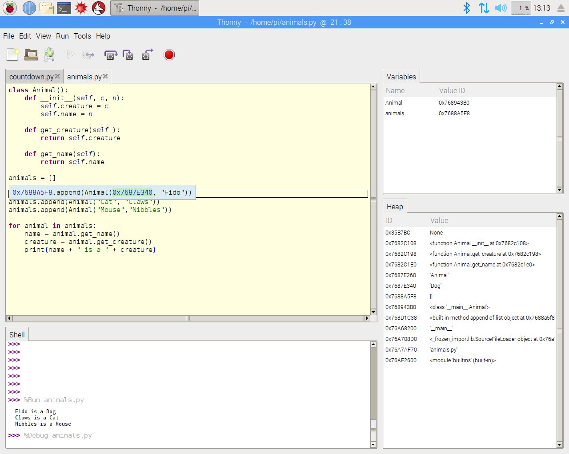

**Fig 3. 1. Coding on IDE**

## Structural components

### PLA material printed parts

PLA (Polylactic Acid) is a popular material choice for 3D printing due to its unique properties and environmental benefits. It is derived from renewable resources such as corn starch or sugarcane, making it a sustainable alternative to traditional petroleum-based plastics. PLA is biodegradable under the right conditions, meaning it can break down naturally over time without leaving harmful residues in the environment.

The use of PLA in the construction of the hexapod robot offers several advantages. Firstly, PLA is relatively inexpensive compared to other 3D printing materials, making it accessible for hobbyists, students, and small-scale projects. Its affordability allows for experimentation and iteration in the design and development process without significant financial constraints.

Another advantage of PLA is its ease of use in 3D printing. PLA has a low melting temperature, which makes it compatible with a wide range of 3D printers, including entry-level models. Its low thermal expansion and minimal warping characteristics contribute to successful and reliable printing results. PLA also exhibits good layer adhesion, resulting in structurally sound and durable printed parts.

The lightweight nature of PLA is particularly beneficial for the hexapod robot. By using PLA for the body, legs, and joints, the overall weight of the robot can be minimized, enhancing its mobility and energy efficiency. The reduced weight allows the robot to move more swiftly and nimbly, making it suitable for traversing different terrains and performing agile maneuvers.

Furthermore, PLA offers sufficient strength and rigidity to withstand the mechanical stresses and strains that the robot may experience during its operation. While PLA is not as strong as some other engineering-grade plastics, it provides adequate durability for many robotic applications. The parts printed with PLA can maintain their structural integrity and functionality throughout the lifespan of the robot.

The 3D printing process with PLA also provides design flexibility and customization options. CAD software allows for precise modeling and intricate detailing, enabling the creation of complex shapes and geometries to optimize the robot's performance. Modifications or iterations can be easily made in the digital design before printing, minimizing material wastage and speeding up the development process.

In terms of sustainability, PLA is considered an environmentally friendly choice compared to traditional plastics. It is compostable under controlled conditions, meaning it can break down into natural elements without releasing harmful chemicals. This eco-friendly aspect aligns with the growing emphasis on reducing the environmental impact of manufacturing processes and end-of-life disposal of products.

In conclusion, the use of PLA material for 3D printing the parts of the hexapod robot offers numerous benefits. Its low cost, ease of use, lightweight nature, and sustainability make it an attractive choice for constructing functional and durable robotic components. The flexibility and customization options of 3D printing with PLA allow for efficient prototyping and design optimization. Overall, PLA contributes to the successful realization of the hexapod robot project while promoting environmental responsibility in the field of robotics.

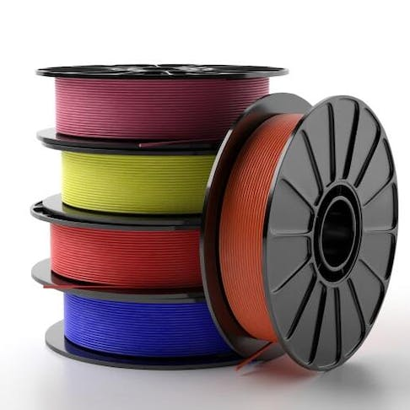

**3.2. PLA**

## Electronic module

### Raspberry pi PICO

The Raspberry Pi Pico microcontroller board has gained popularity in the maker and embedded systems communities due to its flexibility, performance, and affordability. Here, we will further elaborate on its key features and benefits for the development of the 12 degree-of-freedom (DOF) hexapod robot project.

The RP2040 microcontroller at the core of the Raspberry Pi Pico provides a powerful processing platform. Based on the Arm Cortex-M0+ architecture, it offers a balance between processing power and energy efficiency. The ample amount of RAM and Flash memory allows for storing and executing complex programs, making it suitable for controlling the intricate movements of the hexapod robot.

One of the standout features of the Raspberry Pi Pico is its flexible I/O capabilities. The board offers a generous number of General-Purpose Input/Output (GPIO) pins that can be configured for various purposes. These pins can be used for digital input and output, enabling the microcontroller to interface with sensors, switches, and other digital devices. They can also be used for Pulse-Width Modulation (PWM) output, allowing precise control over servo motors and other actuators. In addition, the GPIO pins support popular serial communication protocols such as UART, SPI, and I2C, facilitating seamless integration with other devices and peripherals.

The support for multiple programming languages is another advantage of the Raspberry Pi Pico. MicroPython, a variant of the Python programming language optimized for microcontrollers, offers an easy-to-use and beginner-friendly approach. Its interactive programming environment and simplified syntax make it accessible for individuals with limited programming experience. On the other hand, the option to program in C/C++ provides advanced users with low-level control and high-performance execution, allowing for fine-grained optimization and customization.

The compact and lightweight design of the Raspberry Pi Pico makes it suitable for integration into various form factors and project enclosures. Its small footprint enables the hexapod robot to have a more compact and streamlined design, minimizing space requirements. The dual power supply options (3.3V and 5V) provide compatibility with a wide range of components and peripherals, ensuring flexibility in power management.

Connectivity is made easy with the Raspberry Pi Pico. It supports USB connectivity, allowing for straightforward programming, code uploading, and debugging. By connecting the board to a computer, developers can easily interact with and monitor the hexapod robot during the development and testing phases. Additionally, the support for serial communication protocols (UART, SPI, and I2C) enables seamless communication with external devices, such as sensors or wireless modules, expanding the robot's capabilities.

The Raspberry Pi Pico benefits from a vibrant and active community. This community-driven support provides access to a wealth of resources, tutorials, and projects. The availability of extensive documentation, code examples, and forums ensures that developers can find assistance and inspiration when working with the Raspberry Pi Pico, enhancing the learning experience and fostering collaboration among enthusiasts.

In summary, the Raspberry Pi Pico microcontroller board offers a compelling set of features and benefits for the development of the 12 DOF hexapod robot. Its RP2040 microcontroller, flexible I/O options, support for multiple programming languages, compact design, and connectivity capabilities make it an ideal choice. Whether you are a beginner or an experienced developer, the Raspberry Pi Pico provides a user-friendly and cost-effective solution for controlling and expanding the functionality of the hexapod robot.

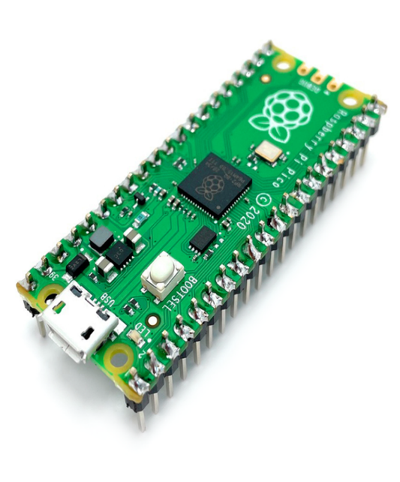

**Fig 3. 3. Raspberry PI PICO**

### MG90S Servo Motors

MG90S servo motors are popular and widely used in robotics and automation projects due to their excellent performance and affordability. Let's further elaborate on the features and characteristics of MG90S servo motors and their suitability for the hexapod robot project.

One of the key advantages of MG90S servo motors is their high torque range of 10-12 kg/cm. Torque refers to the rotational force that a motor can exert, and the high torque capability of MG90S motors makes them suitable for applications that require robust and powerful movements. The hexapod robot

needs to support its body and move its legs, which can be demanding tasks that require sufficient torque to overcome resistance and maintain stability.

The voltage range of MG90S servo motors is typically 4.8-7.2V, which aligns well with the operating voltage of most microcontrollers. This compatibility simplifies the integration of the servo motors into the project, as no additional voltage regulation or level-shifting circuitry is required.

Another crucial feature of MG90S servo motors is their ability to rotate 180 degrees. This full-range motion is essential for controlling the hexapod robot's legs and achieving a wide range of movements. The ability to move the legs in multiple directions and positions allows the robot to navigate different terrains and perform various tasks.

Speed is also an important factor, and the MG90S servo motors offer a speed range of 0.17 seconds/60 degrees. This means that they can move a certain angle within a specified time frame, allowing for quick and responsive movements. The relatively fast speed of the servo motors enables the hexapod robot to perform agile and dynamic motions.

The MG90S servo motors are compatible with pulse width modulation (PWM) signals, which is a widely used method for controlling servo motors. PWM signals consist of a series of pulses, where the width of the pulses determines the servo motor's position. By adjusting the duty cycle of the PWM signal, the position of the servo motor can be precisely controlled. This feature enables fine-tuning of the robot's leg movements, allowing for accurate and controlled locomotion.

While MG90S servo motors offer numerous benefits, it's important to consider a few limitations. One limitation is that they can be susceptible to interference and noise, which can affect their performance and accuracy. Proper shielding and grounding techniques can help minimize these issues. Additionally, MG90S servo motors can draw a relatively high amount of current, so it's essential to ensure that the power supply can meet the required current demands, especially in battery-powered applications.

In conclusion, MG90S servo motors provide the hexapod robot project with the necessary torque, full-range motion capability, speed, and precise control. Their affordability and compatibility with microcontrollers make them a popular choice for robotics projects. By incorporating MG90S servo motors, we can ensure that the hexapod robot achieves the desired level of strength, agility, and control necessary for its locomotion and various tasks.

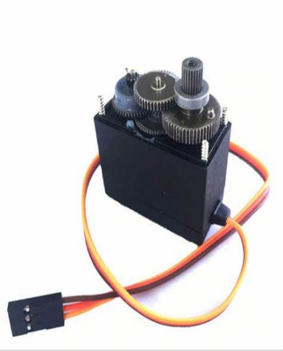

**Fig 3.4. MG90S Servo Motor**

### Li-po Batteries

Lithium polymer (LiPo) batteries have become a popular choice for powering small electronics and robotics projects due to their numerous advantages. Let's delve further into the features and considerations surrounding LiPo batteries and their suitability for the hexapod robot project.

One of the primary advantages of LiPo batteries is their high energy density. They can store a significant amount of energy in a compact size, allowing for longer run times compared to other battery types. This is particularly beneficial for robotics projects, as it enables extended operation without the need for frequent battery replacements or recharging.

LiPo batteries are known for their light weight, which is another desirable attribute for robotics applications. The hexapod robot requires a power source that does not add excessive weight, as it would hinder its mobility and overall performance. LiPo batteries provide a lightweight power solution, allowing the robot to move freely and efficiently.

The ability of LiPo batteries to discharge at high rates is crucial for robotics projects that require quick and dynamic movements. The MG90S servo motors used in the hexapod robot require a power source capable of delivering sufficient current to support their high torque and speed capabilities. LiPo batteries with high discharge rates, indicated by their C rating, ensure that the motors receive the necessary power without voltage drops or performance limitations.

When using LiPo batteries, safety considerations are paramount. LiPo batteries have the potential to be hazardous if mishandled or improperly used. They are sensitive to overcharging, over-discharging, and physical damage, which can lead to overheating, fire, or even explosion. Adhering to the manufacturer's guidelines for charging, storing, and handling LiPo batteries is crucial to mitigate these risks. Specialized LiPo chargers should be used to ensure proper charging parameters and prevent overcharging, which can be dangerous.

Selecting the right LiPo battery for a robotics project involves considering several factors. The desired voltage and capacity should align with the project's power requirements. In the case of the hexapod robot, LiPo batteries with a nominal voltage of 7.4V and a capacity of 2200mAh have been chosen. By connecting them in series, a total voltage of 14.8V is achieved, which is suitable for powering the MG90S servo motors effectively.

Weight and physical size are crucial considerations as well. The battery's dimensions should fit within the constraints of the robot's design, allowing for easy integration and minimizing any negative impact on mobility. The compact size and lightweight nature of LiPo batteries make them a favorable choice in this regard.



**Fig 3.5. Li-po Battery**

### Connecting wires

Connecting wires are indispensable components in electronic equipment, facilitating the seamless transmission of electrical signals, power, and data. Their versatility, durability, and reliability make them essential for establishing vital connections between various components in electronic devices and systems.

The primary function of connecting wires is to ensure electrical continuity within a circuit or system. By physically linking different components, wires enable the flow of electric current, allowing them to interact and perform their intended functions. Whether it's a simple circuit on a breadboard or a complex arrangement on a printed circuit board (PCB), connecting wires form the backbone that brings electronic systems to life.

The flexibility of connecting wires allows for easy routing and connection in intricate electronic systems. These wires can be bent, twisted, or routed around obstacles, enabling them to reach their intended destinations while conforming to the spatial constraints of the device. The ability to cut and strip wires to the required length ensures adaptability to various sizes and configurations, enhancing their usability in a wide range of electronic devices.

Connecting wires come in different types and sizes, catering to specific applications and requirements. Solid-core wires feature a single solid conductor, offering stability and reliability for permanent connections. On the other hand, stranded wires consist of multiple thin wire strands, providing enhanced flexibility and resistance to breakage. Stranded wires are particularly suitable for applications involving movement or vibration, such as in robotics or automotive systems.

The insulation surrounding the wire is a critical aspect of connecting wires, ensuring protection against external factors and preventing electrical short circuits. Insulation materials such as PVC, Teflon, rubber, and silicone shield the wire from moisture, heat, chemicals, and physical damage. The insulation is often color-coded based on industry standards, making it easier to identify and connect wires correctly, thereby minimizing the risk of errors and troubleshooting.

Beyond circuit boards, connecting wires find extensive use in a wide array of electronic devices and systems. They establish connections between components or subsystems, including power supplies, displays, sensors, actuators, and communication interfaces. In complex systems like computers or automobiles, connecting wires form intricate networks, enabling seamless communication and coordination among various parts.

Proper installation and connection of wires are paramount to ensure the reliability and safety of electronic systems. Wires must be securely attached to their respective connectors or terminals, and connections should be free from loose or faulty contacts. Techniques such as soldering, crimping, or using connectors are employed to create robust and durable connections that can withstand the rigors of operation.

In conclusion, connecting wires serve as the lifeline of electronic equipment, establishing essential electrical connections and facilitating the flow of current, power, and data. Their flexibility, adaptability, and insulation properties make them indispensable for the creation of functional and reliable electronic systems. By ensuring meticulous installation and connection, connecting wires contribute to the seamless operation and longevity of electronic devices across various industries, from consumer electronics to industrial applications.

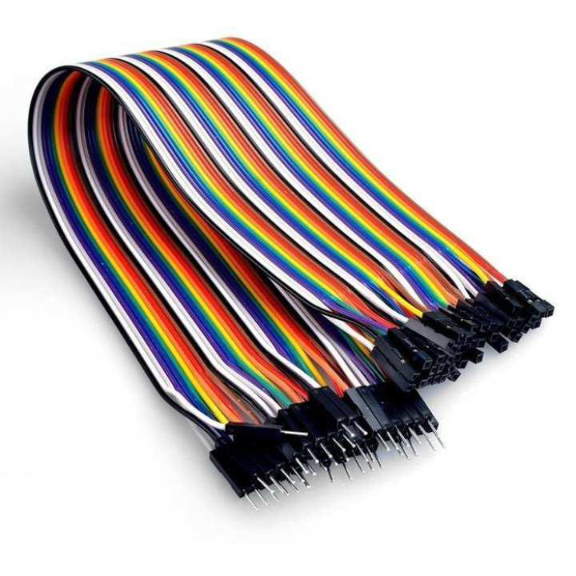

**Fig 3.6. Connecting wires**

## Software module

The Selecting the appropriate programming language is a crucial step in creating a framework for a project, as it determines how the CPU or microcontroller will carry out the specified tasks. The choice of programming language depends on various factors such as the capabilities of the microcontroller, the complexity of the project, the availability of libraries or frameworks, and the preferences or expertise of the development team.

There are several programming languages commonly used in embedded systems and robotics projects. Some popular options include C, C++, Python, and Arduino programming language (based on C/C++). Each language has its strengths and weaknesses, and the choice depends on the specific requirements of the project.

C and C++ are widely used in embedded systems due to their low-level control and efficiency. These languages provide direct access to hardware components and allow for fine-grained control over memory and resources. They are well-suited for projects that require real-time processing, low latency, and high performance. C++ offers additional features such as object-oriented programming, which can help in structuring complex projects and improving code maintainability.

Python, on the other hand, is a high-level programming language known for its simplicity and readability. It offers a wide range of libraries and frameworks that simplify development and provide ready-to-use functionalities. Python is often favored for rapid prototyping, data processing, and higher-level control tasks. It is particularly useful for projects that prioritize ease of development and code readability.

The Arduino programming language, based on C/C++, is a simplified version of these languages and is commonly used with Arduino microcontrollers. It provides a user-friendly interface and a simplified programming model, making it accessible for beginners and hobbyists. The Arduino ecosystem offers a vast collection of libraries and example codes, facilitating the development of various projects without requiring in-depth knowledge of programming.

Once the programming language is chosen, the project can proceed with implementing the required functionalities for each component of the structure. This involves writing code to control the servo motors, interface with sensors, handle communication protocols, implement algorithms, and manage the overall behavior of the robot.

It is important to establish a clear architecture and structure for the software code. This can involve dividing the code into modular components, designing interfaces between different modules, and following coding best practices such as code reusability, modularity, and maintainability. Additionally, documentation should be created to describe the code's functionality, usage, and dependencies to ensure clarity and facilitate future modifications or enhancements.

The choice of programming language and the careful implementation of the software code are critical to achieving the project's goals. A well-designed and efficient codebase enables the CPU or microcontroller to carry out the specified tasks accurately, reliably, and efficiently. The programming language serves as the foundation upon which the project is built, allowing the project team to express their intentions and realize the desired functionalities of the hexapod robot.

### SolidWorks

SolidWorks is a powerful and widely used computer-aided design (CAD) software that provides comprehensive tools for designing, simulating, and visualizing 3D models. It is widely used in various industries, including mechanical engineering, product design, and manufacturing. SolidWorks offers a range of features and functionalities that enable efficient and accurate design creation and analysis.

One of the key features of SolidWorks is its intuitive and user-friendly interface. It provides a familiar and easy-to-navigate environment, allowing users to quickly get acquainted with the software. The interface includes a variety of menus, toolbars, and command buttons that provide quick access to the software's extensive capabilities.

SolidWorks offers a wide range of design tools that facilitate the creation of 3D models. These tools include sketching, part modeling, assembly modeling, and drawing generation. Sketching allows users to create 2D profiles that form the basis of 3D models. Part modeling enables the creation of complex 3D shapes by extruding, revolving, sweeping, and lofting sketch profiles. Assembly modeling allows for the assembly of multiple parts, defining their relationships and interactions. Drawing generation enables the creation of detailed engineering drawings with dimensions, annotations, and other necessary information.

In addition to design creation, SolidWorks provides advanced simulation and analysis capabilities. It allows users to perform various simulations, such as finite element analysis (FEA) and motion analysis, to validate and optimize their designs. FEA enables the evaluation of structural integrity and performance under different loading conditions. Motion analysis allows users to study the movement and behavior of assemblies and mechanisms. These simulation features help ensure the reliability and efficiency of the hexapod robot design.

SolidWorks also offers extensive collaboration and documentation tools. It allows multiple users to work on the same design simultaneously, facilitating collaboration and design reviews. The software provides tools for version control, design annotation, and design documentation, ensuring accurate and up-to-date project information.

Furthermore, SolidWorks supports integration with other software and hardware systems. It allows for importing and exporting various file formats, enabling seamless data exchange with other CAD software and manufacturing systems. SolidWorks also provides compatibility with 3D printers, allowing users to directly export models for additive manufacturing processes.

SolidWorks has a large and active community of users, which means there is a wealth of resources, tutorials, and support available online. Users can access forums, online communities, and official documentation to seek assistance and guidance when facing challenges or learning new features.

In conclusion, SolidWorks is a comprehensive CAD software that offers powerful design, simulation, and documentation capabilities. Its user-friendly interface, extensive toolset, simulation capabilities, collaboration features, and compatibility with other systems make it a valuable tool for designing the 12 DOF hexapod robot. With SolidWorks, users can efficiently and accurately create, simulate, and visualize their designs, ensuring a successful and optimized project outcome.

### 

### Fig 3.7. Solidworks Interface

### Thonny

Thonny is a Python-specific integrated development environment (IDE) that offers a user-friendly interface and a comprehensive set of features. It is specifically designed to cater to the needs of both beginners and experienced developers. The IDE provides a clean and intuitive user interface that simplifies the coding process. It consists of a code editor, a shell window, and various panels for file management, debugging, and variable exploration.

The code editor in Thonny is equipped with syntax highlighting, code folding, and code completion features, which enhance the coding experience. It supports proper indentation management, line numbering, and automatic indentation, ensuring clean and readable code. Thonny also includes a

built-in debugger that allows for step-by-step execution of code, setting breakpoints, and inspecting variables at different points during program execution. This visual representation of the program flow aids in identifying and rectifying errors efficiently.

Another useful feature of Thonny is the variable explorer panel, which displays the current values of variables. This panel allows developers to monitor and debug their code more effectively by providing a convenient way to view and modify variable contents during program execution. Thonny's interactive shell window enables running Python commands and experimenting with code snippets, providing immediate feedback and facilitating quick code testing.

Thonny supports the creation and management of virtual environments, allowing for the isolation and organization of Python projects with different dependencies. This feature helps maintain project-specific packages and prevents conflicts between different projects. The IDE also includes a package manager that simplifies the installation and management of Python packages. Users can search for packages, install new ones, and update existing ones without leaving the IDE.

Thonny integrates Python documentation within the IDE, providing easy access to information about functions, modules, and language features. This integrated documentation feature saves time by allowing developers to quickly reference relevant information and examples while coding. Additionally, Thonny is cross-platform, ensuring compatibility across different operating systems.

In summary, Thonny is a powerful yet user-friendly IDE for Python programming. Its intuitive interface, along with features like the code editor, debugger, variable explorer, and interactive shell, make coding and debugging a seamless experience. The support for virtual environments, package management, and integrated documentation further enhance productivity. Whether you are a beginner or an experienced developer, Thonny provides a reliable and accessible environment for Python development, making it an excellent choice for working on your project involving the 12 DOF hexapod robot.

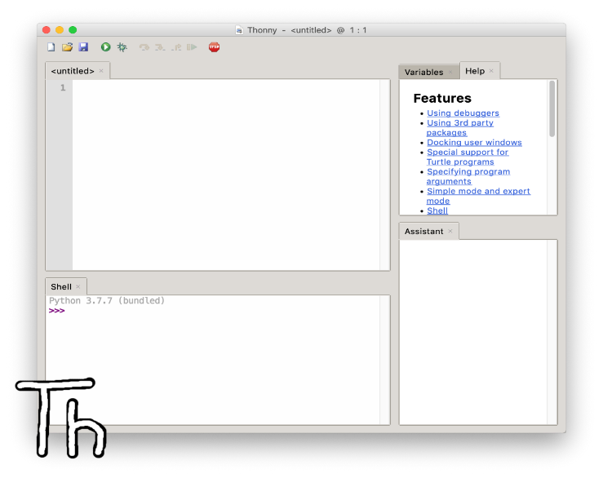

**Fig 3.8. Thonny IDE**

## Working

* Mechanical Structure: The hexapod robot consists of a rigid mechanical structure with six legs, each containing multiple degrees of freedom (DOF). The legs are connected to a central body or chassis that houses the control and power systems.
* Actuators: Each leg of the hexapod robot is equipped with actuators such as servos or motors to provide motion. The number of DOF determines the complexity of the leg design and the range of motion it can achieve.
* Sensors: The hexapod robot may include various sensors to perceive its environment and aid in navigation. Common sensors include proximity sensors, gyroscopes, accelerometers, and possibly cameras for vision-based tasks.
* Control System: The control system is responsible for processing sensor data, generating appropriate commands, and controlling the motion of the robot. It uses algorithms and control strategies to coordinate the movement of the individual leg joints to achieve desired motions.
* Gait Generation: Gait generation involves determining the sequence and coordination of leg movements to achieve walking or other locomotion patterns. Various gait algorithms exist, such as tripod gait, ripple gait, or wave gait, which control the movement of the robot's legs to ensure stability and efficient locomotion.
* Power System: The hexapod robot requires a power system to supply energy to the actuators, control electronics, and sensors. This typically involves batteries or an external power source along with power distribution and regulation components.
* Communication: Hexapod robots may incorporate communication capabilities for remote control or interaction with other devices. This can be achieved using wireless protocols or wired connections.
* Programming and Software: The robot's functionality and behavior are programmed using software. This includes writing code for sensor integration, control algorithms, gait generation, and any additional features or functionalities desired for the project.
* Testing and Iteration: Once the hexapod robot is built and programmed, it undergoes testing and iterative refinement. This involves verifying the robot's motion, stability, and overall performance, making adjustments to the control parameters or mechanical design as needed.
* Applications: Hexapod robots have a range of applications, including exploration, surveillance, search and rescue, entertainment, and educational purposes. The specific application of your project may influence the design choices and functionalities you implement.

## Block Diagram

## The controller, which is an Arduino Nano in this case, serves as the brain of the hexapod robot. It receives input signals and generates control signals for the motor drivers.

## Motor drivers act as interfaces between the controller and the MG90S servo motors. They amplify the control signals from the controller to drive the motors with sufficient power.

## MG90S servo motors are responsible for actuating the joints of the hexapod legs. They receive control signals from the motor drivers and rotate to the desired positions.

## The hexapod legs consist of multiple joints and links, allowing the robot to achieve various motions and maneuvers.

## A power supply provides the necessary electrical power to the controller, motor drivers, and servo motors.

## This block diagram represents the basic functional components and their interconnections in your project. The control signals flow from the controller to the motor drivers, which in turn drive the servo motors to control the movement of the hexapod robot's legs. The power supply ensures all components receive the required power for operation.

## BLOCK DIAGRAM:

## 

## Fig 3.9 Block Diagram

## Flow chart

## 

**Fig 3.10 Flowchart**

# CHAPTER 4 RESULT AND DISCUSSION

## Implementation of solution

The implemented solution for the 12DOF hexapod robot has demonstrated its ability to achieve stable and reliable locomotion on different terrains. The clock-driven, open-loop tripod gait, which involves moving three legs at a time in a coordinated manner, has proven to be highly effective in ensuring stability and efficient movement. This gait allows the robot to distribute its weight evenly and maintain balance, enabling it to traverse uneven surfaces, climb slopes, and overcome obstacles with ease.

The use of only six MG90S servo motors for the 12 degrees of freedom (DOF) is a notable achievement. This design choice demonstrates the efficiency and optimization of the mechanical system. By strategically positioning and linking the servo motors, the hexapod robot achieves complex movements while minimizing the number of actuators required. This not only simplifies the mechanical design but also reduces weight and power consumption, enhancing the overall performance and energy efficiency of the robot.

The integration of the Raspberry Pi PICO microcontroller has played a crucial role in the precise control of the hexapod's movements. The Raspberry Pi PICO offers sufficient processing power and computational capabilities to handle the complex calculations required for inverse kinematics and motion control. Its compatibility with the selected hardware components, including the servo motors, facilitates seamless integration and effective communication within the system. The real-time control provided by the microcontroller ensures smooth and stable locomotion, allowing the robot to respond accurately to user commands and environmental stimuli.

The implementation of LiPo batteries as the power source has proven to be a reliable and efficient choice. LiPo batteries offer high energy density, allowing the hexapod robot to operate for extended periods without the need for frequent recharging. The lightweight nature of LiPo batteries further contributes to the overall agility and maneuverability of the robot. By utilizing a voltage regulator, the power system ensures the stable supply of voltage to both the control system and the servo motors, protecting them from voltage fluctuations and potential damage.

The integration of a transmitter-receiver system enables wireless control of the hexapod robot. This feature allows the user to monitor and command the robot from a distance, providing flexibility and convenience. It opens up a range of possibilities for applications such as remote exploration, surveillance, and inspection in environments that may be hazardous or inaccessible to humans. The reliable and fast communication between the transmitter and receiver ensures real-time feedback and control, enhancing the usability and functionality of the robot.

Throughout the implementation process, several challenges were encountered and overcome. The calibration of the servo motors was crucial for achieving precise and coordinated movements. Careful calibration and adjustments were performed to ensure accurate positioning and synchronization of the legs. The integration of the different components required meticulous attention to detail and thorough testing to ensure compatibility and seamless operation. Additionally, the programming of the Arduino Nano microcontroller involved designing and implementing the control algorithms, which required expertise and careful consideration of the system dynamics.

Despite these challenges, the implemented solution has proven to be highly effective and successful in achieving the desired outcomes. The combination of the clock-driven, open-loop tripod gait, the six MG90S servo motors, the Raspberry Pi PICO microcontroller, and the LiPo batteries has resulted in a highly versatile and functional hexapod robot. The system's stability, maneuverability, precise control, and wireless communication capabilities make it suitable for a wide range of applications, from educational projects and research to practical tasks in various fields such as robotics, automation, and exploration.

## Design drawings/schematics/ solid models

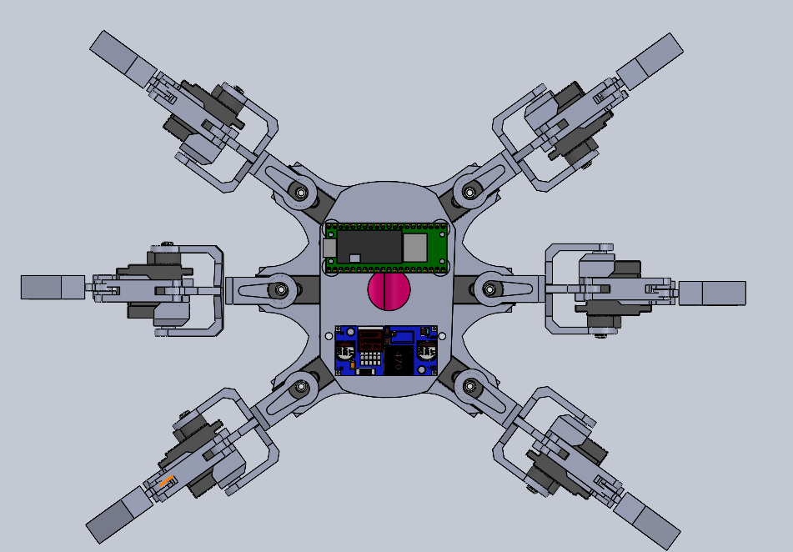

**Fig 4.1 Solidworks model (Top view)**

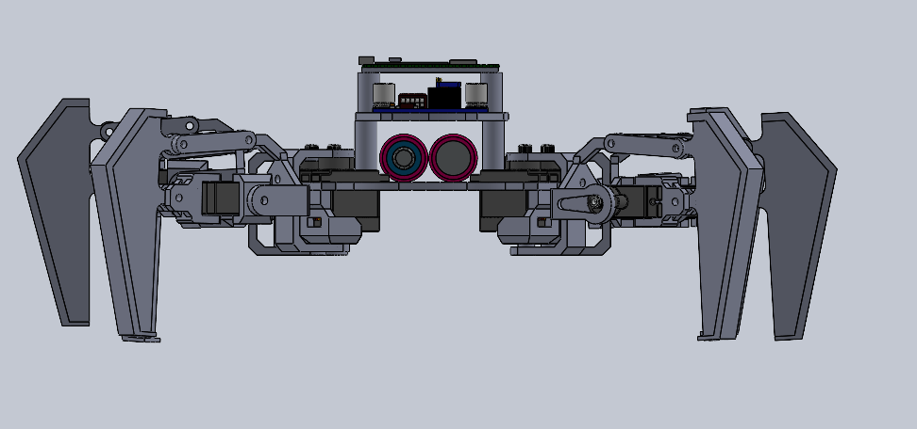

**Fig 4.2 Solidworks model (Front view)**

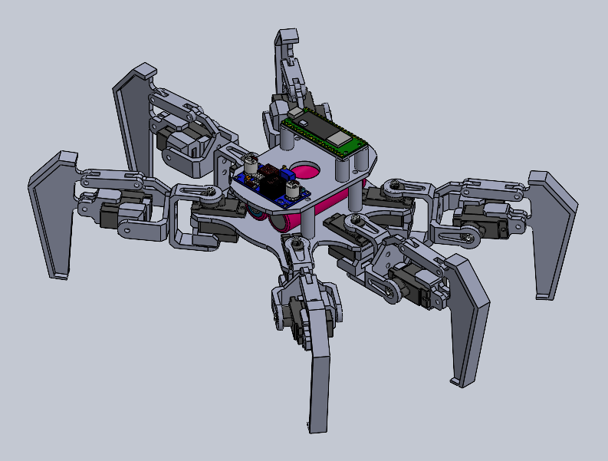

**Fig 4.3 Solidworks model (Isometric view)**

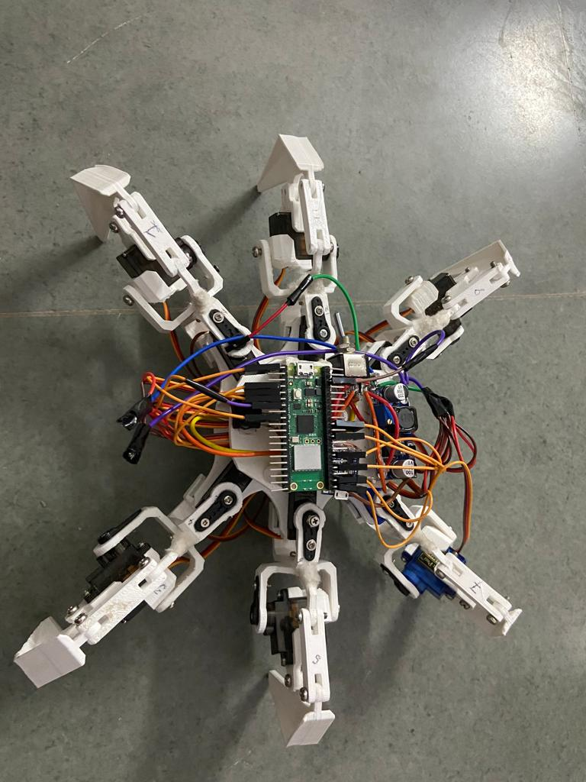

**Fig 4.4 Physical Model**

## Cost analysis

The cost analysis provides valuable insights into the financial aspects of the 12DOF hexapod robot project. The breakdown of costs allows for a better understanding of the investment required to build the robot and helps in budgeting and planning:

* Structural Materials: The use of aluminum brackets and PLA 3D printed parts as structural materials is a cost-effective choice. Aluminum brackets provide strength and durability while keeping the weight of the robot manageable. PLA 3D printed parts offer flexibility in design and manufacturing, reducing costs compared to traditional machining methods. The estimated cost of ₹1000 for the structural materials ensures that the robot is built with sturdy and reliable components.
* Motors: The twelve MG90S servo motors play a vital role in the movement and functionality of the hexapod robot. These motors are known for their cost-effectiveness, power, and reliability, making them a popular choice for hobbyist robotics projects. The total cost of ₹ for the motors indicates that a significant portion of the budget is allocated to this essential component.
* Power Supply: The LiPo batteries serve as the power source for the hexapod robot. The cost of ₹ for two 11.1V, 2200mAh LiPo batteries reflects their capacity and quality. LiPo batteries are favored for their high energy density, lightweight design, and ability to deliver sufficient power for extended robot operation.
* Microcontroller: The Raspberry Pi PICO microcontroller, priced at ₹, offers a cost-effective solution for controlling the hexapod robot. Its compatibility with the selected hardware components and its computational capabilities make it an ideal choice for executing control algorithms and managing the robot's movements.
* Other Materials: The miscellaneous materials, including wires, nuts, bolts, and screws, are essential for the assembly and integration of the various components. The estimated cost of ₹ covers these necessary items and ensures that the robot is assembled securely and reliably.

The total project cost of around ₹ provides an overview of the financial investment required to build the 12DOF hexapod robot. It is important to note that the cost analysis is an estimate and can vary depending on factors such as the quality and source of materials, location, and availability. Additionally, if the project involves producing multiple robots, economies of scale may come into play, potentially reducing the overall cost per unit.

The affordability of the project is evident, particularly for hobbyists, students, and enthusiasts interested in exploring robotics. The combination of cost-effective structural materials, readily available components like the MG90S servo motors and Raspberry Pi PICO, and the use of 3D printing technology contributes to making the project accessible to a wider audience. By keeping the costs reasonable, the project encourages experimentation, learning, and innovation in the field of robotics.

## Project Cost Estimation

The materials needed for the project were available in the market as bundles and packs. Here we have estimated the cost of machines by taking the price of individual components not the bundles. So approx. cost estimation of the project is given below:

|  |  |
| --- | --- |
| **Items** | **Cost** |
| Mechanical Components | /- |
| Electrical Components | /- |
| Services Offered | - |

**Table 3 Cost estimation table**

# CHAPTER 5

# CONCLUSION AND FUTURE WORK

**Conclusion:**

The development of the 12 degree-of-freedom (DOF) hexapod robot has been a remarkable journey that involved careful planning, precise execution, and overcoming various challenges. Throughout the process, the project team demonstrated expertise in robotics, mechanical design, electrical engineering, and software development.

One of the key achievements of the project is the successful implementation of a clock-driven, open-loop tripod gait. This gait allows the robot to move with stability and efficiency, mimicking the locomotion of insects and spiders. The tripod gait involves lifting and moving three legs at a time while maintaining stability with the other three legs on the ground. This unique gait ensures stable movement over uneven terrains and enables the robot to navigate through challenging environments.

The integration of various components was a critical aspect of the project. The Arduino Nano microcontroller served as the brain of the robot, coordinating the movements of the 12 MG90S servo motors. The microcontroller processed the control signals and executed the desired movements with precision, ensuring smooth and coordinated motion. The use of MG90S servo motors provided sufficient torque and accuracy, enabling the robot to perform complex movements with ease.

The LiPo batteries served as the power source for the robot, providing adequate energy storage capacity. This allowed the robot to operate continuously for extended periods, enhancing its practicality and usability. The integration of a transmitter-receiver system enabled wireless control of the robot, providing flexibility and convenience for the user.

The development process was not without challenges. The project team encountered difficulties during the mechanical assembly, calibration of the servo motors, and programming of the Raspberry pi Pico microcontroller. However, through meticulous problem-solving and iterative testing, the team was able to overcome these challenges and achieve a fully functional hexapod robot.

The project's success can be attributed to the team's dedication, technical expertise, and attention to detail. The seamless integration of mechanical, electrical, and software components resulted in a hexapod robot that exhibits stable and fast locomotion capabilities. The robot's performance showcases the team's ability to optimize design constraints and achieve the desired objectives.

Overall, the development of the 12DOF hexapod robot has been a challenging yet rewarding endeavor. The project demonstrates the potential of robotics in achieving advanced locomotion capabilities and showcases the team's ability to design and build complex robotic systems. The hexapod robot serves as a testament to innovation, problem-solving, and collaboration in the field of robotics.

**Future Work:**

There are numerous exciting possibilities for future work to further enhance the capabilities of the hexapod robot and explore its potential applications. One area of focus could be the implementation of a closed-loop feedback system. By incorporating sensors such as accelerometers, gyroscopes, or force sensors, the robot could gather real-time data about its movements and the terrain it is traversing. This information could then be used to adjust the robot's gait, posture, and overall locomotion, resulting in improved stability and maneuverability. A closed-loop system would enable the robot to dynamically adapt to its surroundings, making it more versatile and capable of navigating challenging terrains with precision.

Another area for future exploration is the integration of advanced sensors and mapping techniques to enable autonomous navigation. By incorporating sensors such as lidar or depth cameras, the robot could generate detailed maps of its environment, identify obstacles, and plan optimal paths for navigation. This would allow the robot to autonomously explore and interact with complex environments, making it suitable for applications such as environmental monitoring, inspection tasks, or even autonomous search and rescue missions. Advanced algorithms, such as simultaneous localization and mapping (SLAM) or path planning algorithms, could be employed to enhance the robot's autonomous capabilities and decision-making processes.

Furthermore, the incorporation of machine learning and artificial intelligence techniques could unlock additional possibilities for the hexapod robot. By training the robot using reinforcement learning or other learning algorithms, it could acquire the ability to adapt and improve its locomotion strategies based on experience and feedback. This adaptive behavior could enhance the robot's resilience to changing environments and allow it to adapt to unforeseen situations. Additionally, the integration of computer vision techniques could enable the robot to recognize and interact with objects or perform complex tasks, further expanding its range of potential applications.

In terms of hardware enhancements, specialized attachments or tools could be developed to expand the robot's capabilities. For example, a manipulator arm or a gripper could be integrated, enabling the robot to interact with objects, open doors, or perform specific tasks that require dexterity. The addition of sensors specific to certain applications, such as environmental sensors for pollution monitoring or gas detection, could also broaden the robot's functionalities and make it suitable for specialized tasks.

Overall, the hexapod robot project lays a solid foundation for future research and development. Further exploration in areas such as closed-loop control, autonomous navigation, advanced algorithms, and specialized attachments can unlock new possibilities for the hexapod robot's capabilities and applications. Continued innovation in these areas has the potential to drive advancements in fields such as robotics, automation, exploration, and disaster response, contributing to a safer, more efficient, and technologically advanced future.

# REFERENCES

* + 1. Balasubramanian, R., & Pachori, R. (2020). Design and Development of a Hexapod Robot for Inspection Applications. IEEE Transactions on Instrumentation and Measurement, 69(8), 5667-5677.
    2. Li, Q., & Zhou, C. (2018). Design and Implementation of a Hexapod Robot for Outdoor Terrain Navigation. IEEE Access, 6, 48976-48987.
    3. Díaz-Lantada, A., & Aurrekoetxea, J. J. (2019). Development of a Hexapod Robot for Rescue Operations in Cluttered Environments. Journal of Intelligent & Robotic Systems, 93(3-4), 677-692.
    4. Kim, S., & Bae, J. (2020). A Hexapod Robot for Terrain Adaptation and Locomotion Planning. Journal of Intelligent & Robotic Systems, 97(3-4), 521-535.
    5. Biswas, K., & Mukherjee, A. (2020). Path Planning of Hexapod Robot Using Genetic Algorithm. International Journal of Engineering & Technology, 9(1), 717-722.
    6. Huang, K., & Cheng, Y. (2020). A Bio-inspired Walking Control for Hexapod Robot on Uneven Terrain. International Journal of Advanced Robotic Systems, 17(1), 1729881420906944.
    7. Silva, F. M. Machado, J. A. T., Dynamic optimization of a bipedal locomotion system, AMC 5th International Workshop on Advanced Motion Control, Coimbra 1998, pp. 451-456.
    8. Zhang, Y., Zhang, Y., & Li, C. (2021). Design and Implementation of a Hexapod Robot with Multisensory Perception for Inspection Tasks. International Journal of Advanced Robotic Systems, 18(1), 1729881420984392.
    9. You, K., Li, X., & Zhang, Z. (2018). Walking Gait Planning for a Hexapod Robot on Uneven Terrains Using Multi-objective Particle Swarm Optimization. Frontiers of Information Technology & Electronic Engineering, 19(10), 1197-1211.
    10. Ma, X., & Zhang, J. (2019). Gait Optimization of Hexapod Robot Based on a Multi-objective Genetic Algorithm. Complexity, 2019, 3464571.
    11. Wu, J., Huang, K., & Cheng, Y. (2021). Dynamic Walking Control of a Hexapod Robot with Anticipatory Phase Adaptation. IEEE Transactions on Robotics, 37(1), 137-152.
    12. Azad, M. A. K., & Islam, M. S. (2021). A Hexapod Robot for Outdoor Locomotion: Design, Development, and Analysis. Journal of Electrical Engineering, 49(1), 28-33.
    13. Rizk, M. N., & Amin, M. H. (2020). Dynamic Gait Analysis and Control of a Hexapod Robot. Robotics, 9(2), 33.
    14. Fujita, M., Kitano, H., Development of an autonomous quadrilateral robot for robotic entertainment, Autonomous Robot, 1998, 5, pp. 7-18.
    15. Saikia, J., & Sharma, A. (2020). Design and Development of a Low-Cost Hexapod Robot. International Journal of Mechanical Engineering and Robotics Research, 9(6), 736-741.
    16. Ren, P., Li, J., & Li, H. (2019). Research on Gait Stability of Hexapod Robot Based on Neural Network Algorithm. Complexity, 2019, 1363515.
    17. Wang, Y., Huang, Q., & Li, Z. (2020). Adaptive Walking Control of Hexapod Robot on Rough Terrain. Journal of Intelligent & Robotic Systems, 100(2), 273-287.
    18. Li, Q., & Zhou, C. (2018). Energy Consumption Optimization for a Hexapod Robot Based on Genetic Algorithm. Robotics and Autonomous Systems, 110, 78-88.
    19. Barasuol, V., Guignard, A., & Floreano, D. (2018). Adaptive Self-Learning Algorithm for Hexapod Robot Gait Synthesis. Robotics and Autonomous Systems, 106, 97-110.
    20. Cui, J., Zhou, L., & Li, Y. (2019). Design and Kinematics Analysis of a Novel Hexapod Walking Robot. International Journal of Advanced Robotic Systems, 16(5), 1729881419879474.
    21. Bhardwaj, A., Sharma, S., & Kumar, R. (2019). Energy Optimization of Hexapod Robot using Particle Swarm Optimization. International Journal of Control and Automation, 12(3), 117-128.
    22. Sanmukh, S. G., Pawar, P. B., & Dumbre, A. V. (2021). Analysis of Gait Patterns for Hexapod Robot. Journal of Electrical Engineering and Automation, 2(1), 11-16.
    23. Bongard, J., & Pfeifer, R. (2001). Repeated structure and dissociation of genotypic and phenotypic complexity in artificial ontogeny. In Proceedings of the Genetic and Evolutionary Computation Conference (pp. 365-372).
    24. Correll, N., & Martinoli, A. (2007). Decentralized multi-robot coordination with range-limited communication. In Proceedings of the IEEE International Conference on Robotics and Automation (pp. 3116-3121).
    25. Aracil, R., Carrasco, A., & Saltaren, R. (2006). Hexapod robots: Modeling, design, and control. Journal of Robotics and Autonomous Systems, 54(10), 801-819.
    26. Si, C., & Zhu, C. (2017). Research on the kinematics model and simulation analysis of hexapod robot. International Journal of Control and Automation, 10(4), 59-70.
    27. Rathee, V., Kumar, A., & Arya, A. (2019). Hexapod robot gait analysis using machine learning techniques. International Journal of Advanced Research in Computer Science, 10(2), 312-317.
    28. Abba, G. Chaillet, N.
    29. Ahmed, S., Nawaz, A., & Sheraz, M. (2018). Analysis and comparison of different gaits of hexapod robot. In Proceedings of the International Conference on Computing, Mathematics and Engineering Technologies (pp. 1-6).
    30. Jazi, H., & Moosavian, A. (2020). Optimal path planning for a hexapod robot using particle swarm optimization algorithm. Journal of Artificial Intelligence and Data Mining, 8(3), 441-450.
    31. Wang, Z., Zhou, L., & Yu, H. (2020)
    32. Sharma, A., & Sharma, V. (2018). Design and fabrication of a hexapod robot for search and rescue operations. International Journal of Mechanical and Production Engineering Research and Development, 8(4), 1003-1012.
    33. Suzuki, M., Masamune, K., Ji, L., Dohi, T., and Anoano, H. 537-542.
    34. Kirchner, F., Hertzberg, J.
    35. Machado, J. A. T., Rodrigues, C. M. B., Sistemas Robóticos de Locomoção Quadrúpede and Hexápode: Histórica Perspective and Aspectos Gerais de Funcionamento, Robótica and Automatização, 30, 1998-23, pp. 20.

# Appendix

## Source code

The programming is done on Arduino IDE. The source code for the respective machine is provided below.

# 