Earthquake Prediction using Machine learning using

Ashwini Barbadekar E&TC Dept., VIT, Pune, India.

Email: [swati.shilaskar@vit.edu](mailto:swati.shilaskar@vit.edu)

Sarthak Bhake E&TC Dept., VIT, Pune, India.

Email: sarthak.bhake20@vit.edu

Rushikesh Mali E&TC Dept., VIT, Pune, India.

Email: [rushikesh.mali20@vit.edu](mailto:rushikesh.mali20@vit.edu)

Dyuti Bobby E&TC Dept., VIT, Pune, India.

Email: [sahil.parekh20@vit.edu](mailto:sahil.parekh20@vit.edu)

Ajinkya Sathe. E&TC Dept.,

VIT, Pune, India.

Email: [ajinkya.sathe20@vit.edu](mailto:ajinkya.sathe20@vit.edu)

***Abstract—***

***Keywords—***

1. INTRODUCTION

Earthquakes have been one of the major natural calamities which humans have faced for a very long time. There have been adverse effects of Earthquakes on society ranging from infrastructural damage to massive loss of life which is one of the major repercussions of the disaster. The infrastructural damage causes social as well as economic effects, schools, buildings, houses, factories and roads which are an integrated part of the society are destroyed causing an imbalance in the social equilibrium. This can render many people homeless and children orphans. The economy of the affected region is also heavily affected as the infrastructure of the businesses, shops is damaged as well as the employees of the different institutions are disturbed. This also causes the governments to pour a large amount money to rebuild the damaged sites, markets to crash, bringing an overall economic slowdown. The heavy loss of life also causes psychological effects on the affected people as they loose their loved ones and life's savings.

With the advent of technology and scientific research, there has been a lot of work that has been put in predicting these earthquakes so that all the misery and suffering could be minimized or curbed. One such field of innovation lately has been artificial intelligence. Usage of Artificial Intelligence in the field of analysing and prevention of earthquakes has taken giant strides by analyzing different types of data related to this natural calamity. ML models are extensively trained on historical seismic data in order to find and analyse patterns of seismic movements which lead to a major earthquakes.AI also helps in damage assessment by analysing satellite images and detecting concentrated rubble regions which would assist the authorities in carrying out rescue operations more efficiently.

There are numerous steps taken in order to prevent and minimize the damage caused by earthquakes. The governments have made it mandatory to follow a specific infrastructural design of buildings which can withstand earthquakes thereby minimizing the chance of collapsing. Major countries have seismic data monitoring stations in

various regions which can alert the authorities of any major seismic activity. However, many regions may not have access to resources to apply the building designs as well as build seismic stations which remain one of the major shortcomings. Also, the risk of false alarms or system crash can cause havoc and end up burning through valuable resources. Besides, some areas have limited accessibility, which can cause difficulties in carrying out rescue operations.

The proposed solution to this problem is a machine learning backed model which takes original data from deployed seismic stations and uses it to predict possible regions which could face an earthquake soon. The study uses a ensemble learning approach by using algorithms like Adaboost, Random Forest and XgBoost to correctly classify the data based on it's outcomes. The proposed model is a working real time earthquake predictor with a front end website which will output the latitude and longitude of the place which may face an earthquake.

The rest of the paper is structured as section 2, describing the related work within this field. Section 3 explains the proposed methodology in this work. The section 4 discusses the results obtained from the study. Section 5 concludes the work along with the imminent future opportunities in this domain.

1. RELATED WORK
2. METHODOLOGY
3. *Dataset Collection*

In Fig. 3 the landmarks of the body are connected for feature extraction.

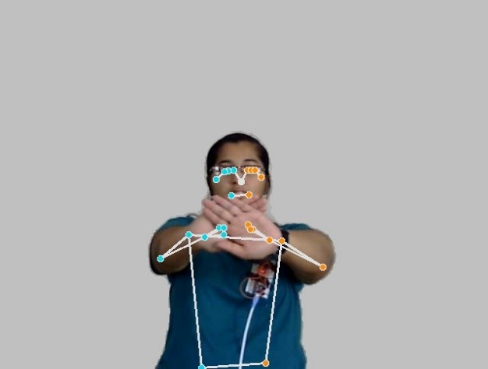

**Fig 3. Landmarks Marking**

1. *Feature Extraction*

The x,y and z coordinates of each landmark are marked in 3-Dimension with respect to image’s height and width. Coordinates x and y are normalized within a range of [0.0, 0.1] corresponding to image’s height and width. Coordinate z corresponds to the depth of landmark where origin was kept at mid of hips. The magnitude of x-coordinate is same as that of z-coordinate.

The list of detected landmarks converted into their original scale and a 3-D plot are illustrated in Fig. 4, Fig. 5.

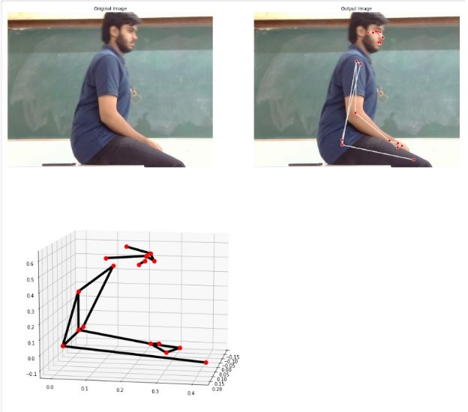

**Fig 4. 3-dimensional coordinates**

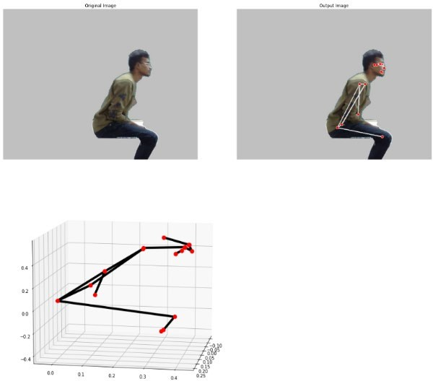

**Fig 5. 3-dimensional coordinates**

Depending upon the exercise performed by the user, postures will be classified into the correct and incorrect postures. For the classification two models are trained and tested to obtain the good accuracy. If the exercise which user is performing belongs to standing, lean forward , trunk rotation or shoulder hike then that particular body posture will be classified as correct one else incorrect one. The percentage of correct and incorrect will be displayed to the user on user interface so that user can correct the posture while doing exercises. The models which trained that are LSTM , Random Forest.

1. *Decision Trees:* DT is a classification tool that utilizes a tree structure comprising of various decisions and their corresponding outcomes.
2. *Long Short Term Memory:* The long-term dependencies are learnt by the LSTM models which is a special type of RNN.
3. *Random Forest:* RF is a classifier that computes an average of decision trees trained on different batches of the dataset.

Algorithm 1 shown underneath deals with the acquisition of data from different subjects.

**Algorithm 1:** Data Acquisition

# Start

1. Setup Holistic model and Drawing utilities.
2. **Input**: a path to a folder of First posture.
3. **For** correct and incorrect videos in folder **Do**
4. Access the correct/ incorrect posture’s video.
5. **For** 40 small videos in correct/incorrect video **Do**
6. Capture frames of small videos.
7. Draw landmarks using pose detection.
8. Extract keypoints.
9. Append and save keypoints into a NumPy list.

# End For

1. **End For**
2. **Output**: List
3. Repeat from step 2 to 12 for all posture’s folder.

# End of Algorithm

Algorithm 2 describes the labelling of the data acquired and storing of the data from the NumPy files into a temporary variable.

**Algorithm 2:** Label and Data

# Start

1. Initialize 2 empty list → Data= [] and Label= [].
2. Input: a path to a folder of First posture
3. **For** correct/incorrect folder **Do**
4. **For** 40 folders in correct/incorrect **Do**
5. Initialize an empty list → Temp = [].
6. **For** 40 NumPy files **Do**
7. Load the NumPy file.
8. Append the data from the file into Temp.

# End For

1. Append the Temp list into Data list.
2. Append the label as 0 and 1.
3. **End** For
4. **End** For
5. Repeat from step 2 to 14 for all posture’s folder.

# End of Algorithm

Algorithm 3 is used for building an LSTM model for correct and incorrect classification of body posture. Here, the data is split into 80:20 ratio and then passed on to the sequential LSTM model for training.

**Algorithm 3:** LSTM Model Building

# Start

1. Data [] ← NumPy array and store.
2. Labels [] ← Categorical values and store.
3. Split the data in the ratio 80:20.
4. Create a Sequential model’s object.
5. Add layers, the last **Dense** layer with 2 neurons.
6. Compile the model with optimizer, loss, and metrics.
7. Fit the data.

# End of Algorithm

The model summary is depcited in the Fig. 6. The total parameters are 204,962 all of which are trainable parameters.

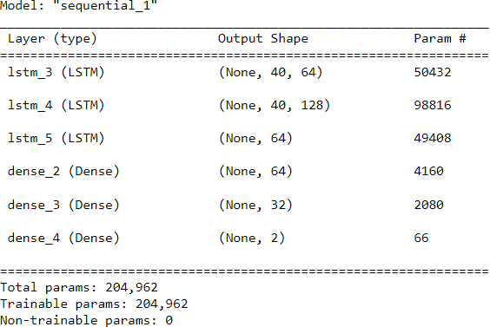

**Fig 6. Model Summary**

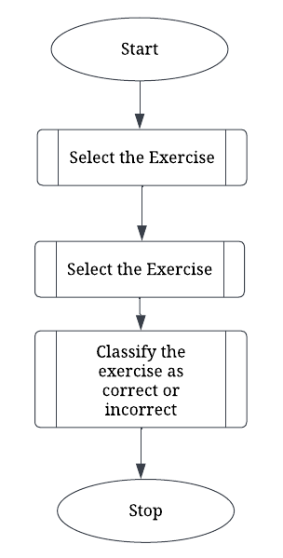

**Fig 7. User flow of the system**

Initially, the image dataset created was resized to 100x100 frames in grayscale. Denoising was performed on these frames using the Gaussian Blur filter. As part of enhancement, edges were detected with the Prewitt operator. Features were then described using the BRISK and FREAK constructors. K-means clustering was performed on the features and Principal Component Analysis (PCA) was used for Diminishing the dimensions. Classifiers Decision Tree (DT) and Random Forest (RF) were trained and tested on this data achieving results depicted in Table 1.

Table 1. Decision tree, Random Forest results

|  |  |  |  |  |
| --- | --- | --- | --- | --- |
|  | **Accuracy** | **Precision** | **Recall** | **F1** |
| **Decision Trees** | 85.50 | 85.32 | 85.41 | 85.50 |
| **Random Forest** | 94.25 | 93.65 | 94.25 | 94.67 |
| **LSTM** | 93.75 | 100 | 87.5 | 93.33 |

**\*Note – All values are in percentage.**

However, this approach does not yield accurate results in real time deployment which was the primary goal of this work.

As a result, RNN (Recurrent Neural Network) is used, which uses sequential or time series data. RNN is trained with train data and tested in real time. The idea behind an RNN is to store a particular layer's output and feed it back to the input in order to predict the outcome of that layer.

Firstly model is trained on the RNN but drawback of rnn is it is not able to connect or use its previous data to preprocess with current frames. In this classification, model should relate the current frames with previous frames because body posture classification depends on long term frames. Hence here RNN fails. Long-term dependencies can be learned using LSTMs, a special kind of RNN. After training the data on LSTM model we calculated the testing accuracy to be 87.5% as depicted in Table 1.

The final system is user driven, where the individual can select actions from “trunk rotation”, lean “forward”, “shoulder hike”, and “standing”.

Figure 8 depicts the scenario where the user performs the exercise as optimally required. As shown in figure, the percentage of exercise being done correctly increases, with the green color on the “correct” label increasing. The display on the frame is “correct” if the individual continues performing the action perfectly. If any of the frames contains an incorrect posture for any of the exercises, “incorrect” is immediately displayed as shown in Figure 9. The blue color on the “incorrect” label starts increasing. Thus, the user can view the accuracy of their performed exercises in real time and correct their posture immediately if incorrectly performed.

**Fig 8. Real time deployment – correct posture**

**Fig 9. Real time deployment – incorrect posture**

Figure 10 displays a comparison of the results for RF, DT and LSTM models.

**Fig 10. Results comparison**

V. CONCLUSION AND FUTURE SCOPE

The research work focuses on the unmanned recognition of posture during rehabilitation therapy for four different exercises viz., trunk rotation, lean forward, shoulder hike, and standing. The developed system employs a real-time body landmark tracking library for a prototype capable of recognizing correct and incorrect body postures in real- time, with good accuracy. The system would prompt the user if incorrect posture were recognized in real time for effective rehabilitation. Future work will focus on combining all different postures important for rehabilitation programs.

References

1. Chang, Yao-Jen, Shu-Fang Chen, and Jun-Da Huang. "A Kinect-based system for physical rehabilitation: A pilot study for young adults with motor disabilities." Research in developmental disabilities 32, no. 6 (2011): 2566-2570.
2. .
3. Ghazal, Sumaira, and Umar S. Khan. "Human posture classification using skeleton information." In 2018 international conference on computing, mathematics and engineering technologies (iCoMET), pp. 1-4. IEEE, 2018.
4. Liu, Mengxing, and Shuming Ye. "A novel body posture recognition system on bed." In 2018 IEEE 3rd International Conference on Signal and Image Processing (ICSIP), pp. 38-42. IEEE, 2018.
5. Iazzi, Abderrazak, Mohammed Rziza, and Rachid Oulad Haj Thami. "Fall detection based on posture analysis and support vector machine." In 2018 4th International Conference on Advanced Technologies for Signal and Image Processing (ATSIP), pp. 1-6. IEEE, 2018.
6. Mase, Jimiama Mafeni, Peter Chapman, Grazziela P. Figueredo, and Mercedes Torres Torres. "A hybrid deep learning approach for driver distraction detection." In 2020 International Conference on Information and Communication Technology Convergence (ICTC), pp. 1-6. IEEE, 2020.
7. Hasib, Rabia, Kaleem Nawaz Khan, Miao Yu, and Muhammad Salman Khan. "Vision-based human posture classification and fall detection using convolutional neural network." In 2021 International Conference on Artificial Intelligence (ICAI), pp. 74-79. IEEE, 2021.
8. Desai, Soham Jayesh, Mohammed Shoaib, and Arijit Raychowdhury. "An ultra-low power,“always-on” camera front-end for posture detection in body worn cameras using restricted boltzman machines." IEEE transactions on multi-scale computing systems 1, no. 4 (2015): 187-194.
9. Orengo, Giancarlo, Antonino Lagati, and Giovanni Saggio. "Modeling wearable bend sensor behavior for human motion capture." IEEE Sensors Journal 14, no. 7 (2014): 2307-2316."
10. Jawed, Unzila, Aiman Mazhar, Faiza Altaf, Abdul Rehman, Sarmad Shams, and Ali Asghar. "Rehabilitation posture correction using neural network." In 2019 4th International Conference on Emerging Trends in Engineering, Sciences and Technology (ICEEST), pp. 1-5. IEEE, 2019.
11. Yu, Xian, Bo Xiao, Ye Tian, Zihao Wu, Qi Liu, Jun Wang, Mingxu Sun, and Xiaodong Liu."A Control and Posture Recognition Strategy for Upper-Limb Rehabilitation of Stroke Patients."Wireless Communications and Mobile Computing 2021 (2021).
12. Rosique, Francisca, Fernando Losilla, and Pedro J. Navarro. "Applying Vision-Based Pose Estimation in a Telerehabilitation Application." Applied Sciences 11, no. 19 (2021): 9132.
13. Zheng, Huiru, Norman D. Black, and Nigel D. Harris. "Position- sensing technologies for movement analysis in stroke rehabilitation." Medical and biological engineering and computing 43, no. 4 (2005): 413-420.
14. Lin, Po-Chieh, Yu-Jung Chen, Wei-Shin Chen, and Yun-Ju Lee. "Automatic real-time occupational posture evaluation and select corresponding ergonomic assessments." Scientific Reports 12, no. 1 (2022): 1-9.
15. Iqbal, Umar, and Juergen Gall. "Multi-person pose estimation with local joint-to-person associations." In European conference on computer vision, pp. 627-642. Springer, Cham, 2016.