Vision Based Floating Garbage Identification

Rushikesh Mali

Electronics & Telecommunication  
Vishwakarma Institute of Technology

Pune,India

rushikesh.mali20@vit.edu

Sahil Parekh

Electronics & Telecommunication

Vishwakarma Institute of Technology

Pune,India

sahil.parekh20@vit.edu

Sarthak Bhake

Electronics & Telecommunication

Vishwakarma Institute of Technology

Pune,India

sarthak.bhake20@vit.edu

Swati Shilaskar

Electronics & Telecommunication

Vishwakarma Institute of Technology

Pune,India

swati.shilaskar@vit.edu

***Abstract*—*Pollution caused due to unregulated dumping of garbage in water bodies has been a problem for some time now. Water Pollution contributes to a lot of environmental hazards and poses a risk to the public health and well-being of humans. Major Steps are being taken to limit this type of pollution but it’s far from being completely tackled. This study proposes s a vision-based approach to identifying different types of floating wastes. Classification-based machine learning algorithms like KNN, Random Forest, XGBoost, SVM, etc are used on a custom-made dataset containing 1500 images of floating waste. Feature extraction of all the images is done using the SIFT technique which is then fed to the ML algorithms. Machine learning techniques like Dimensionality reduction, K fold and GridSearchCV are used to improve the accuracy and optimize model performance The proposed model boasts a highest accuracy of 96 percent with a ROC-AUC score of 0.99. The result of the proposed study is an efficient classification of floating waste in different target classes.***

***Keywords—SIFT, Kmeans Clustering, OpenCV, Floating waste classification, Machine Learning***

1. INTRODUCTION

Global industrialization and population increase are both on the rise but are causing large amounts of pollution giving rise to numerous environmental effects. These effects cover a broad spectrum of hazards ranging from environmental degradation to global warming.

Water Pollution refers to the contamination of water bodies and sources when various pollutants enter the water bodies. This introduction of unwanted foreign substances caused a threat to both human and aquatic life. Contaminated water gives rise to threatening diseases such as typhoid, cholera, malaria, diarrhea. Marine Ecosystems too are majorly affected by water pollution. Various species consume microplastics deteriorating their health, which also causes problems up the food chain. Eutrophication caused by water pollution diminishes the oxygen level of water asphyxiating aquatic plants and marine life. The major contributors to water pollution are plastic wastes, agriculture, wastewater and sewage, oil spills. Marine life is put

into danger when it tangles in plastic and other wastes. Aquatic plastic pollution has affected a minimum of 267 species worldwide. With the rise in use of Artificial Intelligence, various garbage detection systems have been developed in order to curb the plastic pollution. As manual tracking of garbage is tedious and not cost effective there is a need for garbage detection systems which can track garbage precisely, predict the volume and have various functionalities which would help reduce garbage.

This study proposes a garbage detection system which detects garbage and classifies it into one of three classes viz. plastic bottles, plastic bags and bio-degradable garbage.

The paper is organized as follows. The review of the literature addresses the existing systems. The methodology explains the flow of the system starting from feature extraction to the algorithms used. This is followed by the comparing the metrics of the various models.

1. RELATED WORK
2. METHODOLOGY

The outline/flow of the proposed research work can be understood by referring to Fig 1. The figure contains the block diagram of the proposed model, right from data collection to model’s performance evaluation. Feature extraction using SIFT and then dimensionality reduction using K means were the major techniques performed.

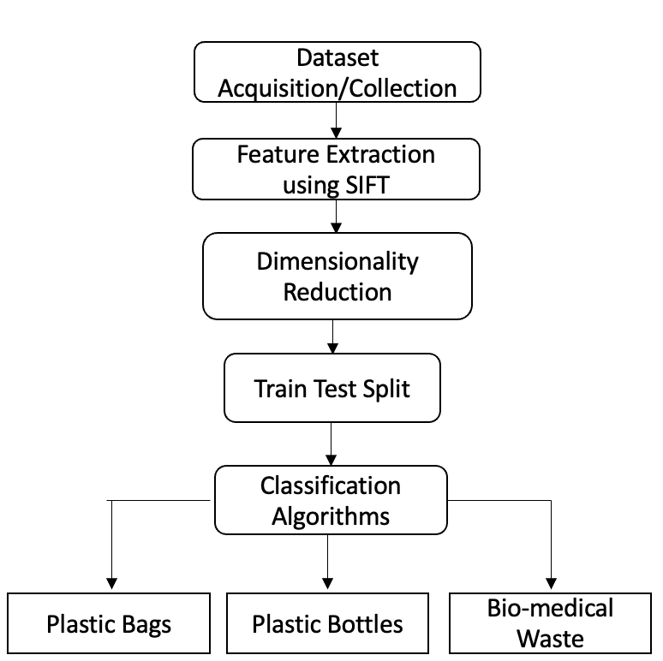

**Fig 1. Block Diagram**

1. *Dataset Collection and Image Pre-Processing*

The data used for the study was custom made by downloading selective images from the internet. The data consists of 3 distinct classes with approximately 500 images in each class, taking it to a total of 1500 sample images. The 3 distinct classes consist of different types of wastes in water bodies viz. Plastic Bottles, Plastic Bags and Biomedical Waste. After the collection of primary images, preprocessing of images was undertaken by resizing them and gray scaling to nullify the RGB channels. Fig 2 shows a sample image of the plastic bottle class before and after gray scaling.

**Fig 2. Gray Scaling of Images**

1. *Feature Extraction using SIFT.*

The feature extraction technique used for this study is Scale-invariant feature transform popularly known as SIFT. This technique is mainly used to detect interest points on specific input images. It also supports the identification of localized features. SIFT can carry out feature identification independently of the image's viewpoint, depth, and scale, in contrast to other feature extraction techniques, which depend on these factors. In the proposed work, SIFT is applied to each image of each class. The output of the feature extractor is a pandas data frame which is then appended to each other to form a combined data frame of features.

Fig 3 shows the sequence of steps followed in SIFT feature extraction technique. Due to these steps, SIFT is said to be very close to our primate visual system.

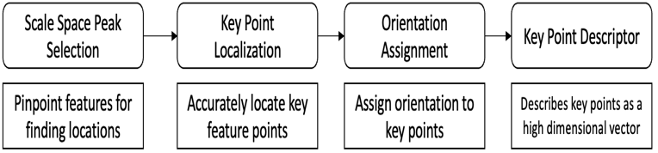

**Fig 3. Sequence of steps in SIFT feature extraction technique**

1. *Dimensionality Reduction*

Dimensionality reduction is a technique in machine learning used to reduce the dimensions (columns) of a particular file. In this study, the output obtained from the SIFT feature extraction technique were huge data frames. After combining the data from all 3 classes the final data frame had a shape of 962917 rows × 128 columns. To reduce the 128 dimensions/columns, k means clustering technique is used which reduces the dimensions to just 8 columns. Finalizing the k in this K means the method is the most essential step. This value is achieved by performing the elbow method which is a graph with the number of clusters on the x-axis and the within-cluster sum of squares (WCSS) on the y-axis. The corresponding value of K where the graph molds into an elbow-like shape is chosen.

Fig 4 illustrates the elbow graph obtained in this proposed study. According to the graph, the corresponding value of K is equal to 7.

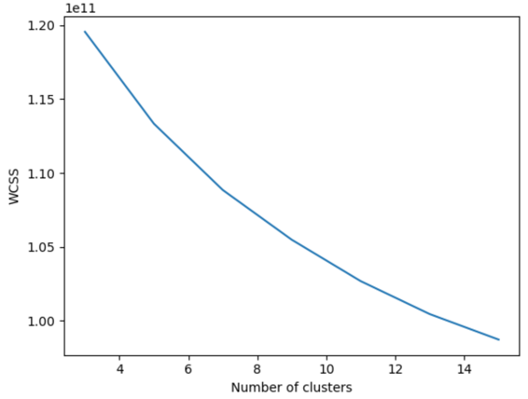

**Fig 4. Elbow method graph (K vs WCSS)**

*D. Classification Algorithms*

Depending upon the type of waste in the input image the image will be classified into 3 classes viz plastic bottles, plastic bags, and biomedical waste. For classification purposes, almost all algorithms have been used to do a comparative analysis between all of them. All algorithms used in the study are listed below with a brief description.

* *Decision Trees*- It builds a tree-like model by recursively splitting the data into subsets based on the most important features, allowing for easy interpretation and visualization of the decision-making process.
* *K Nearest Neighbors*- It is used for predicting the classification or value of a new data point by identifying the k nearest training data points in the feature space and assigning the majority class or average value among the k neighbors.
* *Random Forest*- It creates a collection of decision trees and uses their collective output to make predictions. It reduces overfitting by randomly selecting subsets of features and observations for each tree in the forest.
* *Support Vector Machine*- It constructs a hyperplane or a set of them in a high-dimensional space to separate different classes.
* *XgBoost*- It is a gradient-boosting algorithm that is designed to minimize prediction errors by combining several weak models in a weighted manner.

The specific metrics chosen for evaluating the performance of a classifier are Accuracy, F1 Score and ROC AUC score. These are statistically proven metrics to evaluate the performance of a classifier.

1. *Figures and Tables*

*a) Positioning Figures and Tables:* Place figures and tables at the top and bottom of columns. Avoid placing them in the middle of columns. Large figures and tables may span across both columns. Figure captions should be below the figures; table heads should appear above the tables. Insert figures and tables after they are cited in the text. Use the abbreviation “Fig. 1”, even at the beginning of a sentence.

TABLE I

TABLE TYPE STYLES

|  |  |  |  |
| --- | --- | --- | --- |
| **Table**  **Head** | **Table Column Head** | | |
| ***Table column subhead*** | ***Subhead*** | ***Subhead*** |
| copy | More table copya |  |  |

aSample of a Table footnote.

1. Y. Yorozu, M. Hirano, K. Oka, and Y. Tagawa, “Electron spectroscopy studies on magneto-optical media and plastic substrate interface,” IEEE Transl. J. Magn. Japan, vol. 2, pp. 740–741, August 1987 [Digests 9th Annual Conf. Magnetics Japan, p. 301, 1982].
2. M. Young, The Technical Writer’s Handbook. Mill Valley, CA: Univer- sity Science, 1989.



Fig. 1. Example of a figure caption.

Figure Labels: Use 8 point Times New Roman for Figure labels. Use words rather than symbols or abbreviations when writing Figure axis labels to avoid confusing the reader. As an example, write the quantity “Magnetization”, or “Magnetiza- tion, M”, not just “M”. If including units in the label, present them within parentheses. Do not label axes only with units. In the example, write “Magnetization (A/m)” or “Magnetization A[m(1)] ”, not just “A/m”. Do not label axes with a ratio of quantities and units. For example, write “Temperature (K)”, not “Temperature/K”.

*{ }*

CONCLUSION

The research work aims to classify the floating waste on water bodies which contributes to a significant amount of pollution. The study takes into consideration 3 major pollutants viz plastic bottles, plastic bags, and biomedical waste as classes.

The best-performing classifiers i.e KNN and Random Forest are saved in the form of pickle files which are then further used for predicting the type of waste. The developed system accurately identifies the type of waste in an input image after it is passed to the pickle model.

ACKNOWLEDGMENT

We would like to thank and acknowledge our institute Vishwakarma Institute of Technology, Pune for providing us with a platform to conduct our research. We would also like to express gratitude to our project guide Prof. Swati Shilaskar for her constant support and guidance which kept us motivated during this study.

REFERENCES

1. G. Eason, B. Noble, and I. N. Sneddon, “On certain integrals of Lipschitz-Hankel type involving products of Bessel functions,” Phil. Trans. Roy. Soc. London, vol. A247, pp. 529–551, April 1955.
2. J. Clerk Maxwell, A Treatise on Electricity and Magnetism, 3rd ed., vol.

2. Oxford: Clarendon, 1892, pp.68–73.

1. I. S. Jacobs and C. P. Bean, “Fine particles, thin films and exchange anisotropy,” in Magnetism, vol. III, G. T. Rado and H. Suhl, Eds. New York: Academic, 1963, pp. 271–350.
2. K. Elissa, “Title of paper if known,” unpublished.
3. R. Nicole, “Title of paper with only first word capitalized,” J. Name Stand. Abbrev., in press.