

* **General Information :**

1. **Company Name – TrafikSol ITS Technologies Ltd.**
2. **Product Name – CUDA Installation Process.**
3. **Version –v[1.0.0.0]**
4. **Release Date- 13-01-2025**
5. **Developer Name- Bhakta Charan Rout**

Here’s a well-organized and formatted documentation for diagnosing and resolving CUDA issues with an NVIDIA RTX A4000 or similar GPU:

**CUDA Not Available: Diagnostic and Resolution Guide**

This document provides a step-by-step guide for diagnosing and resolving the "CUDA is not available" error when using NVIDIA GPUs such as the RTX A4000 or other model.

**1. Check if the NVIDIA Driver is Installed and Working**

CUDA requires a compatible NVIDIA driver to function properly. To verify the installation and ensure your GPU is recognized:

* **Run the following command** in your terminal or command prompt:
* nvidia-smi
  + **If this command outputs GPU details**, your NVIDIA driver is installed and functioning correctly.
  + **If it returns an error**, you need to install or update the NVIDIA driver for your GPU. Refer to the [NVIDIA Driver Download Page](https://www.nvidia.com/en-us/drivers/).
  + <https://www.nvidia.com/en-us/drivers/>

**2. Verify CUDA Toolkit Installation**

The CUDA Toolkit must be installed and compatible with your PyTorch version. Here's how to check:

* **Check if CUDA is installed** by running the following command:
* nvcc --version
  + **If this outputs the CUDA version**, the toolkit is installed.
  + **If it’s not installed**, download and install the CUDA Toolkit from the [CUDA Toolkit Downloads](https://developer.nvidia.com/cuda-downloads).
  + <https://developer.nvidia.com/cuda-downloads>

**Install the CUDA Toolkit**

To install CUDA Toolkit (compatible with your GPU and system):

1. Visit the [CUDA Toolkit Download Page](https://developer.nvidia.com/cuda-downloads).
   1. <https://developer.nvidia.com/cuda-downloads>
2. Select the appropriate version (e.g., CUDA 12.0) for your system and follow the installation instructions.

* **Windows Installation Steps**:
  1. Download the .exe installer for your version (e.g., Windows 10/11).
  2. Run the installer and agree to the license agreement.
  3. Choose Express or Custom installation. (Express is recommended.)
  4. Install CUDA Toolkit, NVIDIA Driver (if not already installed), CUDA Samples, and Nsight tools.
  5. 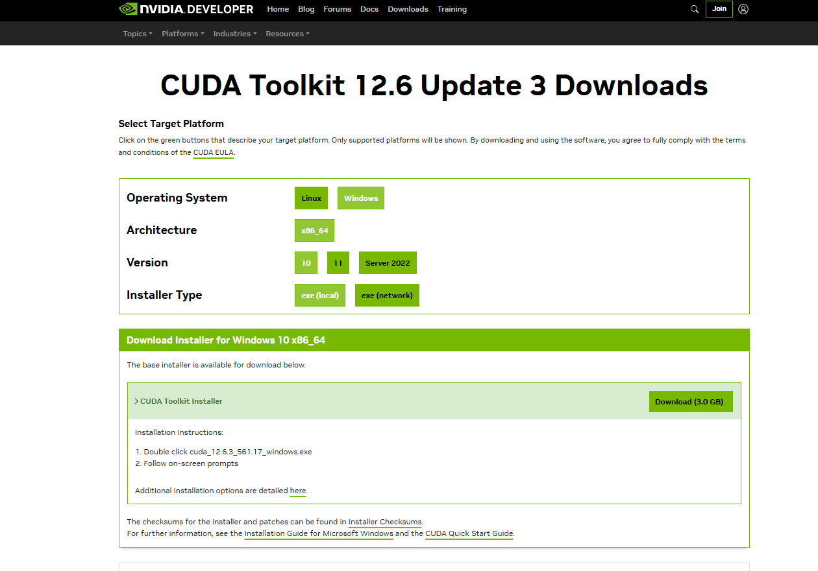After installation, restart your computer.

**3. Add CUDA Toolkit to Environment Variables**

Ensure the CUDA Toolkit is properly configured in your system's PATH:

1. **Open Environment Variables**:
   * Press Win + R, type sysdm.cpl, and press Enter.
   * Go to the **Advanced** tab, click **Environment Variables**.
2. **Edit System PATH**:
   * In the System variables section, find the Path variable, click **Edit**.
   * Add the following paths (adjust based on your installation directory):
     + C:\Program Files\NVIDIA GPU Computing Toolkit\CUDA\v12.0\bin
     + C:\Program Files\NVIDIA GPU Computing Toolkit\CUDA\v12.0\libnvvp
     + C:\Program Files\NVIDIA GPU Computing Toolkit\CUDA\v12.0\include
3. **Save Changes**:
   * 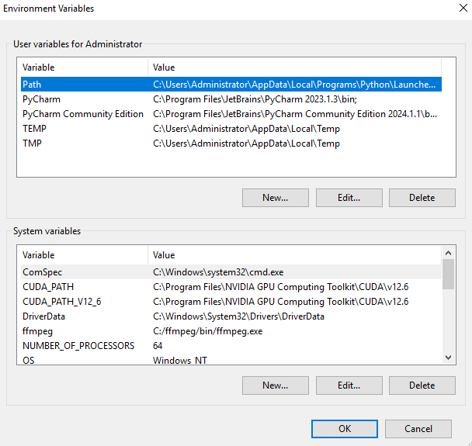Click **OK** to save and close the dialogs.

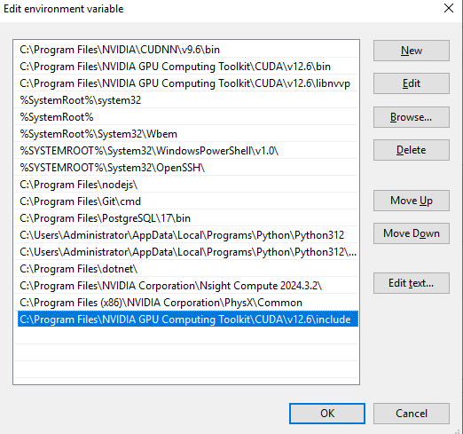

**4. Verify Installation**

After installing CUDA, confirm its installation:

1. **Check CUDA Toolkit Version**:
   * Open a command prompt and run:
   * nvcc --version
   * This should display the installed CUDA version.
2. **Verify GPU Recognition**:
   * Run the following command:
   * nvidia-smi
   * This should display your GPU details along with the driver version.

**5. Install cuDNN (Optional but Recommended)**

cuDNN is essential for deep learning frameworks like PyTorch and TensorFlow.

1. **Download cuDNN**:
   * Visit the [cuDNN Download Page](https://developer.nvidia.com/cudnn) https://developer.nvidia.com/cudnn
   * Download the version compatible with your installed CUDA version.
2. **Install cuDNN**:
   * downloaded .exe.
   * 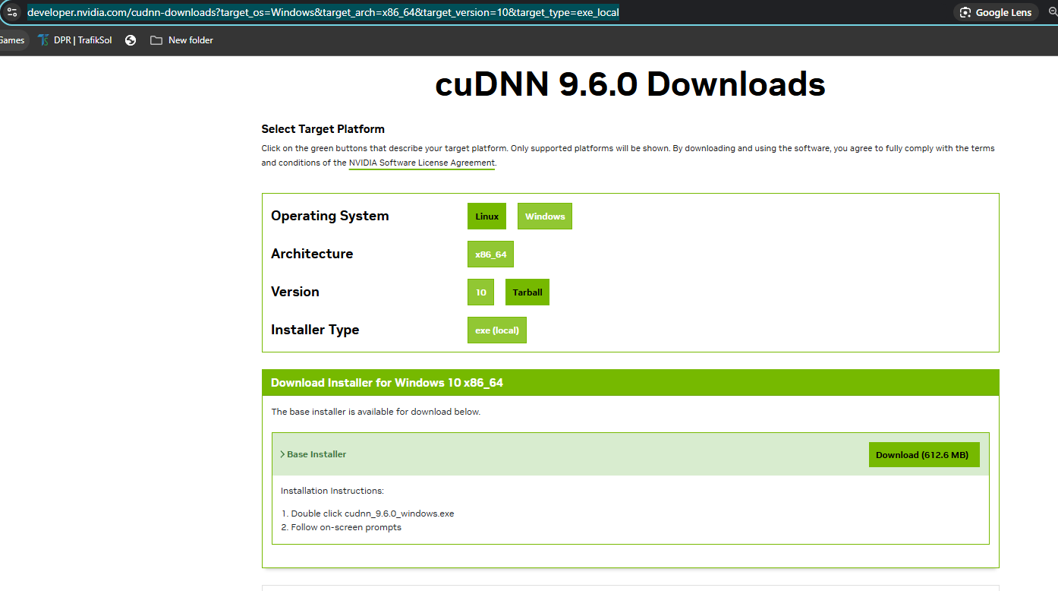Copy the contents (bin, include, and lib folders) to the corresponding directories in C:\Program Files\NVIDIA GPU Computing Toolkit\CUDA\v12.0.

**6. Install PyTorch with GPU Support**

To enable GPU support with PyTorch, install the compatible version based on your CUDA installation.

**Check Installed PyTorch Version**

Run the following command to confirm the installed PyTorch version:

pip show torch

**Uninstall PyTorch**

If necessary, uninstall the current version:

pip uninstall torch torchvision torchaudio -y

**Reinstall PyTorch with GPU Support**

* **For CUDA 12.1**(**Recommended)**:
* pip install torch torchvision torchaudio --index-url https://download.pytorch.org/whl/cu121
* For **CUDA 12.0**
* pip install torch torchvision torchaudio --index-url https://download.pytorch.org/whl/cu120
* For **CUDA 11.8** (if CUDA 12.0 is not compatible):
* pip install torch torchvision torchaudio --index-url <https://download.pytorch.org/whl/cu118>
* Ref- https://pytorch.org/

**7. Verify PyTorch GPU Availability**

To check if PyTorch is using the GPU:

import torch

print(torch.cuda.is_available())

**Check CUDA Details :-**

import torch

print(f"PyTorch version: {torch.__version__}")

print(f"Is CUDA available: {torch.cuda.is_available()}")

print(f"CUDA version supported by PyTorch: {torch.version.cuda}")

print(f"CUDA is available. Number of GPUs: {torch.cuda.device_count()}")

print(f"Current CUDA device: {torch.cuda.current_device()}")

print(f"CUDA device name: {torch.cuda.get_device_name(torch.cuda.current_device())}")

OUTPUT:

PyTorch version: 2.5.1+cu121

Is CUDA available: True

CUDA version supported by PyTorch: 12.1

CUDA is available. Number of GPUs: 2

Current CUDA device: 0

CUDA device name: NVIDIA RTX A4000

This should return True if CUDA is available for PyTorch.

**8. Troubleshooting**

If the above steps do not resolve the issue, consider the following:

* Ensure your **CUDA version** is compatible with your **GPU driver** and **PyTorch version**. Check the [PyTorch Compatibility Chart](https://pytorch.org/get-started/previous-versions/) for supported versions.
* If you're using a **CUDA 12.x version**, ensure that **PyTorch binaries** supporting it are available. As of the latest release, PyTorch officially supports CUDA 12.0 and 12.1.

**Important Notes:**

* **PyTorch Binaries for CUDA 12.4**: At the time of writing, CUDA 12.4 may not be fully supported by PyTorch. It is advisable to use CUDA 11.8 or 12.1 for better compatibility.
* **Avoid Experimental or Unsupported Versions**: Using unsupported versions can result in runtime errors or suboptimal performance.

**Q- pip3 install torch torchvision torchaudio --index-url https://download.pytorch.org/whl/cu124, this version is support**

The PyTorch index URL you mentioned (https://download.pytorch.org/whl/cu124) is for CUDA **12.4** support. As of now cutoff, PyTorch has not officially released binaries supporting CUDA 12.4. The latest supported versions are typically CUDA **11.8**, **12.0**, and **12.1**. ( CUDA **12.4** support may support Future check fully documentation on <https://pytorch.org/> )

### What Should You Do?

To avoid compatibility issues:

1. Stick to **CUDA 11.8** or **12.1**, as these are officially supported and stable.
2. Use the following commands depending on the CUDA version you want:
   * **For CUDA 11.8**:

pip install torch torchvision torchaudio --index-url https://download.pytorch.org/whl/cu118

* + **For CUDA 12.1(Recommended)**:

pip install torch torchvision torchaudio --index-url https://download.pytorch.org/whl/cu121

### Why Avoid cu124?

* PyTorch binaries for cu124 may not exist yet. ( CUDA **12.4** support may support Future check fully documentation on <https://pytorch.org/> )
* Even if they do, they are likely experimental or unsupported.
* Using a version not officially supported can result in runtime errors or suboptimal performance.

### Verify Compatibility:

1. Check PyTorch's official compatibility chart: PyTorch Previous Versions.

Ensure your CUDA driver version matches the PyTorch requirements.

By following this guide, you should be able to diagnose and resolve the "CUDA is not available" error and get your system running with PyTorch GPU support.

C:\Users\Administrator>nvidia-smi

Mon Jan 13 12:54:29 2025

+-----------------------------------------------------------------------------------------+

| NVIDIA-SMI 561.17 Driver Version: 561.17 CUDA Version: 12.6 |

|-----------------------------------------+------------------------+----------------------+

| GPU Name Driver-Model | Bus-Id Disp.A | Volatile Uncorr. ECC |

| Fan Temp Perf Pwr:Usage/Cap | Memory-Usage | GPU-Util Compute M. |

| | | MIG M. |

|=========================================+========================+======================|

| 0 NVIDIA RTX A4000 WDDM | 00000000:03:00.0 Off | Off |

| 41% 33C P8 7W / 140W | 19MiB / 16376MiB | 0% Default |

| | | N/A |

+-----------------------------------------+------------------------+----------------------+

| 1 NVIDIA RTX A4000 WDDM | 00000000:83:00.0 Off | Off |

| 41% 30C P8 5W / 140W | 0MiB / 16376MiB | 0% Default |

| | | N/A |

+-----------------------------------------+------------------------+----------------------+

+-----------------------------------------------------------------------------------------+

| Processes: |

| GPU GI CI PID Type Process name GPU Memory |

| ID ID Usage |

|=========================================================================================|

| 0 N/A N/A 9228 C+G ...5n1h2txyewy\ShellExperienceHost.exe N/A |

| 0 N/A N/A 9492 C+G ....Cortana_cw5n1h2txyewy\SearchUI.exe N/A |

+-----------------------------------------------------------------------------------------+

C:\Users\Administrator>nvcc --version

nvcc: NVIDIA (R) Cuda compiler driver

Copyright (c) 2005-2024 NVIDIA Corporation

Built on Wed_Oct_30_01:18:48_Pacific_Daylight_Time_2024

Cuda compilation tools, release 12.6, V12.6.85

Build cuda_12.6.r12.6/compiler.35059454_0