SCHOOL OF COMPUTER SCIENCE AND ARTIFICIAL INTELLIGENCE |  |  |  |  |  | DEPARTMENT OF COMPUTER SCIENCE ENGINEERING
Program Name: B. Tech |  |  |  |  | Assignment Type: Lab |  |  | AcademicYear:2025-2026
Course Coordinator Name |  |  |  |  | Dr. Rishabh Mittal
Instructor(s)Name |  |  |  |  | Mr. S Naresh Kumar  Ms. B. Swathi  Dr. Sasanko Shekhar Gantayat  Mr. Md Sallauddin  Dr. Mathivanan  Mr. Y Srikanth  Ms. N Shilpa  Dr. Rishabh Mittal (Coordinator)  Dr. R. Prashant Kumar  Mr. Ankushavali MD  Mr. B Viswanath  Ms. Sujitha Reddy  Ms. A. Anitha  Ms. M.Madhuri  Ms. Katherashala Swetha  Ms. Velpula sumalatha  Mr. Bingi Raju
Course Code |  |  |  | 23CS002PC304 | Course Title |  | AI Assisted Coding
Year/Sem |  |  |  | III/II | Regulation |  | R23
Date and Day  of Assignment |  |  |  | Week3-Tuesday | Time(s)
Duration |  |  |  | 2 Hours | Applicable to  Batches |  | 23CSBTB01 To 23CSBTB52
AssignmentNumber:3.2(Present assignment number)/24(Total number of assignments)
 | Q.No. |  | Question |  |  |  |  |  | Expected Time  to complete
 | 1 | Lab 3: Prompt Engineering – Improving Prompts and Context Management  Lab Objectives:  - To understand how prompt structure and wording influence AI-generated code.  - To explore how context (like comments and function names) helps AI generate relevant output.  - To evaluate the quality and accuracy of code based on prompt clarity.  - To develop effective prompting strategies for AI-assisted programming.  Lab Outcomes (LOs):  After completing this lab, students will be able to:  - Generate Python code using Google Gemini in Google Colab.  - Analyze the effectiveness of code explanations and suggestions by Gemini.  - Set up and use Cursor AI for AI-powered coding assistance.  - Evaluate and refactor code using Cursor AI features.  - Compare AI tool behavior and code quality across different platforms.  Task Description-1  - Progressive Prompting for Calculator Design: Ask the AI to design a simple calculator program by initially providing only the function name. Gradually enhance the prompt by adding comments and usage examples.  Expected Output-1  - Comparison showing improvement in AI-generated calculator logic and structure.  Task Description-2  - Refining Prompts for Sorting Logic: Start with a vague prompt for sorting student marks, then refine it to clearly specify sorting order and constraints.  Expected Output-2  - AI-generated sorting function evolves from ambiguous logic to an accurate and efficient implementation.  Task Description-3  - Few-Shot Prompting for Prime Number Validation: Provide multiple input-output examples for a function that checks whether a number is prime. Observe how few-shot prompting improves correctness.  Expected Output-3  - Improved prime-checking function with better edge-case handling.  Task Description-4  - Prompt-Guided UI Design for Student Grading System: Create a user interface for a student grading system that calculates total marks, percentage, and grade based on user input.  Expected Output-4  - Well-structured UI code with accurate calculations and clear output display.  Task Description-5  - Analyzing Prompt Specificity in Unit Conversion Functions: Improving a Unit Conversion Function (Kilometers to Miles and Miles to Kilometers) Using Clear Instructions.  Expected Output-5  - Analysis of code quality and accuracy differences across multiple prompt variations.  Note: Report should be submitted a word document for all tasks in a single document with prompts, comments & code explanation, and output and if required, screenshots |  |  |  |  |  |  |  | Week 3 - Tuesday
TASK-1:

PROMPT: Create a Python function named calculator. Gradually improve it by adding comments and usage examples to enhance logic and structure

CODE:
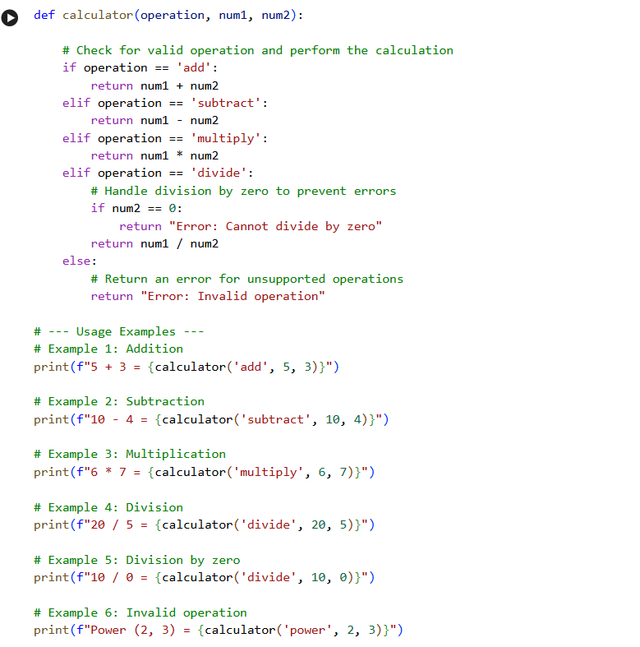
OUTPUT:
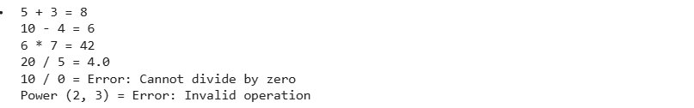
OBSERVATION:
I observe that the calculator function is defined, includes internal comments within its logic, and has uncommented usage examples demonstrating addition, subtraction, multiplication, division, division by zero handling, and invalid operation handling. The output of these examples is also displayed.

TASK-2:

PROMPT: Write a function to sort student marks. Then refine the prompt by specifying sorting order and constraints to improve the sorting logic

CODE:
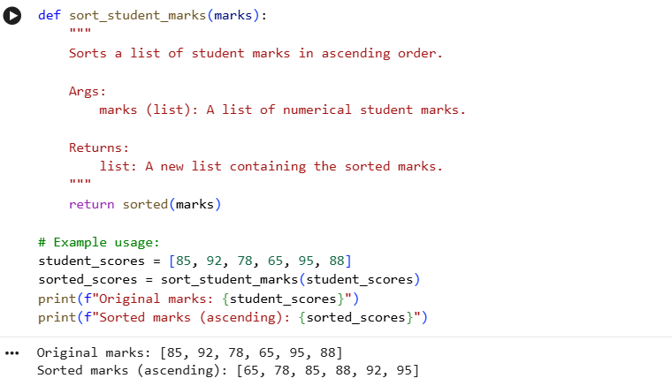

OBSERVATION:
The sort_student_marks function sorts a list of numbers in ascending order, and the usage example demonstrates this with original and sorted student scores.
TASK-3

PROMPT: Using few-shot prompting, provide multiple input–output examples for a function that checks if a number is prime. Then generate the final prime-checking function.

CODE:
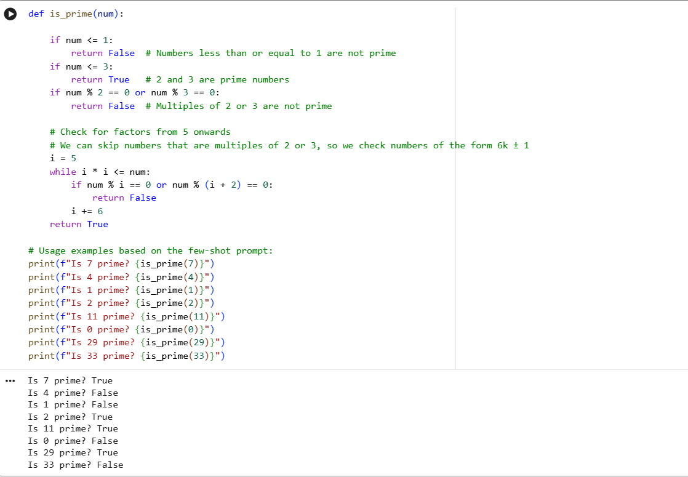
OBSERVATION:
I observe that the is_prime function in cell 0fe3b645 has been edited. The docstring and some of the detailed comments explaining its logic have been removed.

TASK-4

PROMPT: Using few-shot prompting, provide multiple input–output examples for a function that checks if a number is prime. Then generate the final prime-checking function.
CODE:
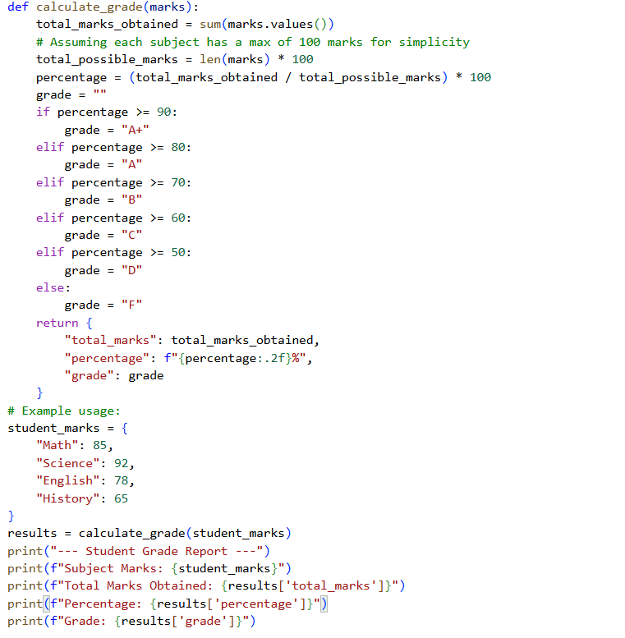
OUTPUT:
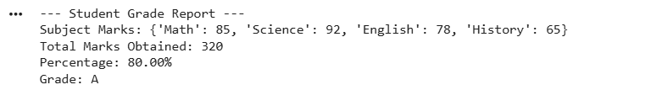
OBSERVATION:

The docstring for the calculate_grade function in cell db7464ab has been removed.

TASK-5:

PROMPT: Create a unit conversion function for kilometers ↔ miles, then refine the prompt with clearer instructions to improve accuracy. Compare how the function quality changes with each refinement
CODE:

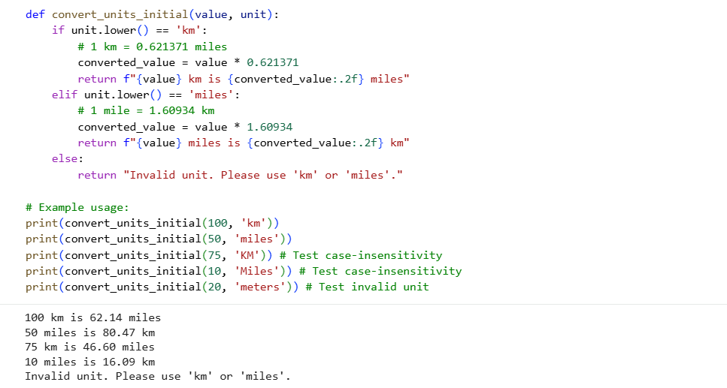
OBSERVATION:
The convert_units_initial function executed correctly, converting kilometers to miles and vice versa for valid inputs, and handling case-insensitivity. It also correctly identified and reported an 'Invalid unit' for an unsupported input.

