SCHOOL OF COMPUTER SCIENCE AND ARTIFICIAL INTELLIGENCE |  |  |  |  | DEPARTMENT OF COMPUTER SCIENCE ENGINEERING
Program Name: B. Tech |  |  |  | Assignment Type: Lab |  |  | AcademicYear:2025-2026
Course Coordinator Name |  |  |  | Dr. Rishabh Mittal
Instructor(s)Name |  |  |  | Mr. S Naresh Kumar  Ms. B. Swathi  Dr. Sasanko Shekhar Gantayat  Mr. Md Sallauddin  Dr. Mathivanan  Mr. Y Srikanth  Ms. N Shilpa  Dr. Rishabh Mittal (Coordinator)  Dr. R. Prashant Kumar  Mr. Ankushavali MD  Mr. B Viswanath  Ms. Sujitha Reddy  Ms. A. Anitha  Ms. M.Madhuri  Ms. Katherashala Swetha  Ms. Velpula sumalatha  Mr. Bingi Raju
Course Code |  |  | 23CS002PC304 | Course Title |  | AI Assisted Coding
Year/Sem |  |  | III/II | Regulation |  | R23
Date and Day  of Assignment |  |  | Week3 - Tuesday | Time(s)
Duration |  |  | 2 Hours | Applicable to  Batches |  | 23CSBTB01 To 23CSBTB52
AssignmentNumber:4.2(Present assignment number)/24(Total number of assignments)
 | Q.No. | Question |  |  |  |  |  | Expected Time  to complete
 | 1 | Lab 4: Advanced Prompt Engineering – Zero-shot, One-shot, and Few-shot Techniques  Lab Objectives:  - To explore and apply different levels of prompt examples in AI-assisted code generation.  - To understand how zero-shot, one-shot, and few-shot prompting affect AI output quality.  - To evaluate the impact of context richness and example quantity on AI performance.  - To build awareness of prompt strategy effectiveness for different problem types.  Lab Outcomes (LOs):  After completing this lab, students will be able to:  - Use zero-shot prompting to instruct AI with minimal context.  - Use one-shot prompting with a single example to guide AI code generation.  - Apply few-shot prompting using multiple examples to improve AI responses.  - Compare AI outputs across the three prompting strategies.  Task Description-1  - Zero-shot: Prompt AI with only the instruction. Write a Python function to determine whether a given number is prime  Expected Output-1  - A basic Python function to check if a number is prime, demonstrating correct logical conditions without relying on examples or additional context  PROMPT: Write a zero-shot Python function that determines whether a given number is prime.  CODE:  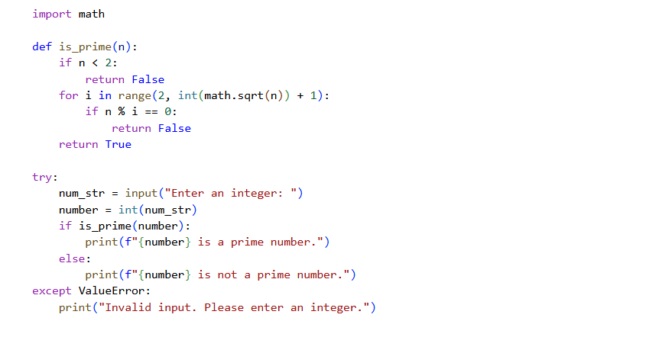  OUTPUT:  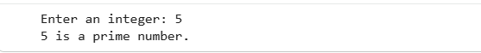  OBSERVATION:  The code received '5' as input and correctly identified it as a prime number. The docstring for the (is_prime) function was also removed.  Task Description-2  - One-shot: Provide one example: Input: [1, 2, 3, 4], Output: 10 to help AI generate a function that calculates the sum of elements in a list.  Expected Output-2  - A correct conversion function guided by the single example.  PROMPT: Using one-shot learning, create a Python function that calculates the sum of elements in a list.  CODE:  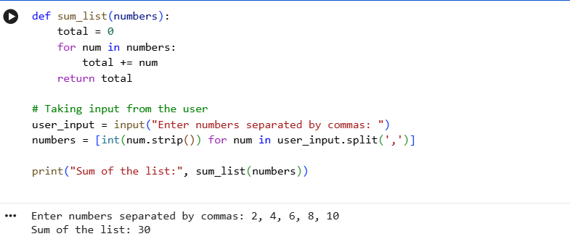  OBSERVATION:  The function correctly reads user input, converts it into a list of integers, and calculates the total using a loop.  It demonstrates proper handling of dynamic input and ensures accurate summation of list elements.  Task Description-3  - Few-shot: Give 2–3 examples to create a function that extracts digits from an alphanumeric string.  Expected Output-3  - Accurate function that returns only the digits from alphanumeric string.  PROMPT: Using few-shot learning, create a Python function that extracts digits from an alphanumeric string.  CODE:  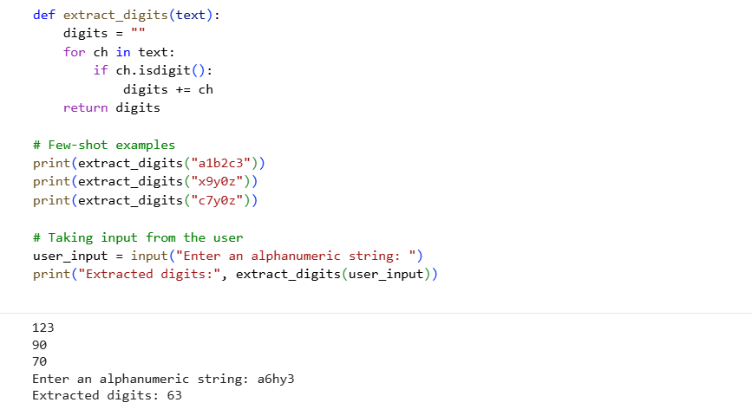  OBSERVATION:  The program successfully extracts digits from multiple user-provided alphanumeric strings using a simple character check.  It demonstrates effective iteration and input handling, ensuring accurate digit extraction for each input.  Task Description-4  - Compare zero-shot vs few-shot prompting for generating a function that counts the number of vowels in a string.  Expected Output-4  - Output comparison + student explanation on how examples helped the model.  PROMPT: Compare zero-shot and few-shot prompting by generating a function that counts vowels in a string, showing both outputs.  CODE:  Zero-shot vowel counting function:  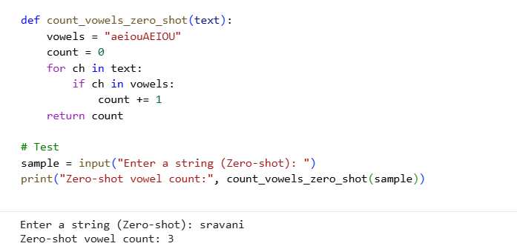  Few-shot vowel counting function:  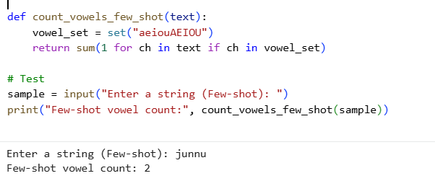  OBSERVATION:  The zero-shot function works correctly but is more basic and less optimized since no examples guide the logic.  The few-shot version is cleaner and more efficient because the provided examples help the model understand the pattern better.  Task Description-5  - Use few-shot prompting with 3 sample inputs to generate a function that determines the minimum of three numbers without using the built-in min() function.  Expected Output-5  - A function that handles all cases with correct logic based on example patterns.  PROMPT:  Using few-shot learning with three sample inputs, create a Python function that determines the minimum of three numbers without using the built-in min() function.  CODE:  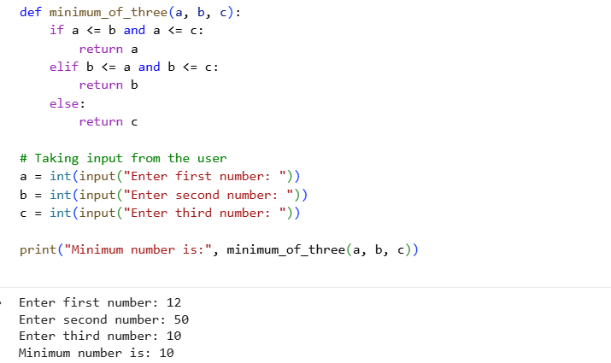  OBSERVATION:  The function correctly finds the minimum of three numbers using logical comparisons without relying on min().  Few-shot examples helped guide the function structure to handle all possible cases efficiently.  Note: Report should be submitted a word document for all tasks in a single document with prompts, comments & code explanation, and output and if required, screenshots |  |  |  |  |  | Week3 - Tuesday

