

**Dharmsinh Desai University,Nadiad**

**Faculty Of Technology**

**Department Of Computer Engineering**

**B. Tech. CE Semester – IV**

**Subject: Software Engineering**

**Project title: *SKOOB(Online Book Reselling Portal)***

**Developed By:**

***Bhakti K. Sanghani (CE-218)***

***Namrata T. Vyas (CE-228)***

**Guided By:**

***Prof. Ankit P. Vaishnav***

***Prof. Jigar Pandya***

**Contents:-**

1.Abstract………………………………………………………………4

2.Introduction…………………………………………………………..5

3. Software Requirement Specifications……………………………………....…………………..6

4. Design

4.1 Use Case diagram..................................................................10

4.2 Class diagram........................................................................12

4.3 Sequence diagram.................................................................13

4.4 Activity diagram...................................................................14

4.5 Data Flow diagram ..............................................................15

4.6 Structure Chart….................................................................18

4.7 Data dictionary ....................................................................19

5. Implementation Detail

5.1 Modules................................................................................

5.2 Major Functionality .............................................................

6. Screenshots………………………………………………...…….

7. Conclusion……………………………………………………......

8. Limitations and Future Enhancements and scope……………….

9. Reference / Bibliography……………………………..………….

***1.Abstract***

*SKOOB is an online book reselling portal which acts as a central database containing a wide collection of books and genres to choose from, including fiction and fantasy, crime and thrillers, cooking, horror, textbooks, historical books and many more.*

*SKOOB acts as a medium between owner and buyer of the book. The owner can sell the used books which, despite having been preloved, are still in optimum condition and at a great price.The user visiting the website can see the wide range of books arranged in respective categories.The user may select the desired book and view its price and can purchase it.*

***2.Introduction***

*Hi.We, Namrata Vyas and Bhakti Sanghani had taken up this project as a part of our curriculum in the 4th semester.The project that we selected involves creating an online portal for reselling books.*

*Reselling a book offline is a very time and tedious task for both the owner and the buyer.Hence we had come up with an alternative that would smoothen the process ,Where books can be sold and bought from the comfort of home through the internet.*

*Through SKOOB,the Owner could add the book by providing the book details,upload some pictures and set a price.The Administrator approve the books and manage the users.The Buyer can view or search for specific book using search bar and filters,select the book, add it into the cart and can purchase it by providing the payment details.After receiving the book,the buyer can also provide feedback and rating.*

***3.Software Requirement Specification***

**R1.Manage Books information :**

**Description :** Add books as per its categories and update its details , view books and search books ,sell books and collect feedback of books, delete books if required.

**R1.1 Add books :**

**Input :** seller provides details of the books.

**Output :** books added.

**R1.2 display books :**

**Input :** user can see books.

**Output :** books are displayed.

**R1.2.1 search books :**

**Input :** Provide name of the book to search.

**Output :** display book that user search.

**R1.3 Update details :**

**Input :** seller update details of his/her own book.

**Output :** details updated.

**R1.4 delete books :**

**Input :** delete books that authentication person want to delete.

**Output :** book deleted.

**R2.Manage Categories :**

**Description :** Add category and its subcategory and remove it.

**R2.1 Add categories and subcategories :**

**Description:**we can add categories comedy,horror,fictional,etc.

**Input :** add various categories and subcategories.  **Error ErrorOutput :** added.

**R2.2 Remove categories :**

**Input :** remove particular category.

**Output :** deleted.

**R3.Manage Selling Books :**

**Description :** Users can sell books , add to their cart , purchase books and payment amount for it.

**R3.1 Sell books :**

**Description :** user provides books for selling.

**R3.1.1 Add books by seller :**

**Input :** add book and its details by seller.

**Output :** confirmation message for adding book.

**R3.1.2 : display book :**

**Input :** user can see books.

**Output :** show books.

**R3.1.3 : Update book details :**

**Input :** seller update details of his/her own book.

**Output :** details updated.

**R3.1.4 delete books :**

**Input :** delete books that authentication person want to delete.

**Output :** book deleted.

**R3.2 Purchase books :**

**Input :** select books that the user wants to purchase.

**Output :** add it to the cart.

**R3.2.1 Add it to cart :**

**Input :** add books to cart that we select for purchase.

**Output :** added in cart.

**R3.2.2 get Payment details:**

**Input :** payment for the book that we purchase.

**Output :** payment confirmation message.

**R3.2.3 Delete books from cart :**

**Input :** delete books that we don’t want.

**Output :** deleted from cart.

**R4.Manage users :**

**Description :** register users and view user details and its books and see its feedback , if the user is not appropriate then delete him/her.

**R4.1 Register :**

**Description :** users must be registered to buy books and sell.

**Input :** user must enter details.

**Output :** confirmation message displayed.

**R4.2 Login :**

**Input :** user has to enter username and password.

**Output :** confirmation successfully and main page displayed.

***4.Design***

***4.1 Use Case diagram***

* ***Admin***

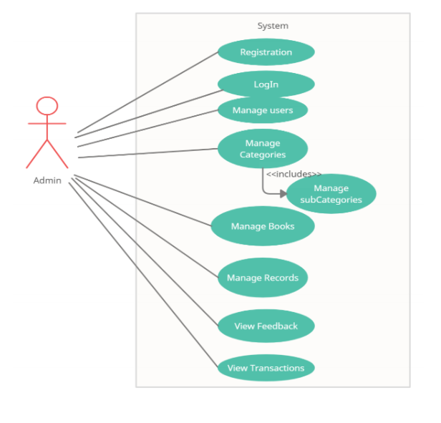

* ***User(Buyer/Seller)***

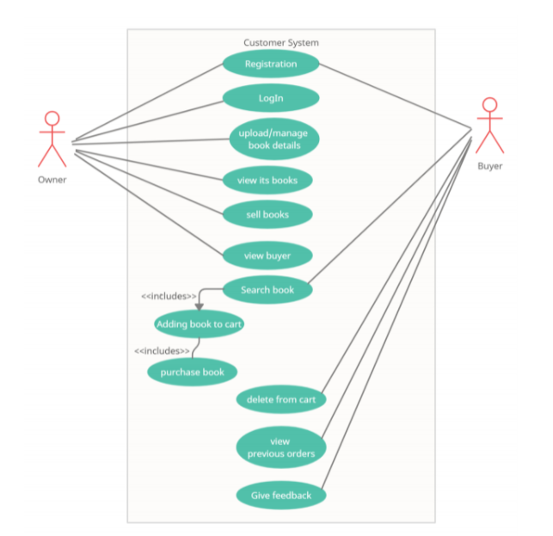

***4.2 Class diagram***

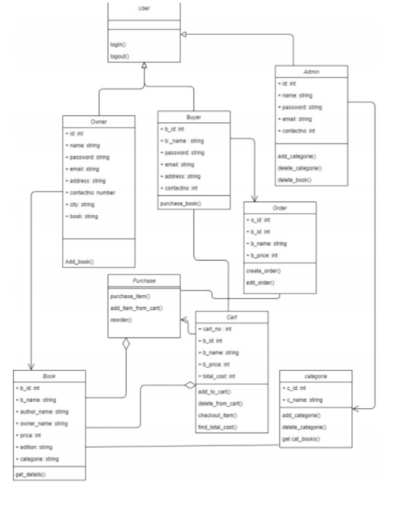

***4.3 Sequence diagram***

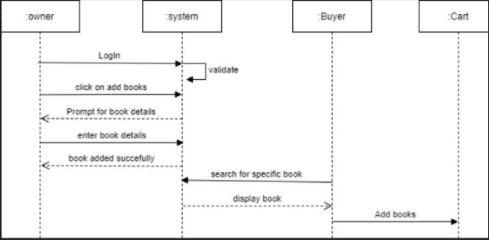

***4.4 Activity diagram***

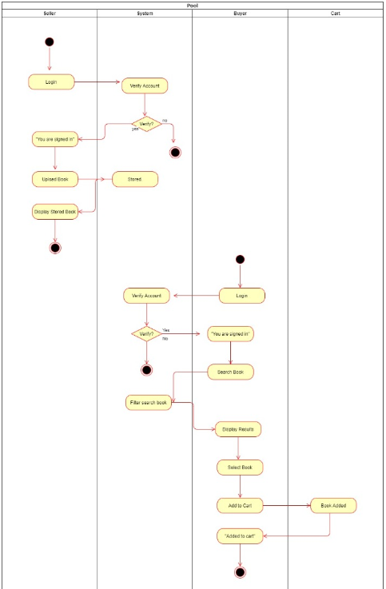

***4.5 Data Flow diagram***

* ***Level 0(Context Diagram)***

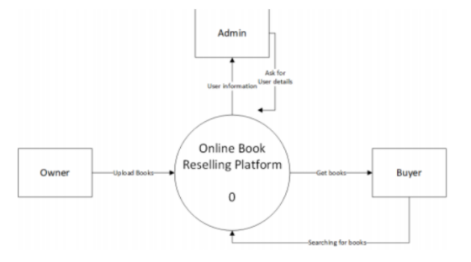

* ***Level 1***

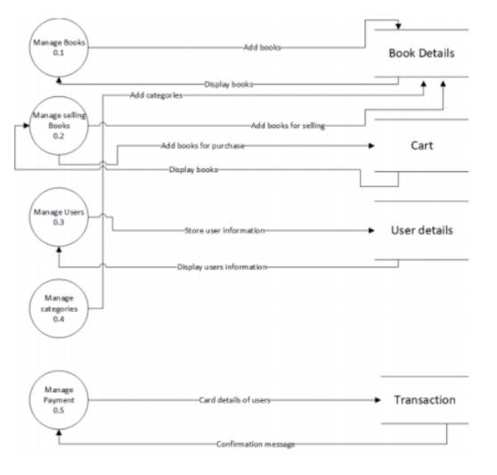

* ***Level 2***

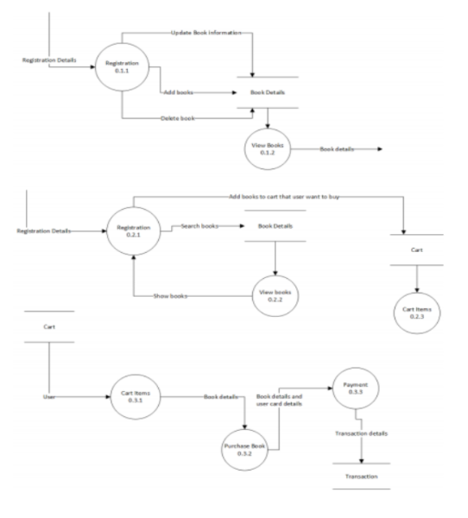

***Structure Chart***

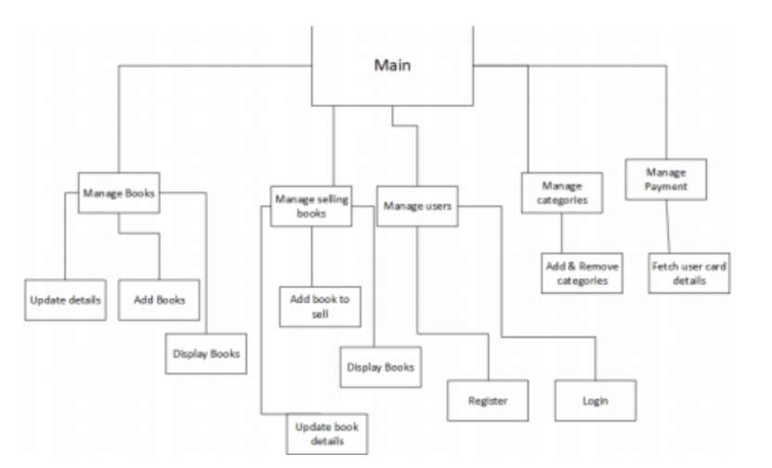

***4.6 Data dictionary***

***5.Implementation Detail***

***5.1 Modules***

***5.2 Major Functionality***

***6. Screenshot***

***7. Conclusion***

*The Online Reselling Portal “SKOOB” provides a one place solution to all the processes occurring during the offline mode.It provides an easy way of selling,searching, keeping record and purchasing of books “ANYTIME.. ANYWHERE”.*

*In brief,It increases both the ease of seller and buyer.*

***8. Limitations and Future Enhancements and Scope***

* ***Limitations***

*Here,we are unable to do Real Payment through a bank account so we created a dummy account for it.*

*Here,we are not providing any facility for the delivery.*

* ***Future Enhancement***

*We can provide the actual payment option.*

*We can provide the facility for the delivery.*

*Admin or Owner could provide discounts for some customers*

* ***Future Scope***

*This website can be used under various situations. Any private organization can make use of it for providing information about the author, content of the books in their database. Modifications can be easily done according to user requirements. It can be used in any type of Book Shop System for managing the transactions and purchasing activities by users and managing the information related to Books.*

***9. Reference / Bibliography***

***Bibliography:-***

* ***Software Engineering - A Practitioner’s Approach***

***Author: Roger S. Pressman***

* ***Fundamentals of Software Engineering***

***Author: Rajib Mall***

***URLs:-***

***Stackoverflow.com***

***Github.com***

***Docs.djangoproject.com***

***Bootstarp.com***

***\*\* THANK YOU \*\****