TE2041 – Interactive Design

A2 - Interactive Prototype, Planning and Development

Danny Dixon

Mrs Kirkham’s Lancashire Cheese – Website Redevelopment

# Summary

This report details the evaluation and further development criteria for consideration on the Mrs Kirkham’s Cheese website prototype. The client currently have a website live which has many opportunities to address in the redesign. With more of an idea of their business focus, a new version has been drafted and is available at the following web address: <http://penguin.uclan.ac.uk/~ddixon1/y2/KirkhamsCheese>

The following information within the report is based on the data within this space.

Table of Contents

Summary 2

Project Management Plan 4

Stages of Development 5

Planning 5

Structure 5

Pages 5

Testing 5

SEO Strategy 6

Business focuses 6

Location/Locality 6

Product category 6

Basic Semantics 6

Page Code Download Report 7

Code Validation Report 8

Index (Home Page) 8

About Page 8

Visit Page 8

Style Guide (v2.0) 8

Colours and Styling 8

Evaluation of Prototype 9

Future Site-Development Strategy 9

Identified Career Development 10

References 11

# Project Management Plan

The following Gantt chart outlines the project timeline for tasks to be completed. The plan is based on an 8-week structure commencing from 28/11/2014 to the final deadline of 16/01/2015.

|  |  |  |  |  |  |  |  |  |
| --- | --- | --- | --- | --- | --- | --- | --- | --- |
| **Task** | **Weeks** | | | | | | | |
| 1 | 2 | 3 | 4 | 5 | 6 | 7 | 8 |
| 1. Structure |  |  |  |  |  |  |  |  |
| a. Framework |  |  |  |  |  |  |  |  |
| 1. Research Foundation vs Bootstrap |  |  |  |  |  |  |  |  |
| 1. Build HTML framework for index |  |  |  |  |  |  |  |  |
| 1. Build HTML framework for about |  |  |  |  |  |  |  |  |
| 1. Build HTML framework for visit |  |  |  |  |  |  |  |  |
| ***FRAMEWORK COMPLETE*** |  |  | ◆ |  |  |  |  |  |
| b. Styling |  |  |  |  |  |  |  |  |
| 1. Colour |  |  |  |  |  |  |  |  |
| 1. Responsive Attributes |  |  |  |  |  |  |  |  |
| 1. Asset Collection and Distribution |  |  |  |  |  |  |  |  |
| ***STYLING COMPLETE*** |  |  |  |  |  | ◆ |  |  |
| 2. Testing |  |  |  |  |  |  |  |  |
| a. Responsive Design |  |  |  |  |  |  |  |  |
| b. Validation |  |  |  |  |  |  |  |  |
| ***TESTING COMPLETE*** |  |  |  |  |  |  | ◆ |  |
| 3. Deployment |  |  |  |  |  |  |  |  |
| a. Upload to Penguin Server |  |  |  |  |  |  |  |  |
| ***PROJECT COMPLETE*** |  |  |  |  |  |  |  | ◆ |

## Stages of Development

Following the build of this prototype, there should be key stages in the further development of this project. Below are the stages.

### Planning

A client meeting will be arranged to showcase the prototype. Notes should be made on how they have received the design, what their main objectives are moving forward and ensuring that their business goals are still within our focus.

### Structure

After the refocus on design and development following the meetings with the client, the development team should start to ensure the file structure of the website is meeting the correct guidelines; that is, matching the planned hierarchy within the FTP structure. If URLs are to change in the future, this structural planning will avoid any instances of the website “404-ing”.

Information taken from performance reports will affect these decisions on structural integrity. As an example, some content may be condensed into a single file to reduce the number of HTTP requests to the server.

### Pages

Content will need to be implemented at this stage. All content should adhere to the client’s brand standards and be the most recent version of all materials. Each page should follow the goals set in the proposal. Functionality for each page should be adjusted so that the website is fully optimised for performance on all platforms. Design aesthetics should be in accordance to the most recent style guide. Frameworks should maintain the “responsive-ness” of the website and allow content to be adjusted for all platforms.

### Testing

The testing stage should be thorough, with each part of the website loaded on different devices using different broadband connection bandwidths. Any issues during this stage should be quickly turned around before moving onto final deployment. Server-side, version control should be in place in case of any problems during transfer of materials via FTP.

# SEO Strategy

Mrs Kirkham’s Cheese is a relatively small-scale business with local links to the city of Preston as well as retail and wholesale connections throughout the UK. The SEO strategy should enhance their online presence and focus on the company’s business goals. Mozilla posted a very useful guide to strategic SEO on their blog space[1] (Lippay, 2010). Below are the 8 summarised steps:

1. Target audience and their needs
2. Categorized Keyword Research
3. Finding Gaps and Opportunities
4. Define Competitors
5. Spying on (and learning from) competitors
6. Customised SEO strategy
7. Must-haves
8. Priorities and summaries

There are three main areas that this SEO strategy should follow based on Kirkham’s business needs.

## Business focuses

The three main focuses as outlined within the client meetings are: trade/wholesale connections and invitations to new distributors, retail links for customers to be able to buy the product and visiting options with ideas around training events being hosted at the venue for chefs/food experts to try out the product alongside their own cooking recipes.

## Location/Locality

With the company being based in Preston, Lancashire; it makes logical sense to include location based SEO keywords and local identifiers so that both local and non-local visitors can get an immediate idea of where the company operates. This would also be a good opportunity for local business links so that relevance and suggestion will be more apparent in a Google search engine.

## Product category

Kirkham’s are in the cheese industry, but as outlined previously, their product is specialist meaning the SEO should highlight their quality. Basic keywords linked to the product such as: “Cheese”, “Dairy” and “Specialty” should be used.

## Basic Semantics

When developing the prototype further, it is important to check the semantics within each webpage. Google now focuses on this content within the HTML to help users navigate a website.

# Page Code Download Report

By running the prototype through metrics analysers like YSlow, it has been simple enough to find opportunities for further development. Below are the results.



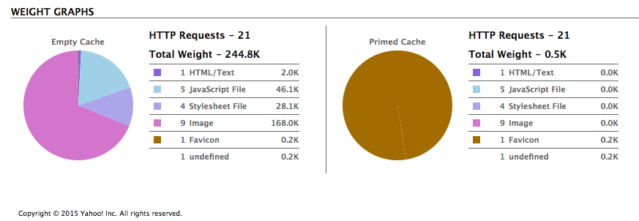

Figure : YSlow Analysis

As can be seen above, the website scored a Grade B overall from YSlow. Most of the criteria scored either an A or B for quality. The score is brought down due to server-side analysis. YSlow will always recommend using a CDN[2] to optimise the way that the website data is distributed worldwide. For this project, it is unlikely that this will be required as most of the business focus is in the UK. However, if the scale of the business demand were to increase, this strategy would have to be reanalysed.

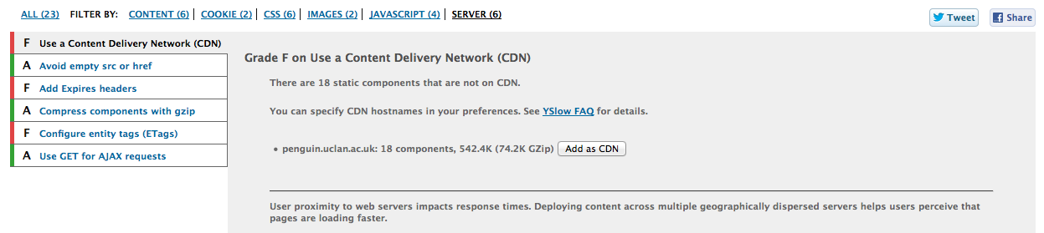

Figure : Server-Side Results

The caching of data is strong on this website. The original download weight shows 244.8K but the cached version shows 0.5K, which is a drastic change. This is a very good result as it allows users to access the website quickly even with slower broadband connections.

# Code Validation Report

The following links are evidence of cleared validation of HTML within the prototype.

## Index (Home Page)

<https://html5.validator.nu/?doc=http%3A%2F%2Fpenguin.uclan.ac.uk%2F~ddixon1%2Fy2%2FKirkhamsCheese>

## About Page

<https://html5.validator.nu/?doc=http%3A%2F%2Fpenguin.uclan.ac.uk%2F~ddixon1%2Fy2%2FKirkhamsCheese%2Fabout.html>

## Visit Page

<https://html5.validator.nu/?doc=http%3A%2F%2Fpenguin.uclan.ac.uk%2F~ddixon1%2Fy2%2FKirkhamsCheese%2Fvisit.html>

# Style Guide (v2.0)

## Colours and Styling

|  |  |
| --- | --- |
| **Content Elements** | **Colour (RGB Value)** |
| Background Colour | #333 |
| Heading 1 | #008CBA |
| Heading 2 | #CC9933 |
| Heading 3, Paragraph | #FFF |
| Inline Link | #CCCCFF |
| Inline Link (on hover) | #0078A0 |

|  |  |  |
| --- | --- | --- |
| **Content Elements** | **Font Family** | **Font Size** |
| Heading 1 | Helvetica Neue, Helvetica, Roboto, Arial, sans-serif; | 2.75rem  (Unit from Foundation Framework) |
| Heading 2 | 2.3125rem  (Unit from Foundation Framework) |
| Heading 3 | 1.6875rem  (Unit from Foundation Framework) |
| Paragraph | 1rem  (Unit from Foundation Framework) |

# Evaluation of Prototype

The prototype redevelopment of Mrs Kirkham’s Cheese addresses a number of opportunities outlined from the proposal stage. A more consistent design has been implemented allowing users to comfortably navigate across pages and access interactive content. All elements have been organised on each page according to grid theory, which has allowed not only for a much neater outlay, but also (with the addition of frameworks) a responsive system, which adapts depending on the users platform of choice. The content is aimed at the business goals as discussed within the original proposal. The prototype contains demo content to illustrate the functionality of interactive elements like image carousels and iframed videos.

There are still a number of opportunities to address moving forward. Some functionality was restricted due to poor time management, resulting in the implementation of code to be missing in some key areas. This can be seen within the navigation of the website on mobile screens. More style choices would have created a much more engaging view for the user upon first glance. Again, poor time management resulted in the final design lacking some important enhancements of colour to draw the attention to certain areas of each page.

It would be nice to see more interactive JQuery elements within the page to modernise the overall look and feel for the user experience. Although the page scales and is responsive, some elements overlap when on mobile.

With another attempt at this project, I would reallocate time to ensure the development stages are a main focus. With the client’s approval, I would like to help them achieve their business goals by allowing their online presence to be as impressive as their product.

# Future Site-Development Strategy

It is important to consider the current online status of the Mrs Kirkham’s brand. Currently their live website does not follow the design and development principles outlined throughout the study of this module. This is a key opportunity to draw customers to the important content within the website by engaging them from the moment the page first loads. The client has a limited social media presence. With further research, there is a huge opportunity for them to be able to find out what is being said about their brand by both customers and trades. Increasing online exposure through social networks and allowing their current fan-base to follow their events on-site and within production could bring a new form of communication and build rapport between the client and their target audience. This information could impact future business decisions which will then be reflected on future developments of their website.

# Identified Career Development

Throughout this module, it has really opened my eyes to the availability of work within the industry. Each week’s task has allowed us as a group to explore what is required within each stage of a “big-build” and through actually working with real clients, we have experienced first-hand the necessary skillset needed to do these jobs in the real world.

From previous and current work experience, I have identified my ability to talk with people, which has focused my attention towards a client liaison-based career. With this I could take my knowledge of project management and my ability to code into each meeting with a client and allow the conversation to be much more realistic and conversational. The last thing a client wants is to have false promises and the last thing the development team needs is to try to work towards goals that aren’t either possible or necessary.

Another focus of mine is to develop my coding experience further by engaging with similar projects. Currently with poor time-management skills and other commitments, I’ve not been able to produce work of maybe the professional standard I should. I do however enjoy building a website from the design perspective and implementing interactive functionality. With more work on this, I could see a progression into front-end web development or user experience design.

# References

1. Lippay, L. (2010) ‘The 8-Step SEO Strategy’, *The Moz Blog*, 6 April. Available at: http://moz.com/blog/the-8step-seo-strategy-step-1-define-your-target-audience-and-their-needs (Accessed: 6 January 2015).
2. Content Delivery Network