Name: Bhakti Santosh Shinde
Class: TY A
Batch: A1
Roll no: 16
PRN: 0124UITF1016
Subject: Machine Learning Lab
Assignment 1: Exploratory data analysis (EDA). Downloading the dataset and perform cleaning of data. Data analysis and Visualization using NumPy, Pandas, Matplotlib/Seaborn, SciPy.

import pandas as pd
import numpy as np
import matplotlib as mlt
from datetime import date

#initial
# use head()
print("----------- Display first 5 column ----------- ")
df = pd.read_csv("C:/Users/BHAKTI/OneDrive/Desktop/SCOE/MLL/WineQT.csv")
print(df.head(10))
print("***************************************************************************************************")

# use tail()
print("----------- Display last 5 column ----------- ")
df =pd.read_csv("C:/Users/BHAKTI/OneDrive/Desktop/SCOE/MLL/WineQT.csv")
print(df.tail())
print("***************************************************************************************************")

#use info()
print("----------- Display All information ----------- ")
df = pd.read_csv("C:/Users/BHAKTI/OneDrive/Desktop/SCOE/MLL/WineQT.csv")
print(df.info())
print("***************************************************************************************************")

#use describe()
print("----------- Give Description ----------- ")
df=pd.read_csv("C:/Users/BHAKTI/OneDrive/Desktop/SCOE/MLL/WineQT.csv")
print(df.describe())
print("***************************************************************************************************")

# data cleaning
# find null value
print("----------- Find null values ----------- ")
df= pd.read_csv("C:/Users/BHAKTI/OneDrive/Desktop/SCOE/MLL/WineQT.csv")
print(df.isnull())
print("***************************************************************************************************")

#sum of all null values
print("----------- Print Sum of all Null values ----------- ")
df= pd.read_csv("C:/Users/BHAKTI/OneDrive/Desktop/SCOE/MLL/WineQT.csv")
print(df.isnull().sum())
print("***************************************************************************************************")

#handle missing values using dropna()
print("----------- Delete all null values ----------- ")
df = pd.read_csv("C:/Users/BHAKTI/OneDrive/Desktop/SCOE/MLL/WineQT.csv")
print(df.dropna())
print("***************************************************************************************************")

#handle missing values using fillna()
print("-----------Fill one number where null values ----------- ")
df = pd.read_csv("C:/Users/BHAKTI/OneDrive/Desktop/SCOE/MLL/WineQT.csv")
print(df.fillna(2))
print("***************************************************************************************************")

#delete dulicate values
print("----------- Remove duplicate values ----------- ")
df = pd.read_csv("C:/Users/BHAKTI/OneDrive/Desktop/SCOE/MLL/WineQT.csv")
print(df.drop_duplicates())
print("***************************************************************************************************")

#type conversion
print("----------- Convert one datatype to another datatype ----------- ")
df = pd.read_csv("C:/Users/BHAKTI/OneDrive/Desktop/SCOE/MLL/WineQT.csv")
print(df.astype(int))
print("***************************************************************************************************")

# give size of all datasheet
print("----------- Display Number of rows and number of Columns ----------- ")
df = pd.read_csv("C:/Users/BHAKTI/OneDrive/Desktop/SCOE/MLL/WineQT.csv")
print(df.shape)
print("***************************************************************************************************")

#showing values like count, mean, standard deviation, minimum and quartiles for each numerical column.
print("----------- display all count mena and all ----------- ")
df = pd.read_csv("C:/Users/BHAKTI/OneDrive/Desktop/SCOE/MLL/WineQT.csv")
print(df.describe().T)
print("***************************************************************************************************")

#show all column names
print("----------- Display all column names ----------- ")
df = pd.read_csv("C:/Users/BHAKTI/OneDrive/Desktop/SCOE/MLL/WineQT.csv")
print(df.columns.tolist())
print("***************************************************************************************************")

#display sum of duplicate values
print("----------- Display sum of all duplicate values ----------- ")
df= pd.read_csv("C:/Users/BHAKTI/OneDrive/Desktop/SCOE/MLL/WineQT.csv")
print(df.duplicated().sum())
print("***************************************************************************************************")

#spliting string , date nd time , group by , find the age curr date nd purchase date , conversion of datatype 2
#date 14-july-2026
#find age and add age column

print("----------- Add Age column And find Age ----------- ")
df = pd.read_csv("C:/Users/BHAKTI/OneDrive/Desktop/SCOE/MLL/archive/used_cars_data.csv")
date.today().year
df['Age']= date.today().year-df['Year']
print(df.head())
print("***************************************************************************************************")

#split the column
print("----------- Split Name column into two another column Brand and Model ----------- ")
df['Brand'] = df.Name.str.split().str.get(0)
df['Model'] = df.Name.str.split().str.get(1)+df.Name.str.split().str.get(2)
print(df.head())
print("***************************************************************************************************")

#print 3 column
print("----------- Print 3 columns ----------- ")
print(df[['Name','Brand','Model']])
print("***************************************************************************************************")

print("----------- Print Categorical Data And Numnerical Data ----------- ")
#print Categorical Variables and Numerical Variables
cat_cols=df.select_dtypes(include=['object']).columns
num_cols = df.select_dtypes(include=np.number).columns.tolist()
print("Categorical Variables:")
print(cat_cols)
print("Numerical Variables:")
print(num_cols)
print("***************************************************************************************************")

OUTPUT:
PS C:\Users\BHAKTI\OneDrive\Desktop\SCOE\MLL> python -u "c:\Users\BHAKTI\OneDrive\Desktop\SCOE\MLL\ASS_1(pandas).py"
----------- Display first 5 column -----------
fixed acidity volatile acidity citric acid residual sugar chlorides free sulfur dioxide ... density pH sulphates alcohol quality Id
0 7.4 0.70 0.00 1.9 0.076 11.0 ... 0.9978 3.51 0.56 9.4 5 0
1 7.8 0.88 0.00 2.6 0.098 25.0 ... 0.9968 3.20 0.68 9.8 5 1
2 7.8 0.76 0.04 2.3 0.092 15.0 ... 0.9970 3.26 0.65 9.8 5 2
3 11.2 0.28 0.56 1.9 0.075 17.0 ... 0.9980 3.16 0.58 9.8 6 3
4 7.4 0.70 0.00 1.9 0.076 11.0 ... 0.9978 3.51 0.56 9.4 5 4
5 7.4 0.66 0.00 1.8 0.075 13.0 ... 0.9978 3.51 0.56 9.4 5 5
6 7.9 0.60 0.06 1.6 0.069 15.0 ... 0.9964 3.30 0.46 9.4 5 6
7 7.3 0.65 0.00 1.2 0.065 15.0 ... 0.9946 3.39 0.47 10.0 7 7
8 7.8 0.58 0.02 2.0 0.073 9.0 ... 0.9968 3.36 0.57 9.5 7 8
9 6.7 0.58 0.08 1.8 0.097 15.0 ... 0.9959 3.28 0.54 9.2 5 10

[10 rows x 13 columns]
***************************************************************************************************
----------- Display last 5 column -----------
fixed acidity volatile acidity citric acid residual sugar chlorides free sulfur dioxide ... density pH sulphates alcohol quality Id
1138 6.3 0.510 0.13 2.3 0.076 29.0 ... 0.99574 3.42 0.75 11.0 6 1592
1139 6.8 0.620 0.08 1.9 0.068 28.0 ... 0.99651 3.42 0.82 9.5 6 1593
1140 6.2 0.600 0.08 2.0 0.090 32.0 ... 0.99490 3.45 0.58 10.5 5 1594
1141 5.9 0.550 0.10 2.2 0.062 39.0 ... 0.99512 3.52 0.76 11.2 6 1595
1142 5.9 0.645 0.12 2.0 0.075 32.0 ... 0.99547 3.57 0.71 10.2 5 1597

[5 rows x 13 columns]
***************************************************************************************************
----------- Display All information -----------
<class 'pandas.core.frame.DataFrame'>
RangeIndex: 1143 entries, 0 to 1142
Data columns (total 13 columns):
# Column Non-Null Count Dtype
--- ------ -------------- -----
0 fixed acidity 1143 non-null float64
1 volatile acidity 1143 non-null float64
2 citric acid 1143 non-null float64
3 residual sugar 1143 non-null float64
4 chlorides 1143 non-null float64
5 free sulfur dioxide 1143 non-null float64
6 total sulfur dioxide 1143 non-null float64
7 density 1143 non-null float64
8 pH 1143 non-null float64
9 sulphates 1143 non-null float64
10 alcohol 1143 non-null float64
11 quality 1143 non-null int64
12 Id 1143 non-null int64
dtypes: float64(11), int64(2)
memory usage: 116.2 KB
None
***************************************************************************************************
----------- Give Description -----------
fixed acidity volatile acidity citric acid residual sugar chlorides ... pH sulphates alcohol quality Id
count 1143.000000 1143.000000 1143.000000 1143.000000 1143.000000 ... 1143.000000 1143.000000 1143.000000 1143.000000 1143.000000
mean 8.311111 0.531339 0.268364 2.532152 0.086933 ... 3.311015 0.657708 10.442111 5.657043 804.969379
std 1.747595 0.179633 0.196686 1.355917 0.047267 ... 0.156664 0.170399 1.082196 0.805824 463.997116
min 4.600000 0.120000 0.000000 0.900000 0.012000 ... 2.740000 0.330000 8.400000 3.000000 0.000000
25% 7.100000 0.392500 0.090000 1.900000 0.070000 ... 3.205000 0.550000 9.500000 5.000000 411.000000
50% 7.900000 0.520000 0.250000 2.200000 0.079000 ... 3.310000 0.620000 10.200000 6.000000 794.000000
75% 9.100000 0.640000 0.420000 2.600000 0.090000 ... 3.400000 0.730000 11.100000 6.000000 1209.500000
max 15.900000 1.580000 1.000000 15.500000 0.611000 ... 4.010000 2.000000 14.900000 8.000000 1597.000000

[8 rows x 13 columns]
***************************************************************************************************
----------- Find null values -----------
fixed acidity volatile acidity citric acid residual sugar chlorides ... pH sulphates alcohol quality Id
0 False False False False False ... False False False False False
1 False False False False False ... False False False False False
2 False False False False False ... False False False False False
3 False False False False False ... False False False False False
4 False False False False False ... False False False False False
... ... ... ... ... ... ... ... ... ... ... ...
1138 False False False False False ... False False False False False
1139 False False False False False ... False False False False False
1140 False False False False False ... False False False False False
1141 False False False False False ... False False False False False
1142 False False False False False ... False False False False False

[1143 rows x 13 columns]
***************************************************************************************************
----------- Print Sum of all Null values -----------
fixed acidity 0
volatile acidity 0
citric acid 0
residual sugar 0
chlorides 0
free sulfur dioxide 0
total sulfur dioxide 0
density 0
pH 0
sulphates 0
alcohol 0
quality 0
Id 0
dtype: int64
***************************************************************************************************
----------- Delete all null values -----------
fixed acidity volatile acidity citric acid residual sugar chlorides free sulfur dioxide ... density pH sulphates alcohol quality Id
0 7.4 0.700 0.00 1.9 0.076 11.0 ... 0.99780 3.51 0.56 9.4 5 0
1 7.8 0.880 0.00 2.6 0.098 25.0 ... 0.99680 3.20 0.68 9.8 5 1
2 7.8 0.760 0.04 2.3 0.092 15.0 ... 0.99700 3.26 0.65 9.8 5 2
3 11.2 0.280 0.56 1.9 0.075 17.0 ... 0.99800 3.16 0.58 9.8 6 3
4 7.4 0.700 0.00 1.9 0.076 11.0 ... 0.99780 3.51 0.56 9.4 5 4
... ... ... ... ... ... ... ... ... ... ... ... ... ...
1138 6.3 0.510 0.13 2.3 0.076 29.0 ... 0.99574 3.42 0.75 11.0 6 1592
1139 6.8 0.620 0.08 1.9 0.068 28.0 ... 0.99651 3.42 0.82 9.5 6 1593
1140 6.2 0.600 0.08 2.0 0.090 32.0 ... 0.99490 3.45 0.58 10.5 5 1594
1141 5.9 0.550 0.10 2.2 0.062 39.0 ... 0.99512 3.52 0.76 11.2 6 1595
1142 5.9 0.645 0.12 2.0 0.075 32.0 ... 0.99547 3.57 0.71 10.2 5 1597

[1143 rows x 13 columns]
***************************************************************************************************
-----------Fill one number where null values -----------
fixed acidity volatile acidity citric acid residual sugar chlorides free sulfur dioxide ... density pH sulphates alcohol quality Id
0 7.4 0.700 0.00 1.9 0.076 11.0 ... 0.99780 3.51 0.56 9.4 5 0
1 7.8 0.880 0.00 2.6 0.098 25.0 ... 0.99680 3.20 0.68 9.8 5 1
2 7.8 0.760 0.04 2.3 0.092 15.0 ... 0.99700 3.26 0.65 9.8 5 2
3 11.2 0.280 0.56 1.9 0.075 17.0 ... 0.99800 3.16 0.58 9.8 6 3
4 7.4 0.700 0.00 1.9 0.076 11.0 ... 0.99780 3.51 0.56 9.4 5 4
... ... ... ... ... ... ... ... ... ... ... ... ... ...
1138 6.3 0.510 0.13 2.3 0.076 29.0 ... 0.99574 3.42 0.75 11.0 6 1592
1139 6.8 0.620 0.08 1.9 0.068 28.0 ... 0.99651 3.42 0.82 9.5 6 1593
1140 6.2 0.600 0.08 2.0 0.090 32.0 ... 0.99490 3.45 0.58 10.5 5 1594
1141 5.9 0.550 0.10 2.2 0.062 39.0 ... 0.99512 3.52 0.76 11.2 6 1595
1142 5.9 0.645 0.12 2.0 0.075 32.0 ... 0.99547 3.57 0.71 10.2 5 1597

[1143 rows x 13 columns]
***************************************************************************************************
----------- Remove duplicate values -----------
fixed acidity volatile acidity citric acid residual sugar chlorides free sulfur dioxide ... density pH sulphates alcohol quality Id
0 7.4 0.700 0.00 1.9 0.076 11.0 ... 0.99780 3.51 0.56 9.4 5 0
1 7.8 0.880 0.00 2.6 0.098 25.0 ... 0.99680 3.20 0.68 9.8 5 1
2 7.8 0.760 0.04 2.3 0.092 15.0 ... 0.99700 3.26 0.65 9.8 5 2
3 11.2 0.280 0.56 1.9 0.075 17.0 ... 0.99800 3.16 0.58 9.8 6 3
4 7.4 0.700 0.00 1.9 0.076 11.0 ... 0.99780 3.51 0.56 9.4 5 4
... ... ... ... ... ... ... ... ... ... ... ... ... ...
1138 6.3 0.510 0.13 2.3 0.076 29.0 ... 0.99574 3.42 0.75 11.0 6 1592
1139 6.8 0.620 0.08 1.9 0.068 28.0 ... 0.99651 3.42 0.82 9.5 6 1593
1140 6.2 0.600 0.08 2.0 0.090 32.0 ... 0.99490 3.45 0.58 10.5 5 1594
1141 5.9 0.550 0.10 2.2 0.062 39.0 ... 0.99512 3.52 0.76 11.2 6 1595
1142 5.9 0.645 0.12 2.0 0.075 32.0 ... 0.99547 3.57 0.71 10.2 5 1597

[1143 rows x 13 columns]
***************************************************************************************************
----------- Convert one datatype to another datatype -----------
fixed acidity volatile acidity citric acid residual sugar chlorides free sulfur dioxide ... density pH sulphates alcohol quality Id
0 7 0 0 1 0 11 ... 0 3 0 9 5 0
1 7 0 0 2 0 25 ... 0 3 0 9 5 1
2 7 0 0 2 0 15 ... 0 3 0 9 5 2
3 11 0 0 1 0 17 ... 0 3 0 9 6 3
4 7 0 0 1 0 11 ... 0 3 0 9 5 4
... ... ... ... ... ... ... ... ... .. ... ... ... ...
1138 6 0 0 2 0 29 ... 0 3 0 11 6 1592
1139 6 0 0 1 0 28 ... 0 3 0 9 6 1593
1140 6 0 0 2 0 32 ... 0 3 0 10 5 1594
1141 5 0 0 2 0 39 ... 0 3 0 11 6 1595
1142 5 0 0 2 0 32 ... 0 3 0 10 5 1597

[1143 rows x 13 columns]
***************************************************************************************************
----------- Display Number of rows and number of Columns -----------
(1143, 13)
***************************************************************************************************
----------- display all count mena and all -----------
count mean std min 25% 50% 75% max
fixed acidity 1143.0 8.311111 1.747595 4.60000 7.10000 7.90000 9.100000 15.90000
volatile acidity 1143.0 0.531339 0.179633 0.12000 0.39250 0.52000 0.640000 1.58000
citric acid 1143.0 0.268364 0.196686 0.00000 0.09000 0.25000 0.420000 1.00000
residual sugar 1143.0 2.532152 1.355917 0.90000 1.90000 2.20000 2.600000 15.50000
chlorides 1143.0 0.086933 0.047267 0.01200 0.07000 0.07900 0.090000 0.61100
free sulfur dioxide 1143.0 15.615486 10.250486 1.00000 7.00000 13.00000 21.000000 68.00000
total sulfur dioxide 1143.0 45.914698 32.782130 6.00000 21.00000 37.00000 61.000000 289.00000
density 1143.0 0.996730 0.001925 0.99007 0.99557 0.99668 0.997845 1.00369
pH 1143.0 3.311015 0.156664 2.74000 3.20500 3.31000 3.400000 4.01000
sulphates 1143.0 0.657708 0.170399 0.33000 0.55000 0.62000 0.730000 2.00000
alcohol 1143.0 10.442111 1.082196 8.40000 9.50000 10.20000 11.100000 14.90000
quality 1143.0 5.657043 0.805824 3.00000 5.00000 6.00000 6.000000 8.00000
Id 1143.0 804.969379 463.997116 0.00000 411.00000 794.00000 1209.500000 1597.00000
***************************************************************************************************
----------- Display all column names -----------
['fixed acidity', 'volatile acidity', 'citric acid', 'residual sugar', 'chlorides', 'free sulfur dioxide', 'total sulfur dioxide', 'density', 'pH', 'sulphates', 'alcohol', 'quality', 'Id']
***************************************************************************************************
----------- Display sum of all duplicate values -----------
0
***************************************************************************************************
----------- Add Age column And find Age -----------
S.No. Name Location Year Kilometers_Driven Fuel_Type ... Engine Power Seats New_Price Price Age
0 0 Maruti Wagon R LXI CNG Mumbai 2010 72000 CNG ... 998 CC 58.16 bhp 5.0 NaN 1.75 16
1 1 Hyundai Creta 1.6 CRDi SX Option Pune 2015 41000 Diesel ... 1582 CC 126.2 bhp 5.0 NaN 12.50 11
2 2 Honda Jazz V Chennai 2011 46000 Petrol ... 1199 CC 88.7 bhp 5.0 8.61 Lakh 4.50 15
3 3 Maruti Ertiga VDI Chennai 2012 87000 Diesel ... 1248 CC 88.76 bhp 7.0 NaN 6.00 14
4 4 Audi A4 New 2.0 TDI Multitronic Coimbatore 2013 40670 Diesel ... 1968 CC 140.8 bhp 5.0 NaN 17.74 13

[5 rows x 15 columns]
***************************************************************************************************
----------- Split Name column into two another column Brand and Model -----------
S.No. Name Location Year Kilometers_Driven Fuel_Type ... Seats New_Price Price Age Brand Model
0 0 Maruti Wagon R LXI CNG Mumbai 2010 72000 CNG ... 5.0 NaN 1.75 16 Maruti WagonR
1 1 Hyundai Creta 1.6 CRDi SX Option Pune 2015 41000 Diesel ... 5.0 NaN 12.50 11 Hyundai Creta1.6
2 2 Honda Jazz V Chennai 2011 46000 Petrol ... 5.0 8.61 Lakh 4.50 15 Honda JazzV
3 3 Maruti Ertiga VDI Chennai 2012 87000 Diesel ... 7.0 NaN 6.00 14 Maruti ErtigaVDI
4 4 Audi A4 New 2.0 TDI Multitronic Coimbatore 2013 40670 Diesel ... 5.0 NaN 17.74 13 Audi A4New

[5 rows x 17 columns]
***************************************************************************************************
----------- Print 3 columns -----------
Name Brand Model
0 Maruti Wagon R LXI CNG Maruti WagonR
1 Hyundai Creta 1.6 CRDi SX Option Hyundai Creta1.6
2 Honda Jazz V Honda JazzV
3 Maruti Ertiga VDI Maruti ErtigaVDI
4 Audi A4 New 2.0 TDI Multitronic Audi A4New
... ... ... ...
7248 Volkswagen Vento Diesel Trendline Volkswagen VentoDiesel
7249 Volkswagen Polo GT TSI Volkswagen PoloGT
7250 Nissan Micra Diesel XV Nissan MicraDiesel
7251 Volkswagen Polo GT TSI Volkswagen PoloGT
7252 Mercedes-Benz E-Class 2009-2013 E 220 CDI Avan... Mercedes-Benz E-Class2009-2013

[7253 rows x 3 columns]
***************************************************************************************************
----------- Print Categorical Data And Numnerical Data -----------
Categorical Variables:
Index(['Name', 'Location', 'Fuel_Type', 'Transmission', 'Owner_Type',
'Mileage', 'Engine', 'Power', 'New_Price', 'Brand', 'Model'],
dtype='object')
Numerical Variables:
['S.No.', 'Year', 'Kilometers_Driven', 'Seats', 'Price', 'Age']
------------------------------------Graphs------------------------------------
#17-7-2026

import pandas as pd
import matplotlib.pyplot as plt

#Bar Graph using for loop
df = pd.read_csv("C:/Users/BHAKTI/OneDrive/Desktop/SCOE/MLL/archive/used_cars_data.csv")

fuel_cou ={}
for fuel in df['Fuel_Type']:
if fuel in fuel_cou:
fuel_cou[fuel] +=1
else:
fuel_cou[fuel] =1
fuel_types=list(fuel_cou.keys())
counts = list (fuel_cou.values())

plt.figure(figsize=(8,16))
plt.bar(fuel_types, counts , color= 'skyblue')
plt.xlabel("Fuel Types")
plt.ylabel("Number of Cars")
plt.title("Car Count by fuel type")
plt.grid(axis='y', linestyle='--')
plt.show()

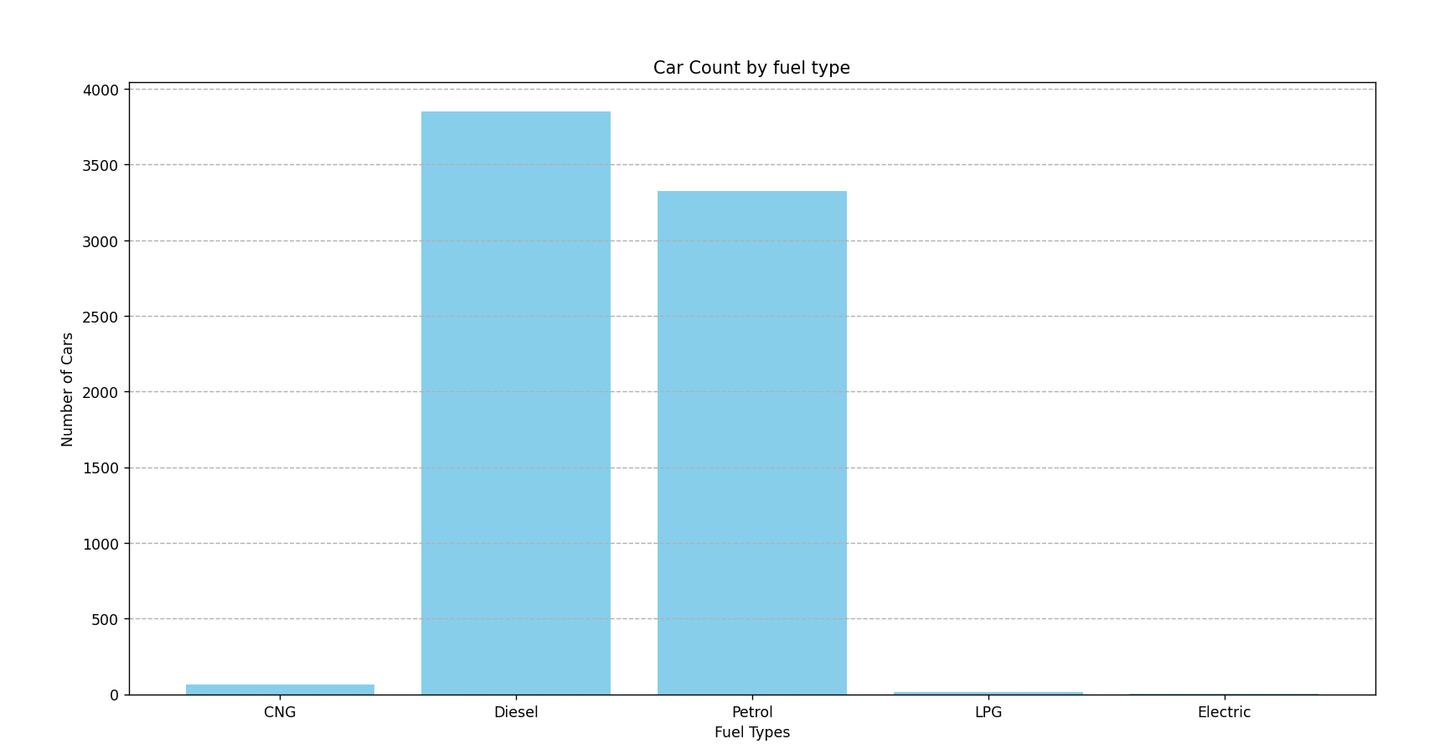
output:

#without for loop bar graph
df = pd.read_csv("C:/Users/BHAKTI/OneDrive/Desktop/SCOE/MLL/archive/used_cars_data.csv")
df.Fuel_Type.value_counts()

plt.figure(figsize=(8,10))
plt.bar(fuel_types,counts,color='red')
plt.xlabel("Fuel Type")
plt.ylabel("Number of Cars")
plt.title("Car Count by Fuel Type")
plt.grid(axis='y',linestyle='--')
plt.show()
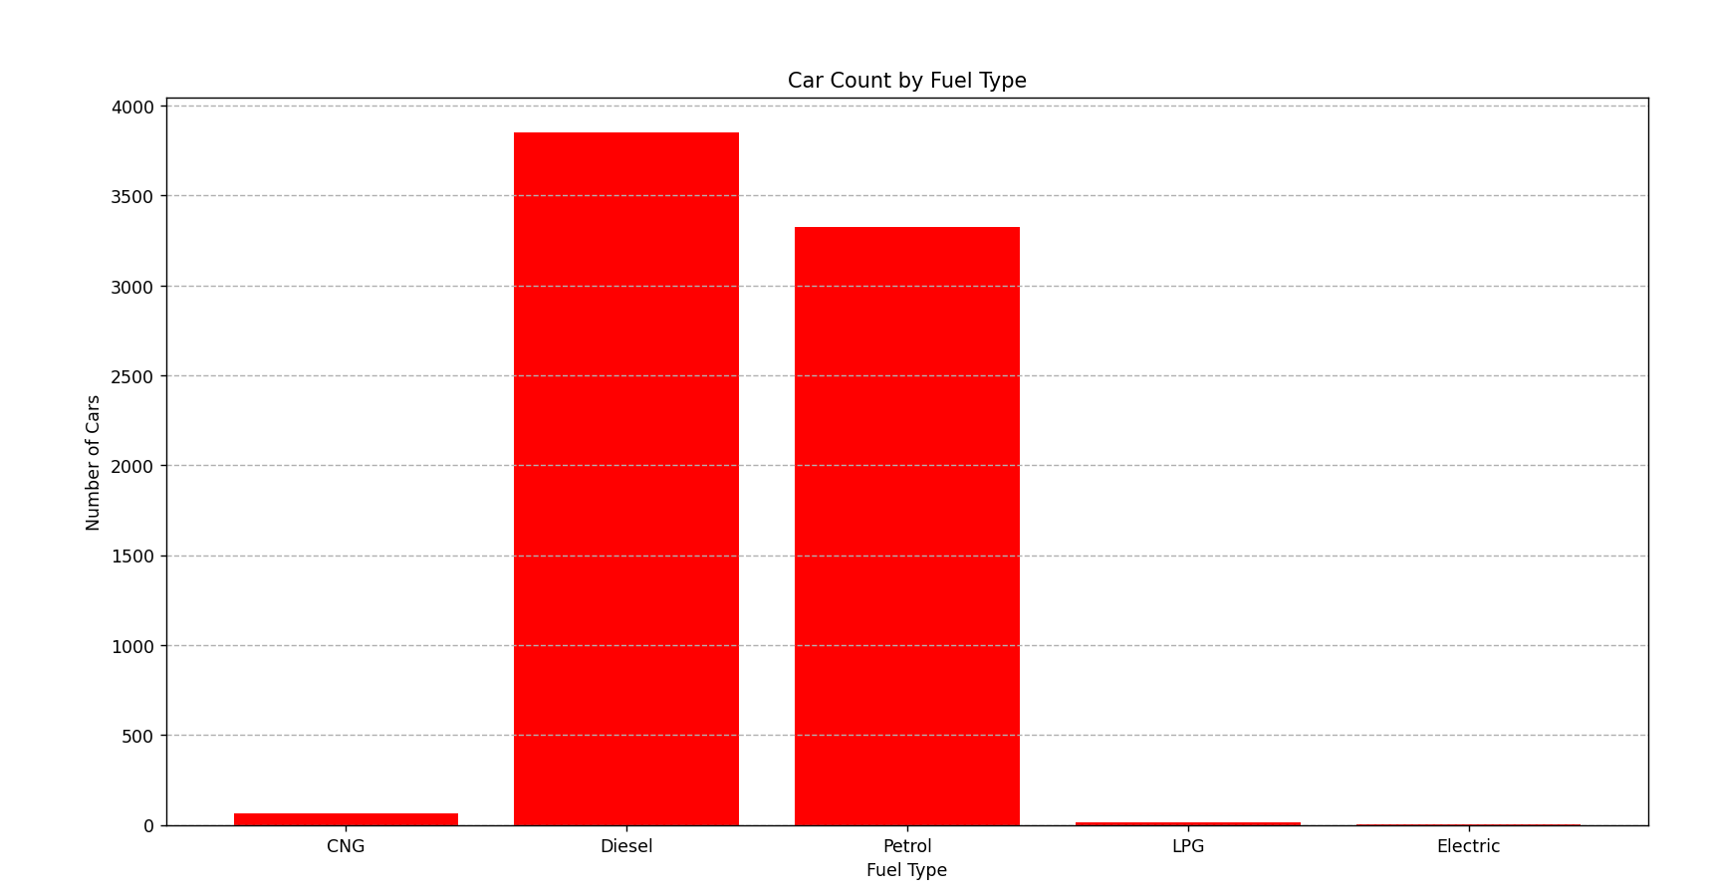
output:

#pie chart
df = pd.read_csv("C:/Users/BHAKTI/OneDrive/Desktop/SCOE/MLL/archive/used_cars_data.csv")
count = df['Owner_Type'].value_counts()
label = count.index
color = {'red','yellow','purple','orange'}
plt.pie(count,labels=label,colors=color)
plt.title("Car Count by there Owners")
plt.axis('equal')
plt.show()

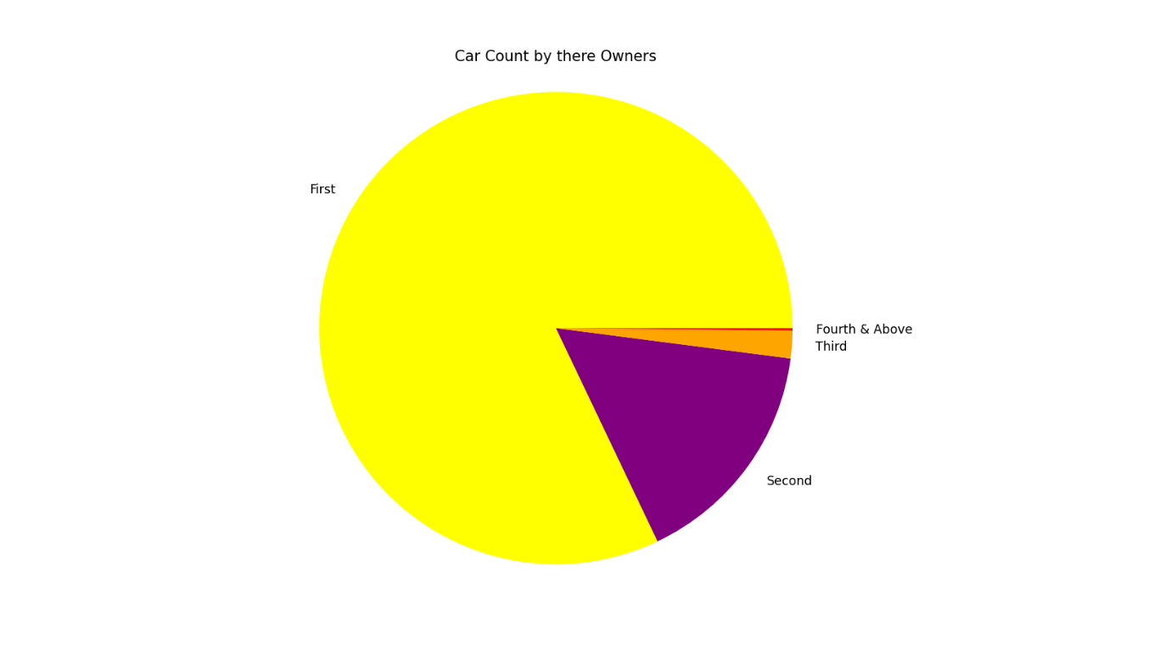
output:

#histogram
df = pd.read_csv("C:/Users/BHAKTI/OneDrive/Desktop/SCOE/MLL/archive/used_cars_data.csv")
fuel_types = df['Fuel_Type'].dropna().unique()
plt.figure(figsize=(8,10))

for fuel in fuel_types:
prices = df[df['Fuel_Type']==fuel]['Price'].dropna()
plt.hist(prices,bins=15, alpha=0.5,label=fuel,edgecolor='black')

plt.title('Price Distubution by car count')
plt.xlabel('Price')
plt.ylabel('Car Count')
plt.legend()
plt.grid(axis='y',linestyle='--')
plt.show()
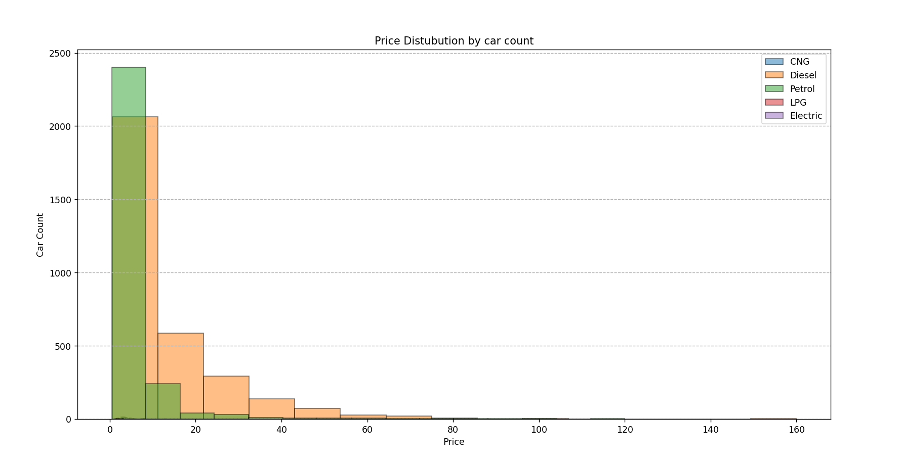
output:

#Scatter Graph
df = pd.read_csv("C:/Users/BHAKTI/OneDrive/Desktop/SCOE/MLL/archive/used_cars_data.csv")
plt.scatter(data=df, x = 'Location' , y ='Kilometers_Driven')
plt.title('Location vs Fuel_Type')
plt.xlabel('Location')
plt.ylabel('Fuel_Type')
plt.legend()
plt.grid()
plt.show()

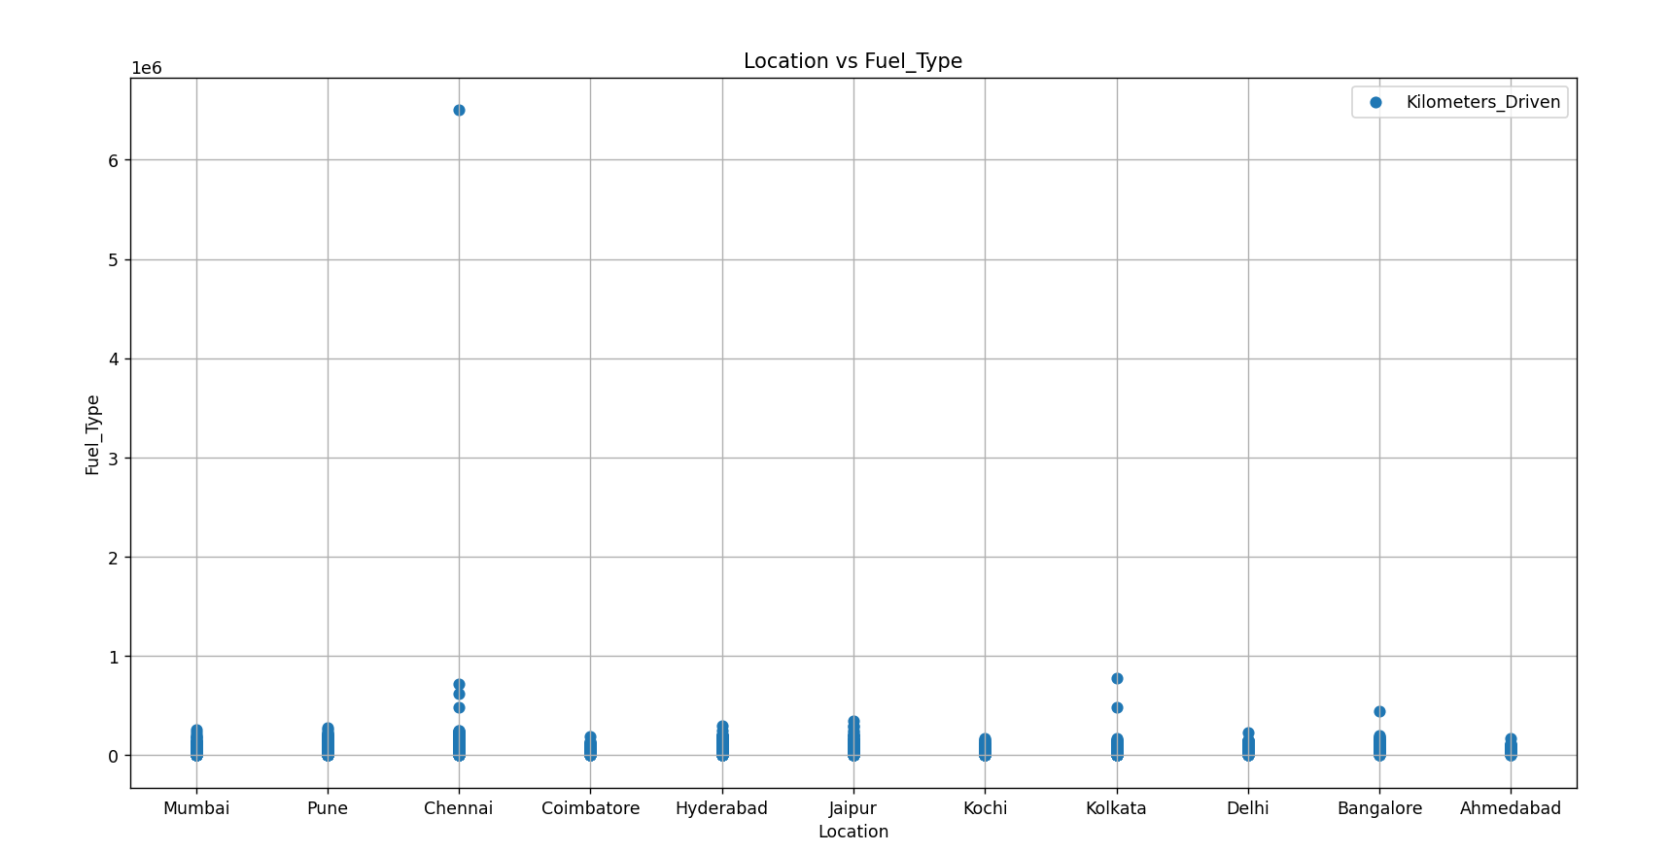
output:

