Name: Bhakti Santosh Shinde
Class: TY A
Batch: A1
Roll no: 16
PRN: 0124UITF1016
Subject: Machine Learning Lab
Assignment 1: Exploratory data analysis (EDA). Downloading the dataset and perform cleaning of data. Data analysis and Visualization using NumPy, Pandas, Matplotlib/Seaborn, SciPy.

import pandas as pd
import matplotlib.pyplot as plt
import seaborn as sns
from sklearn.linear_model import LinearRegression
from sklearn.model_selection import train_test_split
from sklearn.metrics import mean_squared_error ,r2_score,mean_absolute_error,root_mean_squared_error

df = pd.read_csv("C:/Users/BHAKTI/OneDrive/Desktop/SCOE/MLL/archive/Salary_Data.csv")

# Remove rows having missing values
df = df.dropna(subset=['Years of Experience', 'Salary'])

print("Head()\n")#print head
print(df.head())

print("Tail()\n")#print tail
print(df.tail())

print("describe() Function\n")#describe all dataset
print(df.describe())

#Print Scatter Plot
plt.scatter(df['Years of Experience'], df['Salary'], color='lightblue')
plt.title('Salary vs Experience')
plt.xlabel('Years of Experience')
plt.ylabel('Salary')
plt.box(False)
plt.show()

X = df[['Years of Experience']]
y = df['Salary']

X_train, X_test, y_train, y_test = train_test_split(
X, y, test_size=0.2, random_state=0
)

#draw Regreesion Line
lm = LinearRegression()
lm.fit(X_train, y_train)

y_pred_test = lm.predict(X_test)
y_pred_train = lm.predict(X_train)

plt.scatter(X_train, y_train, color = 'orange')
plt.plot(X_train, y_pred_train, color = 'blue')
plt.title('Salary vs Experience (Training Set)')
plt.xlabel('Years of Experience')
plt.ylabel('Salary')
plt.legend(['X_train/Pred(y_test)', 'X_train/y_train'], title = 'Sal/Exp', loc='best', facecolor='pink')
plt.show()

print()
print(f'Coefficient: {lm.coef_}')#print Coefficient
print(f'Intercept: {lm.intercept_}')#print intercept

mean_suq = mean_squared_error(y_test, y_pred_test)#print mean Square root error
mean_abs= mean_absolute_error(y_test, y_pred_test)#print Mean Absolute Error
r_squ = r2_score(y_test, y_pred_test)#print R square error
root_mean_squ= root_mean_squared_error(y_test,y_pred_test)#print Root mean Square Error

print("mean squared error:",mean_suq)
print("mean absolute error:",mean_abs)
print("R-squared:",r_squ)
print("Root Mean Square Error :",root_mean_squ)

Output:
PS C:\Users\BHAKTI\OneDrive\Desktop\SCOE\MLL> python -u "c:\Users\BHAKTI\OneDrive\Desktop\SCOE\MLL\ASS_2.py"
Head()

Age Gender Education Level Job Title Years of Experience Salary
0 32.0 Male Bachelor's Software Engineer 5.0 90000.0
1 28.0 Female Master's Data Analyst 3.0 65000.0
2 45.0 Male PhD Senior Manager 15.0 150000.0
3 36.0 Female Bachelor's Sales Associate 7.0 60000.0
4 52.0 Male Master's Director 20.0 200000.0
Tail()

Age Gender Education Level Job Title Years of Experience Salary
6699 49.0 Female PhD Director of Marketing 20.0 200000.0
6700 32.0 Male High School Sales Associate 3.0 50000.0
6701 30.0 Female Bachelor's Degree Financial Manager 4.0 55000.0
6702 46.0 Male Master's Degree Marketing Manager 14.0 140000.0
6703 26.0 Female High School Sales Executive 1.0 35000.0
describe() Function

Age Years of Experience Salary
count 6699.000000 6699.000000 6699.000000
mean 33.622033 8.095014 115326.964771
std 7.615646 6.059853 52786.183911
min 21.000000 0.000000 350.000000
25% 28.000000 3.000000 70000.000000
50% 32.000000 7.000000 115000.000000
75% 38.000000 12.000000 160000.000000
max 62.000000 34.000000 250000.000000

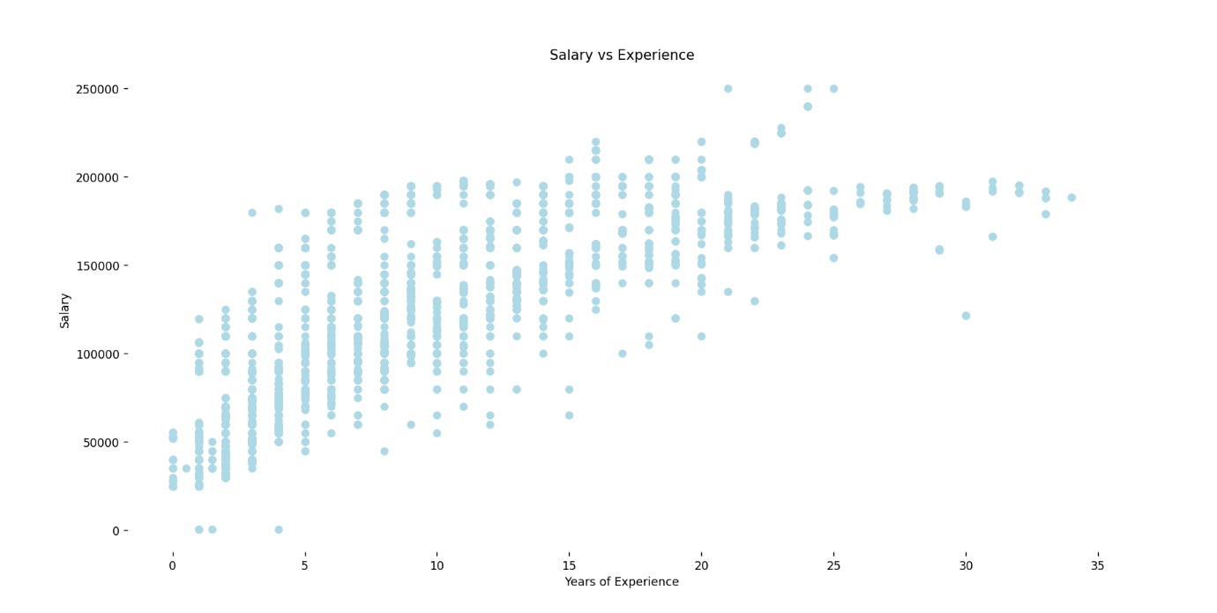

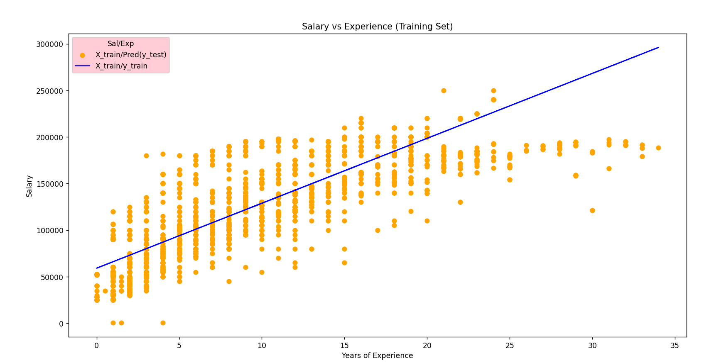

Coefficient: [6969.90703542]
Intercept: 59138.37405340014
mean squared error: 914377037.0373569
mean absolute error: 24796.137171118968
R-squared: 0.6738736688258411
Root Mean Square Error : 30238.667911092856

