Name: Bhakti Santosh Shinde
Class: TY
Div: A
Batch: A1
Roll no.:16
PRN No.:0124UITF1016
Assignment 5

#--------------------Import Libraries---------------------
import pandas as pd
from sklearn.tree import DecisionTreeClassifier, plot_tree
from sklearn.model_selection import train_test_split
from sklearn import metrics
import matplotlib.pyplot as plt

#--------------------Load Dataset---------------------
df = pd.read_csv("C:/Users/BHAKTI/OneDrive/Desktop/SCOE/MLL/archive/diabetes.csv")

#--------------------Select Features---------------------
feature_cols = ['Pregnancies','Insulin','BMI','Age','Glucose','BloodPressure','DiabetesPedigreeFunction']

X = df[feature_cols]
y = df['Outcome']

#--------------------Split Dataset---------------------
X_train, X_test, y_train, y_test = train_test_split(X,y,test_size=0.2,random_state=5)

#--------------------Create Original Decision Tree---------------------
clf = DecisionTreeClassifier(random_state=5)

clf.fit(X_train, y_train)

#--------------------Prediction---------------------
y_pred = clf.predict(X_test)

#--------------------Performance---------------------
print(" ORIGINAL DECISION TREE ")
print()
print("************************************************************************************************************************")
print()

print("Accuracy:", metrics.accuracy_score(y_test, y_pred))
print()
print("************************************************************************************************************************")
print()
print("Recall:", metrics.recall_score(y_test, y_pred))
print()
print("************************************************************************************************************************")
print()
print("F1 Score:", metrics.f1_score(y_test, y_pred))
print()
print("************************************************************************************************************************")
print()
print("Precision:", metrics.precision_score(y_test, y_pred))
print()
print("************************************************************************************************************************")
print()

print("Tree Depth:", clf.get_depth())
print()
print("************************************************************************************************************************")
print()
print("Tree Leaves:", clf.get_n_leaves())
print()
print("************************************************************************************************************************")
print()

#--------------------Display Tree---------------------
plt.figure(figsize=(20, 10))

plot_tree(clf,feature_names=feature_cols,class_names=['0', '1'],filled=True,rounded=True,fontsize=9)

plt.title("Original Decision Tree - Without Pruning")

plt.savefig("diabetes_original.png",dpi=300,bbox_inches="tight")

plt.show()

OUTPUT
ORIGINAL DECISION TREE

************************************************************************************************************************

Accuracy: 0.6818181818181818

************************************************************************************************************************

Recall: 0.6296296296296297

************************************************************************************************************************

F1 Score: 0.5811965811965812

************************************************************************************************************************

Precision: 0.5396825396825397

************************************************************************************************************************

Tree Depth: 13

************************************************************************************************************************

Tree Leaves: 117

************************************************************************************************************************

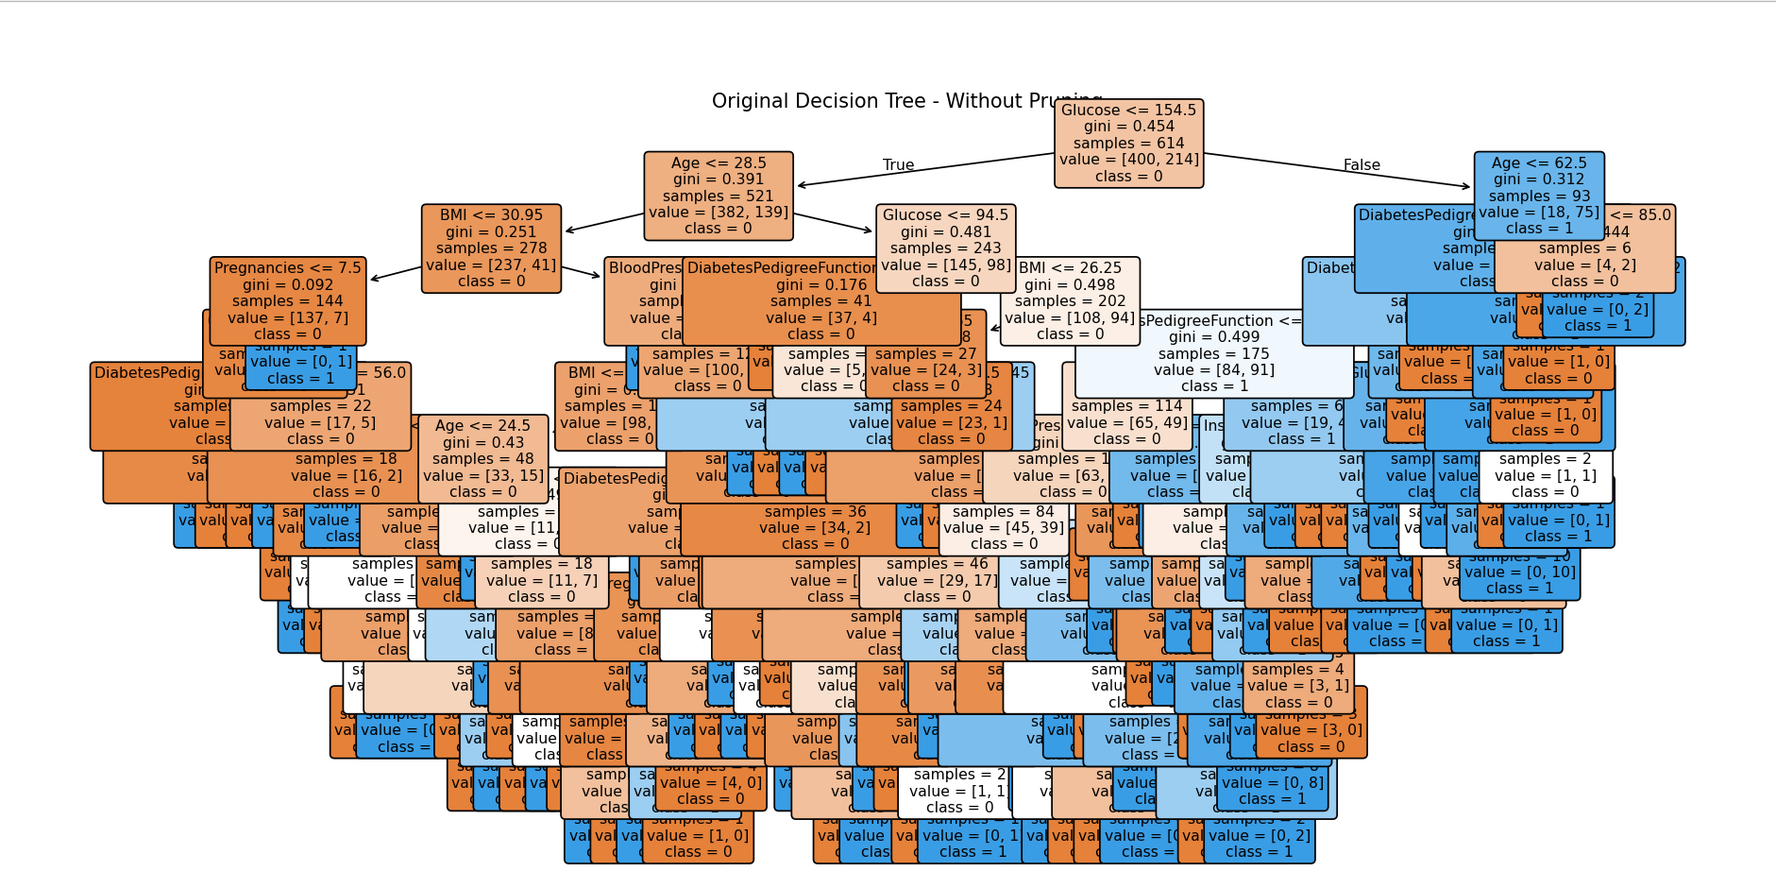

*******************PRE PRUNING*********************

#--------------------Import Libraries---------------------
import pandas as pd
from sklearn.tree import DecisionTreeClassifier, plot_tree
from sklearn.model_selection import train_test_split
from sklearn import metrics
import matplotlib.pyplot as plt

#--------------------Load Dataset---------------------
df = pd.read_csv("C:/Users/BHAKTI/OneDrive/Desktop/SCOE/MLL/archive/diabetes.csv")

#--------------------Select Features---------------------
feature_cols = ['Pregnancies','Insulin','BMI','Age','Glucose','BloodPressure','DiabetesPedigreeFunction']

X = df[feature_cols]
y = df['Outcome']

#--------------------Split Dataset---------------------
X_train, X_test, y_train, y_test = train_test_split(X,y,test_size=0.2,random_state=5)

#--------------------Create PRE-PRUNED Tree---------------------
clf = DecisionTreeClassifier(max_depth=3,min_samples_split=10,min_samples_leaf=5,random_state=5)

#--------------------Train Model---------------------
clf.fit(X_train, y_train)

#--------------------Prediction---------------------
y_pred = clf.predict(X_test)

#--------------------Performance---------------------
print("PRE-PRUNED DECISION TREE")

print()
print("************************************************************************************************************************")
print()

print("Accuracy:", metrics.accuracy_score(y_test, y_pred))
print()
print("************************************************************************************************************************")
print()
print("Recall:", metrics.recall_score(y_test, y_pred))
print()
print("************************************************************************************************************************")
print()
print("F1 Score:", metrics.f1_score(y_test, y_pred))
print()
print("************************************************************************************************************************")
print()
print("Precision:", metrics.precision_score(y_test, y_pred))
print()
print("************************************************************************************************************************")
print()
print("Tree Depth:", clf.get_depth())
print()
print("************************************************************************************************************************")
print()
print("Tree Leaves:", clf.get_n_leaves())
print()
print("************************************************************************************************************************")
print()

#--------------------Display Tree---------------------
plt.figure(figsize=(20, 10))

plot_tree(clf,feature_names=feature_cols,class_names=['0', '1'],filled=True,rounded=True,fontsize=9)

plt.title("Pre-Pruned Decision Tree")

plt.savefig("diabetes_pre_pruned.png",dpi=300,bbox_inches="tight")

plt.show()

OUTPUT:

PRE-PRUNED DECISION TREE

************************************************************************************************************************

Accuracy: 0.7597402597402597

************************************************************************************************************************

Recall: 0.42592592592592593

************************************************************************************************************************

F1 Score: 0.5542168674698795

************************************************************************************************************************

Precision: 0.7931034482758621

************************************************************************************************************************

Tree Depth: 3

************************************************************************************************************************

Tree Leaves: 7

************************************************************************************************************************


