REMOTE PATIENT RISK MONITORING SYSTEM USING IoT

Final Project Report

Submitted By
Bhakti Jaiswal
Internship: Embedded Firmware & IoT
Platform: Elevance Skills
Duration: 2 Months

2026

TABLE OF CONTENTS

- ABSTRACT
- OBJECTIVES
- HARDWARE USED
- SOFTWARE USED
- SYSTEM ARCHITECTURE
- TASK IMPLEMENTATION
- FREERTOS TASK SUMMARY
- MQTT COMMUNICATION
- SAFETY FEATURES
- RESULTS
- FUTURE ENHANCEMENTS
- CONCLUSION
- APPENDIX

1. ABSTRACT
The Remote Patient Risk Monitoring System is an IoT-based healthcare monitoring solution developed using ESP32, FreeRTOS, Adafruit IO, and Wokwi simulation. The system continuously monitors patient health parameters such as Heart Rate, SpO₂, Body Temperature, Blood Pressure, Oxygen Level, Room Temperature, and Air Quality Index (AQI).
The project enables real-time cloud monitoring through Adafruit IO dashboards while simultaneously providing local monitoring on an OLED display. FreeRTOS multitasking is used to execute multiple sensing, monitoring, communication, and control tasks concurrently. The system also incorporates smart medication dosage adjustment, intelligent bed elevation control, adaptive sampling rate, and advanced offline data buffering to improve patient safety and system reliability.

2. OBJECTIVES
The major objectives of this project are:
- Develop a real-time patient monitoring system.
- Monitor multiple health parameters simultaneously.
- Implement multitasking using FreeRTOS.
- Provide remote cloud monitoring using Adafruit IO.
- Improve patient safety using automatic alerts.
- Implement smart medication dosage control.
- Control hospital bed elevation remotely.
- Adjust monitoring frequency dynamically.
- Store data safely during network failures.

HARDWARE USED

Component | Purpose
ESP32 DevKit V1 | Main Controller
OLED SSD1306 Display | Display patient information
Servo Motor | Bed angle control
DS18B20 Sensor (Body) | Body Temperature
DS18B20 Sensor (Room) | Room Temperature
Potentiometer | Oxygen Simulation
Potentiometer | AQI Simulation
Potentiometer | Blood Pressure Simulation
LED | Warning Indicator
Buzzer | Emergency Alert

SOFTWARE USED
- Arduino IDE
- Wokwi Simulator
- ESP32 Arduino Framework
- FreeRTOS
- Adafruit IO
- MQTT Protocol
- Embedded C++

5. SYSTEM ARCHITECTURE
The system consists of three major modules:

5.1 Patient Monitoring Module
Measures:
- Heart Rate
- SpO₂
- Body Temperature
- Blood Pressure

5.2 Environment Monitoring Module
Measures:
- Room Temperature
- Oxygen Level
- Air Quality Index

5.3 Cloud Monitoring Module
Transfers sensor readings to Adafruit IO dashboards through MQTT.

6.TASK IMPLEMENTATION

6.1 Task 1 — Multi-Sensor Expansion using FreeRTOS
Description: Multiple FreeRTOS tasks are created for concurrent execution.
Implemented Tasks:
- Sensor Task
- Environment Task
- Blood Pressure Task
- MQTT Publish Task
- Connection Monitor Task
- Alert Task
- Dosage Task
- Bed Control Task
- OLED Task
- Aggregation Task
FreeRTOS Features Used:
- Queue
- Mutex
- Semaphore
- Watchdog Timer
- Priority Scheduling
Outcome: Multiple sensors run simultaneously without blocking each other.

6.2 Task 2 — Dual Role IoT Monitoring
Two categories of information are monitored.
Medical Dashboard displays:
- Heart Rate
- SpO₂
- Body Temperature
Facility Dashboard displays:
- Room Temperature
- Oxygen Level
- AQI
MQTT Feeds:
- heart-rate
- spo2
- body-temp
- room-temp
- oxygen-level
- aqi
- alerts
Alerts: The system automatically sends alerts whenever abnormal patient or environmental conditions are detected.

6.3 Task 3 — Smart Medication Dosage Adjustment
The medication dosage module allows healthcare staff to remotely update medication dosage values.
Features:
- Safe dosage limits
- Smooth dosage transition
- OLED display of dosage
- LED warning indication
- Buzzer alert for critical dosage
- Critical dosage detection
Safety: The dosage changes gradually rather than instantly, reducing sudden medication changes.

6.4 Task 4 — Intelligent Bed Elevation Control
The system provides automatic and manual hospital bed adjustment.
Operating Modes:
- Sleep Mode — Bed Angle = 10°
- Breathing Mode — Bed Angle = 45°
- Emergency Mode — Bed Angle = 90°
- Manual Mode — Bed angle can also be adjusted remotely
Safety: Critical patient conditions automatically elevate the bed to improve breathing.

6.5 Task 5 — Smart Dynamic Sampling Rate
Instead of fixed sampling intervals, the monitoring rate changes dynamically.
Patient Condition | Sampling Interval
Normal Patient | Every 60 seconds
Moderate Risk | Every 30 seconds
Critical Patient | Every 5 seconds

Advantages:
- Reduces network traffic
- Saves processor time
- Improves emergency response

6.6 Task 6 — Advanced Offline Detection
The system continuously checks WiFi Connection and MQTT Connection.
Operating States: ONLINE, DEGRADED, OFFLINE
Features:
- Offline data buffering
- Automatic cloud synchronization
- Exponential reconnect algorithm
- Offline OLED indication
- Audible warning

7. FREERTOS TASK SUMMARY
Task | Function
Sensor Task | Reads patient sensors
Environment Task | Reads environmental sensors
Extra Vital Task | Blood pressure monitoring
MQTT Publish Task | Uploads data to cloud
Connection Monitor Task | WiFi & MQTT monitoring
Alert Task | Sends cloud alerts
Dosage Task | Medication control
Bed Control Task | Servo control
OLED Task | Updates OLED
Aggregation Task | Creates periodic summaries

8. MQTT COMMUNICATION

8.1 Publish Topics
- heart-rate
- spo2
- body-temp
- room-temp
- oxygen-level
- aqi
- alerts

8.2 Subscribe Topics
- dosage
- bed-control
- sampling-control

9. SAFETY FEATURES
- Continuous health monitoring
- Environmental monitoring
- LED warning
- Buzzer alert
- Smart dosage control
- Automatic bed positioning
- Offline data storage
- Automatic cloud synchronization
- FreeRTOS Watchdog
- Queue based communication

10. RESULTS
The developed Remote Patient Risk Monitoring System successfully demonstrates:
- Multi-task execution using FreeRTOS
- Simultaneous monitoring of multiple sensors
- Cloud connectivity using MQTT
- Real-time dashboard visualization
- OLED based local monitoring
- Adaptive monitoring frequency
- Offline data handling
- Automatic alert generation
- Smart healthcare automation

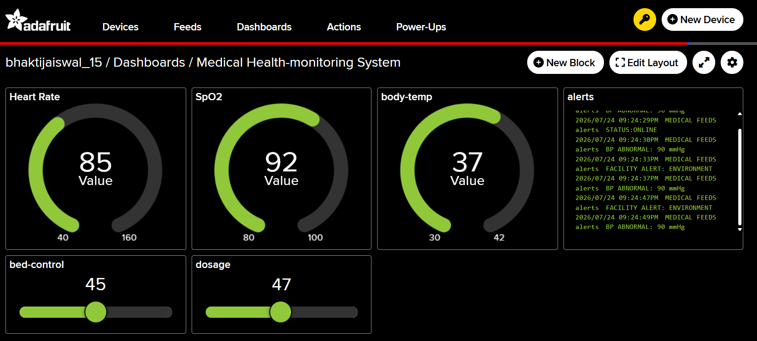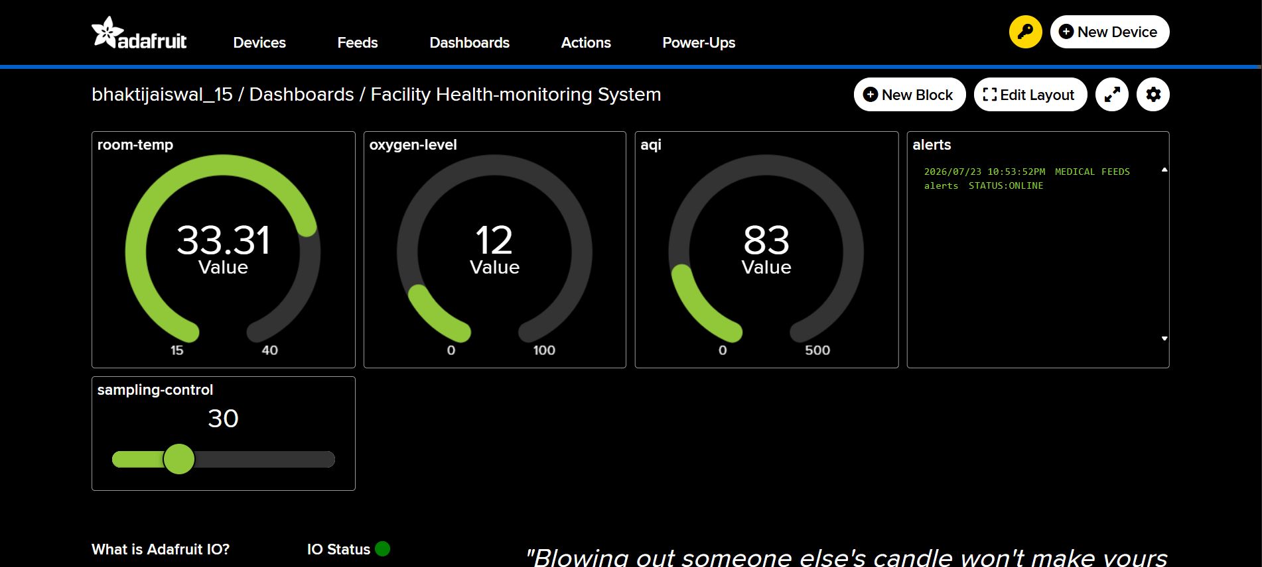

CIRCUIT

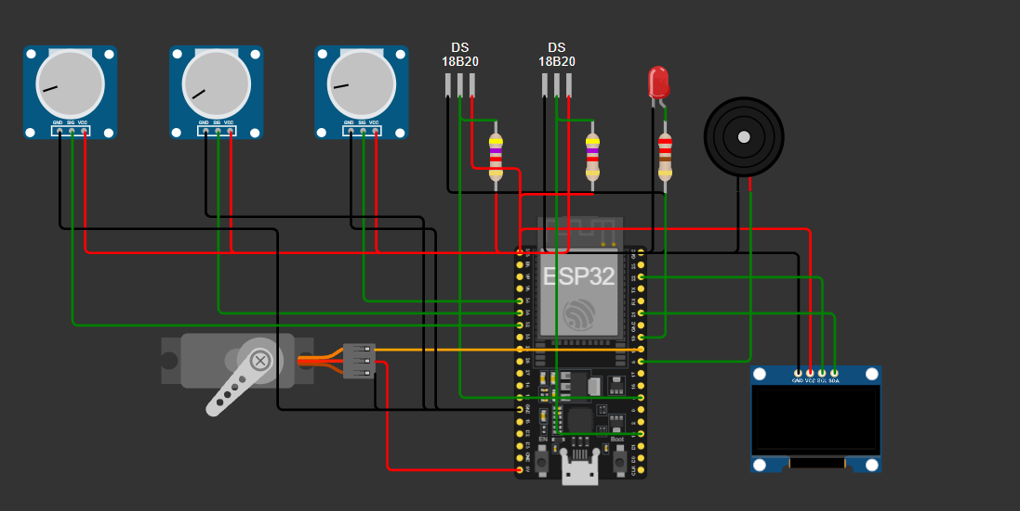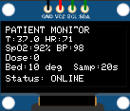

SERIAL MONITOR

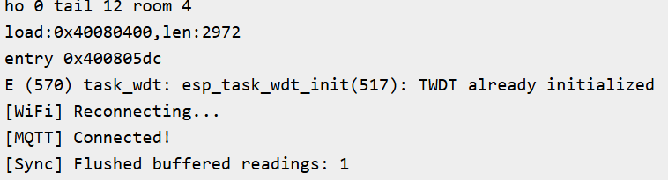

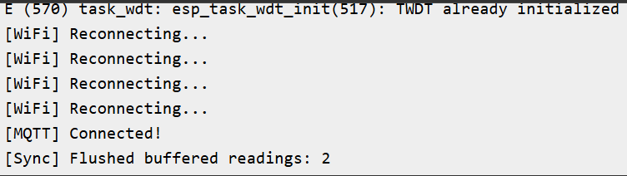

11. FUTURE ENHANCEMENTS
- ECG Sensor Integration
- Real Pulse Sensor
- GSM Based Emergency SMS
- Mobile Application
- AI Based Patient Risk Prediction
- Hospital Database Integration
- Doctor Notification System
- Electronic Health Records (EHR)

12. CONCLUSION
The Remote Patient Risk Monitoring System successfully demonstrates an IoT-enabled healthcare monitoring platform using ESP32, FreeRTOS, and MQTT communication. The project supports concurrent execution of multiple sensing and communication tasks, real-time visualization through cloud dashboards, adaptive sampling, intelligent alert mechanisms, medication dosage control, and remote bed elevation. These features collectively improve patient monitoring efficiency, increase system reliability during network interruptions, and provide a scalable foundation for future smart healthcare applications.

13. APPENDIX
The following items should be inserted here before final submission:
- Circuit diagram (exported from Wokwi)
- System flowchart
- Adafruit IO dashboard screenshots
- OLED display screenshots
- Arduino IDE Serial Monitor screenshots
- Key code snippets for each FreeRTOS task
- Testing results / observation table
- References
- Full source code listing

