**Layout using Bootstrap**

**Program:**

a.html:

<!DOCTYPE html>

<html>

  <head>

    <meta charset="utf-8">

    <title>CS193X: Squarespace layout, finished (non-responsive)</title>

    <link href="https://fonts.googleapis.com/css?family=Lora:400,400i|Open+Sans:400,700" rel="stylesheet">

    <link rel="stylesheet" href="style.css">

  </head>

  <body>

    <header>

        <h1 style="font-family: 'Times New Roman', Times, serif;font-size: 1.5CM;">TRIVIA!</h1>

    </header>

    <section>

      <div id="main">

        <h2 style="color: black;text-align: left;font-family:'Times New Roman', Times, serif, sans-serif;">Part 1: Multiple Choice</h2>

        <hr>

      </div>

         <h3 style="font-family:Arial, Helvetica, sans-serif;;color: black;text-align: left;">What is the currency of Denmark?</h3>

         <h3 style="text-align: left;">

         <button type="button" class="btn btn-primary" style="background-color: rgb(195, 222, 245);" >a) Dollar </button>

         <button type="button" class="btn btn-secondary" style="background-color: rgb(195, 222, 245);">b) Krone</button>

         <button type="button" class="btn btn-success" style="background-color: rgb(195, 222, 245);">c) Rupees</button>

         <button type="button" class="btn btn-danger" style="background-color: rgb(195, 222, 245);">d) Dobra</button>

         </h3>

             <BR>

          <div id="main">

            <h2 style="color: black;text-align: left;font-family:'Times New Roman', Times, serif;">Part 2: Free Response</h2>

            <hr>

          </div>

          <h3 style="font-family:Arial, Helvetica, sans-serif;color: black;text-align: left;">Continental United States has 4 time zones, can you name them?</h3>

          <h3 style="text-align: left;">

          <input id="bhakti"></input>

          <button id="b1" name="Check" left="b1" style="background-color: rgb(195, 222, 245);">Check Answer</button>

          </h3>

    </section>

  </body>

</html>

Style.css:

header {

  color: white;

  background-color:rgb(120, 203, 241);

  background-size: cover;

  background-position: center;

  height: 250px;

  position: relative;

  display: flex;

  flex-direction: column;

  align-items: center;

  justify-content: center;

}

section {

  margin: 100px 125px;

  text-align: left;

}

**Output:**

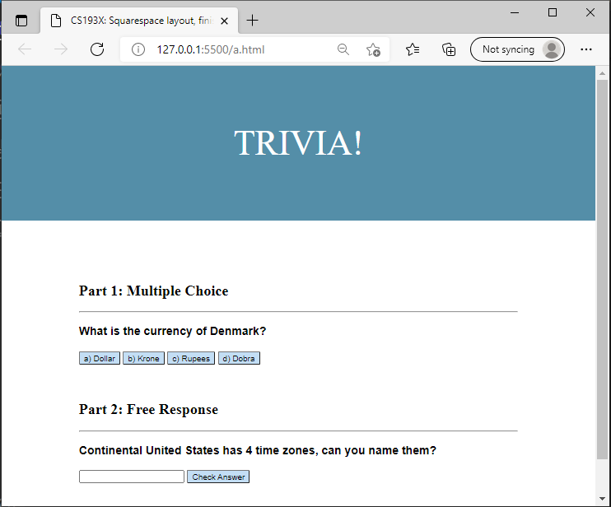

**Conclusion:**

# Thus, we successfully design Layout using Bootstrap.