CS6360 Fall 2016

Assignment 4

Now that you have designed the database for a contact manager, your next task is to write a scaled-back contact manager program. Ideally, your program would have table-maintenance dialogs for every actual data table other than those linked to the contact itself. Since that isn’t practical, create a screen that lets you add, change, and delete contacts. The purpose of this assignment is for you to learn how to interface to a database from within a program.

Add, change, and delete can work with a limited set of tables, although obviously if someone adds complete contact information, include an address, multiple phone numbers, multiple e-mail addresses, and so on, this could end up affecting multiple tables. Keep your program as simple as possible while meeting the criteria. Stored procedures will help greatly.

Always maintain referential integrity both at the database level and at the level of your program; that is, only allow delete of a secondary table item if there are no references to it. Here is a sample screen for this, using the Company database from the text. Obviously you should use your own database.

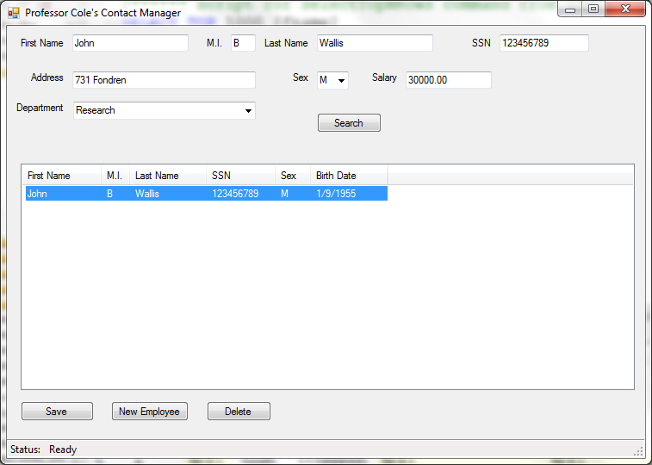

Allowable languages are Java and C#. If you enjoy a challenge and have lots of time, C++ will work too, with MFC. If you use C#, you may not use LINQ; you must actually create the queries or calls to a stored procedure.

If you write in C#, hand in your entire project. If you write in Java, hand in only your .java source files. You will also be required to show your program to the TA to verify functionality. If you have a notebook computer, bring that in. If not, we can set up your database on a UTD system and run your program from a USB drive.

|  |  |
| --- | --- |
| Grading Criteria | |
| Program allows add, change, delete of contacts | 50% |
| Program rejects invalid input | 30% |
| Program is not vulnerable to injected SQL attacks | 10% |
| Program comments meet standards | 10% |
| Total | 100% |