**Assignment 1 – Power BI Installation**

* **Power BI Desktop views**

**Report view -** This is where you can create any number of report pages with visualizations. You can move visualizations around, copy and paste, merge, and so on.

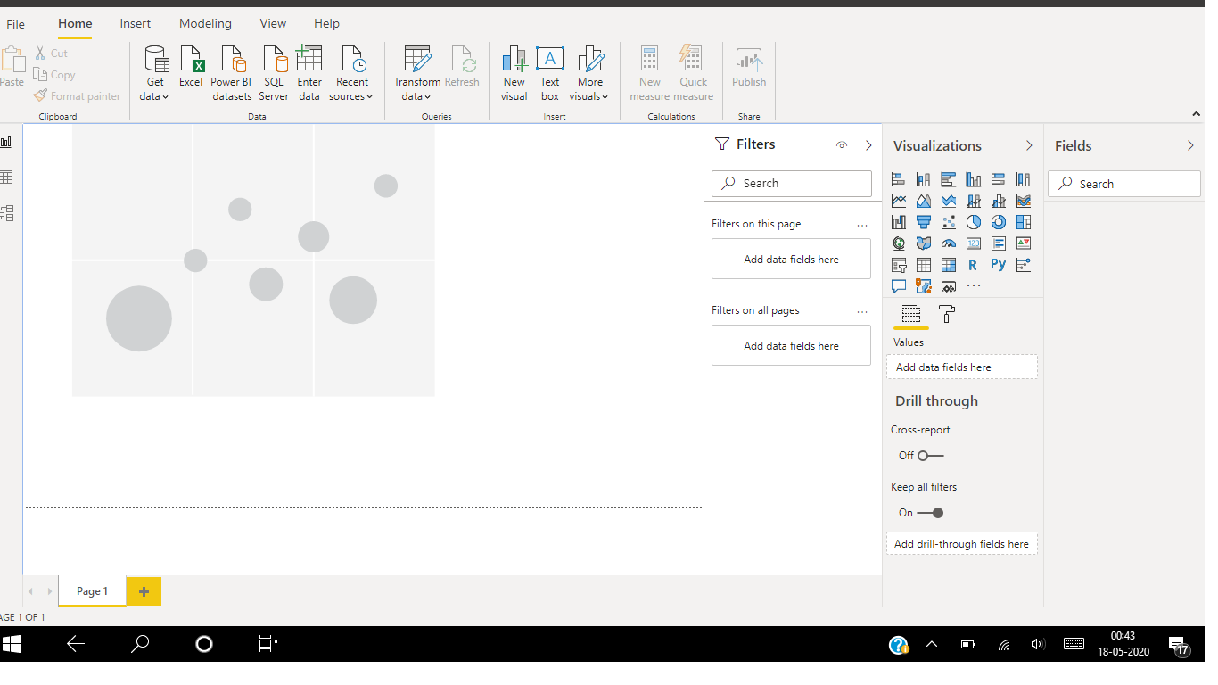

**Data view –** It helps you inspect, explore, and understand data. With Data view, you're looking at your data after it has been loaded into the model.

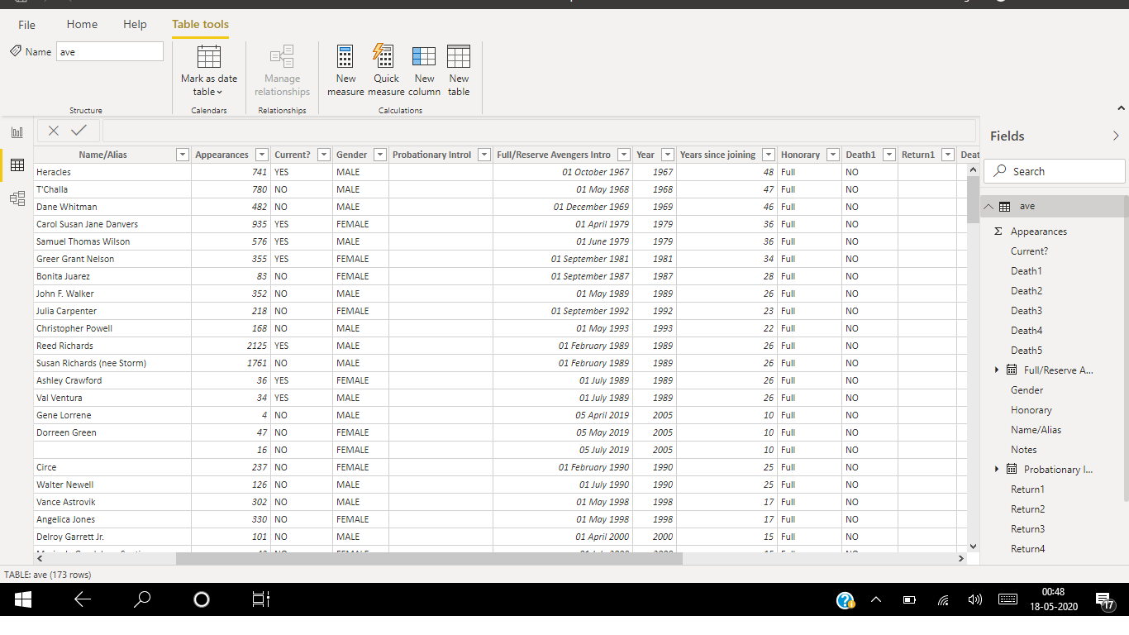

**Model view -** It shows all of the tables, columns, and relationships in your model. This view can be especially helpful when your model has complex relationships between many tables.

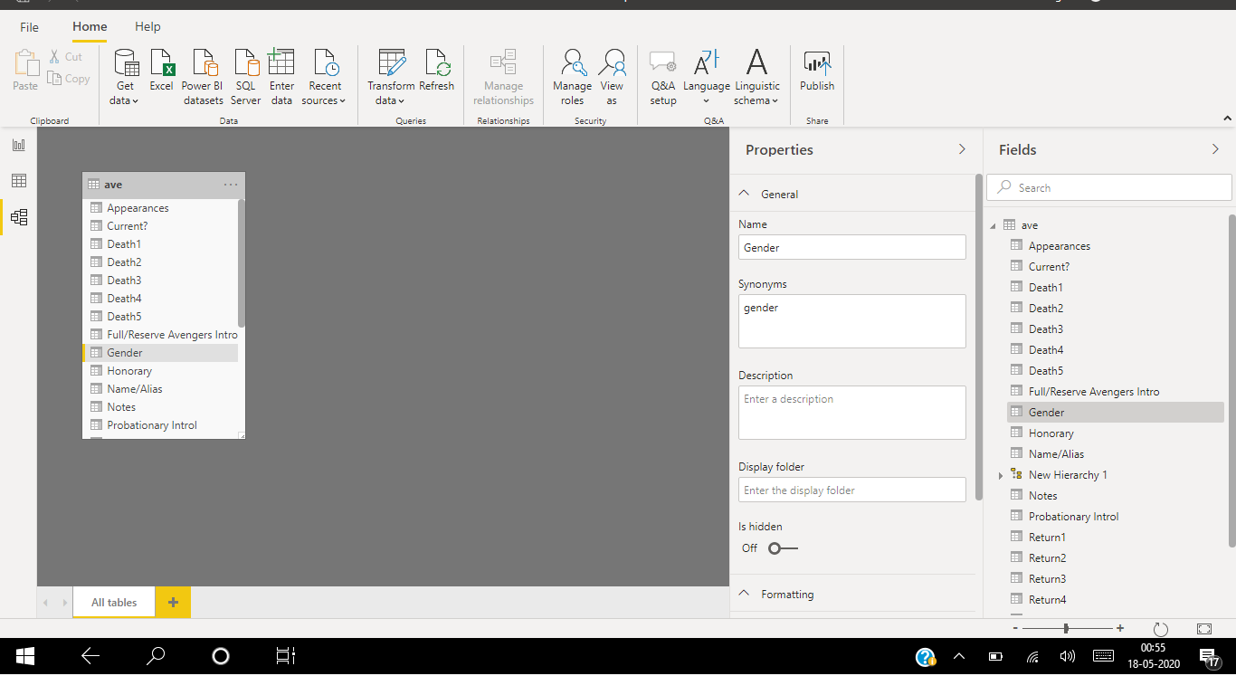

**Query Editor -** It is used to transform or edit data files before they are actually loaded into the **Power BI**. The **Query Editor** plays the role of an intermediate data container where you can modify data by selecting rows and columns, splitting rows and columns, pivoting and unpivoting columns, etc.

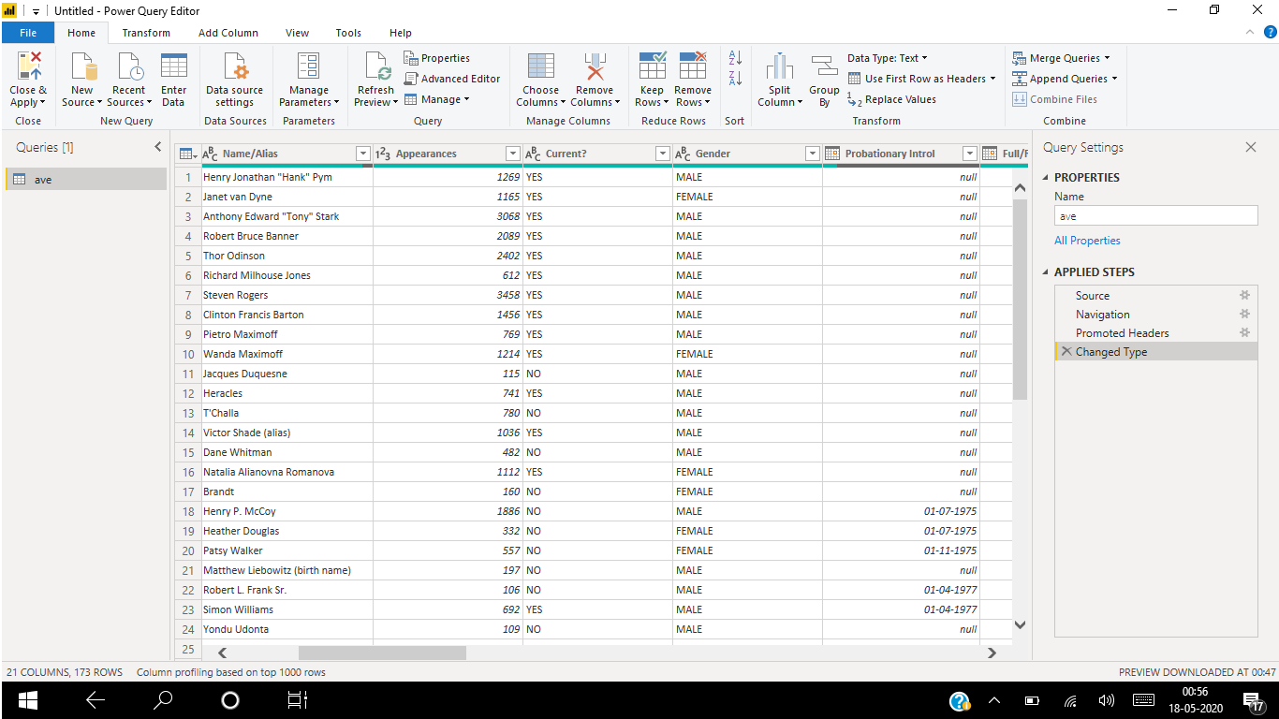

**Advance Editor -** It lets you see the code that **Power Query Editor** is creating with each step. ... A window appears, showing the existing **query** code.

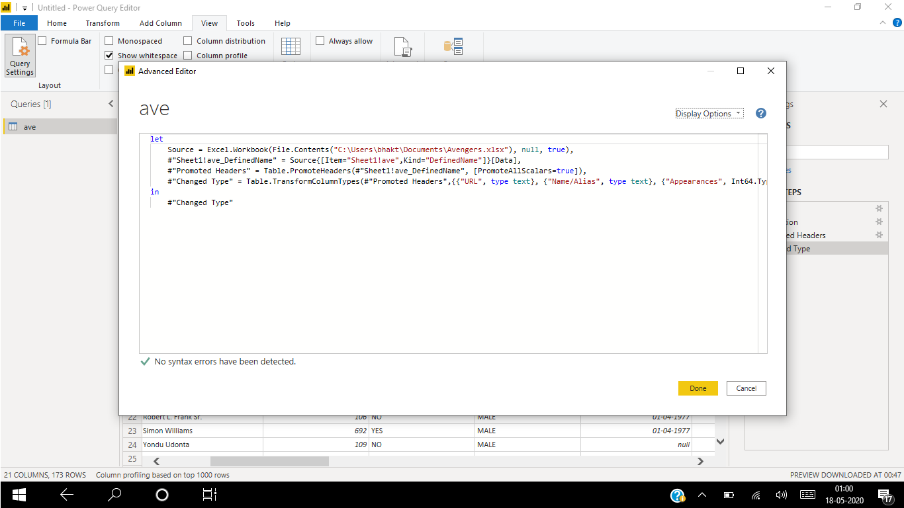

* **Product Details and Pricing**

Power BI comes in three levels – Desktop, Pro, and Premium.

1. **Power BI Desktop -** Power BI Desktop is the free version of Power BI that you can install on your local computer as a program, and acts as a companion desktop application to the full version of Power BI. If you need to consolidate your data sources, create your own reports and conduct your own analysis or test it’s capabilities, it’s the perfect version to start with for all skill levels - whether you’re non-IT and want to make your reports more interactive, or analysts seeking richer detail, it's one of the best business analytics tools to use.

Microsoft has included with Power BI Desktop:

* You can connect and import data from over 70 cloud-based and on-premises sources
* The same rich visualizations and filters from Power BI Pro
* Auto-detect that finds and creates data relationships between tables and formats
* Export your reports to CSV, Microsoft Excel, Microsoft PowerPoint and PDF
* Python support
* Save, upload and publish your reports to the Web and the full Power BI service
* Storage limit of 10 GB per user

Naturally, there are some feature limitations with the free Power BI Desktop that give further incentive to upgrade.

* Can’t share created reports with non-Power BI Pro users
* No App Workspaces
* No API embedding
* No email subscriptions
* No peer-to-peer-sharing
* No support to analyse in Excel within Power BI Desktop

To be very clear: All of Power BI’s basic features - cleaning and preparing data, connectors to data sources, custom reports, visualizations and exports to Microsoft apps are included in Power BI Desktop. Thus, whatever core functionality or features are available in Power BI Desktop are also standard in the higher-tier, paid versions.

**Pricing -** The Desktop level is **free** for individual users.

1. **Power BI Pro -** Power BI Pro is the full version of Power BI, complete with the ability to use Power BI for both building dashboards and reports and unlimited viewing, sharing and consumption of your created reports (and reports shared by others) - the latter not possible with Power BI Desktop.

A breakdown of Power BI Pro’s differences against Power BI Desktop:

* Ability to embed Power BI visuals into apps (PowerApps, SharePoint, Teams, etc)
* Native integration with other Microsoft solutions (Azure Data Services)
* Share datasets, dashboards and reports with other Power BI Pro users
* Can create App Workspaces and peer-to-peer sharing

Power BI Pro is licensed by individual user. For example, if your organization has 20 people that need to full capabilities of self-service BI to create dashboards and reports, you need 20 licenses of Power BI Pro, which gives these users full access to creation of reports and unlimited consumption (viewing) of any created content.

**Pricing -** The Pro plan costs **660 INR** per user per month.

1. **Power BI Premium -** Power BI Premium is the most expensive tier of Power BI currently available and very distinct from the other two versions available on the market.

On top of the features and functionality standard to all versions of the service, users of Power BI Premium get:

* Increased data capacity limits and maximum performance
* Access to one API surface
* Ability to embed Power BI visuals into apps (PowerApps, SharePoint, Teams, etc)
* Larger storage sizes for extended deployments
* Geo distribution, higher refresh rates, isolation, pin to memory, read-only replicas
* Power BI Report Server

Power BI Premium differs from the free version and Power BI pro in its licensing model, which only suits a specific size and type of organization and business scenario. You can purchase Premium in a range of capacity sizes that offer different numbers of memory and virtual cores that can scale as your data analysis requirements change.

**Pricing -** The Premium plan starts at **330,190 INR** a month per dedicated cloud compute and storage resource.