Jeffrey Cruz

11/13/17

CS 361

HW 4: Grammars



## Grammars

*Due on 11/13*

The work has to be done alone or in a group of 2 students.

A hard copy is required. Professional presentation is important.

100 points

**Exercise 1:**

We consider the BNF grammar below:

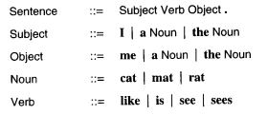

1. Show that **I like the cat.** is recognized by this BNF grammar using a rightmost derivation and, then, a parse tree.

Sentence -> Subject Verb Object -> Subject Verb the Noun -> Subject Verb the cat -> Subject like the cat -> I like the cat

1. Provide an expression that is NOT recognized by the grammar.

I like the dog. This statement is not recognized because Dog is not defined anywhere in this grammar.

**Exercise 2:**

We consider the following grammar:

EXPRESSION ::= NUMERAL | ( EXPRESSION OPERATOR EXPRESSION )

NUMERAL ::= 0 | 1 | 2 | 3 | 4 | 5 | 6 | 7 | 8 | 9

OPERATORS ::= + | -

Show that (4 - (3 + 2)) is a legal EXPRESSION using a leftmost derivation, and,then, a parse tree.

Expression -> (Expression Operator Expression) -> (Numeral Operator Expression) -> (4 Operator Expression) -> (4 – Expression) -> (4 – (Expression Operator Expression)) -> (4 – (Numeral Operator Expression)) -> (4-(3 Operator Expression)) -> (4 – ( 3 + Expression)) -> (4 – (3 + Numeral)) -> (4 – (3+2))

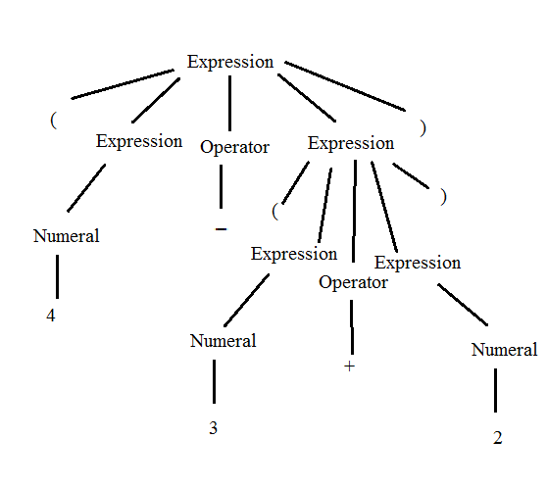

**Exercise 3:**

Show that the following grammar is ambiguous:

X -> a | bX | bXcX

where a,b,c are terminals.

The following grammar is ambigious because there are two different ways to derive/two parse trees we can make for the statement : bbXcX

X -> bX -> bbXcX

X -> bXcX -> bbXcX

**Exercise 4:**

1. Design a BNF grammar that recognizes expressions of the form Ai where A is in {a,b,c} and i is a digit.

i -> 0 | 1 | 2 | 3 | 4 | 5 | 6 | 7 | 8 | 9

A -> a | b | c

Expression -> Ai

1. Design a BNF grammar that recognizes lists of the form A1, A2, A3, …, An. Use question a).

i -> 0 | 1 | 2 | 3 | 4 | 5 | 6 | 7 | 8 | 9

A -> a | b | c

Expression -> Ai

List -> Expression | List, Expression

**Exercise 5:**

1. Write a JAY program that computes the sum of the *n* first numbers with a loop.

void main() {

int n;

int counter;

int sum;

sum = 0;

counter = 0;

while (counter <= n) { 5

sum = sum + counter;

counter = counter + 1

} }

1. Write a JAY program that assigns the minimum of two numbers in a variable called min.

void main() {

int a;

int b;

int min;

if (a < b) { min = a;}

else { min = b; }

}

1. Provide 2 examples of lexical errors in JAY.

4a (Lexical error because Letter Digit is not a definition of anything)

4_ (Lexical error because _ is not in the Jay Lexical Syntax)

1. Provide 2 examples of JAY programs with 2 different syntax errors.

void main(){

int a;

a = 5;

int b; }

This is a syntax error because Jay’s syntax says that a Jay program must have all declarations come before statements.

void main() {

int >;

int b;

int c;

}

This is a syntax error because int >; is not a declaration, a declaration is defined as Type Indentifiers, but > is an operator.

1. Provide 2 examples of JAY programs with errors that are neither detected during the lexical analysis nor during the syntactic analysis.

void main() {

int Num;

int Zero;

int DivideByZero;

Num = 5;

Zero = 0;

DivideByZero = Num/Zero; }

//This is all lexically and syntactically sound, but diving by zero cannot be done. So this is semantically wrong.

void main() {

int NeverDecreasing;

int Counter;

NeverDecreasing = 1;

Counter = 2;

while (NeverDecreasing != 0) {

Counter = Counter * Counter;

} }

//This is lexically and syntactically sound, but it has an infinite loop.