**Lab Practical #01:**

Study of basic networking commands and IP configuration.

**Practical Assignment #01:**

1. Perform and explain various networking commands listed below:
2. ipconfig
3. ping
4. getmac
5. systeminfo
6. traceroute / tracert
7. netstat
8. nslookup
9. hostname
10. pathping
11. arp

## ipconfig

### Description: Displays all current TCP/IP network configuration values and refreshes Dynamic Host Configuration Protocol (DHCP) and Domain Name System (DNS) settings. Used without parameters, ipconfig displays Internet Protocol version 4 (IPv4) and IPv6 addresses, subnet mask, and default gateway for all adapters.

**--------- Details About Command ------**

|  |  |  |
| --- | --- | --- |
| No. | Option | Description |
| 1 | Ipconfig/all | Displays detailed information about all network interfaces on your computer, including the IP address, subnet mask, default gateway, DHCP server, and DNS servers. |
| 2 | Ipconfig/release | Releases the currently assigned IP address of a specific network interface. This can be useful if you are having trouble connecting to the network and want to try getting a new IP address. |
| 3 | Ipconfig/release6 | Releases the IPv6 address for the specified adapter |
| 4 | Ipconfig/renew | Renews the currently assigned IP address of a specific network interface. This can be useful if you think your IP address has expired and you need to get a new one. |
| 5 | Ipconfig/renew6 | Get a New IPv6 Address for All Network Adapters. |

### Implementation:

**----- Screenshot Only (Execute command on command prompt / terminal) -----**

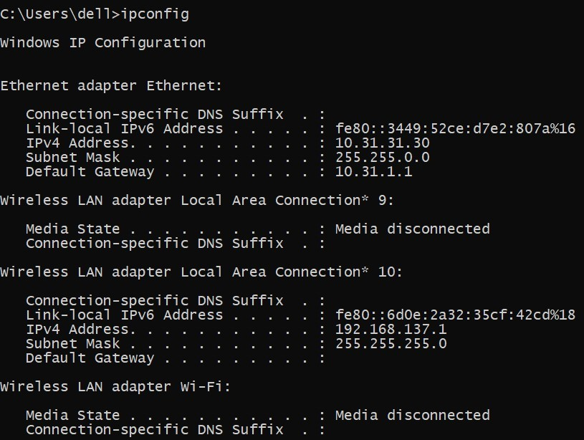

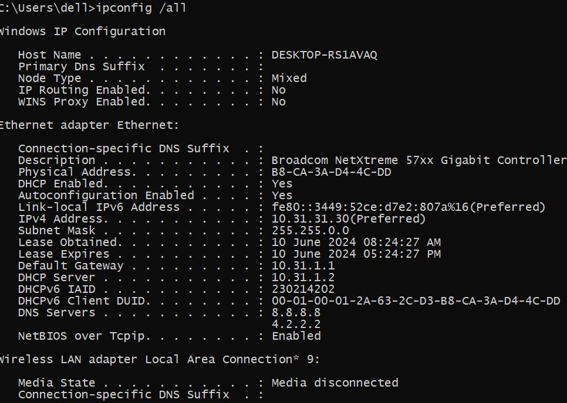

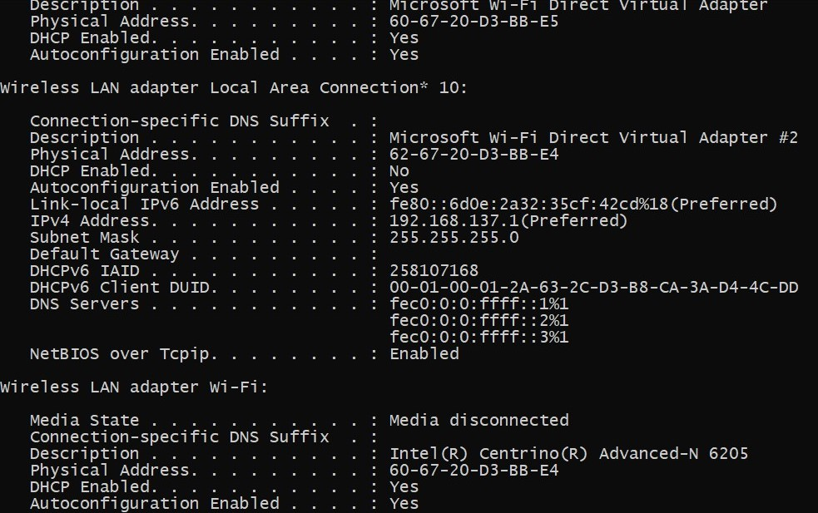

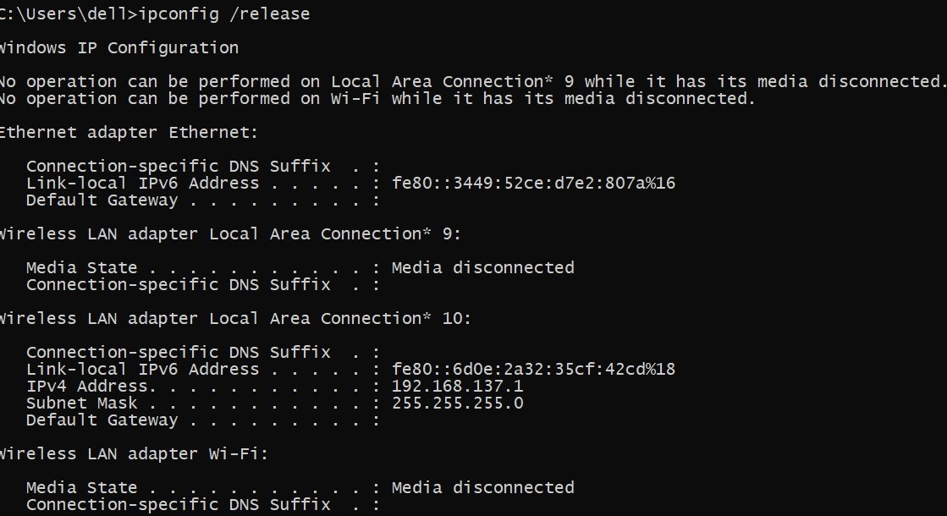

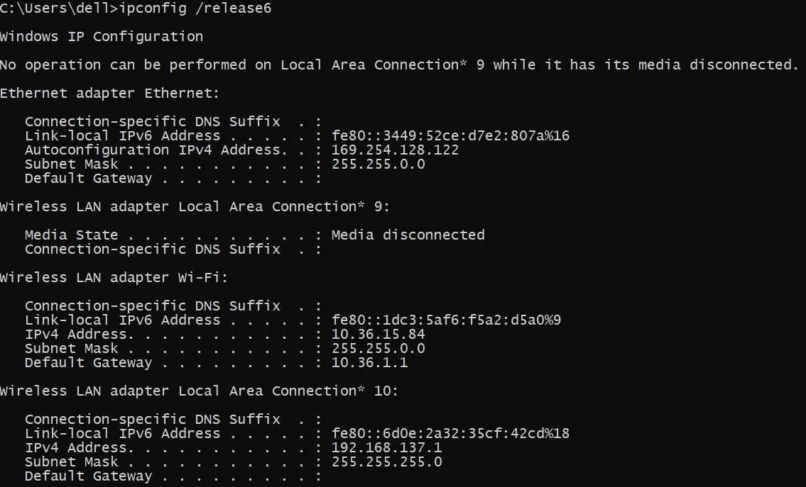

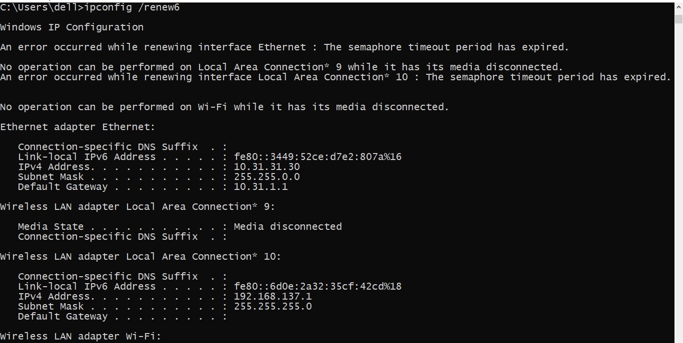

## ping

**Description:** ping is the primary TCP/IP command used to troubleshoot connectivity, reachability, and name resolution. Used without parameters, this command displays Help content. You can also use this command to test both the computer name and the IP address of the computer.

**--------- Details About Command ------**

|  |  |  |
| --- | --- | --- |
| No. | Option | Description |
| 1 | Ping -t | Ping the specified host until stopped.  To see statistics and continue - type Control-Break;  To stop - type Control-C. |
| 2 | Ping -a | Resolve addresses to hostnames. |
| 3 | Ping -n count | Number of echo requests to send. |
| 4 | Ping -6 | Force using IPv6. |
| 5 | Ping -4 | Force using IPv4. |

### Implementation:

**----- Screenshot Only (Execute command on command prompt / terminal) -----**

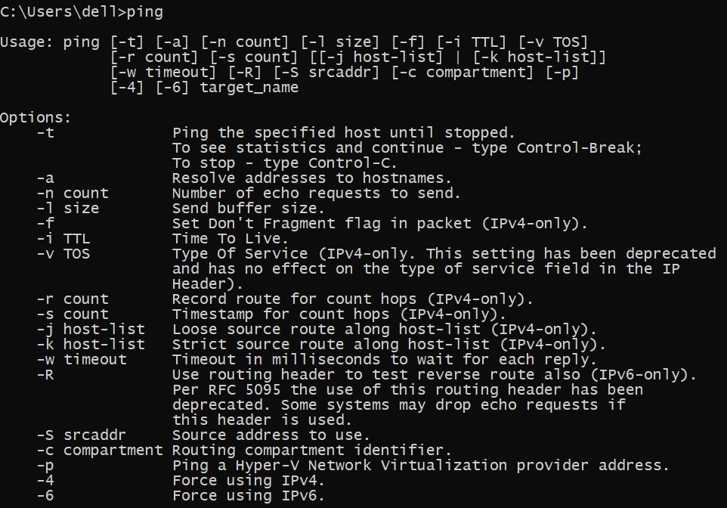

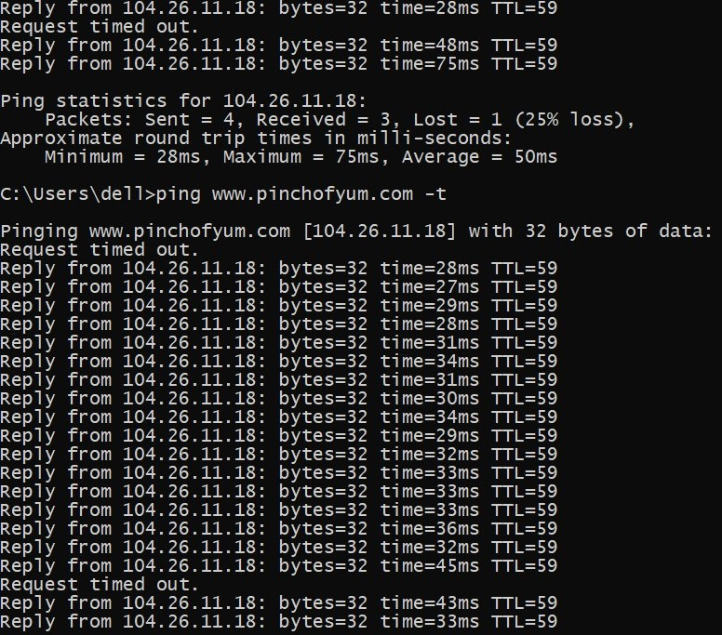

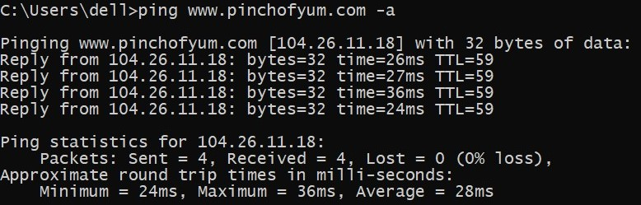

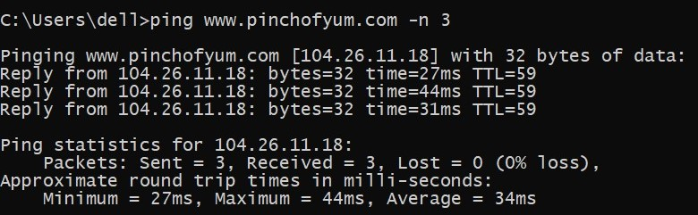

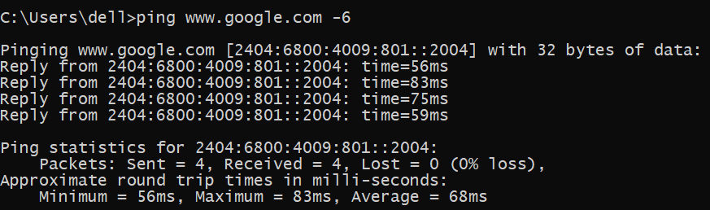

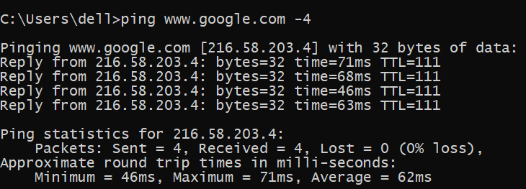

1. **getmac**

**Description:** Getmac is a Windows command used to display the Media Access Control (MAC) addresses for each network adapter in the computer.

**--------- Details About Command ------**

|  |  |  |
| --- | --- | --- |
| No. | Option | Description |
| 1 | Getmac/FO TABLE | Output is to be displayed in TABLE format. |
| 2 | Getmac/FO LIST | Output is to be displayed in LIST format. |
| 3 | Getmac/FO CSV | Output is to be displayed in CSV format. |
| 4 | Getmac/NH | Specifies that the "Column Header" should  not be displayed in the output.  Valid only for TABLE and CSV formats. |
| 5 | Getmac/V | Specifies that verbose output is displayed. |

### Implementation:

**----- Screenshot Only (Execute command on command prompt / terminal) -----**

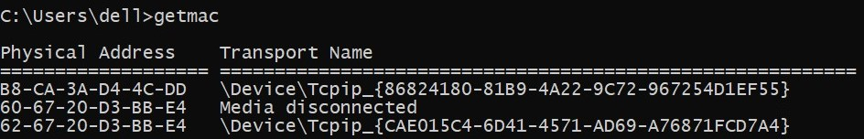

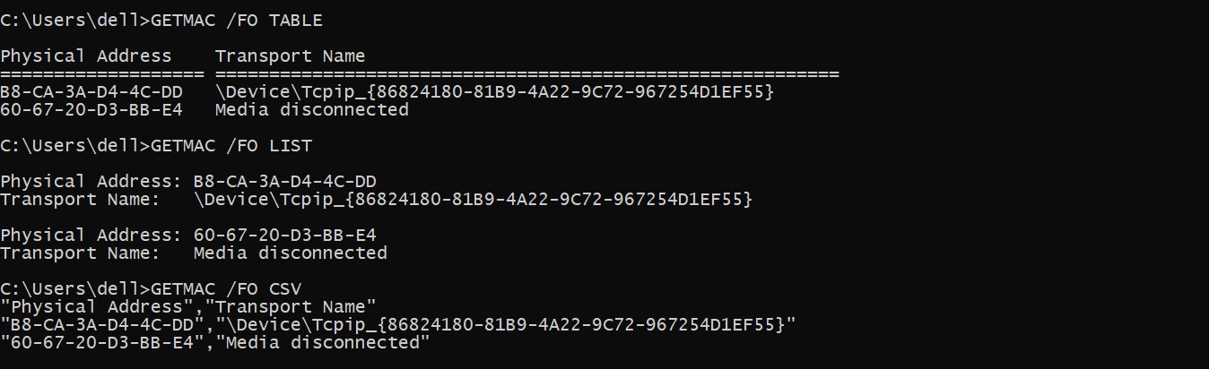

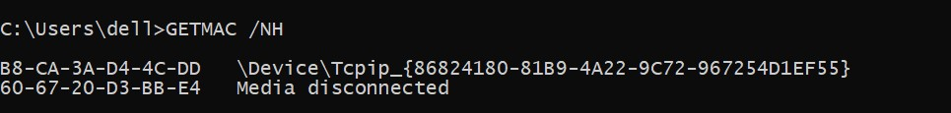

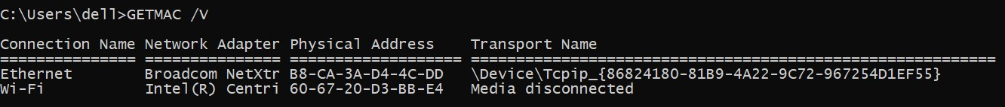

1. **systeminfo**

**Description:** SystemInfo command, which displays a detailed list of configuration information about your Windows 10 PC. The information listed by this command is too lengthy to mention in full but includes the installed version of Windows 10, the host name, the Product ID, the type and number of CPUs, RAM configuration, network card details and installed hotfixes.

**--------- Details About Command ------**

|  |  |  |
| --- | --- | --- |
| No. | Option | Description |
| 1 | systeminfo /FO TABLE | Output is to be displayed in TABLE format. |
| 2 | systeminfo /FO CSV | Output is to be displayed in CSV format. |
| 3 | systeminfo /FO LIST | Output is to be displayed in List format. |
| 4 | systeminfo /S system /NH | Specifies that the "Column Header" should  not be displayed in the output.  Valid only for "TABLE" and "CSV" formats. |
| 5 | systeminfo /? | Displays this help message. |

### Implementation:

**----- Screenshot Only (Execute command on command prompt / terminal) -----**

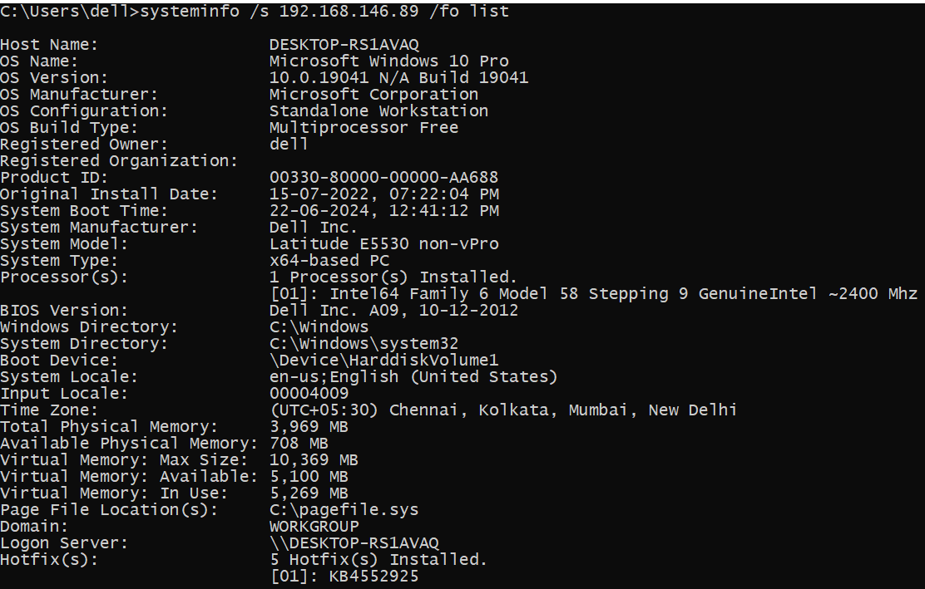

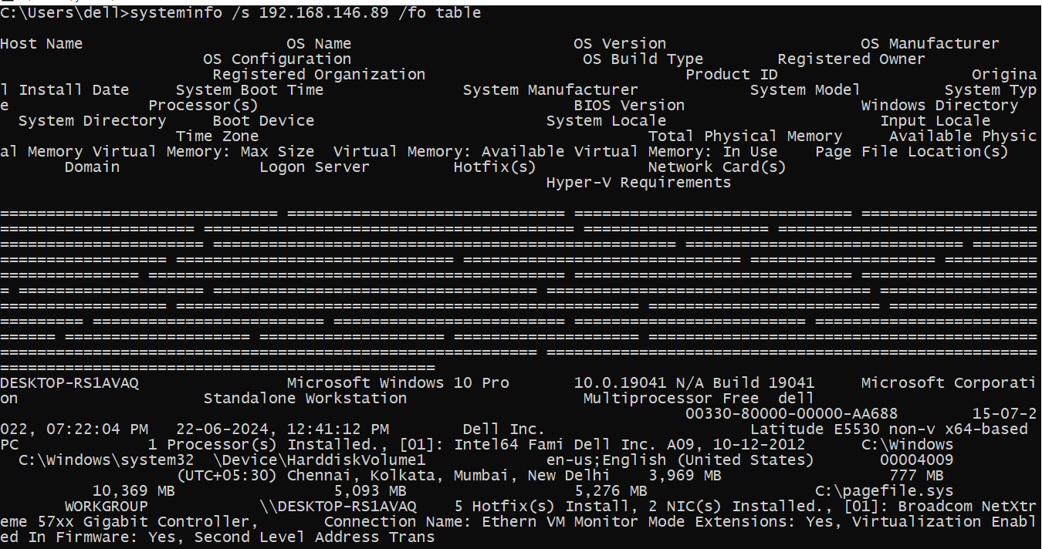

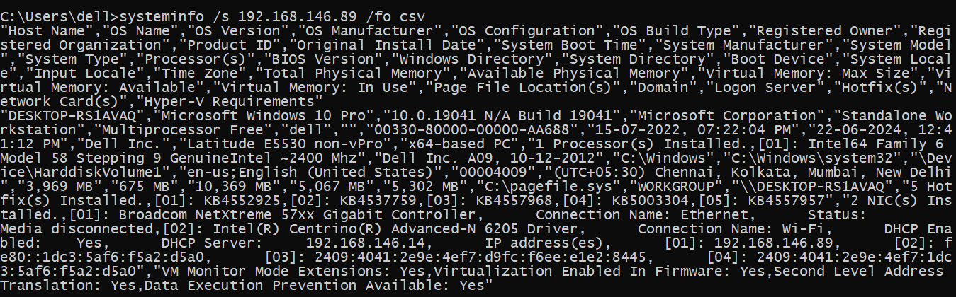

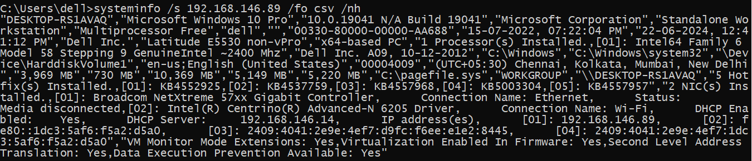

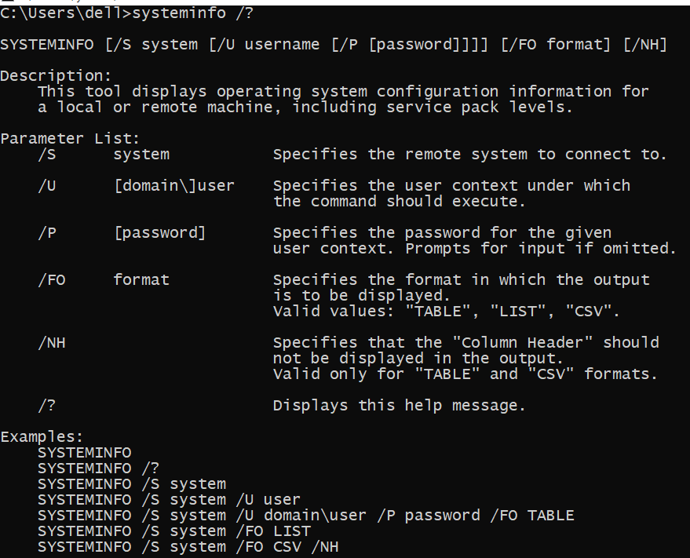

1. **traceroute/tracert**

**Description:** TRACERT (Trace Route), a command-line utility that you can use to trace the path that an Internet Protocol (IP) packet takes to its destination.

**--------- Details About Command ------**

|  |  |  |
| --- | --- | --- |
| No. | Option | Description |
| 1 | tracert -d | Do not resolve addresses to hostnames. |
| 2 | tracert -R | Trace round-trip path (IPv6-only). |
| 3 | tracert -w timeout | Wait timeout milliseconds for each reply. |
| 4 | tracert -j host-list | Loose source route along host-list (IPv4-only). |
| 5 | tracert -4 | Force using IPv4. |

### Implementation:

**----- Screenshot Only (Execute command on command prompt / terminal) -----**

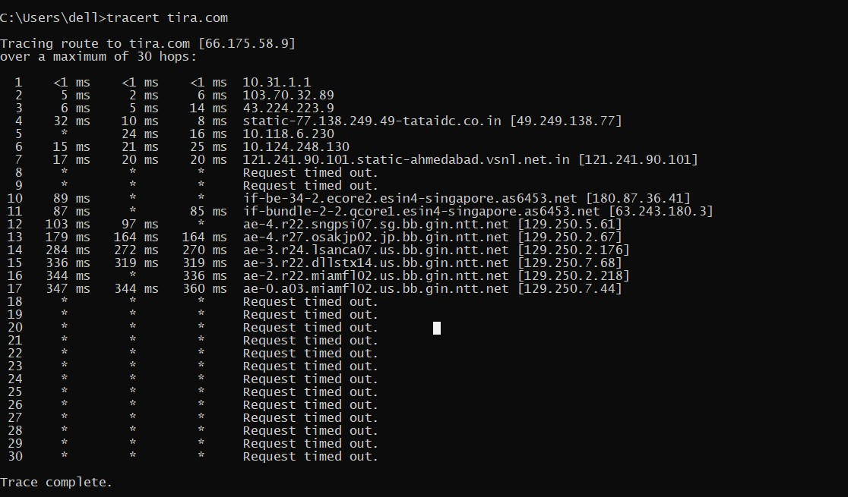

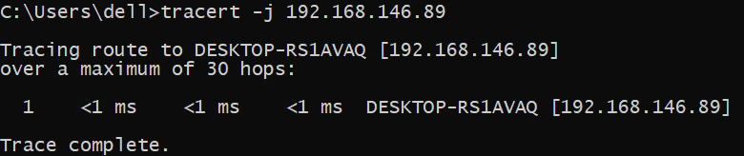

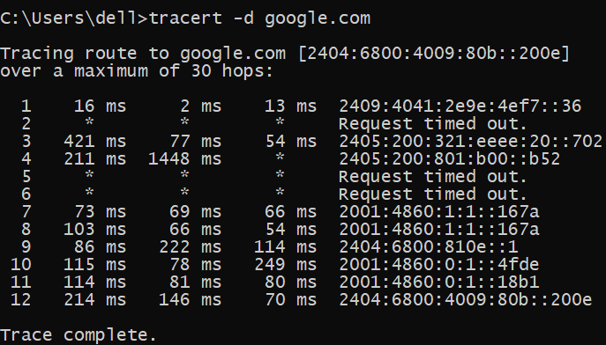

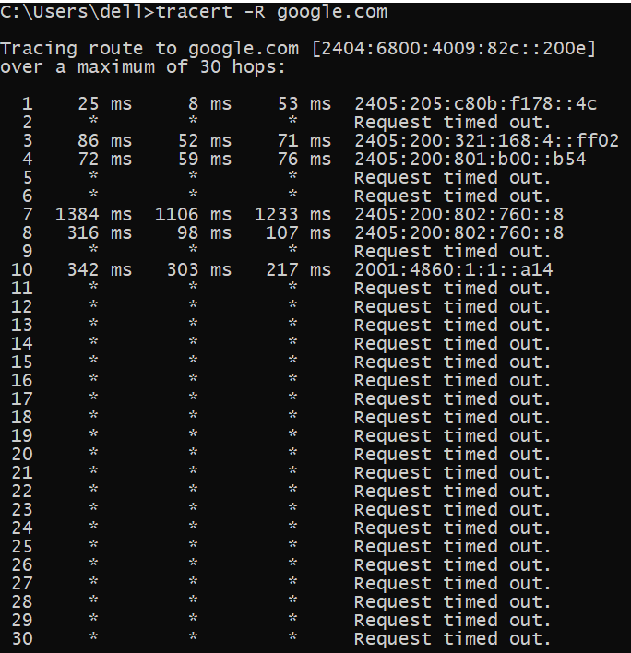

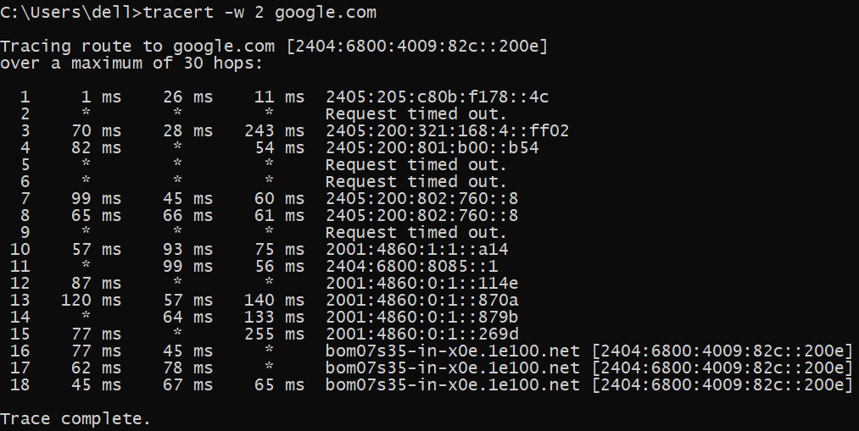

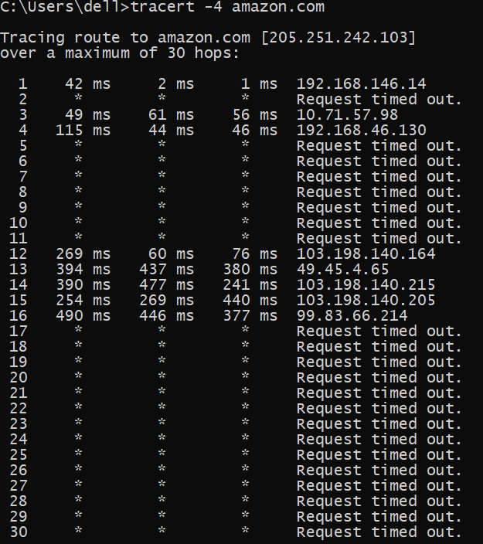

1. **netstat**

**Description:** netstat provides statistics about all active connections so you can find out which computers or networks a PC is connected to. You can use the network tool for Windows, Linux, and macOS conveniently via the command line.

**--------- Details About Command ------**

|  |  |  |
| --- | --- | --- |
| No. | Option | Description |
| 1 | netstat -a | Displays all connections and listening ports. |
| 2 | netstat -f | Displays Fully Qualified Domain Names (FQDN) for foreign  addresses. |
| 3 | netstat -y | Displays the TCP connection template for all connections.  Cannot be combined with the other options. |
| 4 | netstat -t | Displays the current connection offload state. |
| 5 | netstat -r | Displays the routing table. |

### Implementation:

**----- Screenshot Only (Execute command on command prompt / terminal) -----**

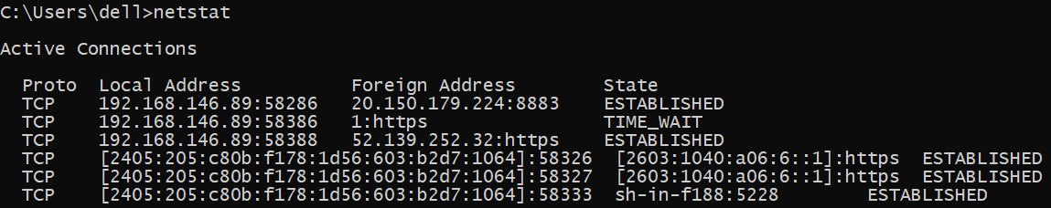

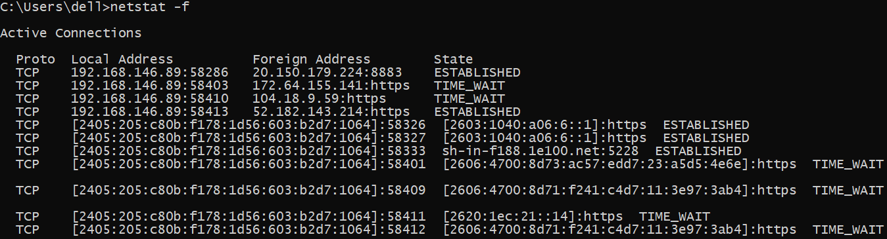

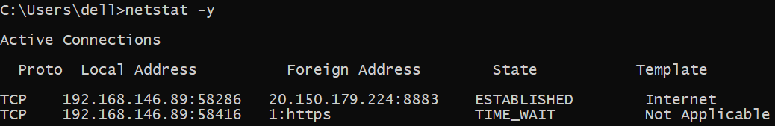

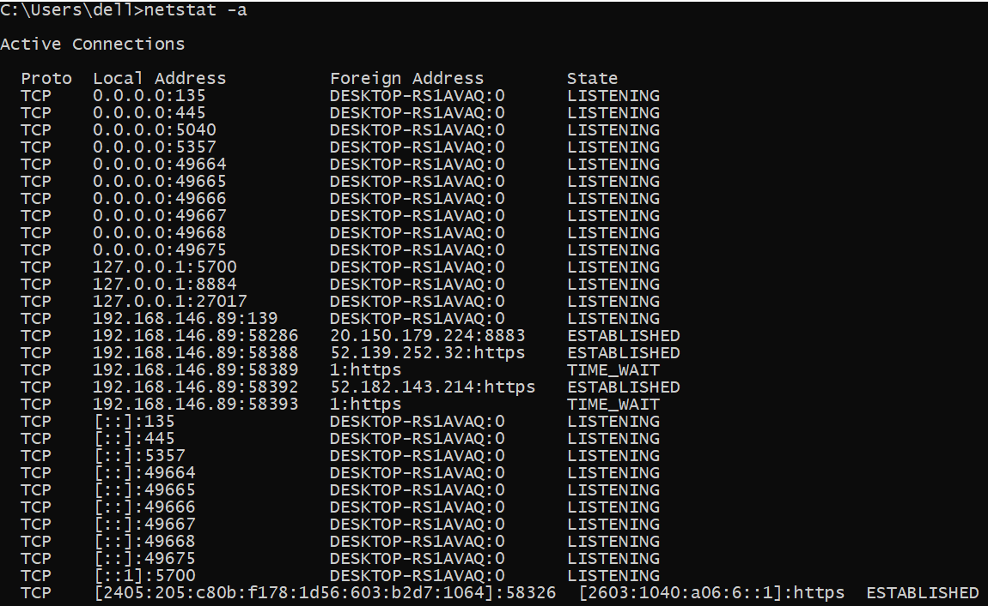

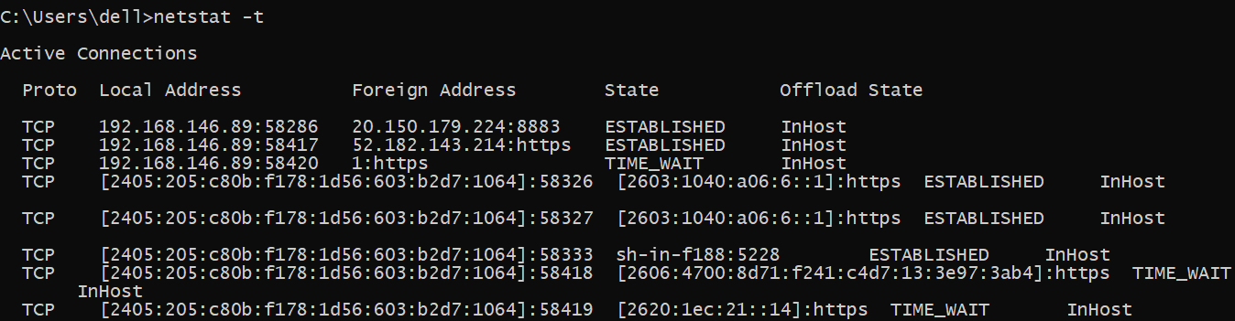

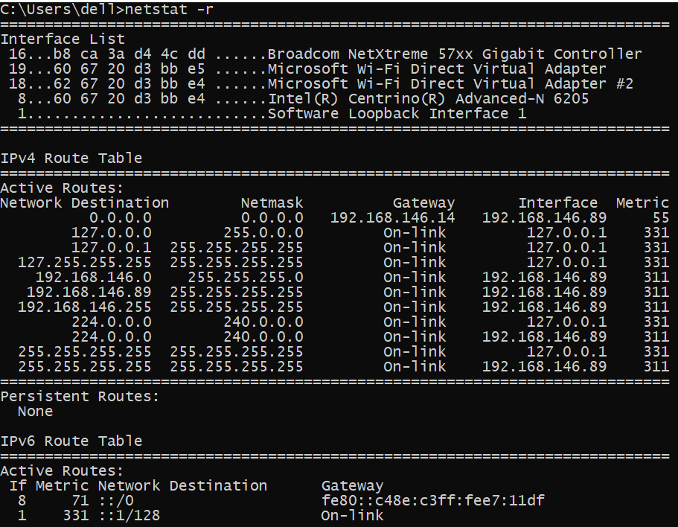

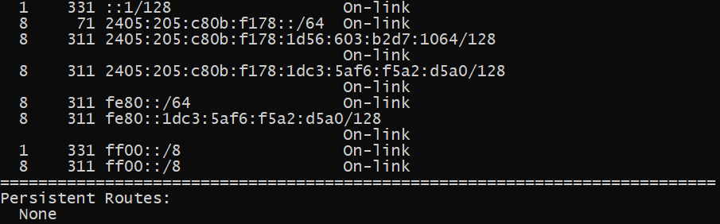

1. **nslookup**

**Description:** Nslookup is the name of a program that lets an Internet server administrator or any computer user enter a host name (for example, "youtube.com") and find out the corresponding IP address or domain name system (DNS) record.

**--------- Details About Command ------**

|  |  |  |
| --- | --- | --- |
| No. | Option | Description |
| 1 | nslookup /? | Displays this help message. |

### Implementation:

**----- Screenshot Only (Execute command on command prompt / terminal) -----**



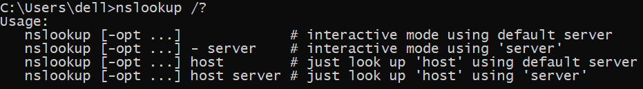

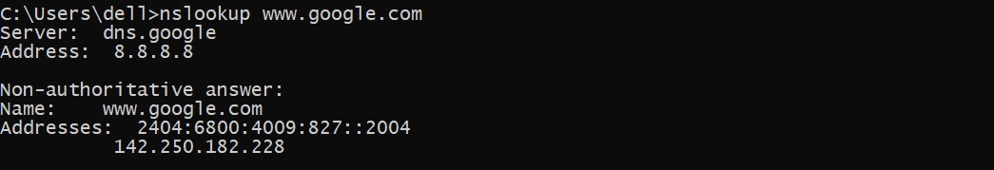

1. **hostname**

### Description: Displays the host name portion of the full computer name of the computer. This command is available only if the Internet Protocol (TCP/IP) protocol is installed as a component in the properties of a network adapter in Network.

### Implementation:

**----- Screenshot Only (Execute command on command prompt / terminal) -----**



1. **pathping**

**Description:** The PathPing command is a command-line network utility supplied in Windows 2000 and beyond that combines the functionality of ping with that of tracert. It is used to locate spots that have network latency and network loss.

**--------- Details About Command ------**

|  |  |  |
| --- | --- | --- |
| No. | Option | Description |
| 1 | pathping -g host-list | Loose source route along host-list. |
| 2 | pathping -h maximum_hops | Maximum number of hops to search for target. |
| 3 | pathping -n | Do not resolve addresses to hostnames. |
| 4 | pathping -4 | Force using IPv4. |
| 5 | pathping -6 | Force using IPv6. |

### Implementation:

**----- Screenshot Only (Execute command on command prompt / terminal) -----**

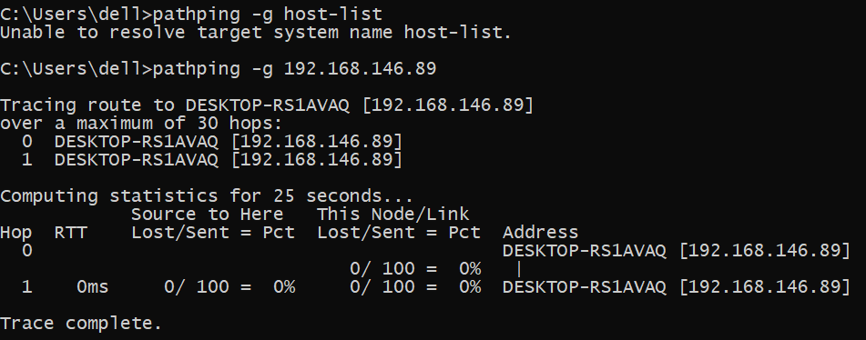

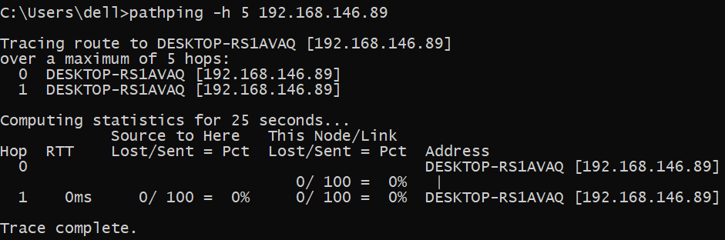

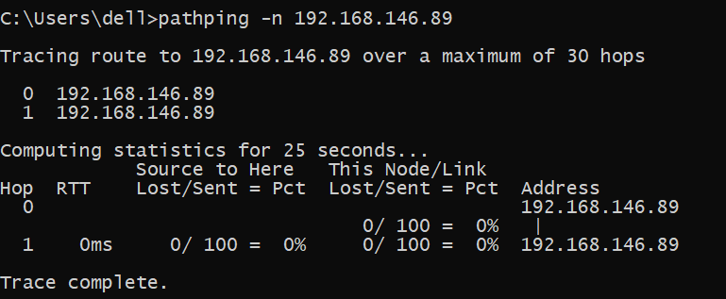

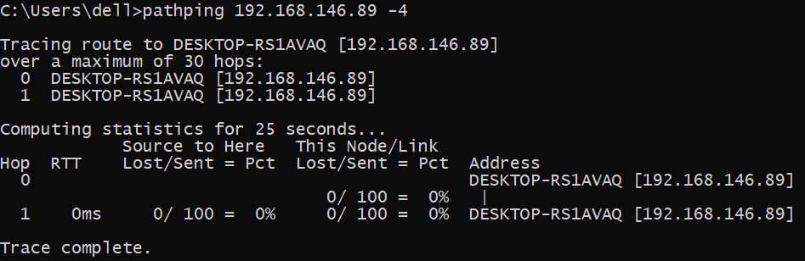

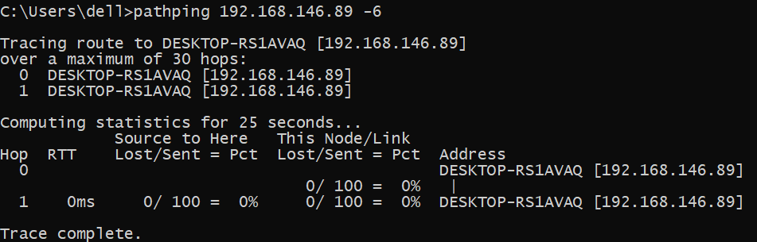

1. **arp**

**Description:** The arp command displays and modifies the Internet-to-adapter address translation tables used by the Address in Networks andcommunication management. The arp command displays the current ARP entry for the host specified by the HostName variable.

**--------- Details About Command ------**

|  |  |  |
| --- | --- | --- |
| No. | Option | Description |
| 1 | arp -a | Displays current ARP entries by interrogating the current  protocol data. If inet_addr is specified, the IP and Physical  addresses for only the specified computer are displayed. If  more than one network interface uses ARP, entries for each ARP. |
| 2 | arp -g | Same as -a. |

### Implementation:

**----- Screenshot Only (Execute command on command prompt / terminal) -----**

