**Lab Practical #05:**

Study the concept of VLAN using packet tracer.

**Practical Assignment #05:**

1. **Implement the different network structures in VLAN and VLAN trunking. Also check connectivity between them using ping command or PDU utility.**

**Instructions:**

1. Different VLANs configuration setup screenshot. (VLAN example given by lab faculty)
2. Write steps to create VLANs in packet tracer.
3. Mention IP address of each pc as label.
4. Ping command or PDU screenshot between two VLANs.
5. **VLAN – 1**

* **Steps for create VLAN -1 :-**

1. Configure a Switch and go to ‘VLAN Database’ 🡪 then create a database student and faculty.
2. Configure 4 PC with labeled and IP address. And connect all four with Switch.
3. Open Switch-1 Dialog and configure PC-1 and PC-2 in student database with access state and configure PC-3 and PC-4 in faculty database with access state.
4. Same as Open Switch-2 Dialog and configure PC-5 and PC-6 in student database with access state and configure PC-7 and PC-8 in faculty database with access state.
5. So as per below image we create a to VLAN student and faculty.
6. The packet are transfer one PC to another PC with an student VLAN like as The packet are transfer one PC to another PC with an faculty VLAN.

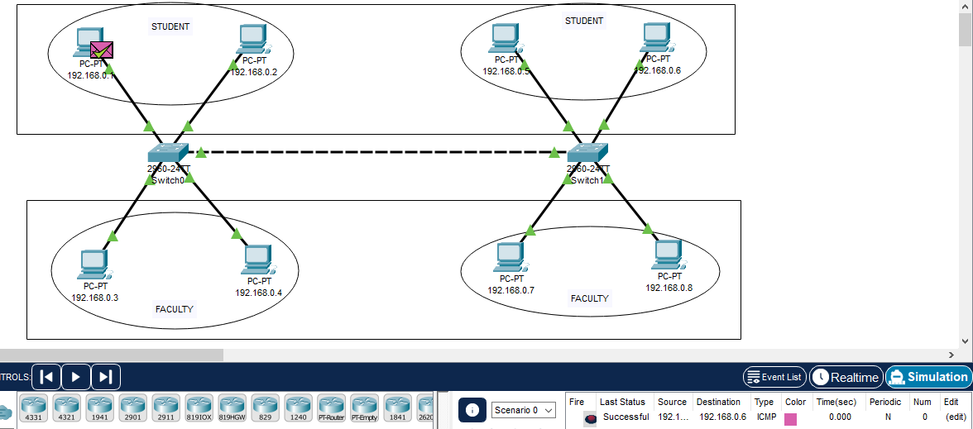

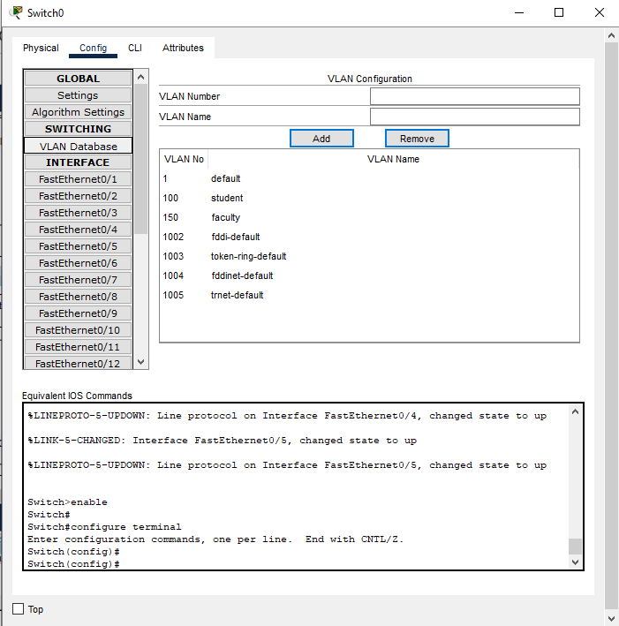

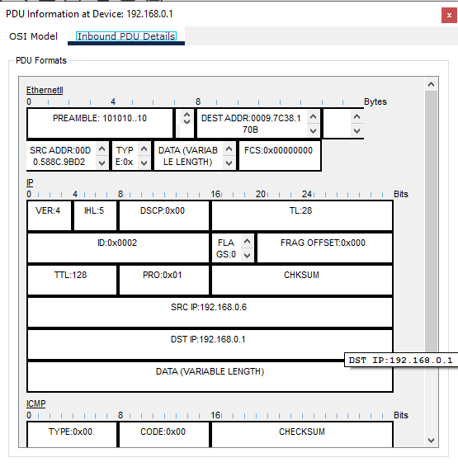

1. **VLAN – 2**

* **Steps for create VLAN -2 :-**

1. Configure a Switch1 and go to ‘VLAN Database’ 🡪 then create a database student and faculty.
2. Configure a Switch2 and go to ‘VLAN Database’ 🡪 then create a database student and faculty.
3. Configure 12 PC with labeled and IP address. And connect all First 6 PC with Switch1 and remaining 6 PC with Switch2.
4. Open Switch-1 Dialog and configure PC-1, PC-2 and PC-3 in student database with access state and configure PC-4, PC-5 and PC-6 in faculty database with access state.
5. Same as Switch-2 Dialog and configure PC-7, PC-8 and PC-9 in student database with access state and configure PC-10, PC-11 and PC-12 in faculty database with access state.
6. So as per below image we create a to VLAN student and faculty.
7. Switch to switch configure database with trunk state.
8. The packet are transfer one PC to another PC with an student VLAN like as The packet are transfer one PC to another PC with an faculty VLAN.

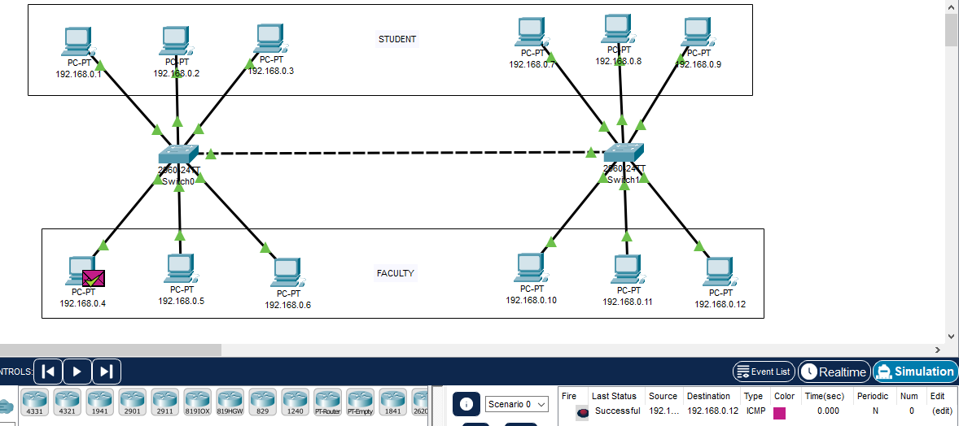

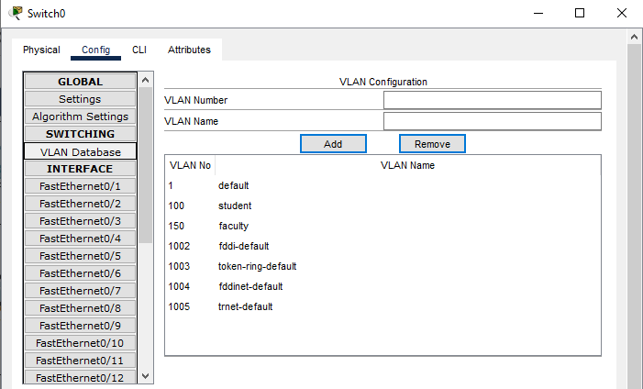

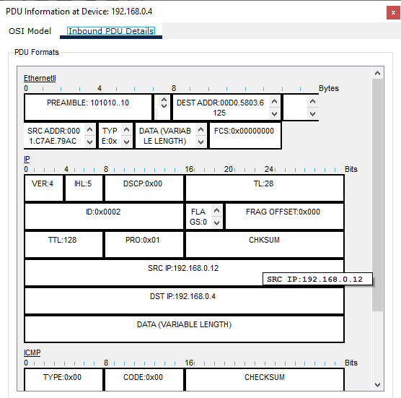

1. **VLAN - 3**

* **Steps for create VLAN:-**

1. Configure a Switch1 and go to ‘VLAN Database’ 🡪 then create a database cousins and friends.
2. Configure a Switch2 and go to ‘VLAN Database’ 🡪 then create a database others and schools.
3. Configure 2 PC with labeled and IP address. And connect all two with Switch1.
4. Configure 2 PC with labeled and IP address. And connect all two with Switch2.
5. Open Switch Dialog and configure PC-1 and PC-2 in cousins database, PC-3 and PC-4 in friends database with access state and configure PC-5 and PC-6 in others database, PC-7 and PC-8 in schools database with access state.
6. So as per below image we create a to VLAN cousins, friends, others and schools.
7. Switch to switch configure database with trunk state.
8. The packet are transfer one PC to another PC with an cousins VLAN like as The packet are transfer one PC to another PC with an friends , others , schools VLAN.

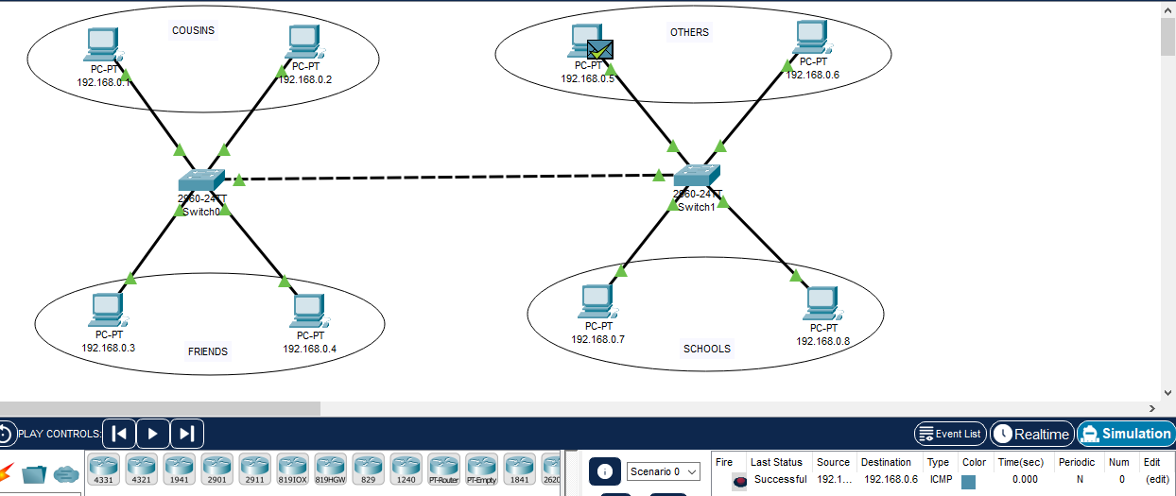

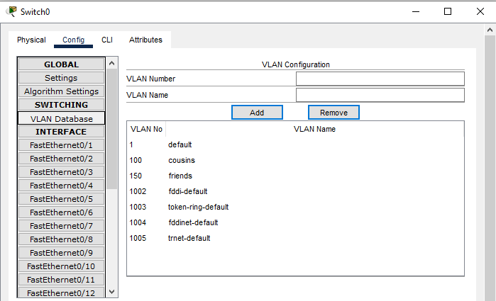

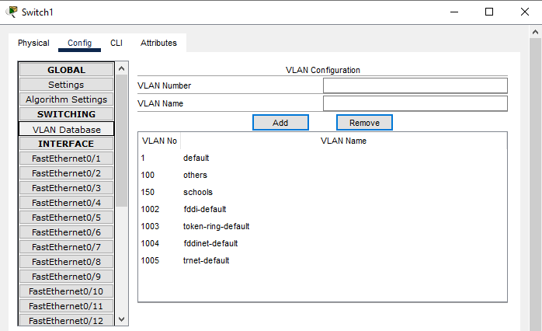

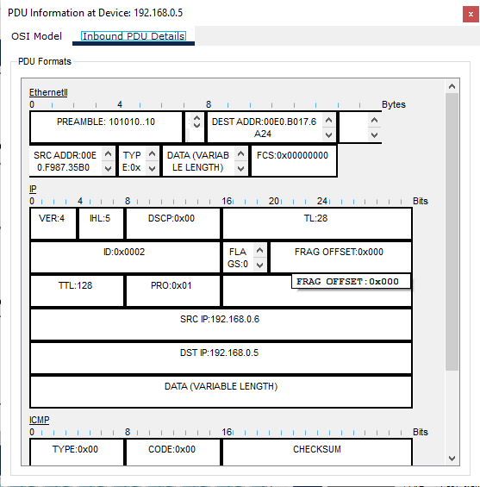

1. **VLAN – 4**

* **Steps for create VLAN - 4:-**

1. Configure a Switch1 and go to ‘VLAN Database’ 🡪 then create a database G-1.
2. Configure a Switch2 and go to ‘VLAN Database’ 🡪 then create a database G-2.
3. Configure 6 PC with labeled and IP address. And connect all First 3 PC with Switch1 and remaining 3 PC with Switch2.
4. Open Switch Dialog and configure PC-1, PC-2 and PC-3 in G-1 database with access state and configure PC-4, PC-5 and PC-6 in G-2 database with access state.
5. So as per below image we create a to VLAN G-1 and G-2.
6. Switch to switch configure database with trunk state.
7. The packet are transfer one PC to another PC with an G-1 VLAN like as The packet are transfer one PC to another PC with an G-2 VLAN.

