CREATE TABLE employee1(ECODE integer, ENAME varchar2(20), GENDER char(1),GRADE char(2),GROSS integer)

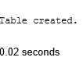

INSERT INTO employee1 values(1001,'BHAKTI','F','E4',50000)

Op:

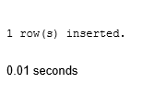

INSERT INTO employee1 values(1002,'SWAPNALI','F','A1',35000)



INSERT INTO employee1 values(1003,'NISHA','F','B2',40000)



INSERT INTO employee1 values(1004,'NULL','M','C4',38965)



Select \*From employee1

