Frequency selective fading

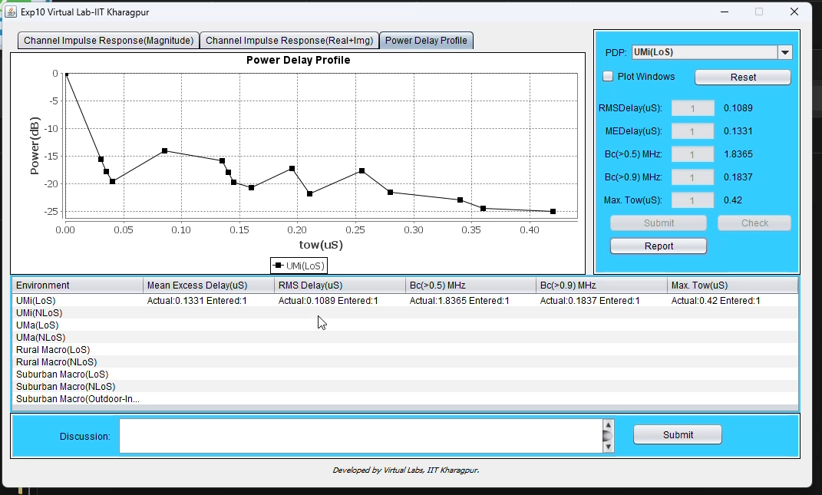
https://chatgpt.com/s/t_6ae8edd3e0c08191a83acdfdd1c87e08

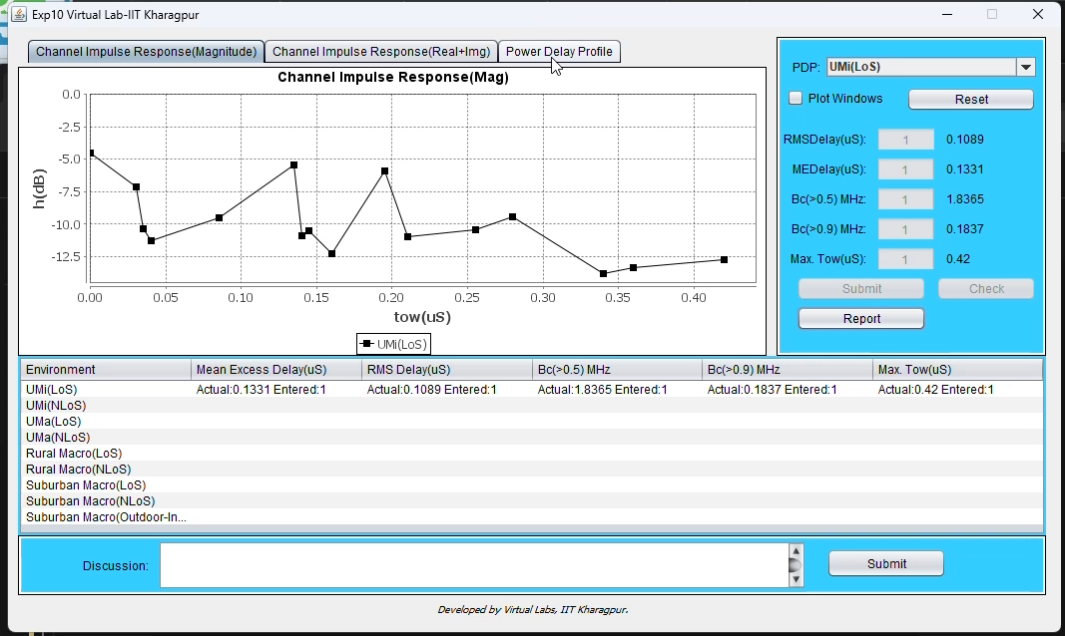
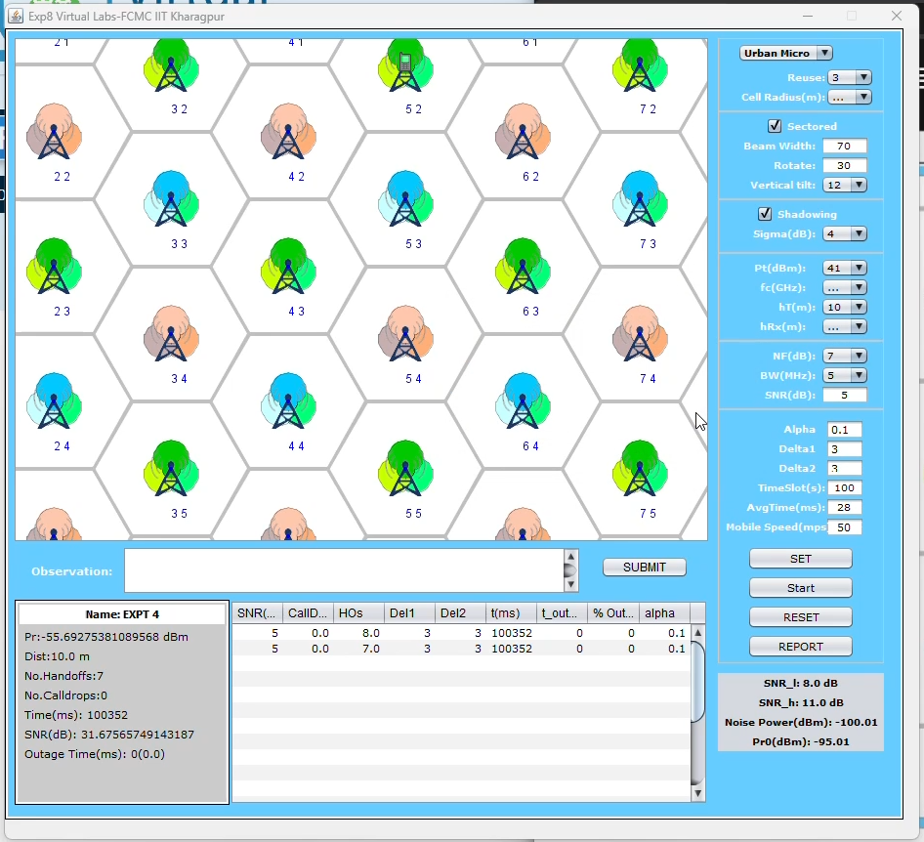
HandOff

